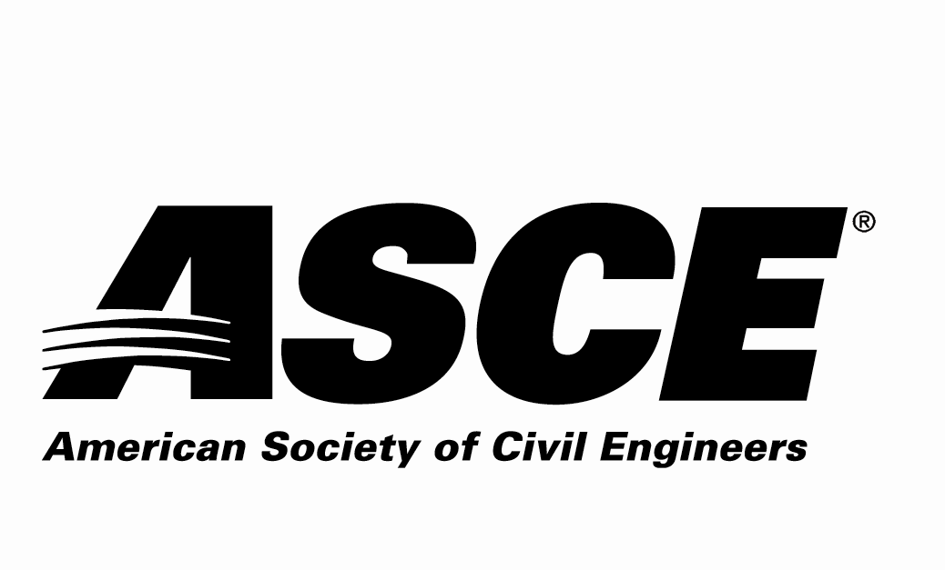 | REGION 7

Individual Nomination Form

Outstanding ASCE Younger Member Award

Due Date: Nominations must be received by April 30, 2021

Application Materials Required
Individual Nomination Form and Electronic Photo of Nominee

Entry Instructions
Electronic submittal is requested. Please e-mail the following 2 electronic files (less than 10 MB per e-mail):
- File 1: Filename = nominee’s last name.pdf
Individual Nomination Form
- File 2: Filename = nominee’s last name.jpg
Photo of the nominee to be used in the awards program

e-mail to: jcjackataylor@gmail.com
E-mail subject line = ASCE R7 Award Application – Outstanding ASCE Younger Member for (nominee’s last name)

For more information contact:
Jennifer Jacka-Taylor - ASCE Region 7 Awards Committee
jcjackataylor@gmail.com or 785-587-5094

Award Criteria
Consideration shall be given to the Engineer that has exhibited professional achievement and has made significant impact to the field of civil engineering. This impact may be through professional activities, ASCE involvement, research and innovative engineering solutions. This award is intended for individuals who are age 35 years or less as of December 1 of the year of the award and a member of ASCE in Region 7.

Awards Ceremony
The selected individual will be recognized during 2021 at the awardee’s Section or Branch meeting.

The Award
The award is intended to recognize the efforts of younger civil engineers to further advance the field of civil engineering through innovative concepts, research, and materials.

Nominator Contact Information (person making the nomination - self nomination encouraged)
Name:
Employer:
Address:
 | Street |  |  | City | State | Zip
Phone Number:
Email Address:
ASCE Membership#:
P.E.? Yes or No

Nominee Contact Information
Name:
Employer:
Address:
 | Street |  |  |  | City |  | State | Zip
Phone Number:
Email Address:
P.E. Registration State |  |  |  | P.E. Registration #

Nominee ASCE Membership Information:
ASCE Section nominee belongs to:
Colorado Section
Denver Branch Northern Branch Southern Branch SW Branch Western Slope Branch
Iowa Section
Kansas Section
Wichita Branch
Kansas City Section
Nebraska Section
South Dakota Section
Black Hills Branch Eastern Branch
St. Louis Section
Wyoming Section
Nomination Information Section:
Please answer the following questions as thoroughly as possible and ensure that the response to this nomination information section is3 pages or less.

1. Describe the nominee’s ASCE involvement.

2. Describe the nominee’s other professional activities.

3. Describe the nominee’s contributions to the profession.

4. Provide any other information regarding the nominee to be considered for this award.

