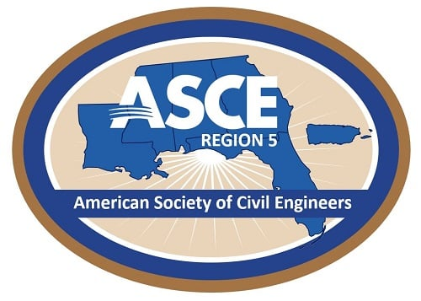
2026 Awards NOMINATION FORM

SUBMITTAL DEADLINE: SEPTEMBER 30, 2026
(PLEASE TYPE OR PRINT)
- Nominee

Nominee's Name:
(First) (M.I.) (Last) (credentials)
(as you would like it to appear on the award)
Award for which member is nominated:
 |  | Civil Engineer of the Year
 |  | Young Civil Engineer (YCE) of the Year (Must be 35 years of age or younger on September 30, 2026)
 |  | Civil Engineering Student of the Year (Must be enrolled in an undergraduate program in the 2025-2026 academic school year)
 |  | Civil Engineering Professor of the Year (Must be employed at a university in the 2025-2026 academic school year)
 |  | Region 5 Wall of Fame
ASCE Member Number:
Number of Years as ASCE Member:
ASCE Member Grade: |  |  |  | Student |  | Fellow
 |  |  |  | Member |  | Distinguished
 |  |  |  | Life
Date of Birth:
Company Name:
Title:
Work Address:
Home Address:
Email:
Phone:
Primary Area of Civil Engineering Practice:
Registrations:
ASCE Involvement:
Professional/Technical Society Involvement:
Civic and Humanitarian Organization Involvement:
Engineering Achievements:
- Award Descriptions:
  - Region 5 Civil Engineer of the Year - awarded annually to one recipient to recognize outstanding achievements of a practicing Civil Engineer that is active within the Region.
  - Region 5 Younger Civil Engineer of the Year - awarded annually to one recipient to recognize outstanding achievements of a practicing Civil Engineer, age 35 or less that is active within the Region.
  - Region 5 Civil Engineering Student of the Year - awarded annually to one recipient to recognize an outstanding Civil Engineering or Civil Engineering Technology Student, enrolled in a Civil Engineering undergraduate program in the 2025-2026 academic school year.
  - Region 5 Civil Engineering Professor of the Year - awarded annually to one recipient to recognize an outstanding Civil Engineering Professor employed at a University Civil Engineering program in the 2025-2026 academic school year.
  - Region 5 Wall of Fame - a designation to honor Civil Engineers that have made a substantial contribution to ASCE, Region 5, and the Civil Engineering community. Nominations will be considered annually, with no more than 3 candidates selected for the honor in a given year.
- Eligibility for the Award

Nominees may only be submitted by a Section within Region 5. Only 1 nomination per Section, per award, may be submitted each year. The selection process is based on the nominee’s contributions to the region, society, profession, the public welfare, and/or humankind as listed under the purpose of the award.
- Qualifications:

- Nominee for Civil Engineer of the Year must be a licensed Professional Engineer and must be an ASCE Member in good standing.
- Nominee for Younger Civil Engineer of the Year must be an ASCE Member in good standing.
- Nominee for Engineering Student of the Year must be an ASCE Student Member in good standing enrolled in an undergraduate Civil Engineering Student.
- Nominee for Civil Engineering Professor of the Year must be an ASCE Member in good standing employed at a University Civil Engineering program.
- Nominee for the Region 5 Wall of Fame must be a Fellow, Distinguished, or Life Member of ASCE, at least 55 years or older, made significant contributions to the Civil Engineering Profession, supported and promoted ASCE, Region 5, and the Civil Engineering Profession, and be endorsed by two Licensed Professional Engineers not on the Board of Directors of the nominating Section.

Nomination Criteria

The following sections present the award nomination criteria that will be considered. The information can be typed and submitted as attachments to the award form (see link below), or the information can be entered electronically, lengthening the form as needed. Nomination should be a maximum of 5 pages (points may be deducted if submission is longer).

- ASCE Involvement: ASCE activities during the past five years, including offices held and awards (20 Points).
- Professional/Technical Society Involvement: Other professional/technical society activities during the past five years, including offices held and awards (20 Points).
- Civic and Humanitarian Organization Involvement: Civic and humanitarian organization activities during the past five years, including positions held (20 Points).
- Engineering Achievements: Submit narrative supporting nominee’s professional or academic achievements (40 Points).
- Additional Requirements:

- A statement of 100 words maximum (one page, double spaced) that supports the nomination showing achievement in Civil Engineering. Statement will include description of awards received in recognition of Civil Engineering accomplishments. NOTE: The statements of the nominees selected for the Civil Engineer of the Year Awards will be used in Region Award announcements and on the Region webpage.
- A nomination letter signed by the sponsor Section. (not included in total page count).
- A resume would be helpful to the judges but is not obligatory (not included in total page count).
- A professional headshot photograph will be required from the winning nominees.
- Name and address of a local newspaper.
- Submittal Requirements

Submittal Deadline: September 30, 2026

Send the completed form to the following address: Tzufit.boyle@gmail.com.
- Award Presentation

Award winners will be contacted by October 31, 2026.

Awards will be presented at a local Section or Branch function.
- Questions

For questions, please contact Tzufit Boyle at Tzufit.boyle@gmail.com or 954.560.9085.

