Membership Development

4.4 Younger Member Recruitment – Baton Rouge Branch
1. Section, Branch | Louisiana Section, Baton Rouge Branch
2. Section/Branch Size | Medium
3. Project Contact
Name | Joshua Olivier, EI
Phone Number
Email | youngmembers@ascebr.org
4. Project Category | Membership Development
5. Project Description | Younger Member Recruitment
6. The Process  (What you did, When and How) | I set a goal for myself as the younger member chair this year—increase the number of active younger members. Our roster is quite large but very few people were coming to the socials. One of the ways I got more participation from the younger members was by having the socials at the same time each month—I chose the second Thursday of the month. Since they knew the date of each social, they were able to keep their schedules open so they can attend the social. I also committed to varying the activities each month. We do not just go to a bar for Happy Hour. We have played laser tag, gone bowling, gone to restaurants, done service projects--each month is something different which I think it keeps the younger members interested and the attendance up!  As for member recruitment, I think recruiting at the college level is the best place to start. Those who hold a position in their student chapter and are active in their student chapter are very likely to stay involved after graduation and possibly even hold a role in the branch. Attending the student chapter meetings is beneficial so they receive the personal attention they deserve. Another really good source for recruitment is the younger member group that you already have. They probably work at an office with many other young engineers so when they have a good time at the social, they will go back to their office and talk about how much fun they had and will recruit their coworkers to attend the next social.
7. Those in Charge (Committee, Task Committee, Etc.)
8. Time Frame  (When Started, When Completed) | Recruitment is an ongoing process. The younger member chair has to keep reminding the students and current younger members that there is a way to stay active in ASCE besides just attending the monthly luncheons.
9. Success Factors  (The Parts that Worked Really Well) | The socials at restaurants instead of bars have been some of the best attended socials! The activities (laser tag, bowling, etc.) were second best! However, it is nice to have a relaxing happy hour every once in a while!
10. Setback Factors  (The Parts that did Not Work Well) | I do not organize socials in the summer months anymore—partly because of my budget but also because many people go on vacation so attendance usually drops in the summer. It is nice to give myself a break as well. We start fresh again in the fall with new ideas for social activities.
11. Creativity  (This is something off the wall that we did) | Something that I tried but never really continued was the “Younger Member Spotlight.” This was an opportunity for younger members to nominate their fellow younger members for something special they did at work or in the community. It is up to them to acknowledge an accomplishment of a fellow yellow member and the nominee would be recognized at the monthly ASCE luncheon. Unfortunately, I never got any nominations the first few months so I stopped trying but it is something that I would like to try again.
12. Administration  (What was most Important?) | I get a lot of support from my board members. I have a very nice budget which allows me to host socials just about once a month including the two socials that are focused on the graduating seniors. I could not do the socials without this support.
13. Follow-Up  (What was most important?) | I always send out an email to the younger members after the social to thank them for coming. I also attach a picture, if we take one, to show all those who didn’t attend how much fun we had.
14. Recommendations  (What you should ALWAYS do with this project?) | Take ideas from those who give it! Do not ignore their suggestions. After all, it is their evening that they are giving up to spend time with the younger member group so you should try to do what they want to do.
15. Cautions  (What you should NEVER do with this project?) | GIVE UP! Keep contacting the younger members. Even if they are reluctant at first, they might just be really busy but they may come to one social and realize what they have been missing and then attend many after that—and maybe even recruit others to come too!
16. The Outcome | Our attendance has exploded since we have had socials every month. It is something for them to look forward to and now that they know when it will be, they don’t have to worry about possibly having other plans or conflicts. It has been great! Our number of active participants has truly grown.
17. Ongoing Activity  (Would you do it again?) | YES…I am still doing socials once a month and they are going very well but I am always looking for new ideas of where to go and what to do.
18. Speaker Contact Information
(person from your Region who would be willing to speak about the Best Practice)
Name
Address
Phone Number
Email
19. Additional Comments | This Best Practice includes the following attachments:  - Photographs of younger member socials and events

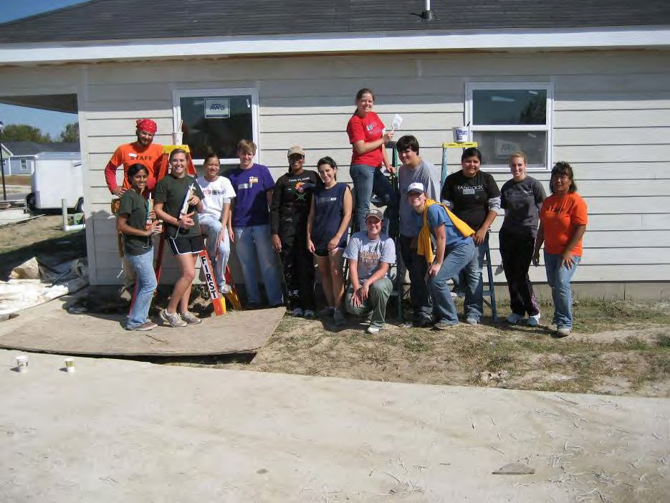

Habitat for Humanity Build with LSU and Southern University (November 2008)

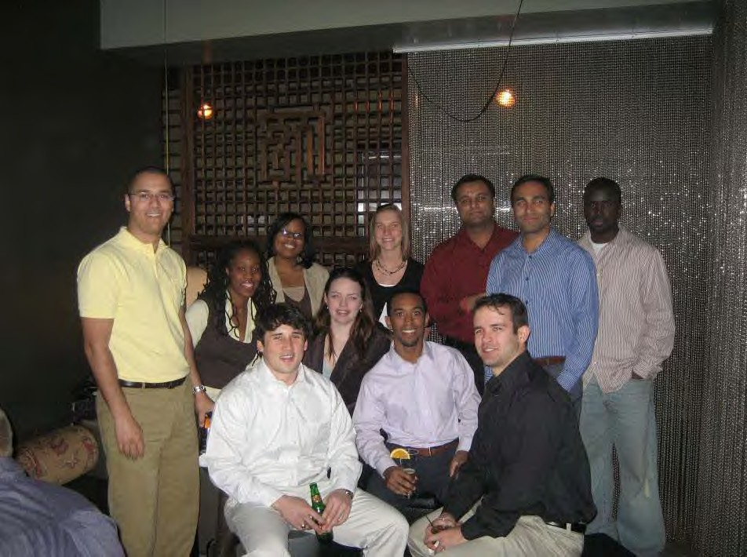

YM Social at Tsunami (February 2009)

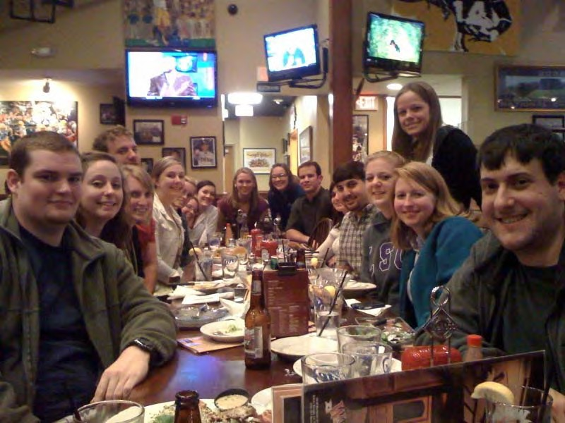

“Senior Night” YM Social at Walk-Ons (March 2010)

