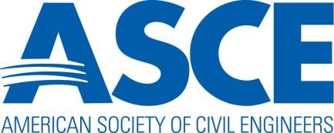

2022-23 Section and Branch
Action and Activity Calendar

2022

March 2-4 Legislative Fly-In (hybrid)

March 15 Committee applications are due

June 1 Submissions are due for the Outstanding Section & Branch Web Award

Sept. 1 Section and Branch Leadership Reports Due

Sept/Oct. Presidents and Governors Forum (Virtual)

Oct 23-26 Annual Convention in Anaheim

Oct. 30 Submissions for the Outstanding Section and Branch Award nominations are due

Nov. 30 Section, Branch, and Region Annual Reports are due

Nov. 30 Section Federal Tax Filing due to ASCE’s Accounting Dept.

2023

January 20-21​ Regions 1, 2, 4, & 5​ Multi Region Leadership Conference in Charlotte, NC

February 3-4​ Regions 3, 6, & 7​ Multi Region Leadership Conference in Denver, CO​
​
February 17-18 Regions 8 & 9​ Multi Region Leadership Conference in Anaheim CA

