Membership Development

4.8 Revival of Dormant Branch – Reading Branch
1. Section, Branch | Lehigh Valley Section, Reading Branch
2. Section/Branch Size | Small
3. Project Contact
Name | John Caperilla, Reading Branch President, Past President Lehigh Valley Section
Phone Number | 610-841-2700
Email | jcaperilla@mctish.com
4. Project Category | Membership Development
5. Project Description | Revive Dormant Branch; Plan to Re-invigorate/ Kick start Idle Branch / Transfer of Branch to another Section.
6. The Process  (What you did, When and How) | - Region 2 along with the Philadelphia Section felt that the Reading Branch would better served by another Section since most of their Section meetings are in Center City Philadelphia which can take up to two hours to get to for Reading Branch members to get to. The Branch at the time was inactive with two Branch Champions that were interested in getting the Branch back up and running.  - The Region reached out to the both the Lehigh Valley & Central Pennsylvania Sections to discuss the plans to see which Section would best serve the Reading Branch Membership. After discussion with the three Sections and the Branch Champions, it was agreed that it would be best to transfer the Branch to the Lehigh Valley Section.  - A meeting with held with the Region, Branch Champions, and Lehigh Valley Section leadership to prepare the formal document to officially transfer the Branch to the Lehigh Valley Section.  - A letter was sent to the Reading Branch members signed by both the Lehigh Valley & Philadelphia Section Presidents indicating to the around 150 members that their Branch will now be part of the Lehigh Valley Section. The letter noted that members had an option to keep their membership with the Philadelphia Section as adding them as additional Section when they renewed their membership.  - The Lehigh Valley Section has a seat for the Reading Branch President in which they can attend the Board meetings and provide a monthly report on the Branch’s activities.  - Since the transfer, the following accomplishments had been achieved:  - The Branch now has a full Board  - Several events are held throughout the year including hard hat tours and happy hours.  - A Branch website was created  - Since the Bylaws of the Branch were not available, a new set of Bylaws were created for the Branch.
7. Those in Charge (Committee, Task Committee, Etc.) | Philadelphia and Lehigh Valley Sections – Support and Input  Region 2 Director & Governors – Support and input  ASCE National Geographical Services – technical support, guidance, and database assistance.
8. Time Frame  (When Started, When Completed) | Started June 2016, transfer was completed in June 2017.
9. Success Factors  (The Parts that Worked Really Well) | Coordination with the Sections and the Region. It was a very smooth process.
10. Setback Factors  (The Parts that did Not Work Well) | None really.
11. Creativity  (This is something off the wall that we did) | None really.
12. Administration  (What was most Important?) | Communication through the process. Since the membership may not understand the reason for the transfer of the Section membership it is important to highlight the benefits of the change. Also having events on a regular basis to show the benefits of the transfer to show the membership that we are now an active Branch.
13. Follow-Up  (What was most important?) | Provided reassurance, resources, and guidance to the Branch Board.
14. Recommendations  (What you should ALWAYS do with this project?) | Carry through to the end; provide resources that were promised to Branch.
15. Cautions  (What you should NEVER do with this project?) | Doing the project without help; not allow team members to be creative.
16. The Outcome | The Branch is now re-established and have relations with Section and now carries out its own yearly program.
17. Ongoing Activity  (Would you do it again?) | Yes, there have been discussion within the Lehigh Valley Section to see if there is an interest to create a branch in Northeast PA for members that live in that area.
18. Speaker Contact Information
(person from your Region who would be willing to speak about the Best Practice)
Name | John Caperilla
Address | 3500 Winchester Road, Suite 300, Allentown, PA 18104
Phone Number | 610-841-2700
Email | jcaperilla@mctish.com
19. Additional Comments | ASCE National gave much praise for the Reading Branch effort. This has been shared with other regions with Section and Branches that are in the same situation.  Success also attributed to Region sponsorship. Region provided lots of support and resources but did not overextend its influence on the Section/ Branch relationship.

4 – Membership Development
4.9

4.9 Recruitment of Section Dues Paying Members – Hawaii Section

1. Section, Branch | Hawaii Section
2. Section/Branch Size | Very Large
3. Project Contact
Name | Tony Lau, PE
Phone Number | (808) 372-7432
Email | tlau_1987@hawaiiantel.net
4. Project Category | Membership Development
5. Project Description | Recruitment of members that pay National dues but do not pay Section dues.
6. The Process  (What you did, When and How) | ASCE does not require its members to pay Section dues. In 2002, about 50-percent of the members assigned to the Hawaii Section did not pay Section dues. The intent of the project was to increase the amount of Hawaii Section dues-paying members.  Membership Committee Chair Stacie Saito Kaneshiro sorted through the list of members assigned to the Hawaii Section to determine which members were not paying Section dues. The list included all grades of members. The committee decided to recruit all grades of members.  The committee determined that the primary reason for members not paying Hawaii Section dues was because they did not understand the value of the Hawaii Section membership to the Hawaii Section, the local civil engineering community and to themselves. The committee drafted a letter to explain the differences between National and Hawaii Section dues and the value that their investment in Hawaii Section membership provides. The letter highlighted activities that the Hawaii Section had accomplished. With postage funding approved by the Hawaii Section Executive Committee, the Membership Committee mailed the letters to each member that did not pay Section dues. Within two months, approximately 10- percent responded with payment of Hawaii Section dues.
7. Those in Charge (Committee, Task Committee, Etc.) | Tony Lau chaired the project with assistance from Membership Committee Chair Stacie Kaneshiro.
8. Time Frame  (When Started, When Completed) | The Membership Committee started in November 2001.
9. Success Factors  (The Parts that Worked Really Well) | The number of members that started paying Section dues in addition to National dues was a valuable investment for the Hawaii Section. Explaining value of the Section membership was well received.
10. Setback Factors  (The Parts that did Not Work Well) | None.
11. Creativity  (This is something off the wall that we did) | Offered to assist members by coordinating the recording of the payment of Section dues with ASCE Membership staff. Recruited members sent their dues payment check to the Hawaii Section Membership Chair. The Membership Chair forwarded the check to ASCE Membership staff and coordinated the recording of the Section dues payment in the National Membership database. The intent was to make it as easy as possible for the recruited member to pay their Section dues.
12. Administration  (What was most Important?) | Ensure that the recruitment letter is concise but with adequate explanation of the value of Section membership to the member, the Section and the civil engineering community. With the large quantity of ASCE literature delivered to each member, it is important to capture the member’s attention. Follow-up phone calls or emails to the mailed letter would have been beneficial.
13. Follow-Up
(What was most important?)
14. Recommendations
(What you should ALWAYS do with this project?)
15. Cautions
(What you should NEVER do with this project?)
16. The Outcome | Most of the recruited Hawaii Section dues-paying members continued to pay Section dues in subsequent years.
17. Ongoing Activity
(Would you do it again?)
18. Speaker Contact Information
(person from your Region who would be willing to speak about the Best Practice)
Name
Address
Phone Number
Email
19. Additional Comments | This Best Practice includes the following attachment:  - Recruitment letter.

Hawaii Section PO Box 917
Honolulu, HI 96808-0917

2002 Hawaii Section Officers

PRESIDENT
Tony Lau
Hawaii Pacific Engineers 1132 Bishop St., Suite 1003
Honolulu, Hawaii 96813-2830
(808) 524-3771, FAX: (808) 538-0445
e-mail: tlau@hawaiipacificengineers.com

PRESIDENT-ELECT
Horst Brandes University of Hawaii at Manoa Department of Civil Engineering Holmes Hall #345, 2540 Dole St.
Honolulu, HI 96822
(808) 956-8969, FAX: (808) 956-5014
e-mail: brandes@wiliki.eng.hawaii.edu

VICE-PRESIDENT
Westley Chun
Engineering Solutions
98-1268 Kaahumanu Street, Suite C-7 Pearl City, Hawaii 96782
(808) 488-0477, FAX: (808) 488-3776
e-mail: wkcchun@engrsol.com

SECRETARY
Keith Niiya
Austin Tsutsumi & Associates 501 Sumner Street, Suite 521
Honolulu, HI 96817-5304
(808) 533-3646, FAX: (808) 526-1267
e-mail: kniiya@atahawaii.com

TREASURER
Walter Billingsley
Belt Collins Hawaii
680 Ala Moana Boulevard, First Floor Honolulu, HI 96813-5406
(808) 539-1432, FAX: (808) 538-7819
e-mail: wbillingsley@beltcollins.com

PAST PRESIDENT
Joanna Seto
State of Hawaii Department of Health Clean Water Branch
919 Ala Moana Blvd., Rm. 301
Honolulu, HI 96814-4920
(808) 586-4329, FAX: (808) 586-4352
  - ail: jseto@eha.health.state.hi.us

YOUNGER MEMBER FORUM DIRECTOR
William Gacutan Allied Builders System 1717 Akahi Street
Honolulu, HI 96819
(808) 847-3763, FAX: (808) 843-0294
e-mail: wgacutan@hotmail.com

October 13, 2012

{Title} {First Name} {Last Name}
{Address}
{City}, {State} {Zip code}

Dear {Title} {Last Name},

The American Society of Civil Engineers (ASCE) Hawaii Section would like to thank you for being a national member of ASCE. Included among the many benefits of national membership in ASCE are discounts on ASCE journals and continuing education courses, subscriptions to ASCE News and Civil Engineering magazine and great life and car insurance rates.

However, our records indicate that you are currently not a member of ASCE Hawaii Section because you have not paid the $20 section dues. We would like to share why it is important to support the local section of ASCE and how it will benefit you.

The ASCE Hawaii Section is one of the more active sections in the nation. Our legislative committee has met with lawmakers to introduce bills to improve the current engineering profession in Hawaii. Our outreach committee has promoted the civil engineering profession in schools to preserve our future. Our national award winning younger member forum has organized a successful PE Refresher Course, promoted the civil engineering profession through its community activities and has assisted the engineering students at the University of Hawaii at Manoa with the transition to the working world. The funding for these and our many other activities comes directly from the number of section members each year.

As a member of the Hawaii Section, you will receive discounts on local ASCE conferences and dinner meetings. You will also receive a copy of the local engineering newsletter, Wiliki O’ Hawaii. If you would like to become an ASCE Hawaii Section member for the year 2002, please mail a $20 check payable to “ASCE Hawaii Section” to the address above. We will update your records with ASCE National. If you have any questions, please call Stacie Saito, Hawaii Section membership chair, at (808) 449-9195 or visit our website at www.ascehawaii.org. We look forward to your support of ASCE Hawaii Section.

Sincerely,
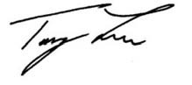
Tony Lau, P.E.
ASCE Hawaii Section President

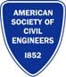
Civil Engineers – Designers and Builders of the Quality of Life

4 – Membership Development
4.10

4.10 Careers Roundtable – Georgia Section

1. Section, Branch | Georgia Section
2. Section/Branch Size | Very Large
3. Project Contact
Name | Melissa Wheeler
Phone Number | (404) 506-2745
Email | mswheele@southernco.com
4. Project Category | Membership Development
5. Project Description | The Careers Round Table is a group of unemployed and underemployed ASCE members that meet regularly to discuss industry trends and career topics helping its members to build leadership skills and position for their next career opportunity.
6. The Process  (What you did, When and How) | In 2009 when the economy left many Section members looking for new career opportunities, it became obvious that the Section needed to step in and help our members. The Employment Round Table, which later became the Careers Round Table, was initiated to provide networking opportunities, mentoring and career support for our displaced members. Working together, the Round Table members shared experiences, conducted mock interviews, reviewed resumes, and spread the word about job opportunities that might be a good fit for someone in the group. The group organized field trips, invited speakers on career and leadership development related topics, and continued to meet during the summer months.
7. Those in Charge (Committee, Task Committee, Etc.) | The Round Table leadership is made up of its members with oversight from seasoned Section leaders. Leading this group and organizing monthly meetings and other activities gives its members the opportunity to grow and develop new skill sets for their future careers. The leadership of the group negotiated several advantages with the Section. These included a small budget to secure several low-cost speakers for the Round Table meetings and discounted or free admission for the monthly Georgia Section meetings for Round Table members who may not be able to afford the cost of the meeting.
8. Time Frame  (When Started, When Completed) | The Georgia Section meets between September and June, on the first Friday of each month beginning at 11:30 am. Since its inception in June - August 2009, the Round Table meets on the same day from 10- 11:30 am. The event is free and requires no prior registration. Non-members, section members and employers are welcome to attend the Careers Round Table prior to joining the Section meeting which is held in an adjacent meeting room. The Round Table also meets at other events including during the summer months.
9. Success Factors  (The Parts that Worked Really Well) | The use of our Section webpage to market the group was successful. In addition, ASCE members made announcements at Section meetings and meetings of the ASCE branches and institutes. For this purpose, a brochure was created and passed out explaining the objectives of the group and inviting people to the meetings.  The Careers Round Table experienced a high rate of success. An Excel spreadsheet was used to track members and keep track of the rate of job placement. Some of the most successful initiatives included:  - Photographer sessions: Held at two Section meetings offering a professional photo for $10 for ASCE members and free for Round Table members.  - Resume Workshops: Conducted several times a year often combined with mock interviews and presentations on the latest industry trends.  - CPA services and advice: Invited speakers presented on taxes, financial planning, deductions and other financial issues related to job hunting.  - Interviewing Sessions: Conducted several times a year often combined with resume reviews and presentations on the latest industry trends practice. During a session the members rotate so that each member can interview and be interviewed 2 to 3 times. Receiving valuable feedback and learning more about each other is appreciated by all.  - Volunteering Opportunities: Group members were encouraged to serve as “volunteers” to key events within our chapter which allowed them free access to PDH credits required for the P.E. license.  Field Trips: Conducted several times a year usually during the summer months when the Section does not meet.
10. Setback Factors  (The Parts that did Not Work Well) | With the job market looking better in the Atlanta area, we did not do a good job with long-term planning for leadership of the group. However, we believe that this group is needed in the long run as a networking place for engineers in transition, hiring managers, and students or recent graduates looking for jobs. At this point we are at a rebuilding phase of the Careers Round Table.
11. Creativity
(This is something off the wall that we did)
12. Administration
(What was most Important?)
13. Follow-Up
(What was most important?)
14. Recommendations
(What you should ALWAYS do with this project?)
15. Cautions
(What you should NEVER do with this project?)
16. The Outcome
17. Ongoing Activity  (Would you do it again?) | ABSOLUTELY.
18. Speaker Contact Information
(person from your Region who would be willing to speak about the Best Practice)
Name
Address
Phone Number
Email
19. Additional Comments | This Best Practice includes the following attachments:  - Careers Roundtable Invitation  - Information about the incentives of attending Careers Roundtable

If you are a civil engineer (or related field) in transition or a recent graduate looking for employment, please join us at the Round Table for a brisk hour of discussion and networking.

We will be sharing key industry information for employment opportunities, economic indicators and trends affecting the profession to support your job search. Participants are encouraged to exchange resumes for objective, tactful reviews. We also have timely speakers and regular workshops to KEEP you employed once you’ve connected into a great job.

The Round Table also welcomes recruiters and employers searching for high quality engineers actively engaged in their career and supporting the profession.

GA Section of ASCE invites you to join the

Careers Round Table Meeting on the first Friday of each month from
10 – 11:30 am

- FREE event and no prior registration required

- Non-members, section members and employers welcome

- The section luncheon meeting starts at 11:30 in an adjacent meeting room

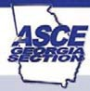

Contact Us
Charter Chair: Suzanne Pylant, EIT, A.M. ASCE
Phone: 404-519-0377 c
Communications: Fabio Molina
305-216-0232 c

Visit us online for upcoming meetings www.ascega.org

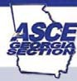
AMERICAN SOCIETY OF CIVIL ENGINEERS
Georgia Section

ASCE GA
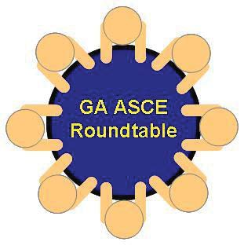
C AREERS ROUND TABLE

Networking and career development, workshops and more for civil engineers and professionals in related fields

ASCE GA

CAREERS

RO UN D TA BL E

Georgia ASCE supports transitioning engineers while building YOUR future value as a professional and leader. YOU ARE NOT ALONE. ASCE
understands YOUR work is most vital to your success after you leave the office. The Round Table provides innovative ways to help you find the BEST fit for your UNIQUE skills:
► NETWORKING
workshops for effective AND efficient connections, not just to your next employer but as you grow in your field – it’s your money and your time…why waste it?

► FREE resume reviews by colleagues in YOUR field- feedback for best employers to consider, regular meetings and a “buddy” system to keep you connected.

► KNOWLEDGEABLE
speakers relevant to your job search – how recently placed individuals succeeded, key employed colleagues and leaders keep you informed of industry TRENDS, improving YOUR interviewing and marketing skills.

► LEADERSHIP training and powerful resume builders to get you noticed.

► ONLINE LINKS in one place to the resources YOU need NOW –secrets and tips for extending your money, other key network groups, and sources to guide your job search.

► CERTIFICATIONS you
want and need require the synergy of TIME and MONEY-come find creative ways to obtain certifications and skills on a budget, get CEUs, PDH’s and resources to support your P.E.

4 – Membership Development
4.11

4.11 Direct Invitation to New CE Graduates – Committee on Younger Members
1. Section, Branch | Committee on Younger Members
2. Section/Branch Size
3. Project Contact
Name | KC Atkins
Phone Number | (651) 365-8524
Email | kcatkins.asce@gmail.com
4. Project Category | Membership Development
5. Project Description | Direct Invitations to New CE Graduates
6. The Process  (What you did, When and How) | Younger Member Groups are encouraged to contact new graduates and supply information regarding ASCE professional membership. The Younger Member Group may have a Civil Engineering Department in their unit or may use the invitations for new hires within their own companies or organizations. The new graduate letter can be modified to be issued from the local section or branch.
7. Those in Charge (Committee, Task Committee, Etc.) | The Younger Member Committees are in charge. It is important for the Committees to request support from their Section and Branch Leadership for manpower and resources. Planning for postage and expenses should also be taken into consideration.
8. Time Frame  (When Started, When Completed) | Ongoing
9. Success Factors  (The Parts that Worked Really Well) | Students have been directly invited to join their local unit, and membership has increased.
10. Setback Factors  (The Parts that did Not Work Well) | This effort needs to be coordinated with the Faculty Advisor and the Practitioner Advisor to have contact with the students to find out where they will live and work post baccalaureate.
11. Creativity
(This is something off the wall that we did)
12. Administration  (What was most Important?) | Planning ahead of December and May graduations is critical. All resources must be in place two months before the invitations are sent. Planning for the next graduation cycle must commence soon after the most recent invitations are sent.
13. Follow-Up  (What was most important?) | 1-on-1 contact is important as a follow up to the letter. A fall and spring visit to Universities/Colleges within the YMGs unit is beneficial to discuss YMGs and activities with upcoming grads.
14. Recommendations  (What you should ALWAYS do with this project?) | Plan ahead and be timely.
15. Cautions  (What you should NEVER do with this project?) | Procrastinate
16. The Outcome
17. Ongoing Activity  (Would you do it again?) | Yes.
18. Speaker Contact Information
(person from your Region who would be willing to speak about the Best Practice)
Name | KC Atkins
Address | 1295 Northland Drive, Suite 200, Mendota Heights, MN 55120
Phone Number | 651-365-8524
Email | kcatkins.asce@gmail.com
19. Additional Comments | Letters from the Committee on Younger Members may be used directly for contact or as a template for Younger Member Groups to use and modify as they see fit for their particular group. It is also CYM’s vision to have these packets available on a traveling Younger Members table at ASCE conferences.  The letters can be modified for use by Sections and Branches and can be customized for soliciting Graduate Students and Young Professionals.  -  This Best Practice includes the following attachments:  - Letters from the Committee on Younger Members

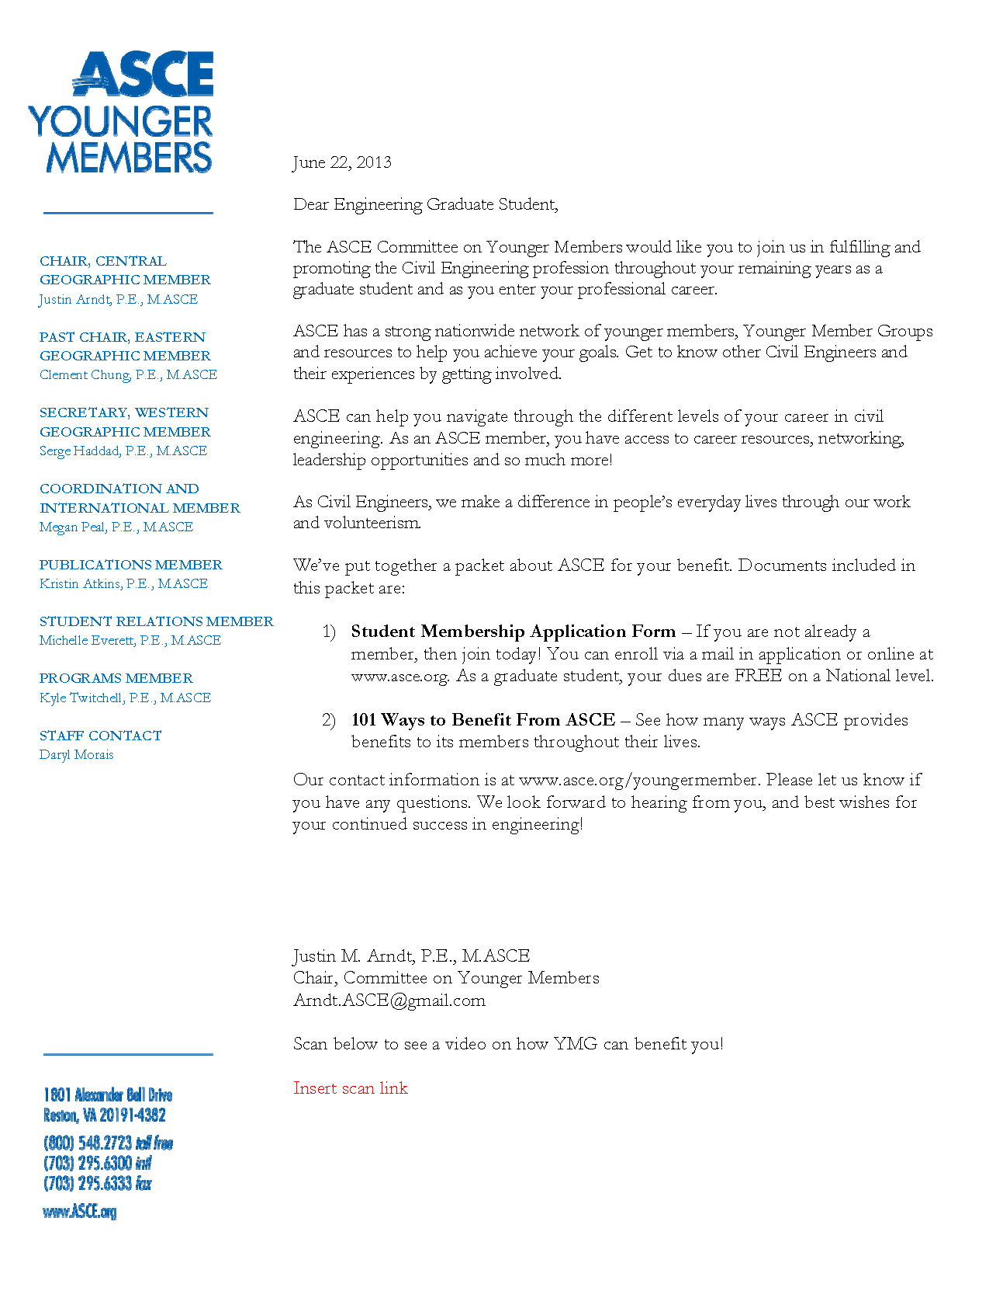
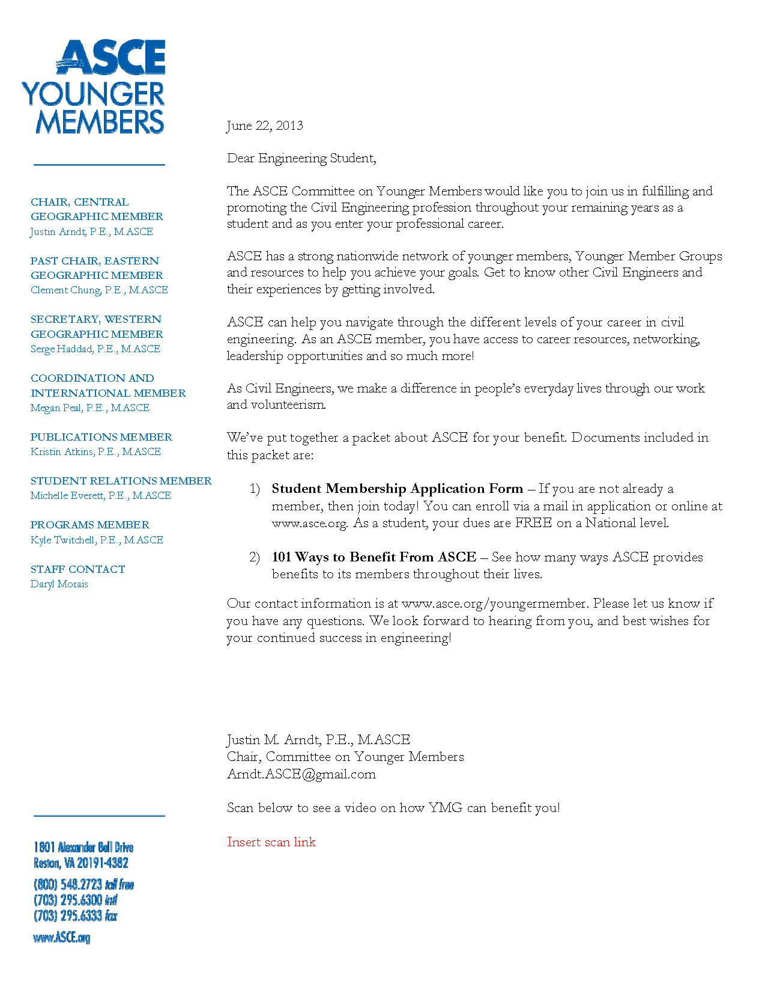
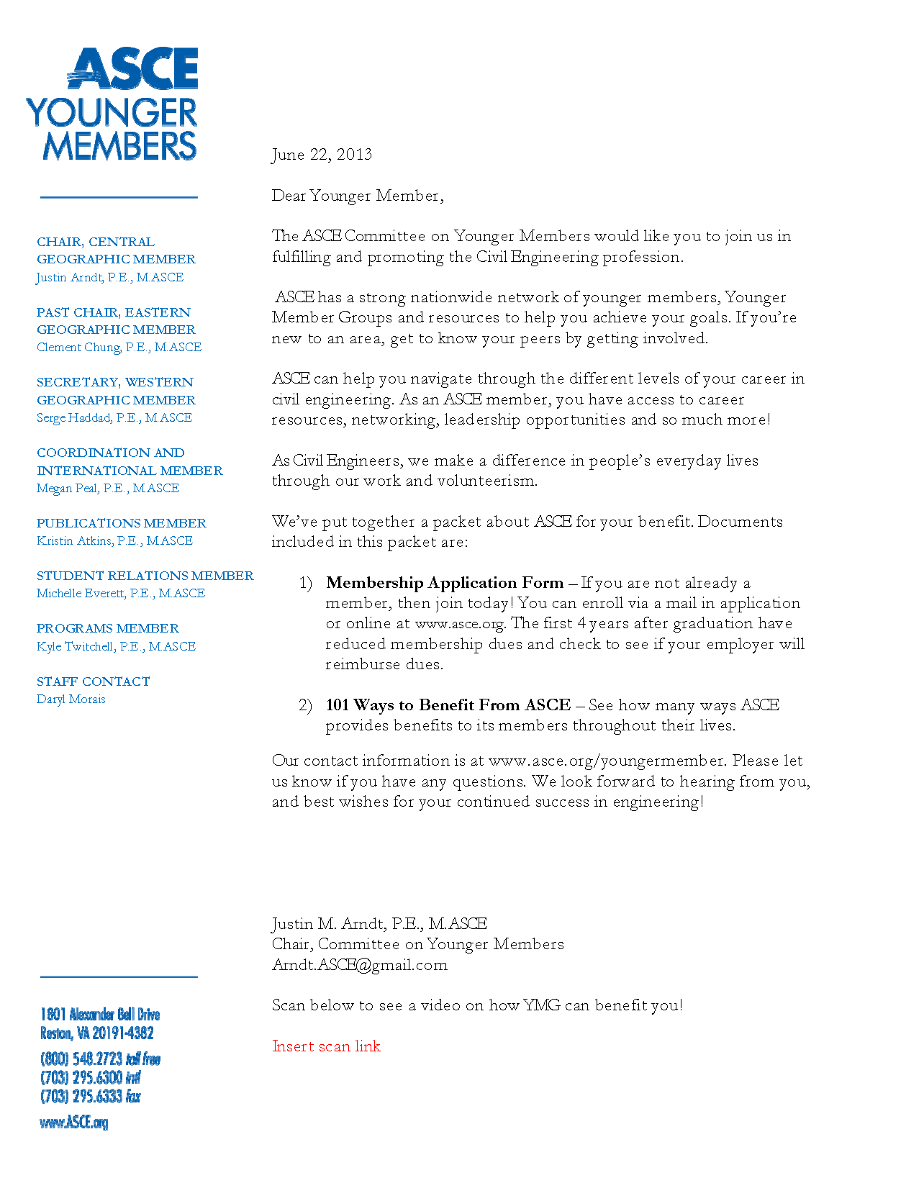
4 – Membership Development
4.12

4.12 Women in Engineering Panel – Orange County Branch YMF
1. Section, Branch | Los Angeles Section, Orange County Branch, Younger Member Forum
2. Section/Branch Size | Large
3. Project Contact
Name | Elizabeth Ruedas
Phone Number | (909) 900-5801
Email | eruedas@cc-eng.com
4. Project Category | Membership Development
5. Project Description | ASCE Orange County Younger Member Forum was proud to host its first Women in Engineering Panel.  In an event that drew over 50 attendees, OC YMF featured the 2015 Women in Engineering Panel on July 21st. The theme of the evening was “Career Advancement and Overcoming Challenges.” With an interactive format, three well-respected, local female professional civil engineers shared their experiences and answered a multitude of questions on Career Advancement, Work/Life Balance, Leadership, Overcoming Challenges Women Face in the Industry, and Finding Your Passion.
6. The Process  (What you did, When and How) | - March 5, 2015 – Remi Candaele, ASCE OC YMF President, and Roxanne Follis, ASCE OC YMF Vice-President, asked Elizabeth Ruedas to lead the planning of the Women in Engineering Panel.  - March 6-15, 2015 – The planning committee was formed, which consisted of Gyan Sinha, Tasha M. Kamegai-Karadi, and Gyssela Quinabo.  - March 16, 2015 (5:30PM-6:00PM) – Women in Engineering Conference Call 1  - Discussed event details  - 4 speakers with moderator  - Various skill/experience levels  - Speakers can come from areas in OC and outside  - Private and public agencies  - Different educational background  - Civil engineers, but can open it to other backgrounds  - Discussed the development of a list of questions and topics  - Survey YMF members and potential attendees for questions/topics  - Discussed the possibility of having a joint event with SWE and/or WTS?  - Discussed venue options  - Aim for large crowd (40-50)  - Put together a draft schedule  - Month of event: July  - Planning Efforts  - Should have topic(s) by mid-April  - Should have speakers confirmed 2 months before event  - Give speakers a date range (i.e. first half of July)  - Bi-weekly conference calls until the day before the event  - Create Google Drive to keep log of action items and people contacted  - March 17, 2015 – Roxanne created a shared Google Drive.  - March 25, 2015 – Elizabeth created a survey to send out to all of our ASCE OC members (Branch, YMF, and Student Chapters).  - Planning committee provided feedback.  - March 30, 2015 (5:30PM-6:00PM) – Women in Engineering Conference Call 2  - Discussed coordination with other organizations  - Event details will be distributed to SWE, but event will not be a joint event  - Need to contact WTS  - Discussed event topics and questions  - Distribute survey  - Deadline for final event topic – April 24th  - Established roles and task leads  - Preparation of flyer – Elizabeth  - Event logistics (location, ticket price, food, plaque/gift, etc.) – Gyssela /Tasha  - Contact speakers – Team effort  - Discussed the creation of a draft budget  - March 31, 2015 – Gyan provided the budget from previous presentations to use as a guide.  - March 31, 2015 – Survey was sent out to our active ASCE OC YMF members.  - April 1, 2015 – Survey was distributed to all ASCE OC members and SWE-OC members.  - April 7, 2015 – Kirsten Zeydel, PE, SE filled out the survey and volunteered to be a panelist.  - April 7, 2015 – Survey was distributed to our Student Chapters (UCI, CSF, and CSLB).  - April 8, 2015 – Elizabeth shared Survey Results with the rest of the committee.  - April 13, 2015 (5:30PM-6:00PM) – Women in Engineering Conference Call 3  - Established event topic and sub-topics based on survey results  - Career Advancement and Overcoming Challenges  - Career Advancement  - Work/Life Balance  - Leadership  - Overcoming Challenges Women Face in Industry  - Finding your Passion  - Established roles and task leads  - Create calendar w/ mini milestones – Elizabeth  - Create draft budget – Elizabeth  - Start question bank - Gyssela  - Give speakers a list of final questions 3 or 4 weeks prior to event  - List of Potential Speakers - Team Effort  - Deadline: April 26th  - Identify potential speakers and input information here – Team Effort  - Kirsten Zeydel, S.E.  - Contact Speakers - Team Effort  - Committee discussed new items  - Date, Venue, and Advertise  - Preparation of flyer – Elizabeth  - April 20, 2015 – Elizabeth created a Google Calendar with mini milestones.  - April 27, 2015 – Elizabeth created a draft budget for the event.  - April 27, 2015 – Gyssela started a list of potential questions on Google Drive.  - April 27, 2015 (5:30PM-6:30PM) – Women in Engineering Conference Call 4  - Established date of the event to be July 21st  - List of potential venues by May 11th  - Start contacting speakers from the list of Potential Speakers  - Kirsten Zeydel – Roxanne  - Anna Lantin – Remi  - Sherry Nour – Gyan  - Gail Farber – Elizabeth  - Lucy Dunn – Margaret  - May 11, 2015 (5:30PM-6:00PM) – Women in Engineering Conference Call 5  - Gyssela and Tasha provided updates regarding potential venues  - Confirmed Speakers  - Kirsten Zeydel – Available July 21st (Roxanne)  - Sherry Nour – Available July 21st (Gyan)  - June 3, 2015 (5:30PM-6:30PM) – Women in Engineering Conference Call 6  - Decided on Dave & Buster’s Irvine Spectrum as event location  - Room: Board Room  - Food: Bennissimo Buffet: Caesar salad, Caprese salad, Roasted Chicken Breast, Veggie Lasagna, Garden Vegetable medley, bread  - Total: $1279.36 inclusive of service & tax  - Cost per Person (assuming 50 people): $25.59  - Deposit: $499.75  - Provided updates regarding confirmed speakers  - Kirsten Zeydel – Available July 21st (Roxanne)  - Sherry Nour – Available July 21st (Gyan)  - Angela George – Available July 21st (Elizabeth)  - Rossana D’Antonio – Available July 21st (Elizabeth)  - Committee discussed new items  - Fee Schedule – Gyan  - Eventbrite Page – Gyan  - Seek Sponsorship – Team Effort  - Distribute “Save the Date” Flyer – Elizabeth  - Look into gift options – Roxanne  - Develop a thorough program – Elizabeth  - Make sure all panelists speak equally  - Audience interaction  - June 5, 2015 – Elizabeth prepared the event flyer.  - Planning committee provided feedback.  - June 8, 2015 – Gyssela paid venue deposit.  - Eizabeth sent Gyssela reimbursement information.  - June 8, 2015 – Gyssela updated budget on Google Drive.  - June 8, 2015 – Gyan made an Eventbrite page for the event.  - June 8, 2015 (5:30PM-6:00PM) – Women in Engineering Conference Call 7  - Elizabeth provided updates regarding the event flyer  - Send out multiple flyers, so that the committee can vote on one  - Send to speakers for approval  - Committee discussed new items  - Advertising Social Media, OC Branch, Other YMFs (LA, SB/R, etc.), Student Chapters, SWE, WTS, UCI EAS, Phi Sigma Rho, Soroptimist, and during upcoming events  - June 8, 2015 – Elizabeth prepared 3 different event flyers for the committee to vote on.  - June 9, 2015 – Planning committee voted and decided on an event flyer.  - Elizabeth sent event flyer to speakers for approval.  - June 17, 2015 – Elizabeth updated the event flyer per comments from speakers and committee.  - June 17, 2015 – Gyan updated Eventbrite with new flyer and ticket prices.  - June 18, 2015 – Elizabeth asked SWE-OC and OC-WTS to help promote the event via email.  - June 22, 2015 – Shared flyer with ASCE OC members via Constant Contact.  - June 22, 2015 – Elizabeth sent those who participated in our survey a discount code (as a small token of appreciation and to encourage registration).  - June 22, 2015 (5:30PM-6:30PM) – Women in Engineering Conference Call 8  - Discussed event topics and questions  - Finalize list of pre-selected questions by June 26th  - Send list to speakers by the end of the month  - Discussed gifts to speakers  - Decided on gift baskets with wine and chocolates  - Discussed advertising  - June 23, 2015 – Gyssela and Elizabeth promoted the event via social media.  - June 25, 2015 - Elizabeth distributed the event flyer at ASCE OC YMF and SWE June 2015 Joint General Meeting.  - June 28, 2015 – Roxanne sent an email to the ASCE OC YMF Board, promoting the Women in Engineering Panel.  - June 29, 2015 – Email blast to ASCE OC members via Constant Contact.  - June 29, 2015 – Elizabeth updated Eventbrite.  - June 30, 2015 – Elizabeth sent flyer to LA YMF.  - July 4, 2015 – Elizabeth sent a draft of the event program to committee.  - Planning committee provided feedback.  - July 6, 2015 (5:30PM-6:30PM) – Women in Engineering Conference Call 9  - Committee provided updates  - Discussed program and decided:  - Short bios at the start of the event  - Make sure all panelists speak equally  - Goal: casual conversation between panelist and audience  - Make sure to keep discussion on track so that every topic is discussed  - Audience can ask questions at any time, but we will ask for questions at the end of every topic (transition into next topic)  - Assign questions to people in audience  - July 7, 2015 – Elizabeth updated Eventbrite (max seating).  - July 7, 2015 – Elizabeth sent Outlook event invite to our OC YMF Board.  - July 7, 2015 – WTS-OC distributed our event flyer to their members.  - July 13, 2015 – Elizabeth sent committee the updated event program and short bios to review.  - July 12, 2015 – Roxanne looked into pre-made wine basket options.  - July 13, 2015 (5:30PM-6:00PM) – Women in Engineering Conference Call 10  - Committee provided updates  - July 14, 2015 – Sent panelist the event program (with pre-selected questions), short bios, and other event details.  - July 15, 2015 – Sent email blast to ASCE OC members via Constant Contact.  - July 17, 2015 – Roxanne purchased pre-made wine baskets.  - July 20, 2015 (5:30PM-6:00PM) – Women in Engineering Conference Call 11  - Committee provided updates  - July 20, 2015 – Gyssela purchased “Thank You” cards for the panelists.  - July 20, 2015 – Gyan put together PowerPoint slides to display at the start of the event, which included the event flyer and a list of upcoming events.  - July 21, 2015 - Angela George informed us that she would not be able to attend the event due to unforeseen circumstances.  - July 21, 2015 – Women in Engineering Panel  - Roxanne brought wine baskets.  - Gyssela brought “Thank You” cards.  - Gyssela made placards.  - Gyssela purchased name tags.  - Roxanne printed future event flyers.  - Elizabeth brought cameras and other equipment.  - Elizabeth paid remaining balance (D&B).  - Gyssela managed check-in table.  - Elizabeth was moderator of event.  - Roxanne provided 2-minute warnings.  - Gyan provided photography of event.  - July 22, 2015 – Elizabeth made a Word document to record “lessons learned.”  - July 24, 2015 – Elizabeth uploaded photos to Google+ and sent link to panelists and committee.
7. Those in Charge (Committee, Task Committee, Etc.) | Women in Engineering Panel planning committee: Elizabeth Ruedas, Remi Candaele, Roxanne Follis, Gyan Sinha, Gyssela Quinabo
8. Time Frame  (When Started, When Completed) | Started March 5, 2015 and completed July 21, 2015
9. Success Factors  (The Parts that Worked Really Well) | Planning committee, Conference calls (action items), Google Drive  - All event documents were well organized  - Survey to ASCE OC members  - Including discount code for filling out the survey  - Encouraged participation and attendance
10. Setback Factors  (The Parts that did Not Work Well) | - Reading long bios at the start of the event  - The venue  - Poor lighting  - A bit small for the number of attendees that we had
11. Creativity  (This is something off the wall that we did) | Included our members in the planning of the event by sending out a survey while still early in the planning process.
12. Administration  (What was most Important?) | Action items
13. Follow-Up  (What was most important?) | Documenting “Lessons Learned”
14. Recommendations  (What you should ALWAYS do with this project?) | - Start planning early  - Make sure everyone has someone who they can relate to on the panel  - Encourage men to attend the event  Regular planning meetings
15. Cautions  (What you should NEVER do with this project?) | Address issues that could potentially offend someone.
16. The Outcome | Great learning and networking opportunity
17. Ongoing Activity  (Would you do it again?) | Absolutely! We are looking to make this a much larger event and hoping to partner up with other organizations in the future.
18. Speaker Contact Information
(person from your Region who would be willing to speak about the Best Practice)
Name | CNC Engineering
Address | 2121 Alton Pkwy, Suite 200  Irvine, CA 92606
Phone Number | (909)900-5801
Email | eruedas@cc-eng.com
19. Additional Comments | This Best Practice includes the following attachments:  - Survey results  - Survey questions

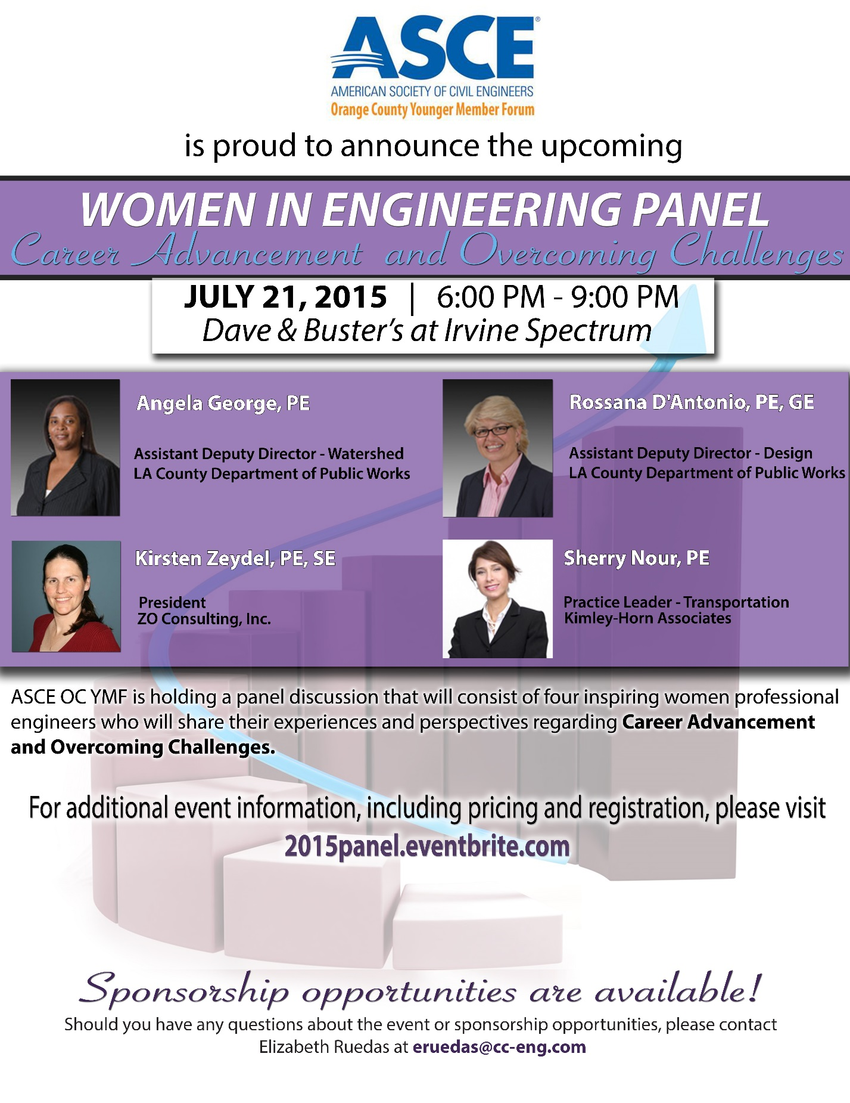

Women in Engineering Panel
July 21, 2015

5:30PM – 6:00PM Set-up
- Food
- Gifts
- Photographer
- Answer any last-minute questions
6:00PM – 6:30PM Networking, ordering drinks and eating
- Individually thank attendees for being there
6:30PM – 6:45PM Introductions
- Committee
- Speakers
6:45PM – 8:30PM Pre-selected questions
- Career Advancement
  - Sherry – How do you know when to move up or move on?
  - Angela – What are some important qualities and skills that women need to be successful and effective in senior level positions?
  - Rossana - Did you have a mentor early in your career? How did you find him/her? What qualities should we look for in a mentor?
  - Kirsten – What soft skills are essential for career advancement? For owning your own business?
  - What are common mistakes that young engineers make that prevent them from advancement? Any specific to women?
  - What was one key decision or position that propelled your career?
- Work/Life Balance
  - Kirsten – How do you balance your time between your family and work obligations? How and when do you start saying no?
  - What would your advice be to women who have or want to start a family, while remaining in the engineering industry?
  - How did your company accommodate you while you were pregnant/on maternity leave/back from maternity leave?
  - Angela – What are some household (or routine) changes that you and your partner had to work through to keep you in industry?
  - Sherry – Describe your experience within professional organizations. How have they helped your career and/or your personal development in the long run?
  - Rosanna – Do you have any advice for those of us interested in going to graduate school while still working?
- Leadership
  - Angela – What advice would you give young female engineers who aspire to have leadership positions in the industry?
  - Sherry – What were some of the challenges that you have faced on your journey to becoming a leader at your company? How did you overcome them?
  - Kirsten – What are some important qualities or traits that women need to have in order to thrive in the engineering industry? How did you acquire them?
  - Rossana – What are some things you have done to differentiate yourself and stand out as a woman engineer in a big company? How do you get noticed?
- Overcoming Challenges Women Face in Industry
  - Angela – What are some effective ways of dealing with discrimination in the workplace, including gender discrimination?
  - Sherry – What are some contributing factors to the lack of women in leadership roles? How can we change this?
  - Rossana – What techniques have you found most useful, in terms of having your ideas heard and recognized?
  - Do you find it to be an advantage or disadvantage to be a woman in a male-dominated field? How can we transform some of these disadvantages, if any, and turn them into opportunities?
  - Kirsten – How do you project confidence? Does this change base on the environment that you are in? Can you give examples?
  - What are some interpersonal skills that are necessary to build relationships? - women working with women; women working with men
- Finding your Passion
  - Angela – How do you keep your love and interest for engineering strong?
  - Rossana – Why do you think women leave the engineering workforce? How can we work together to reduce this number? What are some reasons why you’ve stayed?
  - Kirsten – Have you made any unexpected changes (or deliberate changes) in your career path? If so, please describe your experience.
  - Can you name any books, movies or short films that have had a positive impact on your career?
  - What are some of your favorite creative outlets? Can you name any hobbies/interests that have paired well with your career and/or have contributed to your personal growth?
8:30PM – 8:45PM Questions from audience
8:45PM – 9:00PM Closing
- Present gifts
- Thank everyone for attending
- Mention upcoming events and involvement opportunities

4 – Membership Development
4.13

4.13 Younger Members Forums Best Practices Guide 2018 Edition
1. Section, Branch | Region 9 Younger Member Committee
2. Section/Branch Size | 5 members
3. Project Contact
Name | Guy Hopes
Phone Number | 707-685-3015
Email | Ghopes53@gmail.com
4. Project Category | Communication
5. Project Description | Objective  In order to assist Region 9 and promote communication and interaction between the Younger Member Groups, the Sections, the Branches, and the Student Groups the Region 9 Younger Member Committee has assembled this Best Practice Guide (BPG) to serve as a tool for those purposes. Topics included are as follows:  • Guidance for Traveling Younger Members and Connections to Nearby  Groups  • Communications to Universities and Recruitment  • Championing National and Region 9 initiatives to the Community  • Social Media Opportunities  • Checklist of Best Practices for each Younger Member Group
6. The Process  (What you did, When and How) | Wrote a best management guide outlining the objectives above.
7. Those in Charge (Committee, Task Committee, Etc.) | Committee Chair Guy Hopes  Technical Reviewer Tony Akel  Region 9 YMF Committee’s 2017 & 2018
8. Time Frame  (When Started, When Completed) | 2017 - 2018
9. Success Factors  (The Parts that Worked Really Well) | Leadership and review
10. Setback Factors  (The Parts that did Not Work Well) | Difficult to engage groups to provide feedback, plans to continue updating the document
11. Creativity  (This is something off the wall that we did) | Memorialized events in one location
12. Administration  (What was most Important?) | Consistent follow up
13. Follow-Up  (What was most important?) | Showing useful examples
14. Recommendations  (What you should ALWAYS do with this project?) | Memorialize projects that meet the objectives, present to folks in the Region
15. Cautions  (What you should NEVER do with this project?) | Bookshelf it and not use it
16. The Outcome | Completed document
17. Ongoing Activity  (Would you do it again?) | Yes this is a living document to be updated
18. Speaker Contact Information  (person from your Region who would be willing to speak about the Best Practice) | Guy Hopes
Name | Guy Hopes
Address | 748 Notre Dame Drive, Vacaville, CA 95687
Phone Number | 707-685-3015
Email | Ghopes53@gmail.com
19. Additional Comments  (We strongly recommend attaching relevant photos and graphics) | See document

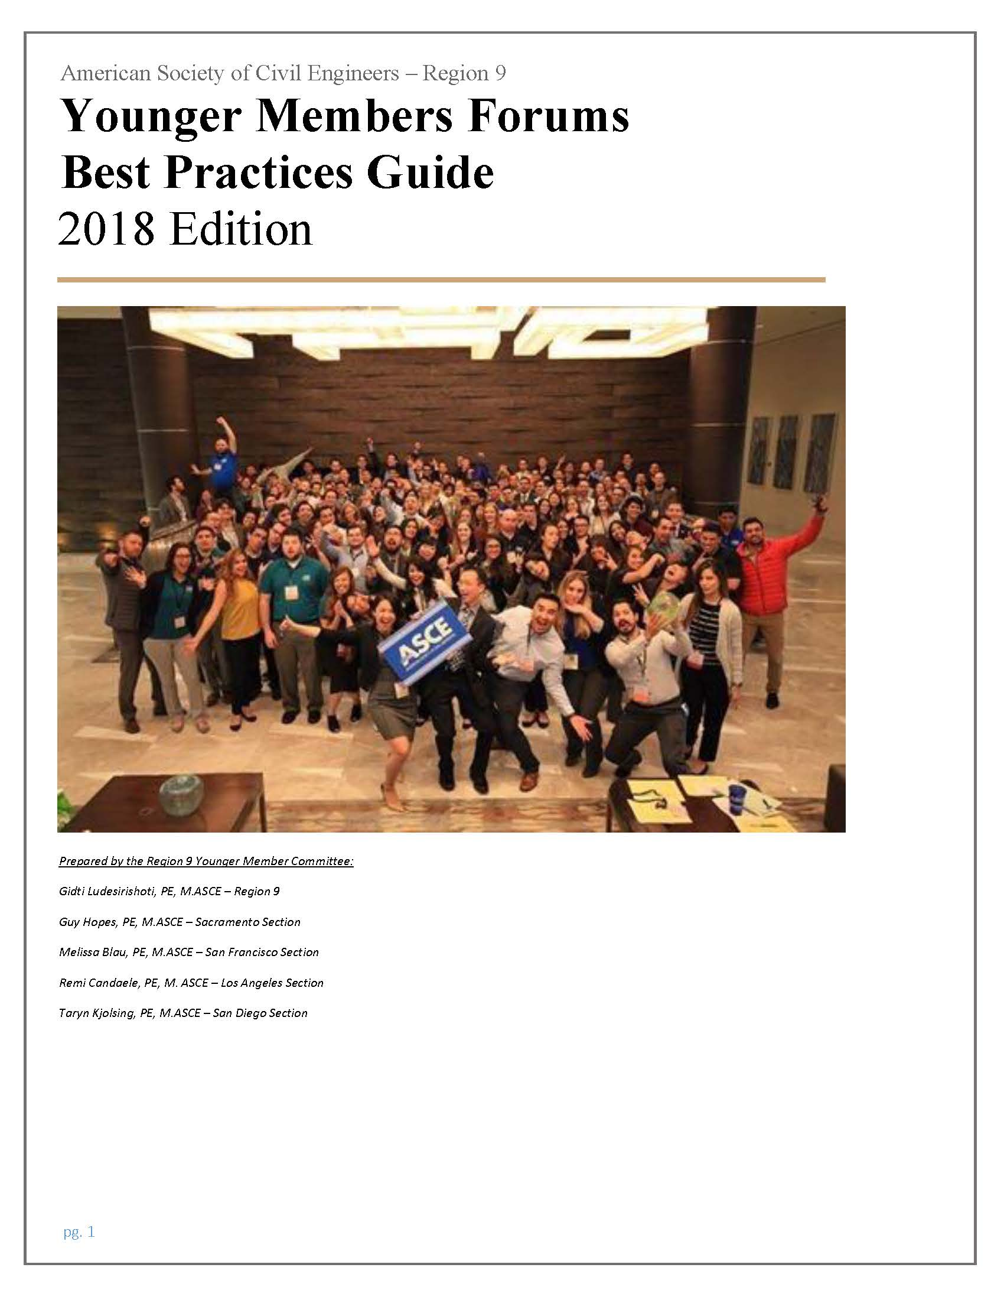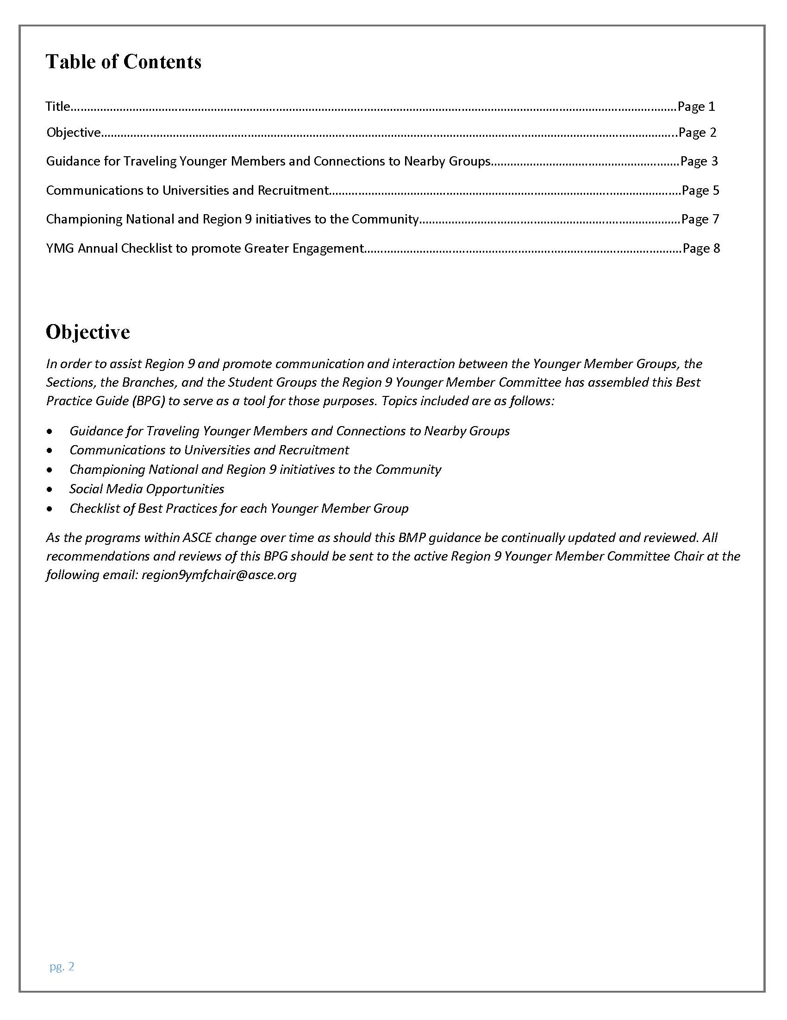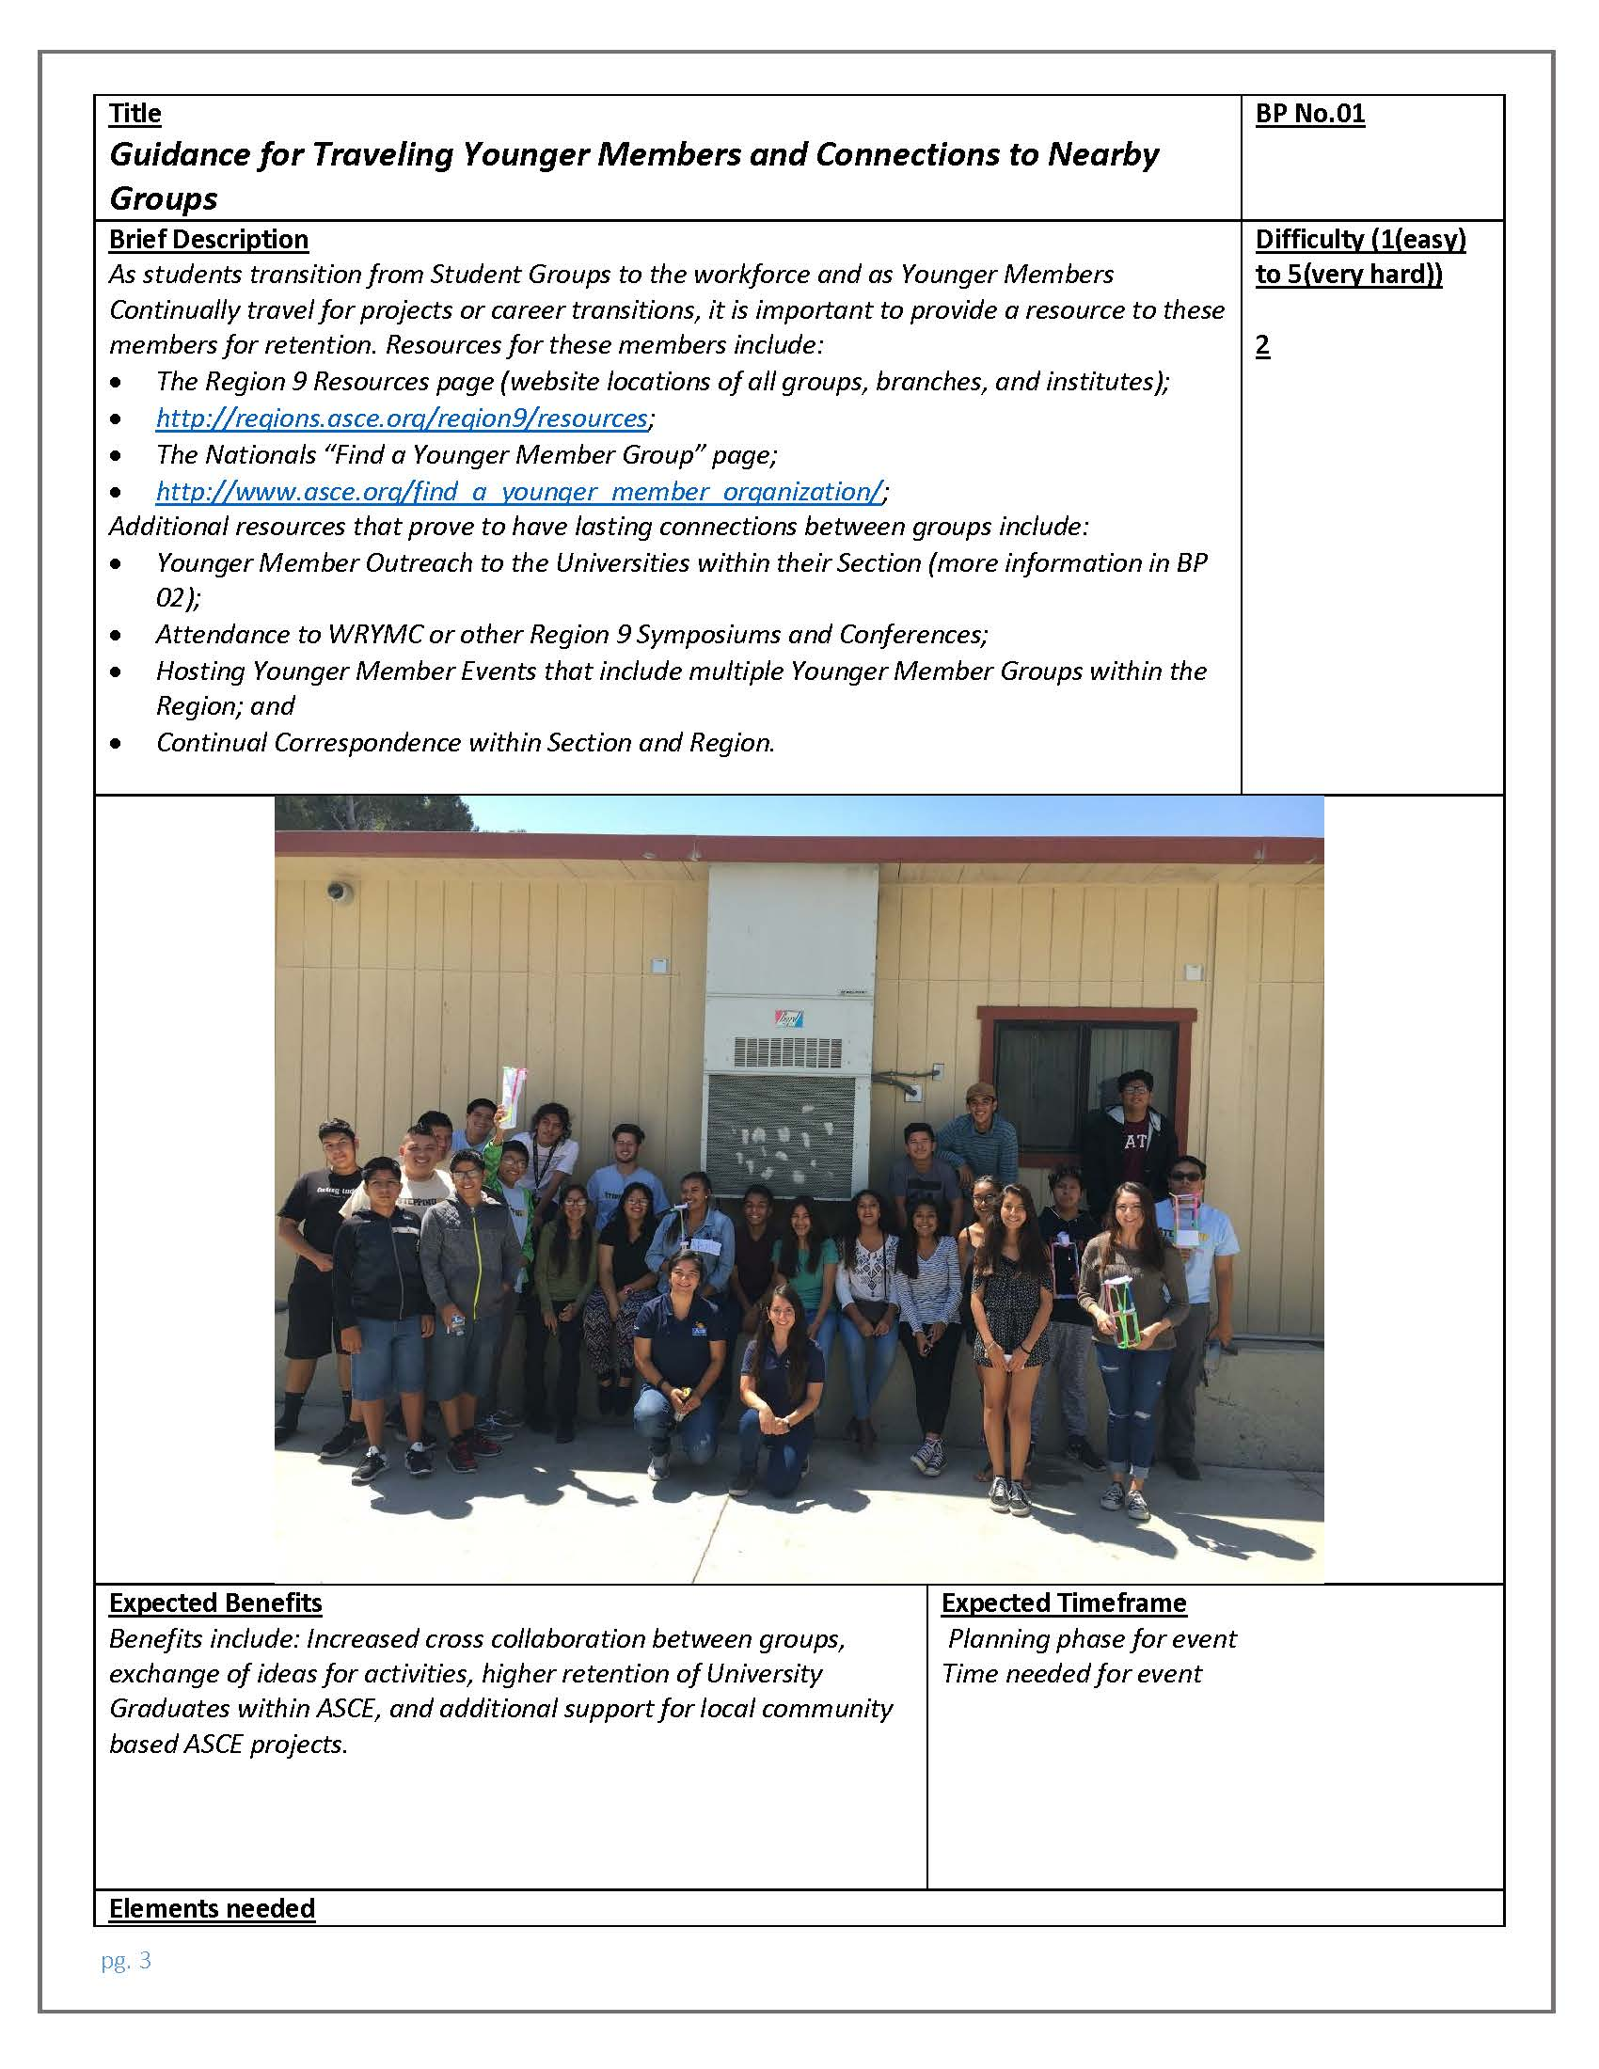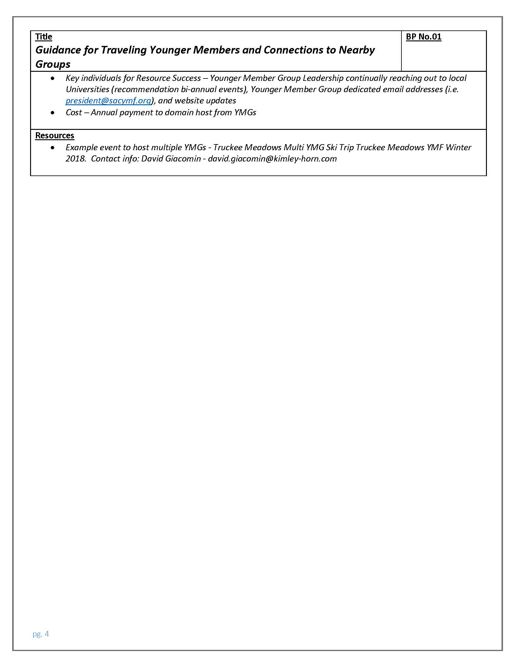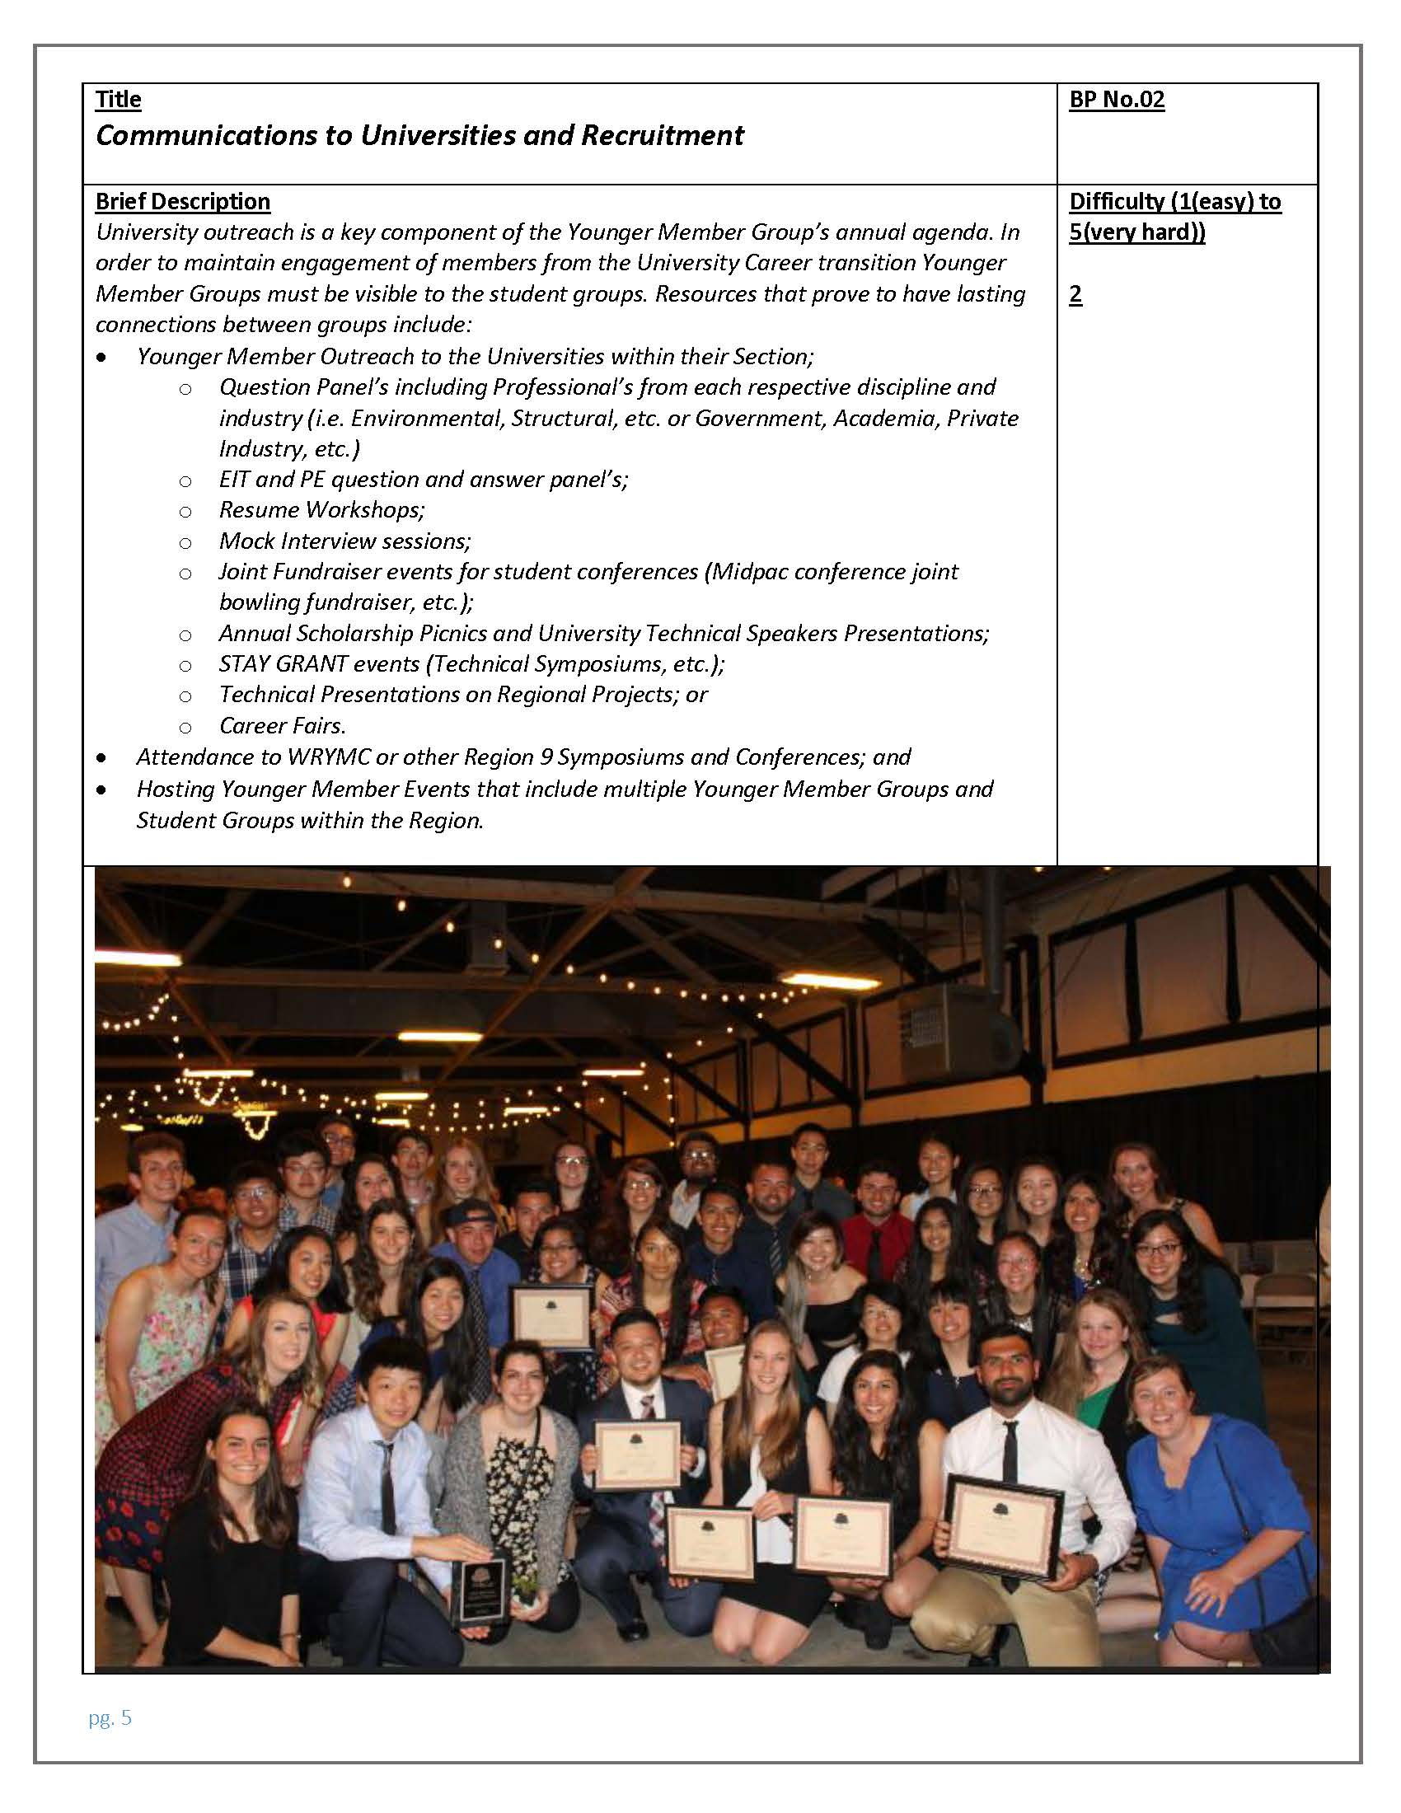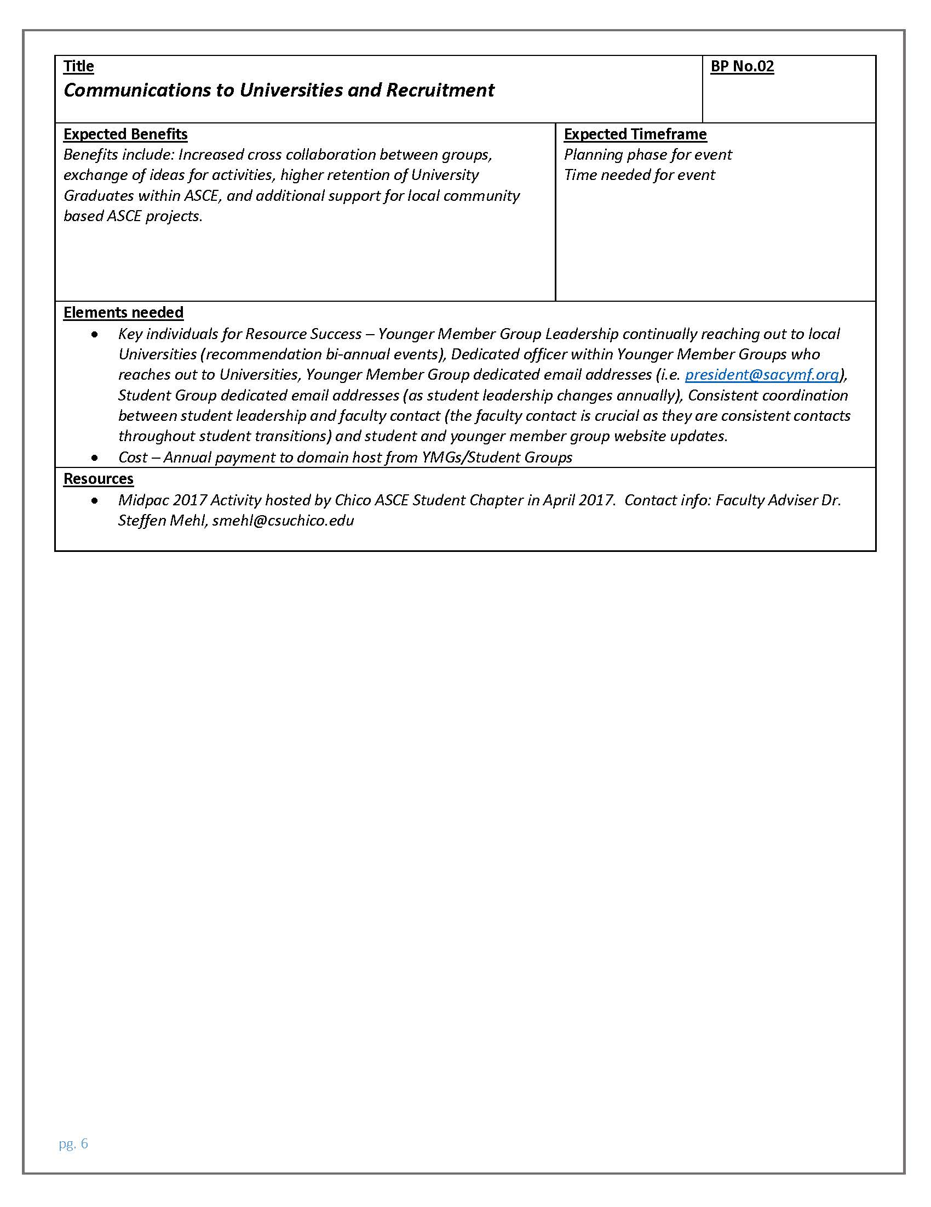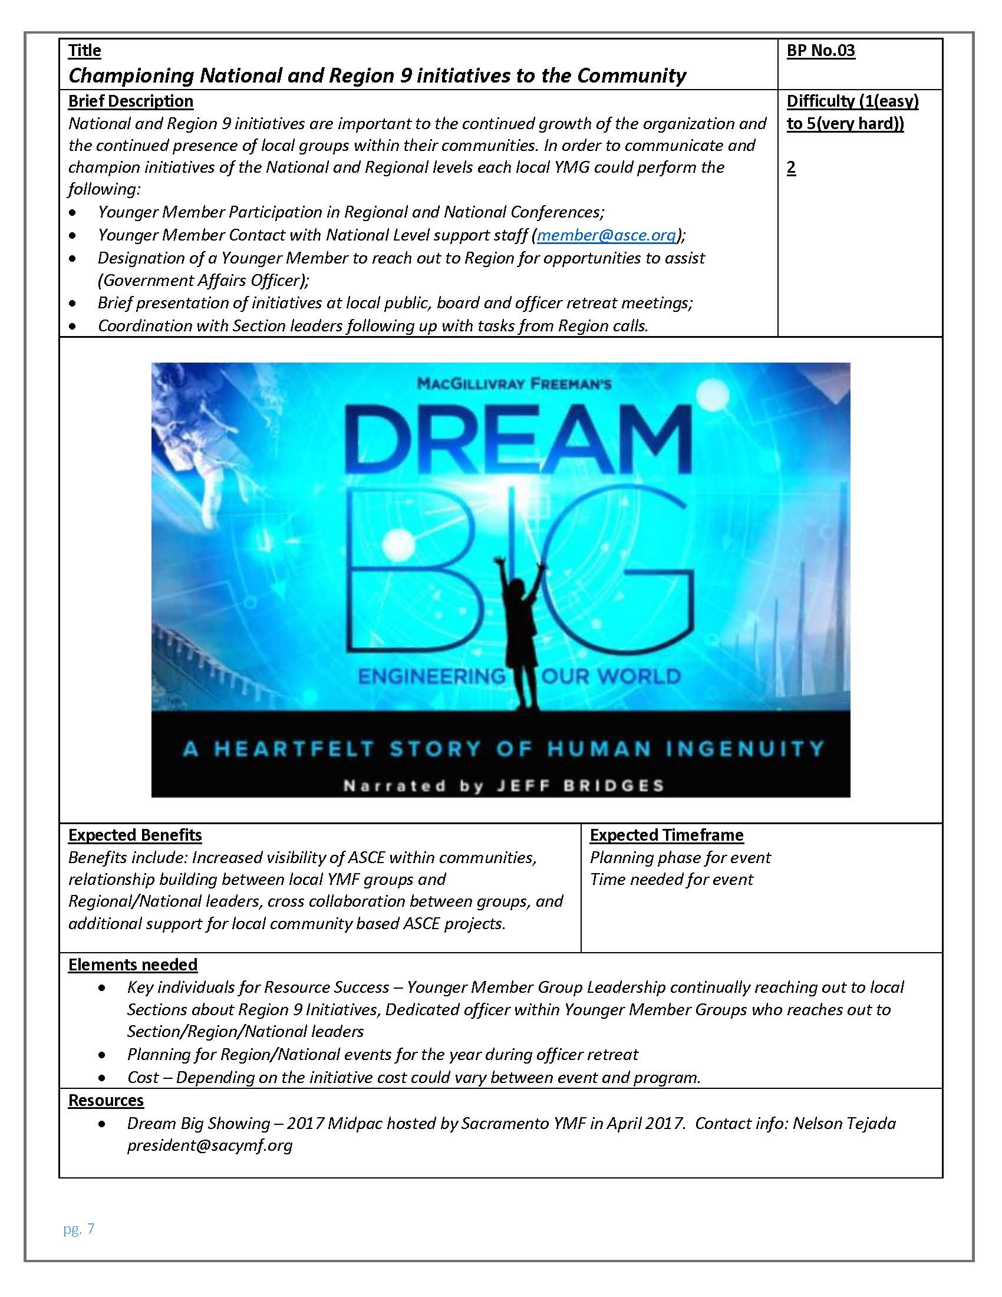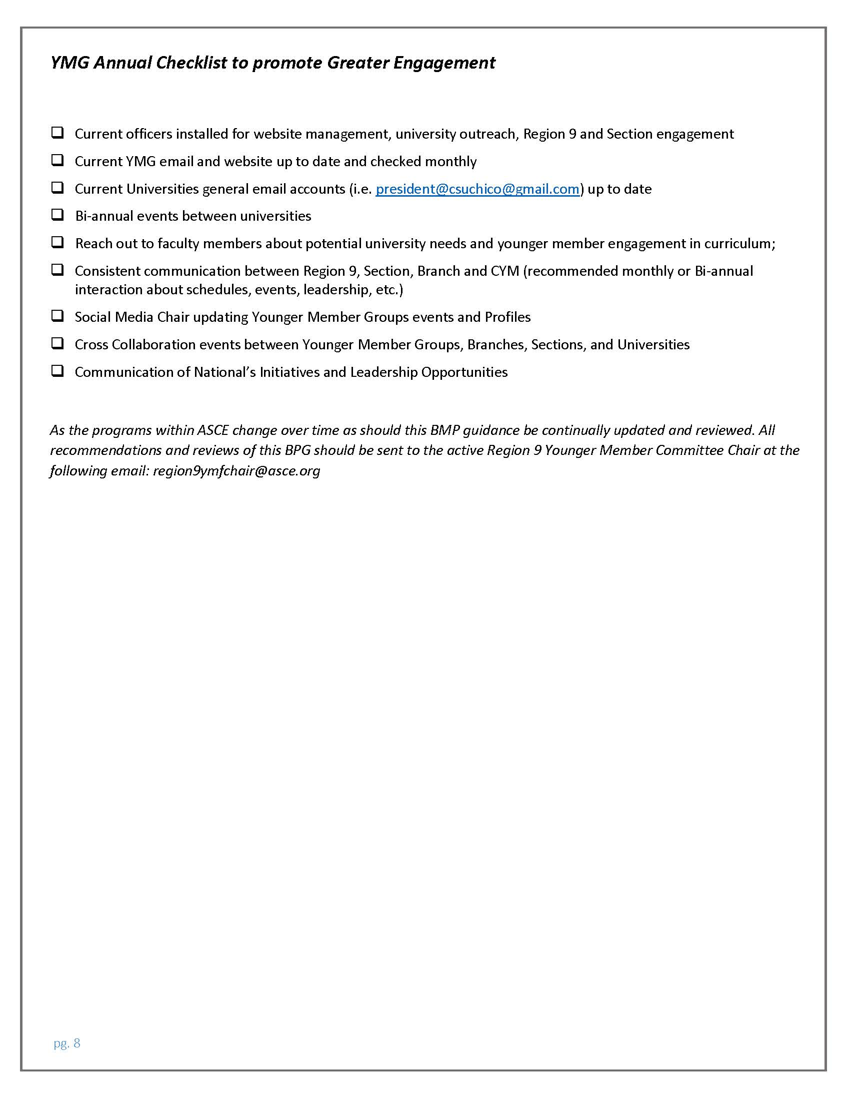

4 – Membership Development
4.14

4.14 ASCE Historic Landmark Scavenger Hunt – Maine Section
1. Section, Branch | Maine Section
2. Section/Branch Size
3. Project Contact
Name | Esther Bizier OR Stephanie Wyman (swyman@vhb.com)
Phone Number | 207-931-8484
Email | esther@main-landdci.com
4. Project Category | Membership Development
5. Project Description | Planned a Scavenger Hunt to find 15 of Maine’s ASCE Historic Civil Engineering Landmarks. ASCE members formed teams (had to have at least 2 ASCE members per team with a maximum of 6 team members) and tried to visit the most locations. The locations were listed on a BINGO sheet. Awards were given for the team who visited the most locations, the first team to achieve a BINGO, youngest team member, most creative team name, most creative picture at a location and most team spirit. The project helped generate lots of photos and excitement for ASCE membership.
6. The Process  (What you did, When and How) | We held the scavenger hunt in 2016/2017 and advertised the event at our annual meeting in May 2016. We did a kickoff BBQ at Fort Williams park in June 2016 which also houses Portland Head Light, one of the Maine Historic Civil Engineering Landmarks. The scavenger hunt ran from the May 2016 annual meeting until April 30, 2017. Teams could sign up at any time and had the year to visit as many landmarks as possible. When they visit a landmark, they had to take a picture with at least 2 team members in it and send it to the organization committee.
7. Those in Charge (Committee, Task Committee, Etc.) | The Diversity Committee organized the event, advertised the event and selected award winners. The committee Chairperson handled all of the team sign-ups and kept track of team progress.
8. Time Frame  (When Started, When Completed) | May 2016 (right after the annual meeting) through April 20, 2017. Awards were presented at the May 2017 annual meeting.
9. Success Factors  (The Parts that Worked Really Well) | The event generated lots of excitement among ASCE members. We received lots of great pictures and monthly updates added interest to our newsletter.
10. Setback Factors  (The Parts that did Not Work Well) | We planned a kick-off barbecue but didn’t have very large attendance.
11. Creativity  (This is something off the wall that we did) | Listed the locations on the BINGO sheet using clues. Teams had to figure out what location the clue was leading to. Clues corresponded to Maine ASCE’s History and Heritage brochure which lists the Historic Civil Engineering Landmarks and gives descriptions on locations and their significance.
12. Administration  (What was most Important?) | Keeping track of team pictures and progress.
13. Follow-Up  (What was most important?) | We had lots of good feedback on the pictures and monthly newsletter updates. Otherwise, we did a presentation at the annual meeting summarizing the event and handing out awards.
14. Recommendations  (What you should ALWAYS do with this project?) | Have awards to instill some friendly competition.
15. Cautions  (What you should NEVER do with this project?) | Don’t list too few locations. We had one team that went to all locations and several teams who made it to almost all locations. At first, we thought 15 locations might be too many, turns out it was just the right number.
16. The Outcome | People had fun, we learned about the State of Maine Civil Engineering Historic Landmarks and generated excitement for the Diversity and History & Heritage Committees.
17. Ongoing Activity  (Would you do it again?) | Yes! We held a scavenger hunt in 2017/2018 for a selection of 15 Maine State Parks and the ongoing 2018/2019 Scavenger Hunt for a “Civil Engineering Potpourri”. We will likely repeat the Historic Landmark Scavenger hunt at some point in the future since it had the most interest.
18. Speaker Contact Information
(person from your Region who would be willing to speak about the Best Practice)
Name | Esther Bizier
Address | 26 Beckler Rd, Livermore, ME 04253
Phone Number | 207-931-8484
Email | esther@main-landdci.com
19. Additional Comments | See photos below:

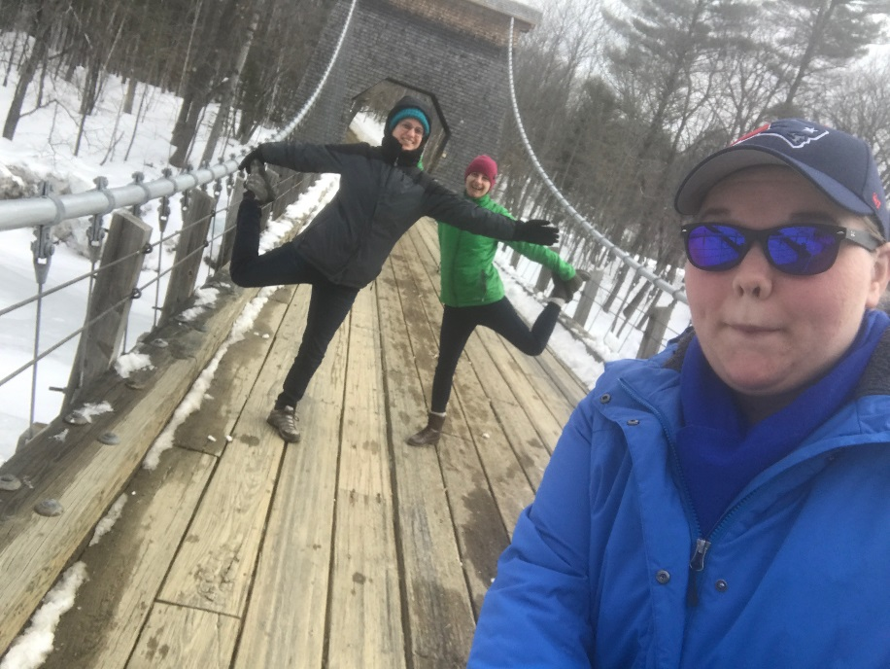

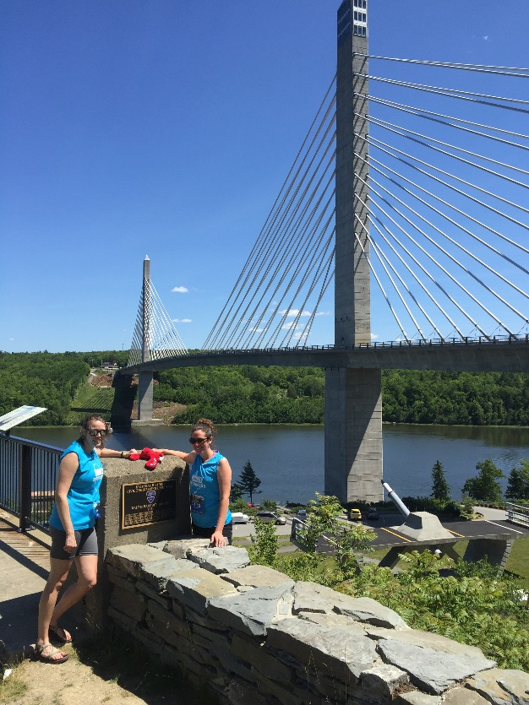

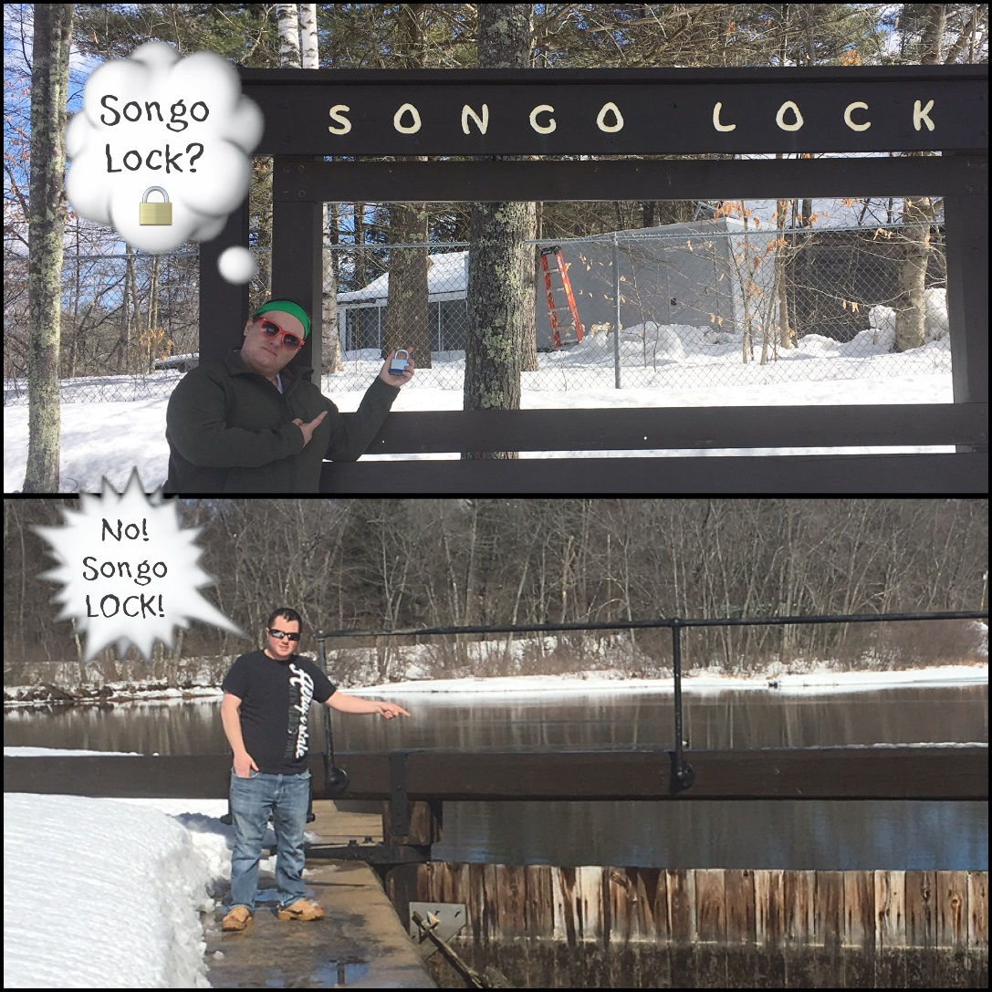

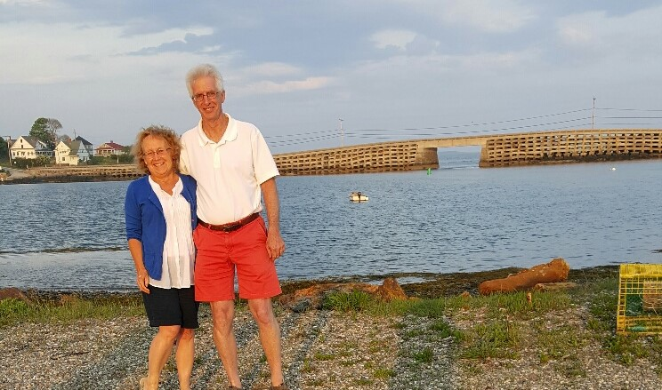

4 – Membership Development
4.15

4.15 PE Review Course – Nashville Branch
1. Section/Branch | Nashville Branch
2. Section/Branch Size | Medium
3. Project Contact
Name | Kenneth Perkins
Phone Number | 901-337-3276
Email | kperkins@nashvilleasce.org
4. Project Category | Membership Development
5. Project Description | The PE Civil Exam Review
6. The Process  (What you did, When and How) | The course is a 10-week course taught by Professional Engineers and based on the Civil Engineering Reference Manual (Lindeburg 15th Edition). It focuses on the "breadth" (morning) portion of the exam and includes general topics covered during the morning part of the exam. Sessions include Water Resources, Geotechnical, Structural, Construction and Transportation.
7. Those in Charge (Committee, Task Committee, Etc.) | Young Members
8. Time Frame  (When Started, When Completed) | The 10-week course is offered twice a year. Once in the fall and once in the spring
9. Success Factors  (The Parts that Worked Really Well) | One of our successful factors was the fact that we offered the classes via a videoconferencing link. This allowed participants to participate that were outside of the Nashville area. We were able to capture students from all over Tennessee.
10. Setback Factors  (The Parts that did Not Work Well) | Having to find a consistent AV person
11. Creativity  (This is something off the wall that we did) | We partnered with a local university to use their classroom facility that has video conferencing and recording capabilities in exchange for helping to promote their FE exam review course.
12. Administration  (What was most Important?) | The most important part was making sure students really understood the materials.
13. Follow-Up  (What was most important?) | Reaching out to the participants and getting their feedback on the class and how they did on the exam.
14. Recommendations  (What you should ALWAYS do with this project?) | Make sure your content is up to date
15. Cautions  (What you should NEVER do with this project?) | You should never send out the class materials to far ahead of the current week’s sessions.
16. The Outcome | We have had really high pass rates
17. Ongoing Activity  (Would you do it again?) | YES
18. Speaker Contact Information
(person from your Region who would be willing to speak about the Best Practice)
Name | Kenneth Perkins
Address | 2021 Emma Kate Ct
Phone Number | 901-337-3276
Email | kperkins@nashvilleasce.org
19. Additional Comments
(We strongly recommend attaching relevant photos and graphics)

