Social Media
Those in charge: The Section and/or Branch appointed lead should be responsible for managing its online presence. We also recommend that the lead have a small group of members to assist with the process of managing social media, as well as identifying and gathering appropriate content.
Benefits: Social media is a useful tool and a way of keeping your Section and/or Branch’s online presence. ASCE uses social media to educate and inform its members, local civil engineers, and interested parties of the public about news and promotions related to ASCE and the profession. Think of what you want to achieve and consider what to focus on. For example, increase the level of member engagement; encourage attendance at the next event; and improve member discussions. Tips include sharing content that highlights members, key trends, and learning opportunities.
Meet the minimum posting guidelines: To successfully engage and expand your audience, it is vital to post content consistently and accurately. An inactive site reflects poorly on your Section and ASCE. The following minimum guidelines serve as a good rule of thumb but keep in mind that social media is not one size fits all. Modify these suggestions to fit the needs of your Section and keep in mind that consistency is essential. The ASCE social media team moderates ASCE affiliated social media sites and will ask administrators to sunset a page if it does not maintain a consistent posting schedule.
Facebook Page
- Suggested Frequency: 2-3x per week
- Optimal Frequency: Daily
LinkedIn Group
- Suggested Frequency: 1x per week
- Optimal Frequency: 2x per week
Twitter Account
- Minimum Frequency: 5-7x weekly
- Suggested Frequency: 2-5x daily
Have a Succession Plan: Be prepared for the day that your social media administrator moves, graduates, gets promoted, or for any other reason no longer has time to dedicate to the upkeep of your Section’s social media platforms. Be sure to have at least one secondary administrator in place.
- Learn tips and best practices of media effectiveness presented in the LTC webinar “How to Maximize Your Social Media Effectiveness During these Virtual Times”
- Other resources are the Social Media Playbook, and Social Media Cheat Sheet.

Facebook Example:
Nigeria Section
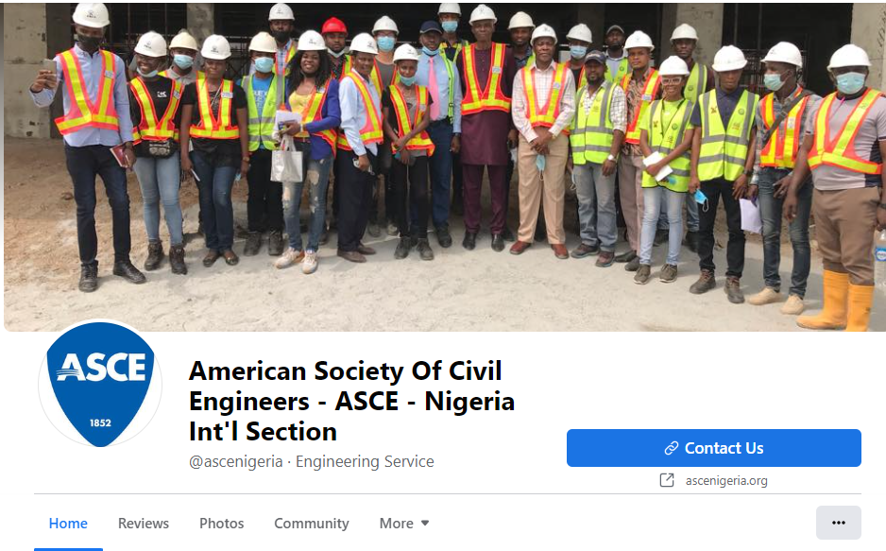
LinkedIn Example:
India Section
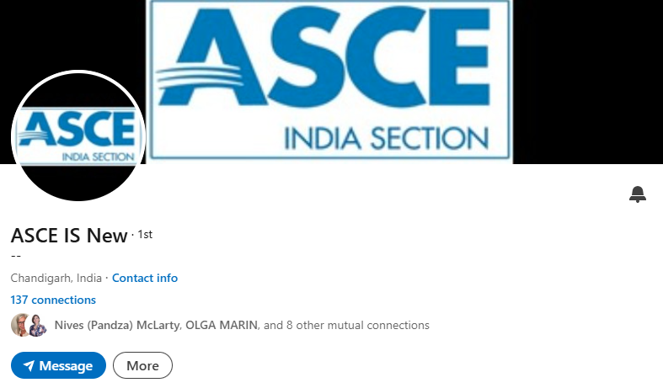

Social Media Cheat Sheet:
