Website

Those in charge: The Section and/or Branch appointed Webmaster should be the primary individual responsible for the website. However, we highly recommend that the Webmaster have a small group of members assisting with the development of the website, as well as identifying and gathering appropriate content for the website.
Benefits: Provides Section and/or Branch member value by keeping members informed and opportunities for professional education and involvement. It’s an avenue to reach out to members, promote your Section and/or Branch activities and events, and showcase special occasions such as officer inaugurations. Tips include adding your mission statement and purpose, as well as links on membership benefits and how to join ASCE. Be sure to keep your members up to date on what events are coming up and what they should expect, as well as what events have already happened and their outcomes and takeaways. It is also easy to maintain a website that can be updated monthly, bi-monthly, or quarterly, with new or updated content.
Recommendations:
- It’s important to frequently add new content to the website (such as news articles) and keep information about future events up to date. This will encourage members to visit the website on a regular basis.
- Don’t include too many features in the initial launch of the website. Consider adding new features in the future once the site is operational.1 - Communication
- It’s important to ensure that different members/groups within the Section and/or Branch contribute material so the overall website provides balanced information.

Additional Ideas:
- Publish a “Message” or “Welcome” from the Section and/or Branch President.
- Consider including news on the local ASCE Student Chapters.
- Publish the newsletter on the Section and/or Branch website.
- Add links to ASCE social media pages.

- Website graphics are another great resource for your digital presence. We have a host of member value images to dress up your website, newsletter, or use for fillers if you have extra white space. Click here for the Website Digital Image Resources.
Website Examples:
Nigeria Section
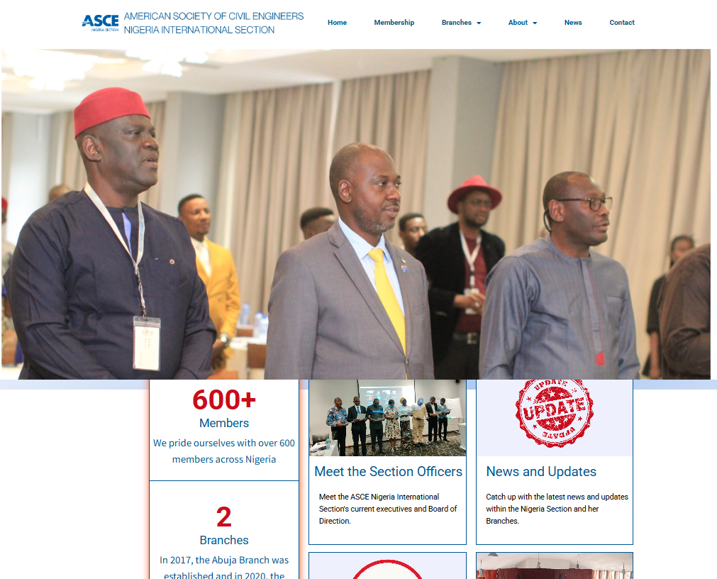
India Section- Southern Region Branch
