Communication

1.9 Newsletter – Orange County Branch
1. Section/Branch | Los Angeles Section, Orange County Branch
2. Section/Branch Size | Large
3. Project Contact
Name | Adeleine J. Tran, PE and Joseph Huynh, EIT
Phone Number | N/A
Email | pc@asceoc.org
4. Project Category | Newsletter Best Practices
5. Project Description | The Newsletter is a way to highlight events that ASCE hosts and engages members by having a venue for them to express and create a name for themselves. Not only so, it provides values to companies by giving them an incentive to become sponsors, since company logos and business cards are featured in the Newsletter, they are highlighted in a positive light amongst the Civil Engineering community.
6. The Process  (What you did, When and How) | The Newsletter started in 2010 and went fully online in May 2011. When we transitioned the Newsletter to a newly formed committee, it began with a strategic planning meeting hosted by the former Editor-in-Chief where the President and Secretary were in attendance, but specifically, Younger Members were invited to be a part of this meeting. Originally, there was only one Editor-in-Chief and then for a while the younger members (us) took on more roles and eventually the Editor-in-Chief passed the torch. The strategic planning meeting went over the process of requesting articles, uploading articles onto the website, and keeping track of all the requests for articles, emails sent, dates of events, etc. in an excel sheet on the Branch’s shared Google Drive. Under the current leadership, an article submission form was created using Google Form, which has the layout of an article and all required information. This helps streamline the article submission process for the members, where the contributors simply input the information into the appropriate boxes, include pictures, and press submit. The editors then do the rest, such as uploading the material and editing the articles for grammar only making sure to keep in-tact the writers voice. See attachment for example of ASCE OC Newsletter Article Submission Form.
7. Those in Charge (Committee, Task Committee, Etc.) | The Newsletter Editor-in-Chief is responsible for the production of the Newsletter, but the President is also largely a driving force in terms of implementing the vision that they have for their year. This year’s President and Past-President had very active participation in the development of the current form and inquiring articles to be written when they see certain events of interest.
8. Time Frame  (When Started, When Completed) | The Branch Newsletter originally started in 2010 and has been passed on over the years. In its current form, the Newsletter is released every two months electronically through our website and with an email blast. See attachment for example of our Newsletter email blast. Things like how the forms are written for contributors to submit their articles are largely based off the guidelines created from the previous editor-in-chiefs.
9. Success Factors  (The Parts that Worked Really Well) | Having a very active branch as well as younger member forum made it easy to find individuals who were willing to write and talk about the events that they put so much effort into. When we reached out to committee chairs, either they would write it or they would delegate or find someone to write articles willingly. These articles have an avenue to put the Branch, out committees, chairs and the civil engineering profession in a good light. What really works is that we have a dedicated committee and we have made a huge effort to automate as much possible with just formatting required on our end to make sure a successful Newsletter can be released. A barrier of entry for most Branches or Sections may be the time commitment involved by volunteers – however, automating tedious processes where possible and being able to reduce hard cost (printing) while allowing opportunities for sponsorships are all excellent selling factors and have helped the Newsletter continue its success.
10. Setback Factors  (The Parts that did Not Work Well) | Some months there just are not enough events to write about or people are too busy to write. We would go months without a Newsletter because we would be so busy with our own personal lives and careers that this Newsletter became a second job. It was too much to handle with the way we had inherited it. The Branch Newsletter used to go out monthly, but it was difficult to constantly request articles from committees and for us to have the time to assemble everything together. Before COVID-19, the Newsletters would go out bi-monthly. However, currently less events are being hosted due to COVID-19, and the Newsletter is now on a quarterly-basis.
11. Creativity  (This is something off the wall that we did) | We upgraded our website and introduced an article submission form, which has all the typical inputs of what is expected of an article and streamlined the whole process. It is still important to be personable and individually ask contributors to write articles because it is important to let people know that they are going above and beyond and that their work matters.
12. Administration  (What was most Important?) | Being personable is important when requesting articles. When inquiring about events and articles to be written, it is very important to know your audience. It gets to a point where a handful of contributors become regulars, because they have an avenue to express themselves in a meaningful way.
13. Follow-Up  (What was most important?) | The most important part is to be passionate about this Newsletter, treat it like your own creation, and when it stops being a passion project, it can feel like draining work. It is important to add your contribution and to also allow others an opportunity to express themselves even if they might not be completely ready, this is an avenue for editors and contributors to grow and it is the authenticity of the writing that gets people to write and to read. When our Newsletter is distributed, we can track how many people open it and which articles are popular. So long as people keep writing, people will keep reading. Additionally, it is important to bring in key leadership to write articles including the President, Secretary and others – writing about relevant topics to the profession and the local community.
14. Recommendations  (What you should ALWAYS do with this project?) | Be personable and treat it like a hobby and not a job. Make sure to be passionate and allow others an opportunity to express themselves, so being tactful and empathetic to people’s situations and allowing them the flexibility to make mistakes and grow, will go a long way. Understand that contributing to the Newsletter is voluntary, so allow people enough time to write and be flexible even when they miss the deadline. If people want to write, let this Newsletter be a way for them to express themselves. If the content is inappropriate, the editor should step in and communicate with the writer, but that has not happened.
15. Cautions  (What you should NEVER do with this project?) | Never pick and choose articles or request/reject any specific topic. This allows people who want to contribute and write an opportunity to do so freely, in relation to the events they are asked to write for, or if they simply want to write an article that they are passionate about.
16. The Outcome | It has led to regular contributors and has solidified the commitments of certain members to continue to seek growth and to continue being a part of this organization. As an organization, the better we do as a team, the better we can do to work towards enhancing our community. Companies and sponsors will see our success and want to be a part of the tremendous value that we bring to the world; as a result, we regularly get sponsored, not just our Newsletter but also individual events. The outcome is a legacy of editor and chiefs and a culture of contributing to this project and passing it on.
17. Ongoing Activity  (Would you do it again?) | Absolutely
18. Speaker Contact Information  (person from your Region who would be willing to speak about the Best Practice) | ASCE OC Branch Publications Committee
Name | Adeleine Tran
Address | 1405 Warner Ave Suite B, Tustin, CA 92780
Phone Number | (714) 259-1224
Email | pc@asceoc.org
19. Additional Comments | http://www.asceoc.org/newsletter

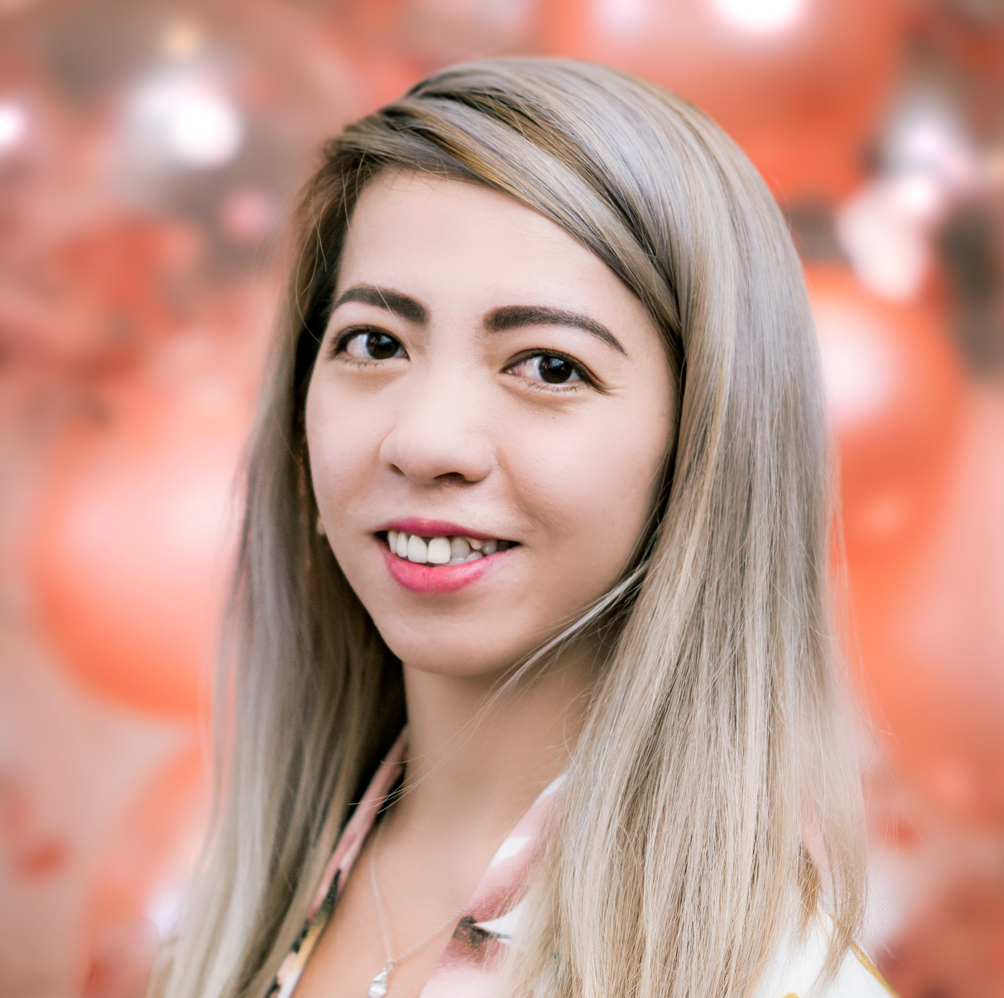 | 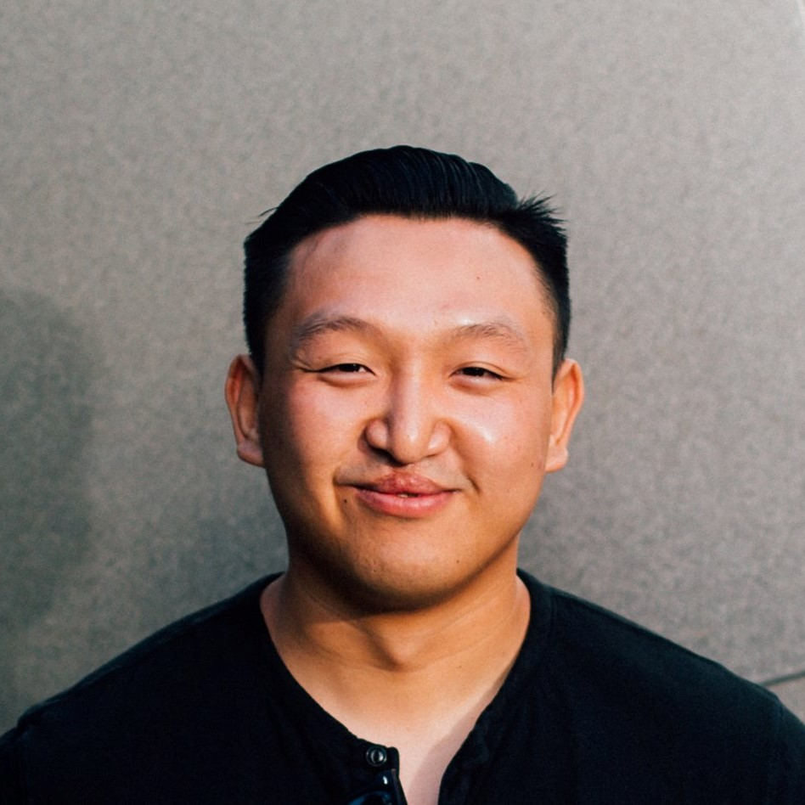
Adeleine J. Tran, P.E.  Editor-in-Chief | Joseph Huynh, E.I.T.  Editor/Article Reviewer
