**Membership Development**

**4.3 Membership Recruitment (Students) – Baton Rouge Branch**

|  |  |  |
| --- | --- | --- |
| **1. Section, Branch** | Louisiana Section, Baton Rouge Branch |  |
| **2. Section/Branch Size** | Medium |  |
| **3. Project Contact** |  | |
| Name | Joshua Olivier, EI | |
| Phone Number |  | |
| Email | youngmembers@ascebr.org | |
| **4. Project Category** | Membership Development | |
| **5. Project Description** | Tips on Recruiting College Students | |
| **6. The Process**  (What you did, When and How) | I started by contacting the presidents of the ASCE student chapters of the colleges in my area, LSU and Southern University. They were a great source to use in order to reach out to all of the student members. I attended their chapter meetings to discuss what the younger member group is all about (the socials, the service projects, etc.) as well as dedicated a specific social twice a year to the senior members. This social was focused on the graduating seniors and paid tribute to their hard work and reminded them it will all pay off soon! Since I, and the other younger members, had been through it all recently, we could relate to their struggles on projects, finals and finding a job. I talked about how there will be other struggles right after graduation but the young professionals they meet in ASCE are there struggling with them and they offer a good support system and networking system that will benefit them socially and professionally. The seniors were able to talk to the younger members who were currently employed at engineering firms in Baton Rouge and create an important relationship that could possibly result in a job opportunity. | |
| **7. Those in Charge** (Committee, Task Committee, Etc.) |  | |
| **8. Time Frame**  (When Started, When Completed) | It is an ongoing process. With each new graduating class, the younger member chair has to keep reminding the students that there is a way to stay active in ASCE after graduation that is still fun and exciting for young professionals. | |
| **9. Success Factors**  (The Parts that Worked Really Well) | Attending the chapter meeting right before the “seniors’ social” really made an impact. A lot of the seniors attended that social because it was fresh in their minds. | |
| **10. Setback Factors**  (The Parts that did Not Work Well) | Just emailing the student chapter presidents did not work—emailing them was a good start but you need to show your face to the students so they know that you care enough about their continued involvement with ASCE to go to their meetings. It also helps them to put a face to a name so when they get the younger member emails and invites to socials, they know who it is coming from. Keep it personal! | |
| **11. Creativity**  (This is something off the wall that we did) | We did a service project in which both student chapters were invited to participate. There was a great turnout from the students and I think they were really impacted by the participation from the younger members. | |
| **12. Administration**  (What was most Important?) | I got a lot of support from my board members. I had a very nice budget which allowed me to host socials just about once a month including the two socials that were focused on the graduating seniors. I could not have done the socials without this support. | |
| **13. Follow-Up**  (What was most important?) | Thanking the students for allowing us to come to their meeting as well as thanking those students who went to the social keeps the lines of communication open for future events. I also sent the student chapter presidents the pictures that we took. They posted pictures on their website as did we. For those who were not able to attend, they were able to see how much fun we had as a group and hopefully, it encourages them to attend the next social. | |
| **14. Recommendations**  (What you should ALWAYS do with this project?) | KEEP IT PERSONAL! Go to at least one meeting each semester. It helps to bring other young professionals with you just to show the bond that the younger member group has. It also shows how committed we are to making sure that they stay involved after graduation. | |
| **15. Cautions**  (What you should NEVER do with this project?) | GIVE UP! Keep contacting the students. Even if they are reluctant as sophomores or even juniors, by their senior year, when they are really thinking about what they want to do after graduation, what you have done up to that point will stick with them and they are more likely to get involved with ASCE after graduation. | |
| **16. The Outcome** | We have had tremendous participation from the recent graduates at our socials and at our monthly chapter luncheons. These students have told other students how much fun they are having and our number of active participants has truly grown. | |
| **17. Ongoing Activity**  (Would you do it again?) | YES…I try to go every semester to at least one student chapter meeting. There are always new students joining so it is important to keep showing your face and reminding them about ASCE opportunities. | |
| **18. Speaker Contact Information**  (person from your Region who would be willing to speak about the Best Practice) |  | |
| Name |  | |
| Address |  | |
| Phone Number |  | |
| Email |  | |
| **19. Additional Comments** |  | |

**4 – Membership Development**

**4.4**

**4.4 Younger Member Recruitment – Baton Rouge Branch**

|  |  |  |
| --- | --- | --- |
| **1. Section, Branch** | Louisiana Section, Baton Rouge Branch |  |
| **2. Section/Branch Size** | Medium |  |
| **3. Project Contact** |  | |
| Name | Danielle Welborn | |
| Phone Number | (225) 907-7821 | |
| Email | [brasce.ym@gmail.com](mailto:brasce.ym@gmail.com) | |
| **4. Project Category** | Membership Development | |
| **5. Project Description** | Younger Member Recruitment | |
| **6. The Process**  (What you did, When and How) | I set a goal for myself as the younger member chair this year—increase the number of active younger members. Our roster is quite large but very few people were coming to the socials. One of the ways I got more participation from the younger members was by having the socials at the same time each month—I chose the second Thursday of the month. Since they knew the date of each social, they were able to keep their schedules open so they can attend the social. I also committed to varying the activities each month. We do not just go to a bar for Happy Hour. We have played laser tag, gone bowling, gone to restaurants, done service projects--each month is something different which I think it keeps the younger members interested and the attendance up!  As for member recruitment, I think recruiting at the college level is the best place to start. Those who hold a position in their student chapter and are active in their student chapter are very likely to stay involved after graduation and possibly even hold a role in the branch. Attending the student chapter meetings is beneficial so they receive the personal attention they deserve. Another really good source for recruitment is the younger member group that you already have. They probably work at an office with many other young engineers so when they have a good time at the social, they will go back to their office and talk about how much fun they had and will recruit their coworkers to attend the next social. | |
| **7. Those in Charge** (Committee, Task Committee, Etc.) |  | |
| **8. Time Frame**  (When Started, When Completed) | Recruitment is an ongoing process. The younger member chair has to keep reminding the students and current younger members that there is a way to stay active in ASCE besides just attending the monthly luncheons. | |
| **9. Success Factors**  (The Parts that Worked Really Well) | The socials at restaurants instead of bars have been some of the best attended socials! The activities (laser tag, bowling, etc.) were second best! However, it is nice to have a relaxing happy hour every once in a while! | |
| **10. Setback Factors**  (The Parts that did Not Work Well) | I do not organize socials in the summer months anymore—partly because of my budget but also because many people go on vacation so attendance usually drops in the summer. It is nice to give myself a break as well. We start fresh again in the fall with new ideas for social activities. | |
| **11. Creativity**  (This is something off the wall that we did) | Something that I tried but never really continued was the “Younger Member Spotlight.” This was an opportunity for younger members to nominate their fellow younger members for something special they did at work or in the community. It is up to them to acknowledge an accomplishment of a fellow yellow member and the nominee would be recognized at the monthly ASCE luncheon. Unfortunately, I never got any nominations the first few months so I stopped trying but it is something that I would like to try again. | |
| **12. Administration**  (What was most Important?) | I get a lot of support from my board members. I have a very nice budget which allows me to host socials just about once a month including the two socials that are focused on the graduating seniors. I could not do the socials without this support. | |
| **13. Follow-Up**  (What was most important?) | I always send out an email to the younger members after the social to thank them for coming. I also attach a picture, if we take one, to show all those who didn’t attend how much fun we had. | |
| **14. Recommendations**  (What you should ALWAYS do with this project?) | Take ideas from those who give it! Do not ignore their suggestions. After all, it is their evening that they are giving up to spend time with the younger member group so you should try to do what they want to do. | |
| **15. Cautions**  (What you should NEVER do with this project?) | GIVE UP! Keep contacting the younger members. Even if they are reluctant at first, they might just be really busy but they may come to one social and realize what they have been missing and then attend many after that—and maybe even recruit others to come too! | |
| **16. The Outcome** | Our attendance has exploded since we have had socials every month. It is something for them to look forward to and now that they know when it will be, they don’t have to worry about possibly having other plans or conflicts. It has been great! Our number of active participants has truly grown. | |
| **17. Ongoing Activity**  (Would you do it again?) | YES…I am still doing socials once a month and they are going very well but I am always looking for new ideas of where to go and what to do. | |
| **18. Speaker Contact Information**  (person from your Region who would be willing to speak about the Best Practice) |  | |
| Name |  | |
| Address |  | |
| Phone Number |  | |
| Email |  | |
| **19. Additional Comments** | This Best Practice includes the following attachments:   * Photographs of younger member socials and events | |

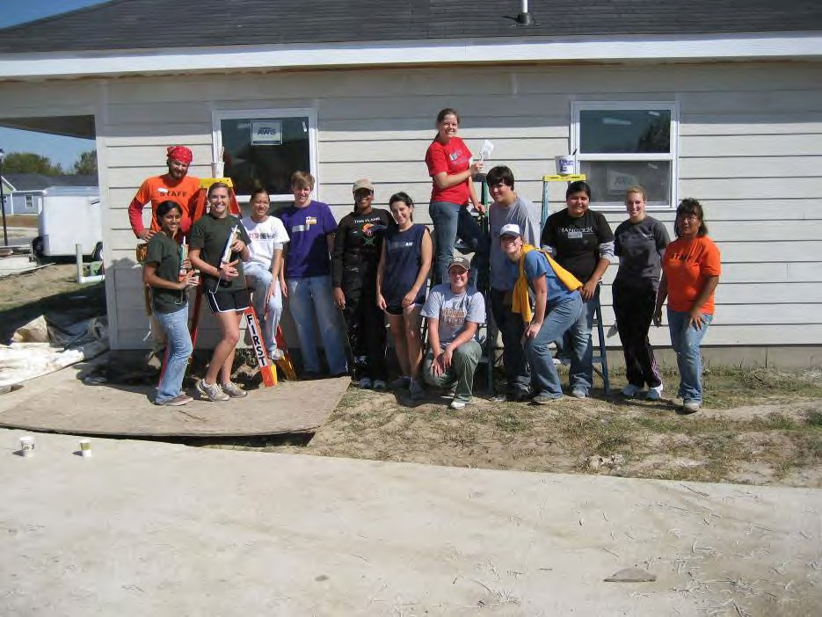

**Habitat for Humanity Build with LSU and Southern University (November 2008)**

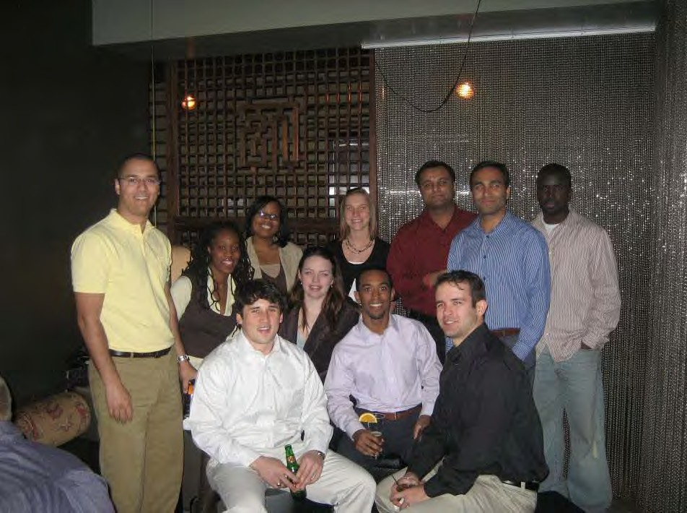

**YM Social at Tsunami (February 2009)**

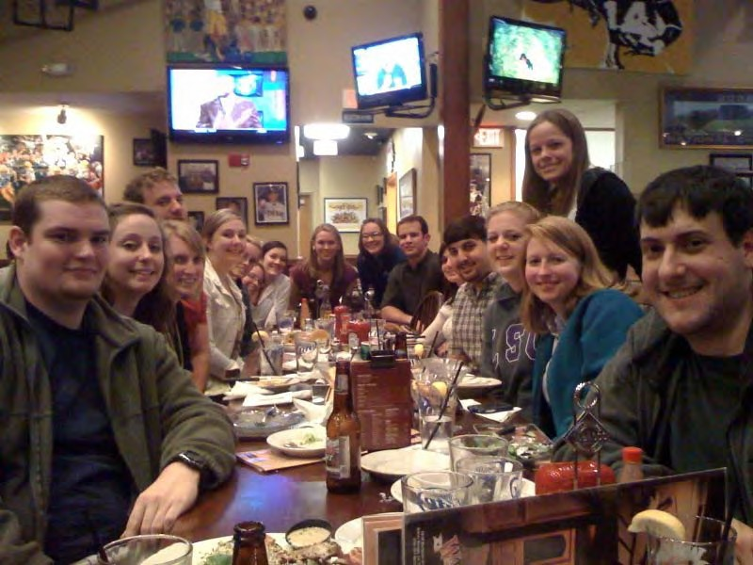

**“Senior Night” YM Social at Walk-Ons (March 2010)**

**4 – Membership Development**

**4.5**

**4.5** **Region Governor Leadership Training – Boston Section**

|  |  |  |
| --- | --- | --- |
| **1. Section, Branch** | Boston Section (BCES) |  |
| **2. Section/Branch Size** | Very Large |  |
| **3. Project Contact** |  | |
| Name | Very Large | |
| Phone Number | Anni Autio | |
| Email | (617) 452-6309 | |
| **4. Project Category** | Membership Development | |
| **5. Project Description** | Transition from Section President to Region Governor based on Region 1 Board of Governor observations (also applicable to finding and training your successor) | |
| **6. The Process**  (What you did, When and How) | Maintaining continuity on the Region Board of Governors begins during the third-year term of a Region Governor…first with candidate selection (Fall-Winter) followed by opportunities for job shadowing and sharing of pertinent correspondence (e.g., eRoom enrollment, mailings to Section/Branch presidents, copies of the Section Informant, Region Governor e- mails, and so forth) as well as identifying available resources including go-to contacts. The intent is to build and maintain a strong organization that has growth potential and enables everyone coming to a leadership position to build upon the foundation given (entrusted) to them. Recognition for the need was based on the limited exposure of the governor candidate to the Region Board and its activities. | |
| **7. Those in Charge** (Committee, Task Committee, Etc.) | As this is a prototype project, Anni Autio (Region Historian, Past ASCE Officer and Section President) initiated the activity and engaged the current Region Governor candidate to self-tabulate and track information received prior to his formal induction. This will be reviewed later to determine what advance information was helpful so that a schedule can be drafted for the next transition. | |
| **8. Time Frame**  (When Started, When Completed) | * Start: September 2010 (announcement of opening) * Mid-term: April 2011 (candidate determined, start of information sharing)   End (of cycle): September 2011 (Governor orientation/induction) | |
| **9. Success Factors**  (The Parts that Worked Really Well) |  | |
| **10. Setback Factors**  (The Parts that did Not Work Well) |  | |
| **11. Creativity**  (This is something off the wall that we did) |  | |
| **12. Administration**  (What was most Important?) | This process creates the opportunity for past Region Governors/ASCE Officers to share experiences and provide guidance for incoming leaders. This also enables current Section and Region officers to remain focused on their roles without adding to their workloads and provides an opportunity for past Governors to remain active after their term expires. | |
| **13. Follow-Up**  (What was most important?) | A feedback loop was developed at the onset so that the action can be tracked and refined for the next cycle. | |
| **14. Recommendations**  (What you should ALWAYS do with this project?) | Coaching continuity is important and reminders of the calendar elements. It cannot be assumed that candidates are already on established mailing lists, including the one use by the Region Board. At a minimum, monthly check-ins should be conducted. | |
| **15. Cautions**  (What you should NEVER do with this project?) | Interaction and feedback are important throughout the cycle. The end of each session should be positive with acknowledgement and appreciation on the level of commitment the candidate has agreed to accept and the benefits that can be attained for this volunteer service. | |
| **16. The Outcome** | To be determined at a later date | |
| **17. Ongoing Activity**  (Would you do it again?) | Absolutely. Strong leadership transitions are important to the vitality of a growing organization. Anticipating weaknesses in advance provides opportunities to make timely reinforcement. | |
| **18. Speaker Contact Information**  (person from your Region who would be willing to speak about the Best Practice) |  | |
| Name |  | |
| Address |  | |
| Phone Number |  | |
| Email |  | |
| **19. Additional Comments** |  | |

**4 – Membership Development**

**4.6**

**4.6** **Life Member Forum – Los Angeles Section**

|  |  |  |
| --- | --- | --- |
| **1. Section, Branch** | Los Angeles Section |  |
| **2. Section/Branch Size** | Very Large |  |
| **3. Project Contact** |  | |
| Name | Jay Higgins | |
| Phone Number | (818) 406-4896 | |
| Email | jay.higgins@aecom.com | |
| **4. Project Category** | Membership Development | |
| **5. Project Description** | Life Member Involvement | |
| **6. The Process**  (What you did, When and How)  1The material in this Best Practices Guide section was excerpt from *Guidelines for Life Member Involvement in ASCE,* dated March 2009, prepared by the Task Committee on Life Member Involvement, Norm Buehring, Chair. A copy of the report may be obtained from the Society’s Geographic Services Division.  2The material in this section was excerpt from the *Los Angeles Section 2009-2010 Annual Report.* A copy is available from the Los Angeles Section Secretary upon request. | **Formation of the Life Member Organization1**  Life Member status is generally conferred by ASCE when a member reaches age 65 and fulfills a number of years of ASCE membership. Current data indicates that there about 20,000 members eligible to become a Life Member, which is about 15% of ASCE membership, and the numbers will certainly grow in the future.  Life Members have the energy, experience and the enthusiasm to be involved in a great variety of activities that serve their desire to contribute to their chosen profession, but also is of service to the local organization membership. Getting started to create a Life Member organization for a Section/ Branch is a two-step process. First, an officer of the local organization must believe in the value of more Life Member participation and support the commitment of resources to the effort. Second, a motivated and enthusiastic Life Member champion must be selected that can contact and recruit other Life Members and foster their involvement in local organization activities. In some cases, an organization may find it appropriate to create a start-up team.  Life Members add great value to ASCE, to the community in which they live, and, at the same time get a sense of contribution and accomplishment on a professional and personal level. Following are some of the activities that have already been done by Life Members at the Section and Branch level:   1. Recognize their peers through Awards Programs and/or recognition of achievement, such as becoming a Life Member. 2. Recognize Life Members through articles in Section/Branch Newsletters. 3. Volunteer for Section/Branch activities. 4. Promote ASCE initiatives at the Local/Regional or Society level. 5. Organize and/or provide speakers for a speaker’s bureau.   Help improve communications through work on a web site or by providing hard copies for members who don’t use computers.   * Prepare a Life Members Newsletter. * Lead and/or participate in Engineer Week activities. * Organize History and Heritage projects/activities. * Assist Student Chapters with programs/activities. * * Mentor students and younger members. * * Involvement with engineering related public projects (speak at public hearings). * Lead and/or assist with the preparation and dissemination of local Infrastructure Report Cards. * Organize or assist in disaster preparedness programs. * Offer transportation to other Life Members who want to participate but can no longer drive. * Help with fundraising such as golf tournaments and seminars. * Assist the formation of other Life Member Groups. * Digitize Section/Branch records and important historical information.   An ASCE study on Life Members has shown that the program outlined above will result in increased Life Member participation at the local level. The keys are Section/Branch support, a motivated champion, and a program that utilizes the elements of these Guidelines that are appropriate for the specific Section or Branch.  ~~Los Angeles Section Life Member Forum2~~  The Los Angeles Section (Section) Life Member Forum (LMF), created in the early 1990s, has been very successful over the years, and serves as a model for the Society for Life Member involvement. The Life Members are involved in several activities with the primary event being a brunch held each year to induct those members that have reached Life Member status into the Section’s Life Member Forum. The goal of the brunch, held in each year February or March, is to recognize lifetime achievements, encourage them to stay active in ASCE, and get involved in Section’s Life Member Forum activities.  The Life Member Forum held its annual Life Member Brunch in 2010 on March 6th. This event provided special recognition to the dedication and service of all new Life Members. Each year it has become a Section tradition to invite the Society President-Elect to be the guest speaker at the brunch. The guest speaker at the 2010 event was then President-elect, Kathy Caldwell P.E., F. ASCE. Kathy spoke on the Vision for 2025. Each Life Member’s bio was shown in the event program and each was presented a plaque by Kathy Caldwell and Jay Higgins, P.E., M. ASCE, Los Angeles Section President recognizing their new membership status.  The Section has led the Society in Life Member activities. The forum is very active in events that benefit the membership of the Section at all levels in their careers, including student and younger members. Our Life Members have been active in: history and heritage, recognition of national and local historic civil engineering landmarks; mentoring programs at the high school and college levels: providing input at public hearings for pending infrastructure projects; suggesting building code changes or implementation of code standards to public officials; and involvement in community projects such a habit for humanity. These activities have provided significant value to our members, public officials, and the general public. | |
| **7. Those in Charge** (Committee, Task Committee, Etc.) | Larry Lewis is the current President of the Los Angeles Section Life Member Forum. His contact information is: 562 927-2088 (Home Phone); [ml3lewis@gmail.com](mailto:ml3lewis@gmail.com) | |
| **8. Time Frame**  (When Started, When Completed) | The Los Angeles Section Life Member Forum was created in the early 1990s as a result of the efforts of Bob Bein, P.E., past President of ASCE (2001) and the Los Angeles Section (1992), and retired Caltrans District Director, Keith McKean, P.E., now deceased. | |
| **9. Success Factors**  (The Parts that Worked Really Well) | The monthly meetings of the Life Member Forum keep the members connected and actively planning their next activity. | |
| **10. Setback Factors**  (The Parts that did Not Work Well) | With a geographic area as large as the Los Angeles Section, it is difficult to get all members involved in the meetings. We are currently investigating the possibility of forming Branch Life Member Forums to reach more of our Life Members and provide activities closer to their homes. | |
| **11. Creativity**  (This is something off the wall that we did) |  | |
| **12. Administration**  (What was most Important?) | The use of the Section administrative services provider to support communication and arrange meetings is important aspect of the success of the LMF. | |
| **13. Follow-Up**  (What was most important?) | Follow up communication to new inductees will significantly improve participation (e.g. due to better communication, a recent nuclear-powered field trip/tour resulted in improved participation. Participation went from an average approximately 10 LMF members to 40 LMF members due an effort to contact the recent inductees). | |
| **14. Recommendations**  (What you should ALWAYS do with this project?) | Have person to person contact when inviting Life Member inductees to the annual brunch event. | |
| **15. Cautions**  (What you should NEVER do with this project?) | Relay totally on e-mail for distribution of information. | |
| **16. The Outcome** | Absolutely. The contributions of the Life Member Forum to our activities and Board meetings are a significant part of the success of the Section. | |
| **17. Ongoing Activity**  (Would you do it again?) |  | |
| **18. Speaker Contact Information**  (person from your Region who would be willing to speak about the Best Practice) |  | |
| Name |  | |
| Address |  | |
| Phone Number |  | |
| Email |  | |
| **19. Additional Comments** | This Best Practice includes the following attachment:   * Photo of the 2010 Life Member Forum Brunch | |

Photo from the 2010 Life Member Forum Brunch held on March 6th

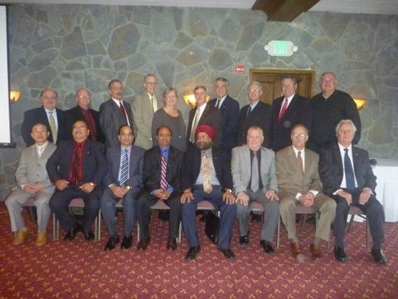

**4 – Membership Development**

**4.7**

**4.7** **Membership Survey – National Capital Section**

|  |  |  |
| --- | --- | --- |
| **1. Section, Branch** | National Capital Section |  |
| **2. Section/Branch Size** | Very Large |  |
| **3. Project Contact** |  | |
| Name | Christian J. Manalo, P.E., DEE | |
| Phone Number | (703) 626-1031 | |
| Email | [manalo_christian@bah.com](mailto:manalo_christian@bah.com) | |
| **4. Project Category** | Membership Development | |
| **5. Project Description** | The National Capital Section (NCS) formed a Management and Best Practices Subcommittee in September 2010 to evaluate Section activities and identify means for optimizing value of NCS membership. As part of the Subcommittee’s efforts, a membership survey was conducted and the results provided in an interim finding report. | |
| **6. The Process**  (What you did, When and How) | The survey was performed as one part of a larger focused effort to improve benefits to our Section members. The survey was conducted via Cvent (www.cvent.com), an online service that members also use to register for section meetings. The survey began with an email announcement on December 8, 2010 and survey responses were received over a two- week period. The survey consisted of 12 mostly multiple-choice questions but also included open-ended questions where respondents could provide additional input. The survey results were compiled and interpreted to identify specific areas of improvement for the section. Results were also compared to an earlier membership survey performed in 1998 to identify trends over time. | |
| **7. Those in Charge** (Committee, Task Committee, Etc.) | The Subcommittee was formed upon approval of the Section Board of Directors. Work was led by a subcommittee chair and supported by members of the Section. | |
| **8. Time Frame**  (When Started, When Completed) | Subcommittee was formed in September 2010. Survey questionnaire was developed during the Fall of 2010 and conducted in December 2010. Results were analyzed throughout January 2011 and first presented to the Section leadership during its regular Board of Directors meeting in February 2011. Conclusions from the survey will also be included in a larger Subcommittee report to be completed by Fall 2011. | |
| **9. Success Factors**  (The Parts that Worked Really Well) | The survey questionnaire was craftily developed to ensure results would be beneficial to the decision-making of the Section leadership. Issues of concern included how to improve attendance at Section meetings and greater participation among our members. Most questions dealt with providing insight into these two specific issues. The questions were vetted among Section leaders prior to releasing the survey. Additionally, results of the survey were not simply released as-is. Answers to each survey question were analyzed deeply to determine linkages with answers to other questions and identify trends among demographics and over time. | |
| **10. Setback Factors**  (The Parts that did Not Work Well) | Response rate to the survey was about 16-percent of our members, which is approximately the same percentage that responds to our Section monthly meeting announcements. A higher rate would have been preferred. A high-level analysis of the respondents’ backgrounds however correlated well with demographic information that we already possessed from our membership database (e.g., ages, gender, specialties, etc.). | |
| **11. Creativity**  (This is something off the wall that we did) | Among the innovative things we did was to map out the locations where members both worked and lived to find out where the optimal locations would be for meetings both in the daytime and in the evening. Another thing we did was find out what other professional or industry associations that members were a part of to identify potential organizations for joint activities and also to coordinate the timing of future events. | |
| **12. Administration**  (What was most Important?) | It was important to have a Subcommittee chair and members with strong interest in organizational development and improvement. The Subcommittee met near weekly during its first three months to discuss and plan activities, including survey development, interviews of key leaders, literature review, and data interpretation. | |
| **13. Follow-Up**  (What was most important?) | A fair amount of resources were required to interpret data after receiving the survey results. Even after initial presentation of the survey’s findings, follow-up questions were naturally asked by the Section leadership. Questions such as which types of members answered questions in certain ways proved helpful in answering to delve into the root causes for issues that were identified. | |
| **14. Recommendations**  (What you should ALWAYS do with this project?) | This survey was largely a success not only in the results that were discovered but even the process itself. By announcing and advertising the survey, Section members were appreciative of the efforts being made by the Section leadership to evaluate its own performance in trying to improve the value of their membership. | |
| **15. Cautions**  (What you should NEVER do with this project?) | The large amount of data received from the survey could be interpreted in many ways. The results must be looked at objectively and carefully in order to be truly reflective of the interests and needs of Section members. | |
| **16. The Outcome** | The Section leadership continues to review the results of the survey as needed when planning activities, including but not limited to the selection of topics, speakers, locations, and timing. | |
| **17. Ongoing Activity**  (Would you do it again?) |  | |
| **18. Speaker Contact Information**  (person from your Region who would be willing to speak about the Best Practice) |  | |
| Name |  | |
| Address |  | |
| Phone Number |  | |
| Email |  | |
| **19. Additional Comments** | This Best Practice includes the following attachments:   * Survey results * Survey questions | |



**ASCE-NCS Management and Best Practices Subcommittee**

**PRELIMINARY FINDINGS REPORT – Part 1**

**July 6, 2011**

**Table of Contents**

 Executive Summary

 Introduction and Background

 Member Analyses

 Best Practices Review

 Meetings Analysis

 Conclusions and Recommendations

***© 2011 ASCE-NCS Board*** 1

**Table of Contents**

 Executive Summary

 Introduction and Background

 Member Analyses

 Best Practices Review

 Meetings Analysis

 Conclusions and Recommendations

***© 2011 ASCE-NCS Board*** 2

**Executive Summary**

 The ASCE-NCS Management and Best Practices Subcommittee was developed to evaluate

Section activities and identify means for optimizing the overall value of NCS membership.

 Work consisted of identifying member interests, exploring best practices, and evaluating meetings and other activities. As part of this work, a membership survey was conducted and interviews were held with NCS leadership, university faculty, and other chapters and organizations.

 Overall, members expressed general satisfaction with NCS (survey showed 89-percent favorable rating), and interest in section activities has been increasing over the past few years. Several activities stand out in particular for their success, including university engagement, Young Members Forum, Sustainability Awards Banquet, and monthly section meetings.

 There are a number of areas where further gains can be made, particularly in attracting and retaining next generation of leaders and widening the scope of activities to include greater areas of interest. Many ideas are suggested within this report, including greater involvement by committees.

***© 2011 ASCE-NCS Board*** 3

**Executive Summary (cont’d)**

 Construction was identified as the area of greatest interest per the membership survey (45%).

This was followed almost equally by Transportation & Development, Environmental and Water Resources, and Structural Engineering (34-36%). Other significant areas included Sustainability, History & Heritage, Geotechnical Engineering, and Architectural Engineering.

 24-percent of members are over the age of 65. 22-percent of members are under the age of

35.

 Meetings were most desired on Tuesdays, Wednesdays, and Thursdays. Time of day for meetings was nearly split with 45% of respondents preferring evening and 41% daytime.

 Washington DC and Arlington were the area’s most members preferred as the meeting location (up to 22%), however a significant number of members selected Tysons Corner (17%). A substantial number of members also selected Rockville and Bethesda (10%).

***© 2011 ASCE-NCS Board*** 4

**Table of Contents**

 Executive Summary

 Introduction and Background

 Member Analyses

 Best Practices Review

 Meetings Analysis

 Conclusions and Recommendations

***© 2011 ASCE-NCS Board*** 5

**Introduction and Background**

 The Management and Best Practices Subcommittee was formed to evaluate Section activities and identify means for optimizing the value of NCS membership. Subcommittee activities include:

* + Analysis of monthly meetings, including attendance, costs, and benefits;
  + Compiling and reviewing industry statistics and studies applicable to Section activities;
  + Developing and conducting membership survey, and analyzing responses;
  + Assessing and evaluating young member and university involvement;
  + Reviewing best practices of other ASCE chapters and organizations for potential adoption by NCS;
  + Evaluating geographic and demographic distribution of NCS members to assist in planning future activities; and
  + Identifying and evaluating potential partnerships and sponsorships.

 The Subcommittee was formed in September 2010 and chaired by Christian Manalo.

Subcommittee members included Rollie Berry, Kari Kubista, Nashwa Alrawahy, and Isaias

Espinoza.

***© 2011 ASCE-NCS Board*** 6

**Table of Contents**

 Executive Summary

 Introduction and Background

 Member Analyses

 Best Practices Review

 Meetings Analysis

 Conclusions and Recommendations

***© 2011 ASCE-NCS Board*** 7

**ASCE-NCS member backgrounds were evaluated to identify interests and assess their level of engagement with section activities**



 Membership roster from August 2010 was evaluated for information regarding membership grades, institutes involvement, education levels, and other demographics.



 A membership survey was performed over a three-week period in December 2010 to further identify areas of interest, identify barriers to participation, assess member satisfaction, and gain other input for improving section activities.

 A previous membership survey was performed in 1998. Results from the previous survey were compared to current data to identify any trends.

**Evaluation Statistics**

 3,059 members are included in the August 2010

membership roster.

 488 persons responded to the December 2010 membership survey, approx. 16%. As such, the results are not fully representative of NCS members as a whole; an inherent bias exists in the results. Typical open rate for NCS general meeting announcements is 18-20%.

***© 2011 ASCE-NCS Board*** 8

**Membership dropped across most membership grades since 1998, with exception of Students, which increased more than 50-percent**

 Overall membership dropped

approx. 7% since 1998 (from 3,265

to 3,053).

* + - Reductions between 7-9% occurred across most grades – Member, Associate, Affiliate, and Fellow.
    - Student membership increased 51-percent

MEMBER

ASSOCIATE

AFFILIATE

FELLOW



225

203

310

651

598

*1998 2010*

1721

1866

 Life Members currently make up

22% of our membership.

 General membership reduction may be due to larger industry trend…. technical persons trending

STUDENT

2

HONORARY

5

207

211

319

toward IT professions.

0 200 400 600 800 1000 1200 1400 1600 1800 2000

Notes:

1. 2010 values are based on ASCE-NCS membership database dated August 2010. 1998 values are based on previous membership database.

***© 2011 ASCE-NCS Board*** 9

**Primary interest in Architectural and Geotechnical Engineering increased significantly since 1998, while Environmental/Water Resources and Transportation/Development dropped significantly**

 Contributors to changing demographic include industry trends, however committee activity and speaker lineup for monthly meetings can also play a major factor.

 Water/Environment: Approx. 20% of NCS members are also a member of a sister water organization (AWRA,

Engineering Mechanics

Oceans, Coastal, Ports & Rivers

Architectural Engineering

Geotechnical Engineering

Transportation & Development



1%

2%

3%

4%

1%

7%

4%

10%

*1998 Survey (All Members) 2010 Institutes (All Members)*

18%

FWQA, WEF, AWWA).

 Transportation/Development: Approx. 8% of NCS members are a member of a sister transportation organization (AASHTO, APTA, TRB)

Construction

Structural Engineering

Environmental & Water Resources

13%

16%

19%

20%

20%

25%

37%

Notes:

1. Members were placed in only one category of interest.

0% 5% 10% 15% 20% 25% 30% 35% 40%

1. 2010 values are based on all NCS members in ASCE Institutes. 1998 values are also based on all NCS members, combining multiple interest areas matching the Institutes’ focus.
2. 1998 Environmental/Water Resources includes Water Resources Planning & Mgmt., Water Resources Engg., and Environmental Engg.. 1998 Transportation & Development includes Transportation Engg., Urban Planning & Development, and Air Transportation.

**Members responding to the 2010 survey closely match demographics of the overall NCS membership**

 Institute participation among survey respondents matched

Engineering Mechanics

**Institute Participation**



2%

2%

very closely to proportions in the

membership database (as

shown in chart).

4%

Oceans, Coastal, Ports & Rivers

4%

7%

Architectural Engineering

7%

*2010 Membershjp Database*

*2010 Survey Respondents*

 Median age for all NCS members was 53; median age for survey respondents was 54.

 Responses to the 2010 survey must still be viewed in light of only a

16-percent response rate.

Geotechnical Engineering

Transportation & Development

Construction

Structural Engineering

Environmental & Water Resources

10%

11%

13%

15%

19%

18%

20%

18%

25%

26%

Responders tend to be more active, interested, or have more time.

0% 5% 10% 15% 20% 25% 30% 35% 40%

***© 2011 ASCE-NCS Board*** 11

**Construction was identified as the greatest overall area of interest, followed almost equally by Transportation/Development, Environmental/Water Resources, and Structural Engineering**

Construction Transportation and Development Environmental and Water Structural Engineering

Sustainability History and Heritage Geotechnical Engineering Architectural Engineering

Coastal, Oceans, Ports and Rivers

Engineering Mechanics

10%

6%

36%

35%

34%

28%

24%

21%

18%

45%



**Other Areas of Interest as**

**Identified by Respondents**

Critical Infrastructure

Leadership & Management

BIM (Building Information Modeling) Intelligent Infrastructure

Highway retaining walls Project/CN Management

Medical facilities

Energy & energy efficiency

Risk & reliability Project Management Airports & Railways

Low Volume Road Development &

Maintenance

Geomatics Engineering Green Energy Innovation Fire Protection

Other

7%

0% 10% 20% 30% 40% 50%

Hydraulics & Hydrology

Marketing

Natural Disasters International Development Conflict Resolution & Public

Participation

Notes:

 Respondents allowed to select more than one area of interest.

 Sustainability, a relatively new concept, also received a significant amount of interest.

Engineering & Project management Site Design/Land Development Engineering & Process Automation Facility Maintenance

Security

International; management I

1. Values based on 2010 membership survey.

**Washington DC, Arlington, and Tysons Corner were selected as the locations members most preferred to meet, irrespective of day or time**

Washington, DC

Arlington Tysons Corner Alexandria Rockville Bethesda Gaithersburg

Other

13%

9%

22%

21%

26%

38%

44%

48%

0% 10% 20% 30% 40% 50% 60%

Notes:

1. Values based on 2010 membership survey.
2. Respondents were allowed to select more than one

location.

***© 2011 ASCE-NCS Board*** 13

**The geographic distribution of members mostly centers around DC, Arlington, and Tysons Corner during the work day**



 23% of members identified

their work location as DC.

 >55% of members are located within a 20-minute

drive to Arlington.

 Locating a daytime meeting in Arlington may be considered an ideal location, specifically if its’ close to Metro and Route 66 (e.g., Rosslyn)

Notes:

1. Based on responses to 2010 membership survey,

***© 2011 ASCE-NCS Board*** 14

**In the evening, the population shifts significantly westward into Virginia and towards Montgomery County**

Notes:

 DC population drops substantially from 23% in daytime to 6% in evening.

 Nearly 75% of members are located within a 30- minute drive of Tysons Corner (non-rush hour).

 Locating an evening meeting en-route between Arlington and Tysons Corner may be considered an ideal location (e.g. Ballston, Falls Church). Proximity to Metro would be critical to accommodate rail commuters.

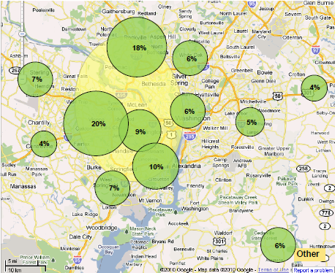

1. Based on responses to 2010 membership survey,

***© 2011 ASCE-NCS Board*** 15

**Members selected Tuesday, Wednesday, and Thursday as the most preferred days for meeting**

 Friday, Saturday and Sunday were the least preferred days to meet.

 Some interviewed members expressed interest in performing construction site visits on Saturdays.

 Scheduling regular meetings on the same day of the week each month generally improves attendance.

90%

80%

70%

**Most Preferred Days for Meeting**

60%

50%

40%

30%

20%

10%

67%

81% 80% 82%

59%

56%

47%

0%

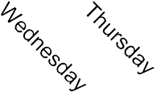

Notes:

1. Based on responses to 2010 membership survey.
2. Respondents were allowed to select more than one day.

***© 2011 ASCE-NCS Board*** 16

**Members preferring to meet in the daytime nearly equaled that of those who preferred the evening**

 NCS should strongly consider scheduling regular meetings in the daytime. Members also tend to be more concentrated in population centers during the day.

***All Respondents***

Daytime Only (Morning, Lunch, or Afternoon)

Evening Only

41%

45%

 Of members interested in meeting during the daytime,

Daytime or Evening

14%

0% 20% 40% 60%

most preferred time was during lunch.

***All Respondents Selecting Daytime***

Morning Lunch Afternoon

21%

27%

71%

Notes:

1. Based on responses to 2010 membership survey.
2. Respondents were allowed to select more than one time of day. Less than 20% of respondents selected more than one time.

0% 20% 40% 60% 80%

***© 2011 ASCE-NCS Board*** 17

**Education/Learning was the benefit of most interest to members, followed by Networking opportunities**



Education/Learning (e.g., listening to speakers and topics of interest)

Networking (e.g., meeting/socializing with fellow CE professionals)

Volunteer opportunities

Other

15%

5%

51%

71%

**Other Benefits of Interest as Identified by Respondents**

Training seminars Engineering Articles

History & Heritage events

Observe efficacy of association PDH Credits

Critical Infrastructure Business development

Project Experiences and Industry Best

Practices

Association

0% 20% 40% 60% 80%

 Events that provide an opportunity to both educate and network are ideal in terms of receiving the greatest number of attendees.

Local mailings Newsletter

Occasional Programs

Professional Development Publications

 Education/learning is primarily a function of the topic.

Topics/speakers should be selected based on members’ interests as identified in survey.

 Monthly meeting structure can potentially be modified to devote more time/attention toward networking (e.g., sponsors welcome table, recognizing special guests, approachability of speaker and Board, facilitating introductions, etc.)

Notes:

1. Based on responses to 2010 membership survey.
2. Respondents were allowed to select more than one benefit.

***© 2011 ASCE-NCS Board*** 18

**The main reason members are unable to attend meetings is due to time; travel and interest level are also major reasons**

I do not have time to attend Their meetings are held outside of my local

area and I am not willing to travel to attend

The topics and/or speakers do not interest me

The meals are too expensive

I do not receive information in a timely manner to put the meeting on my calendar

27%

27%

9%

7%

59%

Other

15%

0% 20% 40% 60% 80%

 Of those respondents that did not have time to attend, only 12-percent noted that the meetings were outside their local area, and they were not willing to travel to attend.

 40-percent of respondents responded that they are reimbursed for registration costs.

 31-percent would be encouraged if a guest/spouse could attend for free or at a discount.

Notes:

1. Based on responses to 2010 membership survey.
2. Respondents were allowed to select more than one reason.

***© 2011 ASCE-NCS Board*** 19

**Members are active in many other associations, specifically SAME, NSPE, and Water/Environmental organizations**

Society of American Military Engineers (SAME) National Society of Professional Engineers (NSPE)

Engineers without Borders (EWB) American Water Works Association (AWWA)

U.S. Green Building Council (USGBC) Water Environment Federation (WEF)

American Association of State Highway and… Structural Engineers Association (SEA)

Construction Management Association of America (CMAA)

11%

10%

9%

8%

5%

5%

5%

5%

4%

American Water Resources Association (AWRA) 3% American Academy of Environmental Engineers (AAEE) 2%

American Public Transportation Association (APTA) 2%

Society of Women Engineers (SWE) 2%

American Public Works Association 2% Transportation Research Board 1%

**Highest Selected**

**Water/Environmental Transportation Sustainability**

**Other**

20%

8%

5%

Notes:

Association for the Advancement of Cost Engineering… 1% Federal Water Quality Association (FWQA) 1%

Institute of Electrical and Electronics Engineers (IEEE) 1% American Institute of Chemical Engineers (AlChE) 1%

American Planning Association (APA) 1% American Society of Mechanical Engineers (ASME) 1% National Ground Water Association (NGWA) 1%

American Institute of Architects (AIA) 0%

American Nuclear Society (ANS) 0% Geospatial Information and Technology Association (GITA) 0%

Institute of Industrial Engineers (IIE) 0% International Association of Emergency Managers (IAEM) 0%

 Joint membership provides opportunities to reach out to other organizations.

 Conversely, competition for time and

interest can reduce member involvement.

Based on responses to 2010 membership survey. Respondents were allowed to select multiple answers. Approx. 130 of 488 respondents noted they were a member of an association “other” than those listed.

0% 2% 4% 6% 8% 10% 12%

***© 2011 ASCE-NCS Board*** 20

**Of the highest overlapping organizations, only SAME, AWRA, and FWQA were identified as having regularly scheduled monthly or bimonthly meetings**

**Regular Meeting Schedule**



Society of American Military Engineers (SAME) DC Post– meets 3rd or 4th Thursday each month at DC Navy Yard

Northern Virginia Post – meets 1st Thursday of each month at Ft. Belvoir

National Society of Professional Engineers (NSPE) DCSPE: meets 1st Friday of each month; VSPE: no regularly scheduled meetings Engineers without Borders (EWB) DC: meets 3rd or 4th Thursday of each month

American Water Works Association (AWWA) CSAWWA/VAAWWA – no regularly scheduled monthly meetings U.S. Green Building Council (USGBC) No regularly scheduled monthly meetings

Water Environment Federation (WEF) NVRAC and CWEA – no regularly scheduled monthly meetings

American Association of State Highway and Transportation Officials (AASHTO) No regularly scheduled monthly meetings

Structural Engineers Association (SEA) Metro DC: regularly meets monthly on Wednesdays; week varies Construction Management Association of America (CMAA) No regularly scheduled monthly meetings

American Water Resources Association (AWRA) Meets every other month (Sep, Nov, Jan, Mar, May); day varies American Academy of Environmental Engineers (AAEE) No regularly scheduled monthly meetings

American Public Transportation Association (APTA) Unknown Society of Women Engineers (SWE) Unknown

American Public Works Association DC/MD/VA Section - No regularly scheduled monthly meetings

Association for the Advancement of Cost Engineering International (AACEi) Unknown

Federal Water Quality Association (FWQA) Generally meets every other month (Oct, Dec, Feb, Apr); day varies Institute of Electrical and Electronics Engineers (IEEE) Unknown

American Institute of Chemical Engineers (AlChE) Unknown American Planning Association (APA) Unknown American Society of Mechanical Engineers (ASME) Unknown National Ground Water Association (NGWA) Unknown American Institute of Architects (AIA) Unknown American Nuclear Society (ANS) Unknown Geospatial Information and Technology Association (GITA) Unknown Institute of Industrial Engineers (IIE) Unknown International Association of Emergency Managers (IAEM) Unknown

Notes:

1. Information obtained primarily through website research.

**ASCE-NCS members include alumni from all the local college civil engineering programs, most notably George Washington and Catholic Universities**

University of the District of Columbia 2

George Mason University 7

Howard University 7

Catholic University 17

George Washington University 19

0 5 10 15 20

 Local alumni provide opportunities for mentorship, speaker engagements, career counseling,

and networking.

 The faculty advisor for all local student chapters were interviewed during this study; strong interest was expressed in having NCS assist with identifying job opportunities, career counseling, and increased presence of professionals at campus events.

Notes:

1. Based on responses to 2010 membership survey.

***© 2011 ASCE-NCS Board*** 22

**Overall satisfaction in ASCE-NCS is very high, although improvements can be made**

80%

70%

60%

50%

40%

68%

 Nearly 90-percent of respondents expressed satisfaction with ASCE-NCS, 21-percent of whom expressed extreme satisfaction.

 It should be re-emphasized that survey yielded a 16-percent response rate and level of satisfaction among non-respondents is uncertain.

30%



20%

21%

**Comments Provided and Notes for**

**Extremely Dissatisfied Members**

10%

0%

10%

1%

* + More appealing meeting venues with better food.
  + Broader range of speakers (but maybe it's just

me and my particular interests that cause

your programs not to interest me).

* + 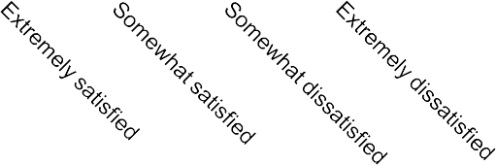No reason given.
  + Schedule, expensive, location
  + Interested in speaking (??)

Notes:

1. Based on responses to 2010 membership survey.

**Participation with ASCE-NCS is primarily focused around attending meetings of interest**

350

300

250

200

150

100

335

68

 The vast majority of members would like to participate with NCS by attending meetings. Reasons for such include educational/learning and networking opportunities.

 14% of respondents expressed interest in helping with outreach activities, while 8% are interested to help plan events and meetings.

 7-percent of respondents expressed interest in speaking at a future

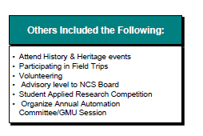event.

50 40 35

11 18

0

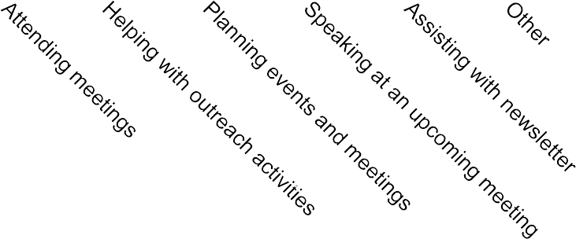

**Othersd theFollowing:**

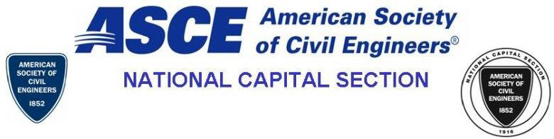

**Thank you for verifying the below information.**

|  |  |  |
| --- | --- | --- |
| **\***Work ZIP/Postal Code: |  |  |
| Home ZIP/Postal Code: |  |  |

**Which subject area(s) are of most interest to you?**



Environmental and Water Resources

Architectural Engineering



Construction

Coastal, Oceans, Ports and Rivers



Engineering Mechanics

Geotechnical Engineering



Structural Engineering

Transportation and Development



History and Heritage

Sustainability

|  |  |  |  |  |
| --- | --- | --- | --- | --- |
|  |  | Other: |  |  |

**Which benefit do you most like to get out of our section?**



Networking (e.g., meeting/socializing with fellow CE professionals)

Education/Learning (e.g., listening to speakers and topics of interest)

|  |  |  |  |  |
| --- | --- | --- | --- | --- |
|  |  | Volunteer opportunities | | |
|  | | |  |  |



Other

**Are you reimbursed for the costs of registering for ASCE-NCS events?**



No Yes

**Which day(s) do you least prefer to meet**



Monday

Tuesday



Wednesday

Thursday



Friday

Saturday



Sunday

**Which time(s) of day do you most prefer to attend events, irrespective of location**



Morning

Lunch



Afternoon

Evening

**Which location do you most prefer to meet (please choose up to three locations)?**



Washington, DC

Arlington



Alexandria

Tysons Corner



Bethesda

Rockville

|  |  |  |  |  |
| --- | --- | --- | --- | --- |
|  |  | Gaithersburg | | |
|  | | |  |  |



Other

**The main reason(s) I have not attended Section meetings in the past**



I do not have time to attend meetings when they are offered

The topics and/or speakers do not interest me



I do not receive information in a timely manner to put the meeting on my calendar

The meals are too expensive



The meetings are held outside of my local area and I am not willing to travel to attend

N/A

|  |  |  |  |  |
| --- | --- | --- | --- | --- |
|  |  | Other |  |  |

**If you were allowed to bring a guest or spouse to a meeting at a discounted fee (or at no charge), would this encourage you to attend a meeting?**



Yes

No

N/A

**What other industry/trade associations do you belong to? (list all that apply)**



American Academy of Environmental Engineers (AAEE)

American Association of State Highway and Transportation Officials (AASHTO)



Association for the Advancement of Cost Engineering International (AACEi)

American Institute of Architects (AIA)



American Institute of Chemical Engineers (AlChE)

American Nuclear Society (ANS)



American Planning Association (APA)

American Public Transportation Association (APTA)



American Society of Mechanical Engineers (ASME)

American Water Resources Association (AWRA)



American Water Works Association (AWWA)

Construction Management Association of America (CMAA)



Engineers without Borders (EWB)

Federal Water Quality Association (FWQA)



Geospatial Information and Technology Association (GITA)

Institute of Electrical and Electronics Engineers (IEEE)



Institute of Industrial Engineers (IIE)

International Association of Emergency Managers (IAEM)



National Ground Water Association (NGWA)

National Society of Professional Engineers (NSPE)



Society of American Military Engineers (SAME)

Society of Women Engineers (SWE)



Structural Engineers Association (SEA)

U.S. Green Building Council (USGBC)

|  |  |  |  |  |
| --- | --- | --- | --- | --- |
|  |  | Water Environment Federation (WEF) | | |
|  | | |  |  |



Other



**How do you rate your overall satisfaction with the ASCE-NCS?**

Extremely satisfied

Somewhat satisfied

Somewhat dissatisfied

Extremely dissatisfied

NA

**Please list any areas where the NCS needs improvement:**

**Please list any additional comments (positive or negative feedback):**

Cvent Web Surveys Software

Copyright © 2000-2010 Cvent. All rights reserve