Government Relations

3.2 Legislative Affairs Committee – Orange County Branch
1. Section/Branch | Orange County Branch
2. Section/Branch Size | Large
3. Project Contact
Name | Patrick Tierney
Phone Number | 508 – 367 – 9623
Email | Patrick.Tierney@mbakerintl.com
4. Project Category | Government Relations
5. Project Description | Reenergizing our Government Relations Committee
6. The Process  (What you did, When and How) | The Government Relations Committee is the advocacy arm of the Orange County Branch. Over the past two years the Government Relations Committee has hosted events to gain membership and grow expertise with government relations within our local region. By growing the committee, ASCE can better influence decisions that affect the civil engineering community.  The events described in this document include;  - Government Relations Committee Kickoff Meeting  - Legislative Fly-In 101 Workshop  - Office Meetings with Elected Officials – Congresswoman Katie Porter  - A Panel on SB1  - Super Tuesday Happy Hour  - Funding during COVID panel  To plan for these events the Committee established regular monthly meetings. We have found that having regular meetings encourages the team to actively be thinking about our next events. Meeting agendas included goal setting, discussion of recent policy events, updates from other ASCE groups, and ASCE Government Relations key contact information.  Government Relations Kickoff Meeting  The Government Relations Committee hosted a kickoff meeting at Karl Straus Brewery on April 24th, 2019 to discuss goals and establish early membership. Each attendee had different levels of experience with legislative affairs and ideas for the direction of the Committee. A contact list and vital connections for were established at the kickoff meeting. Attendees were asked to sign in and identify if they would like to be included in the initial committee email list. After the kickoff event, the committee continued to grow membership through networking at ASCE events and referrals.  A Panel on SB1  The Government Relations Committee partnered with the Transportation and Development Institute (TD&I) to host A Panel on SB1 on September 11th, 2019 at the UC Irvine University Club. The panel was moderated by Dina Rochford, Vice President at Leighton Group. Panelists were leaders from local transportation agencies,  - Jim Beil, Executive Director of Capital Programs at OCTA  - Ryan Chamberlain, District 12 Director at Caltrans  - And Nardy Khan, Deputy Director of Infrastructure Programs at OCPW  Senate Bill 1 (SB1) enacted gas tax collection throughout the State of California to increase funding for infrastructure projects. The bill was upheld through referendum before the panel event. Discussion centered around how these funds are applied to projects. In addition, panelists discussed agency directions independent of SB1 such as project delivery or complete streets. Overall, this event was a huge success because of the opportunity for ASCE members to network with leaders in the industry. Over 70 people attended to network and listen to the all-star panel. This event would not be possible without the partnership and leadership of the TD&I.  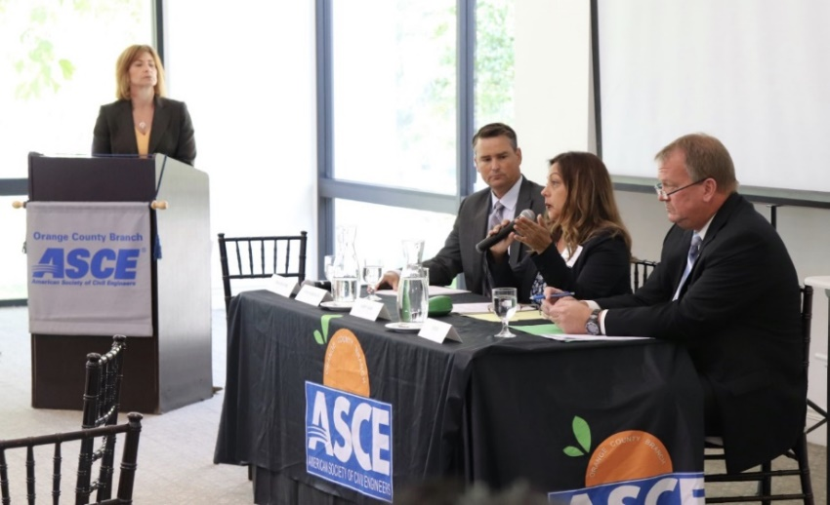  TD&I is a longstanding group with consistent membership and expertise on hosting events. Partnering allowed the Government Relations Committee access to a larger network and the opportunity to learn how to host events. When growing a committee, partnerships like this are critical for success.  A Panel on SB 1 - Panelist and Moderator at UCI  Legislative Fly-in Workshop  ASCE organizes annual trips to the State capitol in Sacramento and federal capitol in Washington DC. Attendees at these events receive training on government relations and visit their legislator’s offices to discuss infrastructure policies. These events are central to learning about advocacy at ASCE and an exciting opportunity to make connections. Due to high demand, attendees are selected through an application process.  The ASCE Government Relations Committee organized an informational session about the capitol visits to encourage members to apply. The event was hosted on October 30th, 2019 at the Michael Baker International office, before the application deadline for the Washington DC trip. At the event attendees were also briefed the ASCE Key Contact Program which provides essential government relations information.  Dinner was provided and about 10 people attended. The workshop was a fun way to connect with members and share insight on advocacy opportunities at ASCE. Unfortunately, the trips to Washington DC and Sacramento were canceled in the following year due to the COVID-19 pandemic.  Office Meetings with Elected Officials – Congresswoman Katie Porter  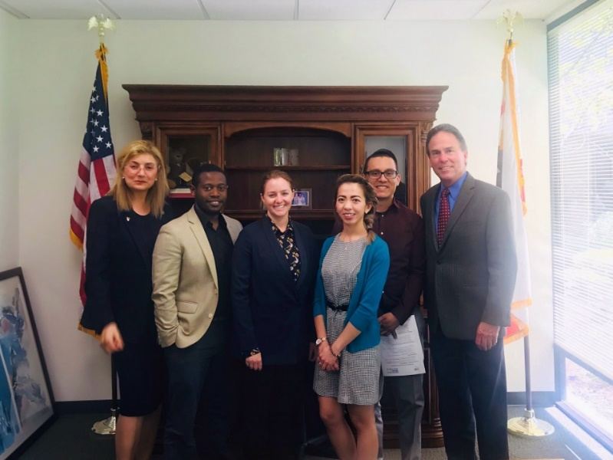  A proven way to build influence is to follow-up with connections. ASCE members extended connections made at capitol visits by organizing local office visits to deliver ASCE materials directly to policy makers. Local office visits can be more effective than capitol visits because elected officials want to hear from their local constituents the most. This is also a great opportunity to invite elected officials to ASCE events or ask to collaborate on future events.  ASCE Government Relations Team at Congresswoman Katie Porters office  A contact list of elected officials in Orange County was created with each legislator’s office location, district and contact information. Contact information was gathered from local office websites or from information received at past capitol visits to Sacramento and Washington DC.  Adeleine Tran lead an office visit at Congresswoman Katie Porters office in Irvine on May 22nd, 2019. The event was attended by other ASCE members and two of Katie Porters staff, the district director Kelley Jones and Senior Field Representative Karen Cohn. At this meeting the team shared the ASCE infrastructure report card, Save America’s Infrastructure App, Dream Big Movie and discussed opportunities for future collaboration on K-12 outreach activities.  Super Tuesday Happy Hour  Presidential election years are an exciting time in the United States. The Government Relations Committee harnessed some of that excitement by organizing a happy hour event at Carl Straus Brewery on Super Tuesday in 2020. Between 10 and 15 people showed up for beer, tacos and a discussion on Automated Vehicle policies lead by Robert Martinez.  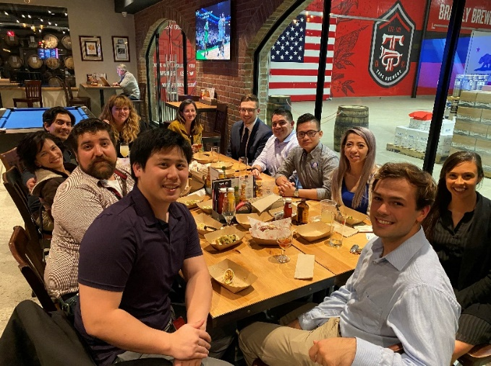  A reporter from the Washington Post surprised the group by attending the event and interviewed several attendees on their thoughts about Super Tuesday. The event was another fun way to connect with ASCE members and discuss government relations. The reporter showing up was an opportunity for members to practice speaking to press and gain exposure. Speaking to the press requires expertise to stay on message and handle each question with care.  ASCE Government Relations Committee on Super Tuesday  Funding during COVID panel  COVID-19 affected human life in almost every aspect, including government relations and the civil engineering industry. To help members gain insight on the impacts, the Government Relations Committee organized a panel discussion with ASCE policy experts. The panel was moderated by Dr. Cris Liban, Chief Sustainability officer at LA Metro. Panelists included;  - Caroline Sevier, Director of Government Relations at ASCE  - Kenneth Rosenfield, Assistant City Manager at City of Laguna Hills  - And Jeffery Cooper, Director of Infrastructure at Irvine NV5  The conversation centered around how COVID-19 has changed business practice and funding for civil engineering projects. It was also a calling for civil engineers to get more involved in policy discussions, to become more active in shaping the future. Hosting the event virtually over a zoom call was a unique challenge and may have helped attendance reach 40 people. This could not have been accomplished without the support from the ASCE Orange County Branch programs committee. The event highlighted the need to create partnership and utilize networks.  In conclusion, the ASCE OC Government Relations committee grew membership and branch members became more excited about advocacy. The happy hour events and panel discussions were effective in bringing members together to discuss policy. These events would not be possible without partnerships. The workshop on capitol visits helped engage members with ASCE Government Relations functions. Local legislative office visits were opportunities for members to directly advocate for the civil engineering industry and further develop connections from capitol visits. Preparation at monthly committee meetings and partnerships were essential for reenergizing the ASCE OC Government Relations Committee and more effectively advocate for civil engineering.
7. Those in Charge (Committee, Task Committee, Etc.) | The Section Government Relations Committee Co-Chair are;  - Adeleine Tran – Jacobs Engineering  - Patrick Tierney – Michael Baker International
8. Time Frame  (When Started, When Completed) | Fiscal Years (FY) 2018-2020 and is continuing in FY 2020-2021.
9. Success Factors  (The Parts that Worked Really Well) | Panel discussions, workshops and happy hour events were effective at informing members and growing interest in the government relations committee.
10. Setback Factors  (The Parts that did Not Work Well) | Consistent attendance at monthly meetings was difficult. Setting up local legislature visits was a challenge. Follow-up was not always completed or received a response. Also, several members interested in going to legislative capitol visits were not selected due to limited accepted applications.
11. Creativity  (This is something off the wall that we did) | Hosting the virtual meeting provided insight during uncertain times. Holding the happy hour during a political event, Super Tuesday, was added another level of excitement and attracted a new reporter.
12. Administration  (What was most Important?) | Hosting regular meetings to discuss events and other happenings in policy or at ASCE. Also attending other committee or professional organization events is helpful to form partnerships that can be utilized to accomplish goals.
13. Follow-Up  (What was most important?) | Once contacts have been established, continue to build the relationships by reaching out to them with invitations to events and new information.
14. Recommendations  (What you should ALWAYS do with this project?) | Have several planning meetings before events and make the events fun with happy hours or high-level networking opportunities.
15. Cautions  (What you should NEVER do with this project?) | Never present information if you are not prepared and always be respectful. Government relationships include risk because policies can have a high level of impact and rely on accurate information. If you do not understand an issue or know the answer to a question, it is best to say that you do not know, then follow up with prepared information afterwards. Government relations is political and political discussions can become emotional. Discussions often includes opposing viewpoints or sensitive topics. When there is a disagreement is it important to be respectful and listen to others when they express their viewpoints. Disrespectful or defensive tones can harm important relationships and should never be considered productive.
16. The Outcome | ASCE Orange County Branch members gained knowledge about advocacy and how government policy affects the civil engineering industry.
17. Ongoing Activity  (Would you do it again?) | Yes. These past efforts are being continued for FY 2020-2021 and beyond.
18. Speaker Contact Information
(person from your Region who would be willing to speak about the Best Practice)
Name | Patrick Tierney
Email | Patrick.Tierney@mbakerintl.com
Phone Number | 508 – 367 – 9623
19. Additional Comments

