Women in Construction Week – Orange County Branch Construction Institute

1. Section, Branch | Los Angeles Section, Orange County Branch, Construction Institute
2. Section/Branch Size | Large
3. Project Contact
Name | Maryam Takla
Phone Number | (818) 624-4680
Email | maryamtakla@gmail.com
4. Project Category | Membership Development, Professional Development
5. Project Description | ASCE Orange County Construction Institute was proud to host its first Women in Construction Week celebration after the success of the Women In Construction day event the year prior (2020).  In a week-long event that drew over 100 attendees, OC CI featured the 2021 Women in Construction week on March 8th to March 12th, with an event unique to each day . The theme of each evening was as follows: Skincare and Makeup Monday, Real Talk Tuesday, Women Empowerment Wednesday, Tech Talk Thursday, and Stretch & Flex Friday. Despite the use of a Zoom platform for all events, an interactive format was maintained through Q&A’s, fishbowl sessions, breakout rooms, and live tutorials to follow. The week incorporated 2 light hearted, fun events and 3 professional development events with a diverse group of speakers to ensure all attendees could resonate with at least one speaker.
6. The Process  (What you did, When and How) | - November, 2020 – Maryam Takla, ASCE OC CI Vice Chair, asked Melissa Hilsabeck, ASCE OC YMF President and Amber Shah, ASCE OC CI Past Chair, to assist in leading the Women in Construction Week events.  - Meeting 1 - Event proposal reviewed, revised and approved. Event  preparation timeline reviewed and approved for moving forward. Action items assigned.  - Meeting 2 - Sponsorship packages prepared. Contents include - Sponsor Info Packet, Event Concept Flyer, Sponsor Package Flyer

- Google drive folder created to store content for all days and preparation/planning documents.

- Sponsorship package reviewed and edited.

- December, 2020 –Sponsorship packets were distributed, speakers were secured.

  - Sponsorship packets distributed to last year’s participating companies and new construction companies.

  - Project Glimmer form submitted for Sephora gift boxes for first 50 signups.

  - Received $500 in funding from LA Section Joint meeting

  - Maryam secured Sephora makeup artist for Makeup Monday

  - Melissa secured yoga instructor, Natalie Jensen (ASCE OC) for Stretch & Flex Friday

  - Received makeup box goodies at the ASCE office

  - Meeting 3 - plan flyers and social media posts, review past and
assign new action items, review secured and needed speakers - Opened to YMF board members for volunteer opportunities

    - Flyers & Sticker Designs assigned to Clarissa Teng, YMF Communications Committee member

    - Eventbrite Setup assigned to Raul Rodriguez, YMF Internal Activities Co-Chair and Maryam Takla

- January, 2021 – Event concept flyer posted & Early Registration opens.

  - Event concept flyer shared on all social media to begin “the hype” and promote early registration late January
  - Meeting 4 - review secured and needed speakers for Tuesday,
Wednesday and Thursday events, draft scholarship applications,

- Scholarship applications assigned to Amber, Past CI Chair and Clay Walker, CI Chair to draft
- Eventbrite drafted and ready for sales beginning late January
  - Includes flyers & banners for every day event
  - Includes individual promo codes per company ex: Company40 - 40 free individual tickets
- Meeting 5 - Eric Warner, CI board member, confirmed Thursday
speakers, majority Tuesday speakers confirmed by team, Amy Griffin, CI board member secured Wednesday professional coach speaker. Looking at more items to include in the gift boxes
  - Melissa assigned to reach out to Chloe (LA YMF) as a potential intro for Wednesday
- Early Registration opened
- Meeting 6 - Scholarship form drafted

- February, 2021 – Normal Registration opens

  - Early Registration closes and Normal Registration opens

  - Meeting 7 - to address event needs still standing one month prior to event and tighten loose ends for social media blasts and marketing

  - Event info is shared on social media with speaker and scholarship info

  - Meeting 8 - Speaker gifts and budget review

  - Clarissa created themed presentation slides

  - Melissa picked up Sully Miller company swag

- March, 2021 – Gifts are sent out and WIC week is celebrated. “Lessons Learned” and “Best Practices”

  - Gifts for Early Registration are distributed through mail

  - Event is held. Surveys and recordings are distributed at the end of each event through recap emails.

- “Thank You” pdfs are sent to attendees (event recaps, sponsorships included) with a survey for the overall event

- Plus/Delta to review what went well and what can be improved for next year’s event.
7. Those in Charge  (Committee, Task Committee, Etc.) | Women in Construction Week planning committee: Maryam Takla, Melissa Hilabeck, Amber Shah, Clarissa Teng, Mario Martinez, Eric Warner, Amy Griffin, Natalie Jensen, Gyssela Quinabo, Esmeralda Briseno
8. Time Frame  (When Started, When Completed) | Started November 20, 2020 and completed March 12, 2021
9. Success Factors (The Parts that Worked Really Well) | Planning committee, Conference calls (action items), Google Drive, having a Facebook group chat  - All event documents were well organized  - quick messages to team
10. Setback Factors (The Parts that did Not Work Well) | We weren’t able to sync a calendar invite through Eventbrite to act as an automatic reminder with the zoom info.
11. Creativity  (This is something off the wall that we did) | Sent out recap emails after each day Raffle off panelist book recommendations
12. Administration  (What was most Important?) | Commitment dates to action items to have a realistic timeline and accountability
13. Follow-Up  (What was most important?) | Documenting “Lessons Learned”, Plus/Delta, and Sponsors list
14. Recommendations (What you should ALWAYS do with this project?) | - Start planning early  - Make sure everyone has someone who they can relate to on the panel  - Encourage men to attend the event  - If virtual Include zoom link info separately with calendar invite to speakers - send zoom link one week before and the day before/morning of the event  - Regular planning meetings
15. Cautions  (What you should NEVER do with this project?) | - Address issues that could potentially offend someone  - Indicate that women are better than men
16. The Outcome | Great learning and networking opportunity. It helped get our name out there as a  relatively new institute.
17. Ongoing Activity  (Would you do it again?) | Yes! So many lessons learned and still a lot of potential to grow. We may still be able to keep it week long (maybe not all of the days) and hoping to partner up with other organizations in the future. ie: SWE, NAWIC
18. Speaker Contact
Information

(person from your Region who would be willing to speak about the Best
Practice)
Name | Maryam Takla
Address | 16842 Hiawatha St. Granada Hills, CA 91344
Phone Number | (818)624-4680
Email | maryamtakla@gmail.com
19. Additional Comments | This Best Practice includes the following attachments:  - Event Flyers  - Event Recap

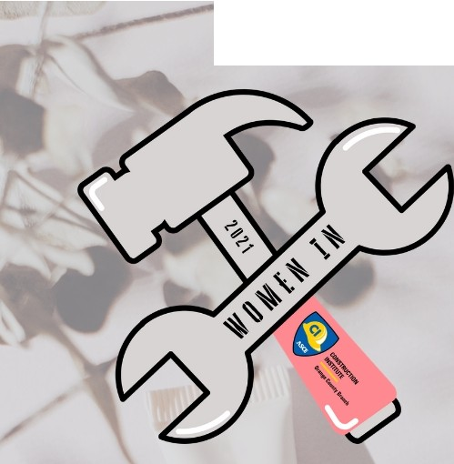
INTERNATIONAL
(t

DAY

CIINSiRUCTION
WHEN: MARCH 8, 2021AT 6:00 PM WHERE:ZOOM

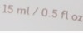MARIA LEHMAN, P.E., ENV SP, F.ASCE
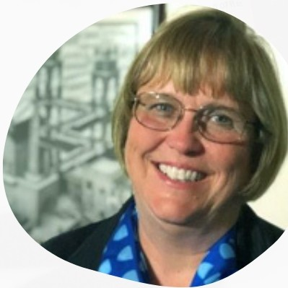
mR
MARIA LEHMAN, P.E, F.ASCE, ENV SP,. IS GHD'S
INFRASTRUCTURE MARKET LEADER FOR THE UNITED STATES SINCE MAY OF 2020. MARIA WAS THE FORMER VICE PRESIDENT FOR CRITICAL INFRASTRUCTURE FOR PARSONS, COO AND ACTING EXECUTIVE DIRECTOR OF THE NEW YORK STATE THRUWAY AUTHORITY AND COMMISSIONER OF PUBLIC WORKS FOR ERIE COUNTY, NY. SHE HAS 40 YEARS OF DIVERSE, INCREASINGLY RESPONSIBLE, MUL Tl- DISCIPLINARY TECHNICAL AND LEADERSHIP EXPERIENCE, BOTH IN THE PRIVATE AND PUBLIC SECTORS, AND IN

U.S. INFRASTRUCTURE
MARKET LEADER
GHD
TRADITIONAL AND ALTERNATIVE DELIVERY. SHE RECEIVED HER BS IN CIVIL ENGINEERING AT THE STATE UNIVERSITY OF NEW YORK AT BUFF ALO, MAGNA CUM LAUDE, AND IS A LICENSED PROFESSIONAL ENGINEER IN SEVERAL STATES.
SHE IS CURRENTLY THE NATIONAL TREASURER FOR THE AMERICAN SOCIETY OF CIVIL ENGINEERS (ASCE), AND IS A CURRENT CANDIDATE FOR NATIONAL PRESIDENT-ELECT OF ASCE.
REGlffllTION
\ '· 'l

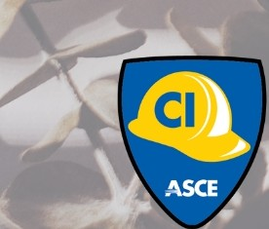
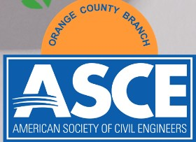
CONSTIIUCTION
INSTITUTE
Ol'lllp County Branch

[K{□ [ .[

t:ONSTRUCTIIIN
& MAKEUP

1®0000£1
WHEN: MARCH 8, 2021AT 6:00 PM WHERE:ZOOM

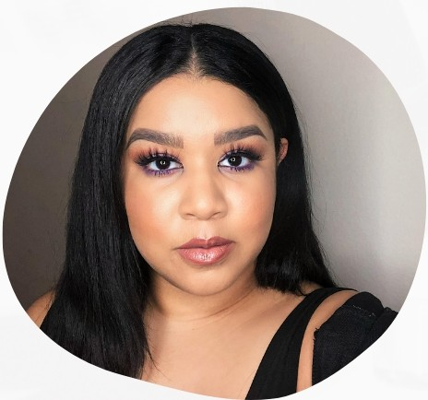
MAKEUP ARTIST
SEPHORA
CARMELLA DIAZ-LOLAR
CARMELLA DIAZ-LOLAR (FACE BY MELLA) IS KANSAS BORN, TEXAS RAISED AND CURRENTLY RESIDING IN LOS ANGELES, CALIFORNIA IN THE SAN FERNANDO VALLEY. SHE RECEIVED HER DEGREE AT AMDA; THE COLLEGE AND CONSERVATORY OF THE PERFORMING ARTS IN HOLLYWOOD IN 2012. CARMELLA HAS BEEN WORKING AS A MAKEUP ARTIST WITH SEPHORA FOR 5 YEARS. YOU CAN SEE HER LATEST WORK IN "UNCLE ED'S BUCKET LIST" ON AMAZON.

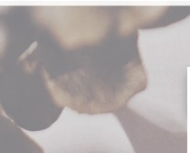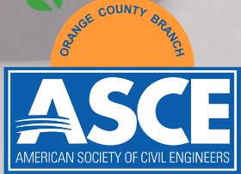
REGI IUTIIN
\
CONSTIIUCTION
INSTITUTE
Ol'lllp County Branch

IN:rERNATIONAL
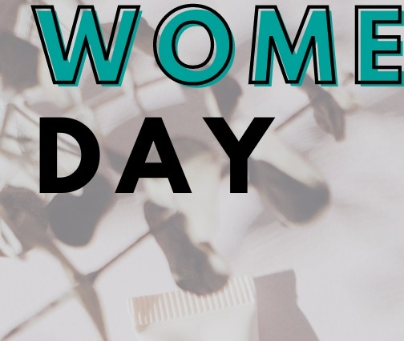
\t
[K{□OO [ J
& MAKEUP

WHEN: MARCH 8, 2021AT 6:00 PM WHERE:ZOOM

1 £W

JOIN US IN CELEBRATING INTERNATIONAL WOMEN'S DAY! WE WILL KICK-OFF THE EVENING WITH OUR KEYNOTE SPEAKER, MARIA LEHMAN, ASCE SOCIETY PRESIDENT-ELECT NOMINEE, AND HIGHLIGHT INSPIRING WOMEN IN HISTORY WHO HAVE PAVED THE WAY IN THE ENGINEERING AND CONSTRUCTION INDUSTRIES.

AS THE INDUSTRY CONTINUES TO SHIFT, WORK-LIFE BALANCE HAS BECOME A COMMON THEME. YOUR MENTAL, EMOTIONAL AND PHYSICAL WELL-BEING ARE IMPORTANT PIECES TO THAT BALANCE. INVESTING IN YOURSELF TO ACHIEVE THE TRIFECTA IS INDIVIDUALLY UNIQUE AND ONE EXAMPLE IS SELF-CARE THROUGH MEANS OF SKINCARE. WITH AN ENERGETIC SCHEDULE, YOU CAN STILL PAMPER YOURSELF BY ACING THE BASICS. WE WILL ROUND OUT OUR EVENING BY PROVIDING A SKINCARE 101 GUIDE FOLLOWED BY A FUN MAKE-UP TUTORIAL.

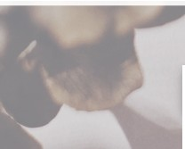
REGI IUTIIN
\
CONSTIIUCTION
INSTITUTE
Ol'lllp County Branch

[ J [L TALK
.-----.,
f 'I!'!'
.,
- ....
/ V.
j.R_U !))l)¼,

11 ,,
WHEN: MARCH 9, 2021AT 6:00 PM WHERE:ZOOM

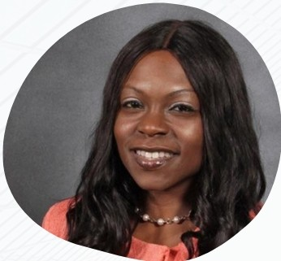
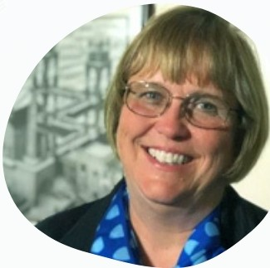
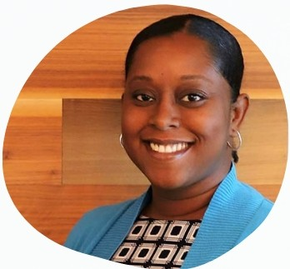
DR. GIOVANNA BRASFIELD MARIA LEHMAN, PE, ENV SP KAMECIA MASON

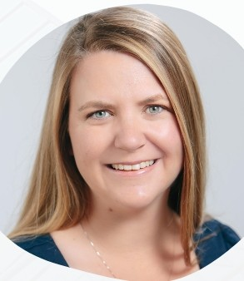
FLATIRON GHD MCCARTHY

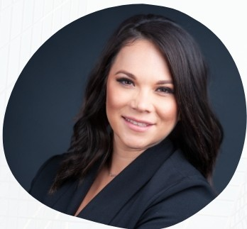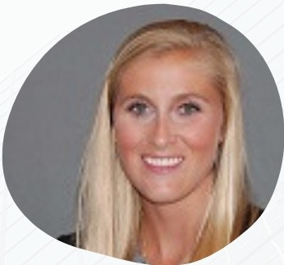

NATASSIA KNUTSON MARGARET DUFF

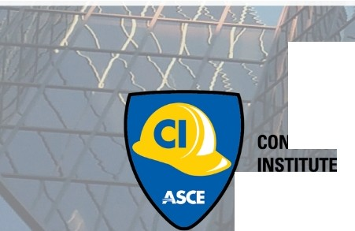
PROJECTSUPPORTSERVICES TURNER
If J
STRUCl10N

Ol'HII County Branch
AMY GRIFFIN

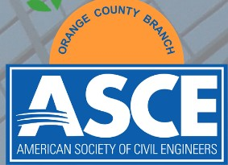
ORTIZ

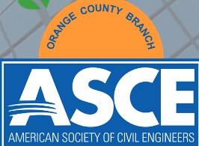
[ .[ [L
TALK

lm lii
WHEN: MARCH 9, 2021AT 6:00 PM WHERE:ZOOM

LET'S HAVE A CONVERSATION!
REGARDLESS OF PERSONALITY TYPES, THERE ARE SOME CONVERSATIONS THAT ARE DIFFICULT, PERIOD. MAYBE IT'S A CONVERSATION WITH YOUR CLIENT TO ASK FOR AN ADDITIONAL ADD SERVICE? MAYBE IT'S TALKING TO YOUR BOSS ABOUT WANTING TO TAKE ON MORE RESPONSIBILITY? OR PERHAPS IT'S NOT A CONVERSATION AT ALL, BUT A DESIRE TO CREA TE A MORE COHESIVE TEAM ENVIRONMENT?

TODA Y'S FOCUS WILL BE ENGAGING IN PROFESSIONAL RELATIONSHIPS AND CONFLICT RESOLUTION CONVERSATIONS IN SMALL BREAK-OUT GROUPS LEAD BY SOME OF OUR INDUSTRY LEADERS FOLLOWED BY A DIVERSE PANEL OF WOMEN.
IJnllteCNlltyBruch

l:ONSTRIICTIIIN
\W/@lMlrnOO
EMPOWERMENT

@00 @£W
WHEN: MARCH 10, 2021AT 6:00 PM WHERE:ZOOM

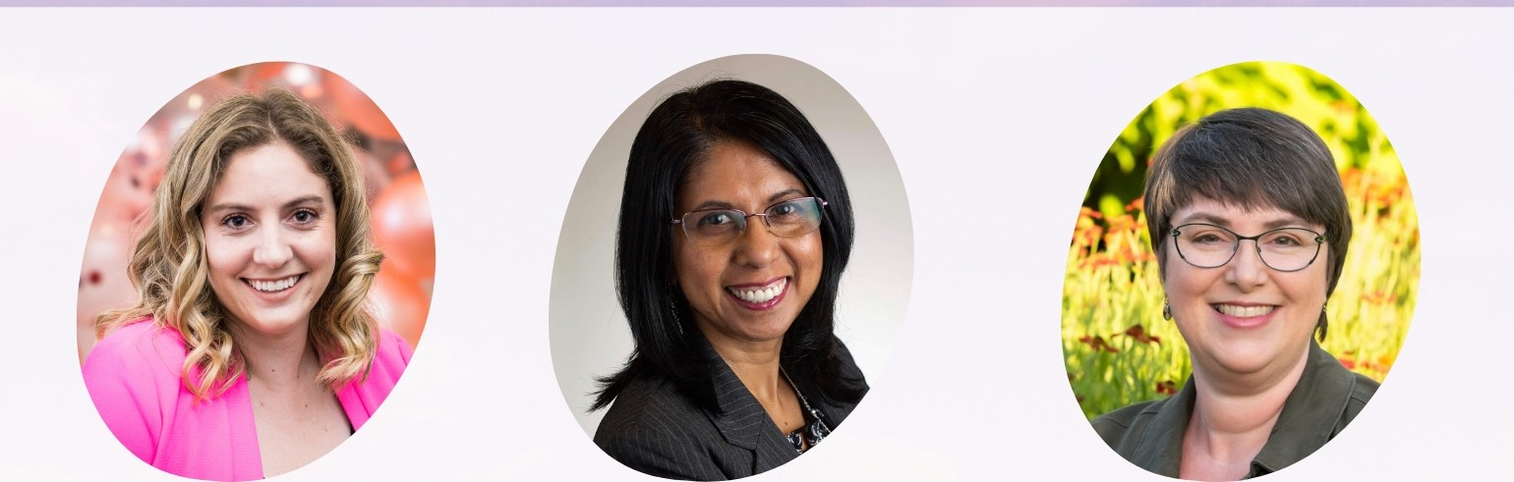
CHLOE GHARIOS, Ell SHARMIN BANU, MS, PCC BARBARA VISSER, CPCC, ACC
CIVIL DESIGN ENGINEER EXECUTIVE COACH LEADERSHIP COACH
LADWP INTERNATIONAL COACH INTERNATIONAL COACH
FEDERATION FEDERATION

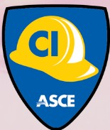
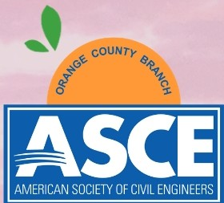
REGISTRATION

CONSTRUCTION INSTITUTE

Orange County Branch

l:ONSTRIICTIIIN
\W/@lMlrnOO
EMPOWERMENT

0000 @W£
WHEN: MARCH 10, 2021AT 6:00 PM WHERE:ZOOM

LEADERSHIP COACHING
IT'S TIME TO CREATE YOUR DREAMS INTO EXISTENCE! FROM THE CREATOR OF THE VIRAL STOMPING OUT STEREOTYPES HASHTAG COMES AN EMPOWERING PRESENTATION THAT PACKS A PUNCH OF CONFIDENCE. TODAY YOU WILL DISCOVER HOW TO ACHIEVE SUSTAINABLE EXCELLENCE BY LEARNING HOW TO BREAK DOWN YOUR GOALS, OPTIMIZING YOUR POTENTIAL, AND ADVOCATING FOR YOURSELF AS A LEADER. SPECIAL BONUS!! ONE ON ONE LEADERSHIP COACHING WILL BE AVAILABLE ON FRIDAY & SATURDAY. SOMETIMES YOU NEED TO BE YOUR BIGGEST CHEERLEADER AND THIS SESSION WILL GIVE YOU A FRESH BOOST OF INSPIRATION.

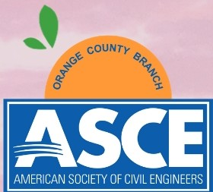
(

Washington State
Charter Chapter

CONSTRUCTION INSTITUTE

Orange County Branch

REGISTRATION

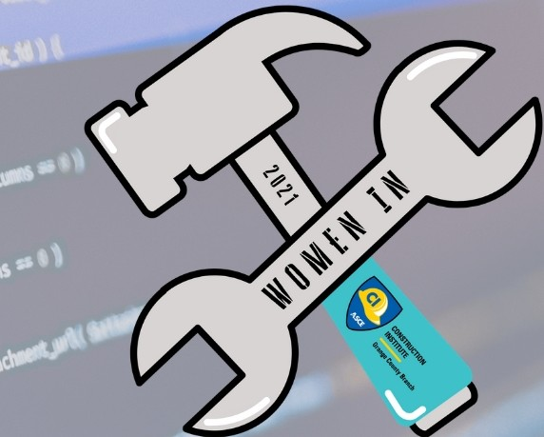

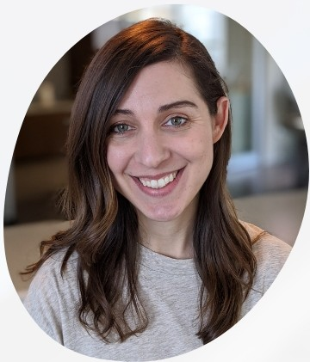
AMANDA WIETING SENIOR TECHNICAL ACCOUNT MANAGER
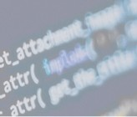BLUE' ll
CONSTRUCTION
WHEN: MARCH 11, 2021AT 6:00 PM
WHERE:ZOOM
,rrn rnl
TALK

noo IA\W

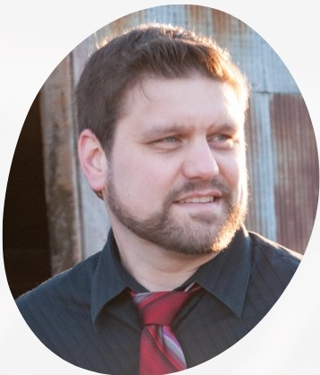
TROY DEGROOT CONSULTANT, INSTRUCTOR, & IMPLEMENTATION SPECIALIST
b., fR2

IEGISTIATIIN

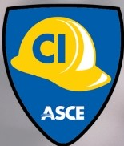
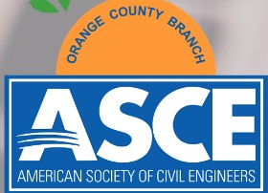
CONSTRUCTION INSTITUTE
Orange County Branch

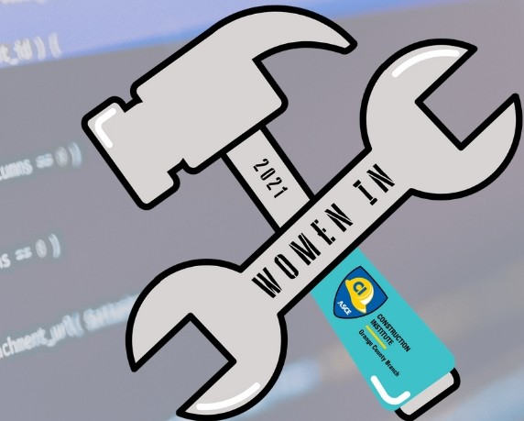
,rrn rnl
TALK

noo IA\W
CONSTRUCTION
WHEN: MARCH 11, 2021AT 6:00 PM
WHERE:ZOOM

BLUEBEAM TIPS & TRICKS
BLUEBEAM IS ONE OF THE MORE COMMONLY USED SOFTWARE TO COMPLETE DAILY ENGINEERING AND CONSTRUCTION TASKS. FROM CREATING PLANNING MARK­ UPS TO RESPONDING TO RFIS TO COLLABORATING WITH THE ENTIRE TEAM DURING A STUDIO SESSION. WHATEVER YOU DESIRE, BLUEBEAM CAN DO FOR YOU! SHARPEN YOUR TECHNICAL SKILLS AND LEARN THE TIPS AND TRICKS OF BLUEBEAM WITH AMANDA WIETING, SR. TECHNICAL ACCOUNT MANAGER WITH BLUEBEAM AND TROY DEGROOT, OWNER OF U CHAPTER 2 AND AUTHOR OF BLUEBEAMANDBURGERS.COM. THIS SESSION WILL INTRODUCE THE 5 KEY FEATURES THAT SEEM TO BE UNDER­ UTILIZED ACROSS REVU, ALONG WITH A FEW CUSTOM ESTIMATING EXAMPLES INCLUDING WINDOW ASSEMBLIES, REBAR QUANTITIES AND OCCUPANCY CALCULATIONS. WE'LL WRAP UP WITH A SNEAK PEAK OF WHAT'S COMING NEXT FROM BLUEBEAM, FEATURING MEMBERS OF BLUEBEAM'S PRODUCT TEAM.
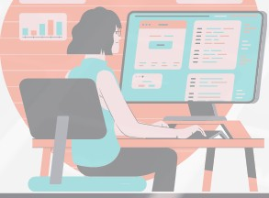I.!]

BLUEBEAM.
A NEMETSCHEK COMPANY

IEGISTIATIIN
rfj JU

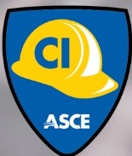
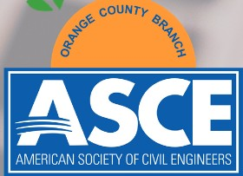
CONSTRUCTION INSTITim
Or11119 County Bra•h

CONSiRlll:illlN

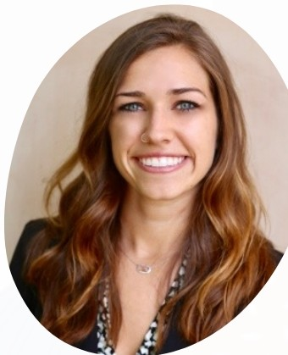

CIVIL ENGINEER
WSP

CONSTRUCTION INSTITUTE
-
Orange County Branch
ASCE
1f [ .[1f [H]
& FLEX

R £W
WHEN: MARCH 12, 2021AT 5:30 PM WHERE:ZOOM

NATALIE JENSEN, PE
NATALIE IS A CIVIL ENGINEER AT WSP. SHE RECEIVED HER YOGA SCULPT CERTIFICATION FROM COREPOWER YOGA (CPY) IN 2018. SINCE BEING HIRED AS A PART TIME YOGA INSTRUCTOR AT CPY, SHE HAS HOSTED HUNDREDS OF LIVE GROUP YOGA CLASSES. THIS YEAR, SHE VIRTUALLY LED HER WSP TEAM IN YOGA STRETCHES AT THE END OF THEIR LONG WORK DAYS. NAT ALIE HAS PLANNED A COMPLETELY UNIQUE CLASS FOR WIC WEEK, FOCUSING ON THE WORD "EMPOWERMENT".

WHAT TO BRING FRIDAY
- OPEN SPACE
- WATER
- TOWEL
- CHAIR
- MAT (OPTIONAL)

REGISTRATION

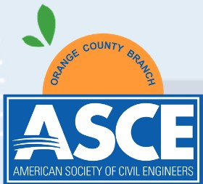

CONSiRlll:illlN
1f [ .[1f [H]
& FLEX

R £W
WHEN: MARCH 12, 2021AT 5:30 PM WHERE:ZOOM

STOP, DROP, FLOW
INHALE THIS WEEK'S ACCOMPLISHED MEETINGS. EXHALE ALL THE EMAILS THAT CAN WAIT TILL MONDAY.
START YOUR WEEKEND BALANCED AT HEART'S CENTER. YOUR HAMSTRINGS, BACK AND EYE SIGHT WILL THANK YOU FOR FINALLY GETTING OUT OF THAT COMPUTER CHAIR
AND BREATHING LIFE INTO YOUR LIGAMENTS. NAMASTE.

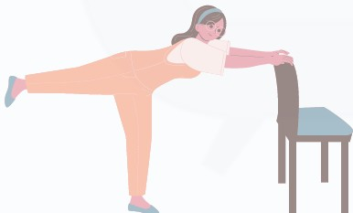

REGISTRATION
-

CONSTRUCTION INSTITUTE
ASCE

Orange County Branch

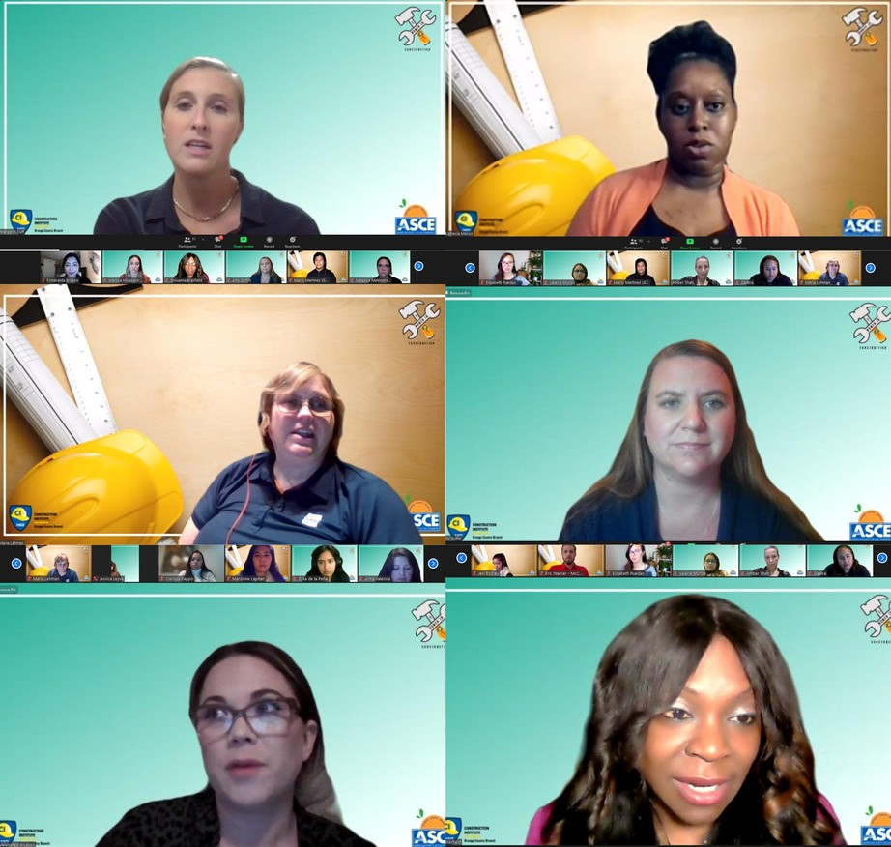
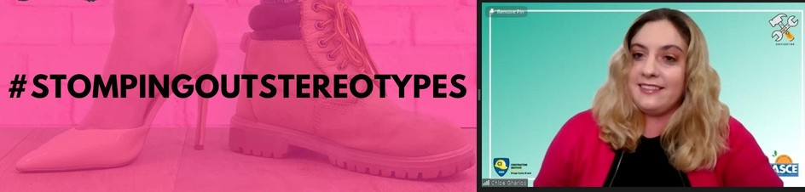
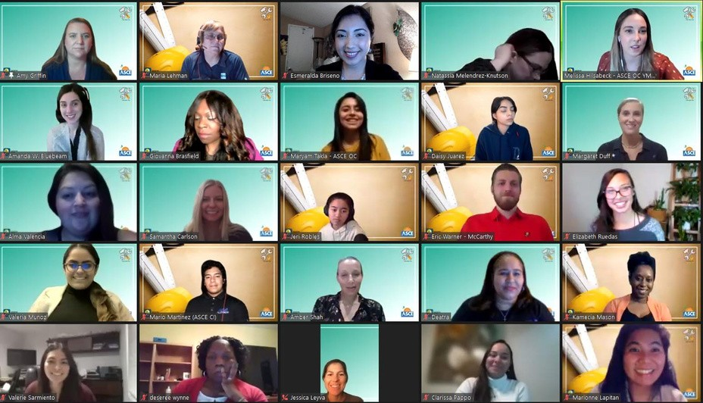
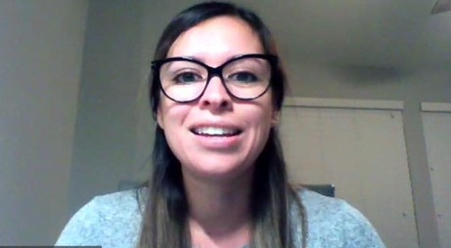
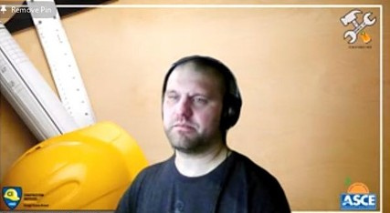
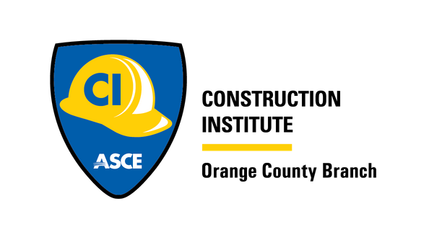
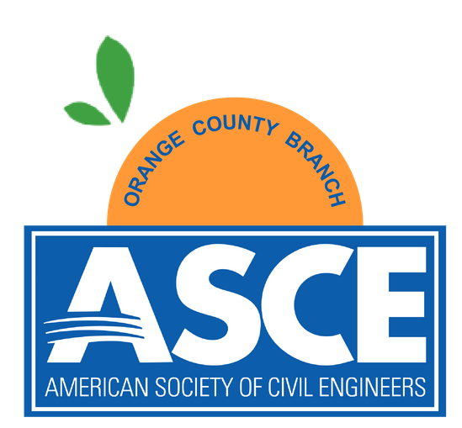

WOMEN IN CONSTRUCTION WEEK

2021 RECAP

THANK YOU FOR CELEBRATING WOMEN IN CONSTRUCTION WEEK 2021 WITH THE ASCE OC CONSTRUCTION INSTITUTE!
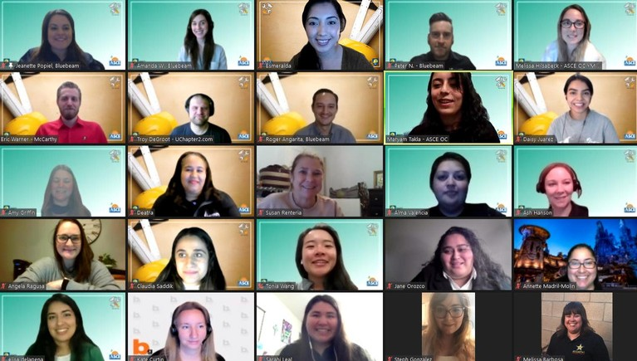
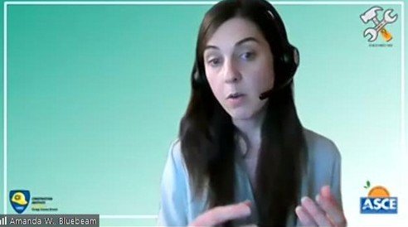
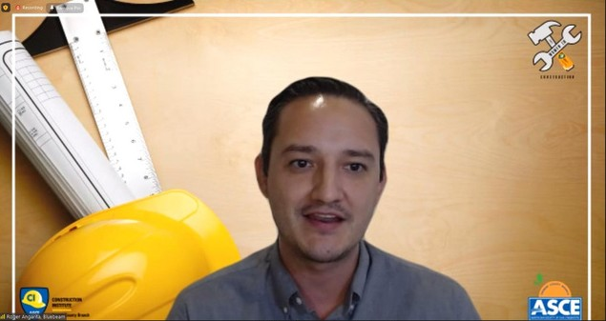
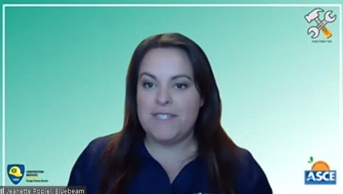
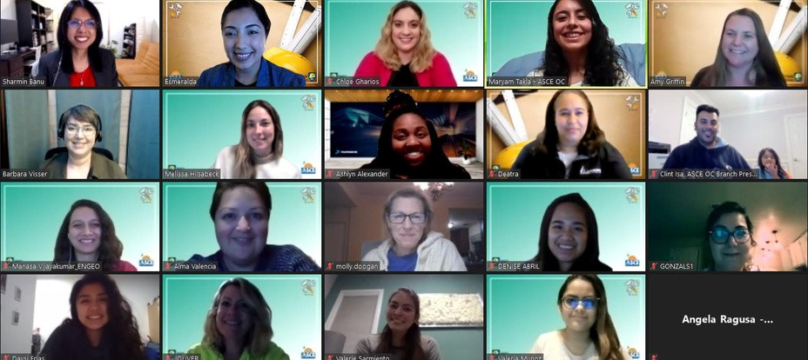
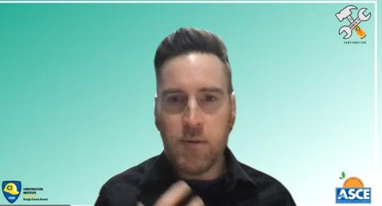
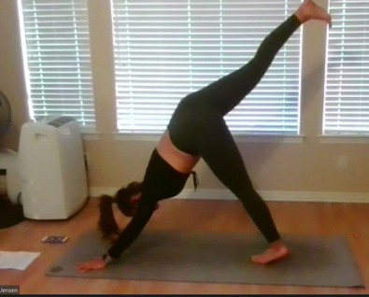
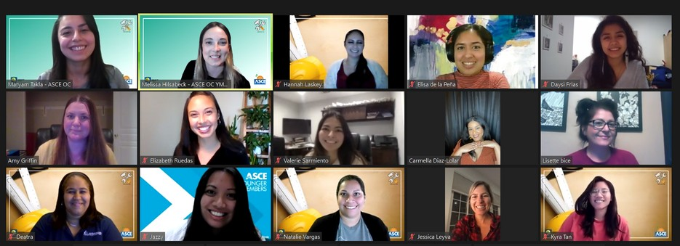
- W IC W E E K C O M M I T T E E

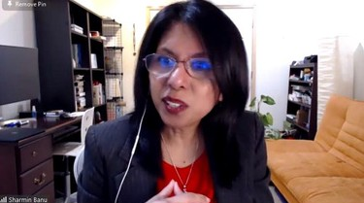
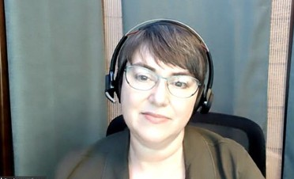

T H A N K Y O U T O O U R

INTERNATIONAL WOMEN'S DAY
SKINCARE & MAKEUP
MON
TALK
TUE

MARIA LEHMAN, P.E., ENV SP, F.ASCE
GHD

CARMELLA DIAZ-LOLAR
SEPHORA
DR. GIOVANNA BRASFIELD
FLATIRON
MARIA LEHMAN, P.E., ENV SP, F.ASCE
GHD
NATASSIA KNUTSON-MELENDREZ
PROJECT SUPPORT SERVICES

WOMEN EMPOWERMENT
WED

SHARMIN BANU, MS, PCC
ICF - WASHINGTON STATE CHAPTER

BARBARA VISSER, CPCC, ACC
ICF - WASHINGTON STATE CHAPTER
MAGGIE DUFF
TURNER

TECH TALK

THU
KAMECIA MASON
MCCARTHY
AMY GRIFFIN, PE
ORTIZ

STRETCH & FLEX

FRI

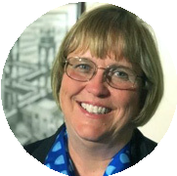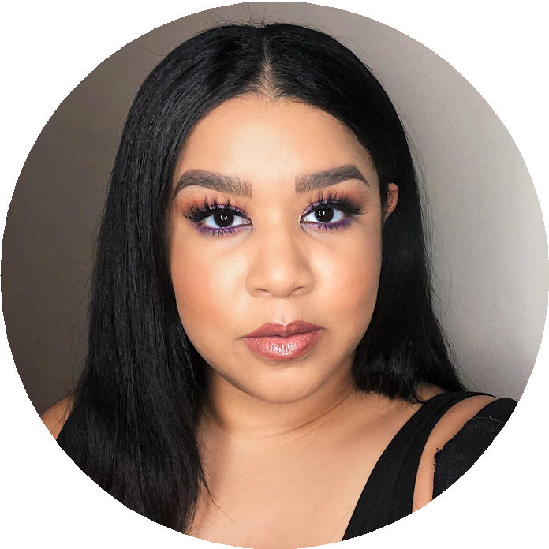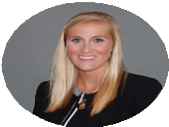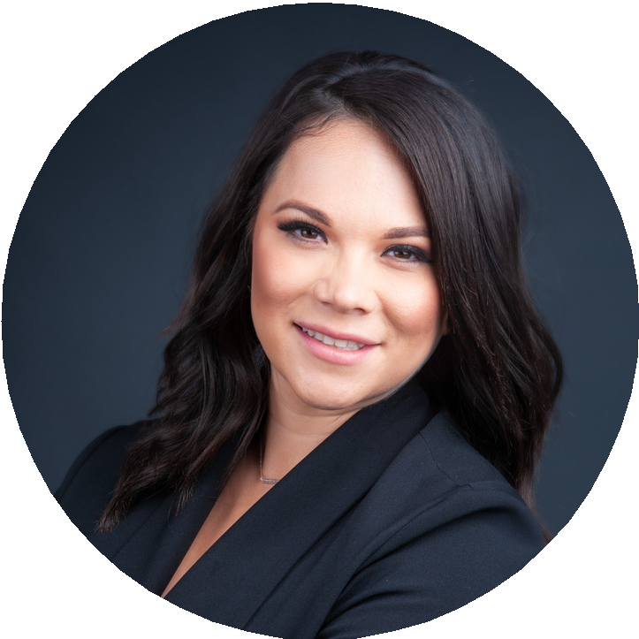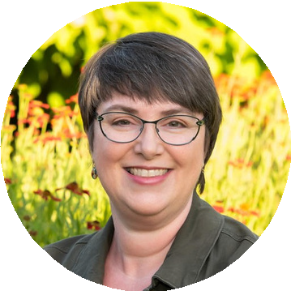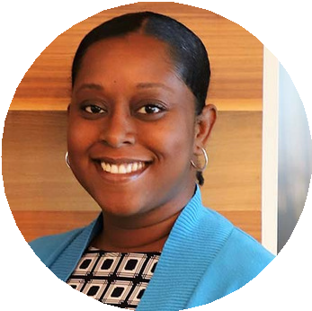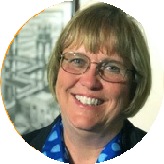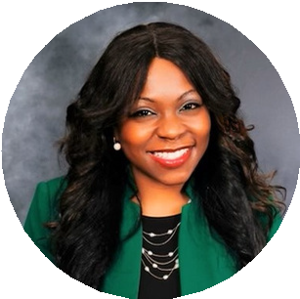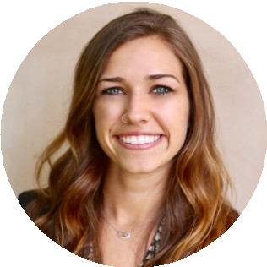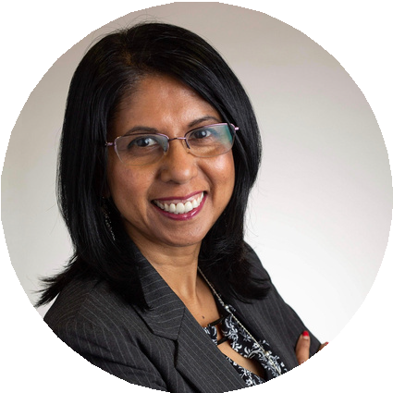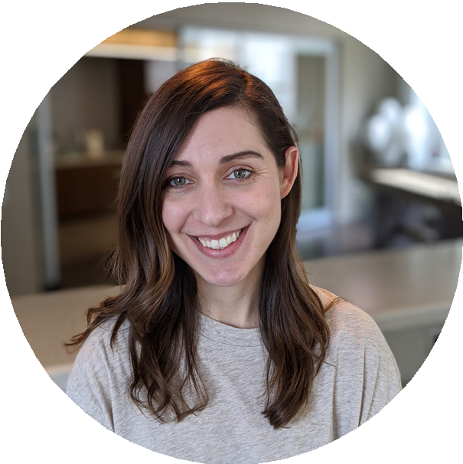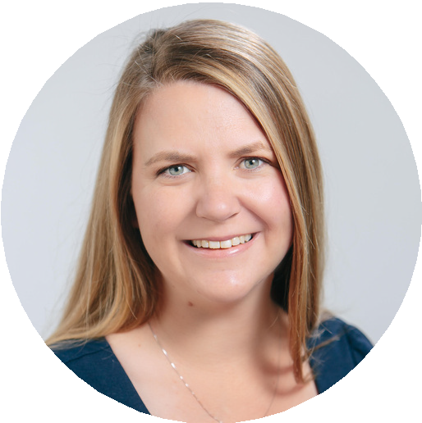CHLOE GHARIOS, EIT
LADWP
AMANDA WIETING
BLUEBEAM
TROY DEGROOT
UCHAPTER2
NATALIE JENSEN, PE
WSP

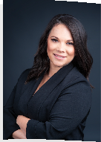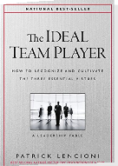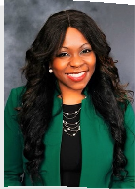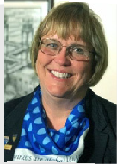

NATASSIA'S RECOMMENDATION: THE IDEAL TEAM PLAYER

WIC 2021 SPEAKER BOOK
RECOMMENDATIONS
BY PATRICK LENCIONI
DR.G'S RECOMMENDATION: HOW WOMEN RISW
BY SALLY HELGESEN
MARIA'S RECOMMENDATION: READY FOR TAKEOFF!
BY DEAN MILLAR

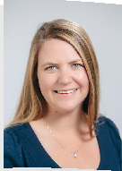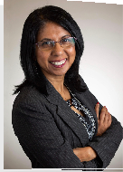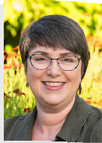

AMY'S RECOMMENDATION:
THE POWER OF VULNERABILITY BY BRENE BROWN
SHARMIN'S RECOMMENDATION: DESIGNING YOUR LIFE
BY BILL BURNETT & DAVE EVANS
BARBARA'S RECOMMENDATION: HAPPIER
BY TAL BEN-SHAHAR

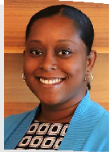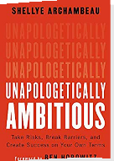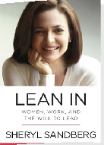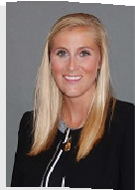

KAMECIA'S RECOMMENDATION: UNAPOLOGETICALLY AMBITIOUS BY SHELLYE ARCHAMBEAU
CHLOE'S RECOMMENDATION: LEAN IN
BY SHERYL SANDBERG
MAGGIE'S RECOMMENDATION: EDUCATED
BY TARA WESTOVER

WIC 2021 SCHOLARSHIP

RECIPIENTS

VALERIE SARMIENTO CAL POLY POMONA

MARIONNE LAPITAN CAL POLY POMONA

JERI ROBLES CAL POLY POMONA
SAFETY VEST RAFFLE WINNER:
JULIA VISHNEV

COURTESY OF

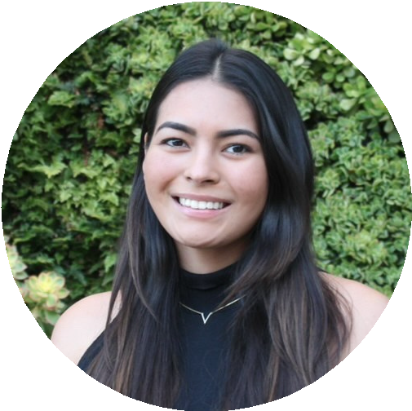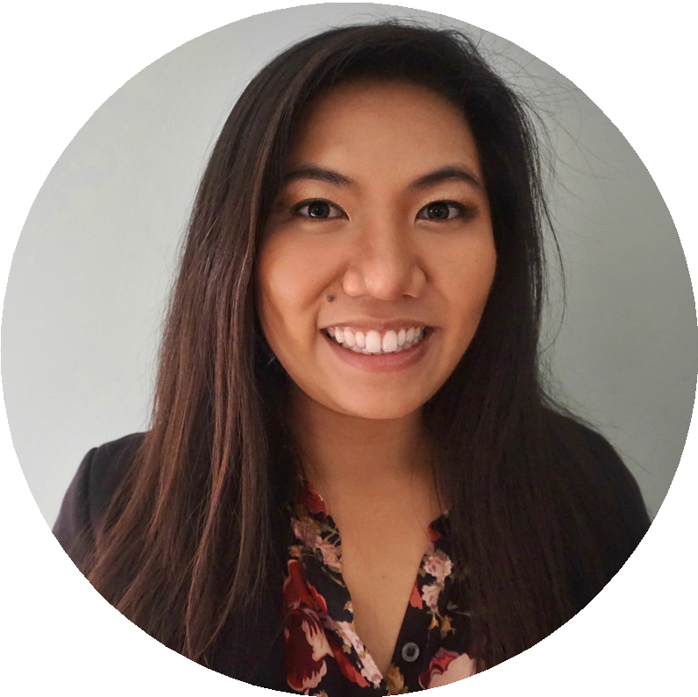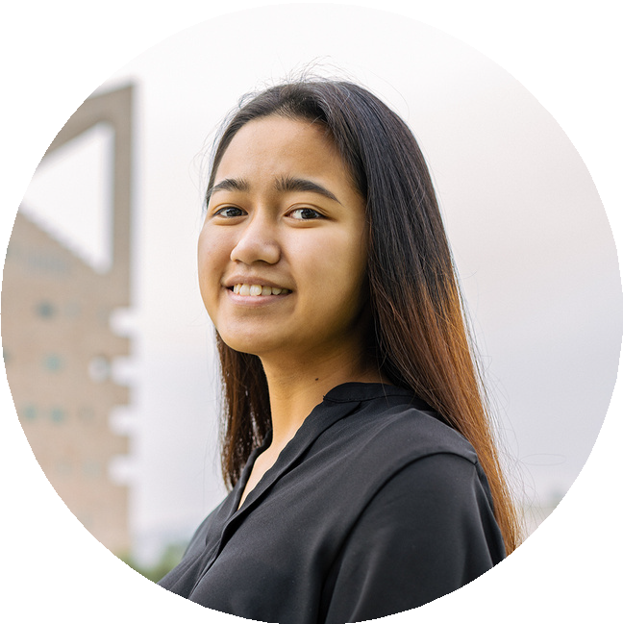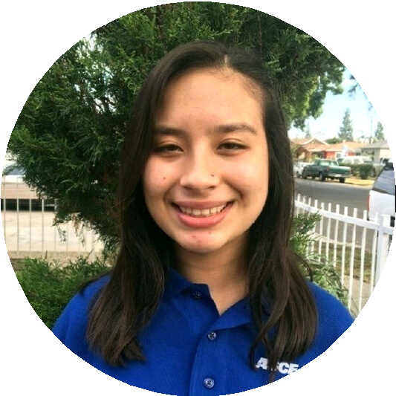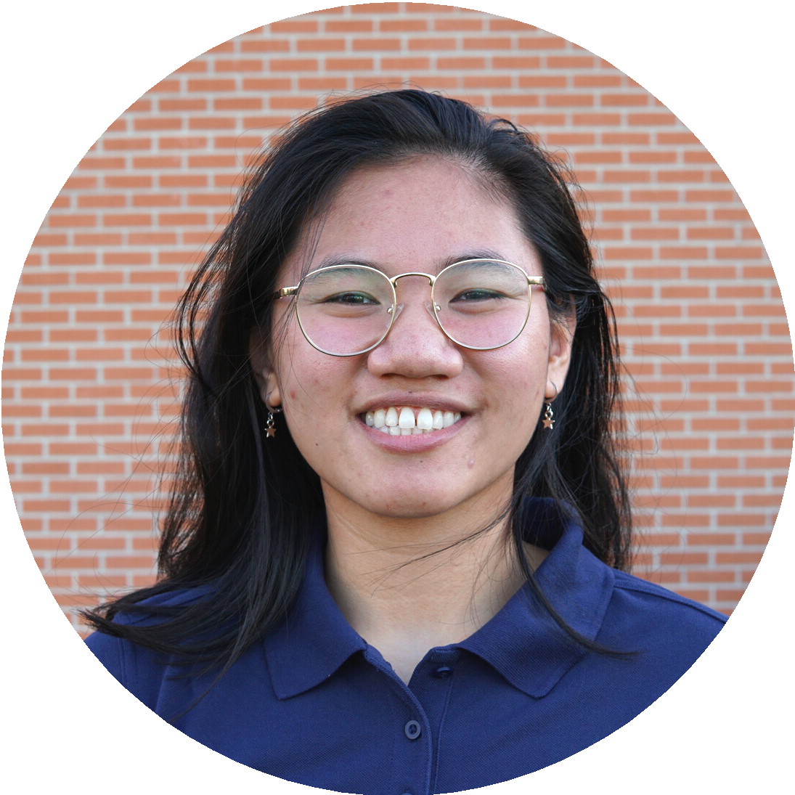MARIA MEDINA-MUNOZ UC IRVINE
KYRA TAN CSU LONG BEACH

T H A N K Y O U T O O U R

WIC WEEK 2021 COMMITTEE

GOLD SPONSORS

MARYAM TAKLA, EIT
WIC WEEK CHAIR TURNER

AMBER SHAH, PE
WIC WEEK CHAIR CITY OF LAGUNA HILLS

MELISSA HILSABECK, EIT
ASCE OC YMF PRESIDENT LPA

BRONZE SPONSORS
SILVER SPONSORS

MARIO MARTINEZ, EIT CLARISSA TENG, EIT
NATALIE JENSEN, PE
LISETTE BICE, PE

FLATIRON

GHD

WSP

ADURRA

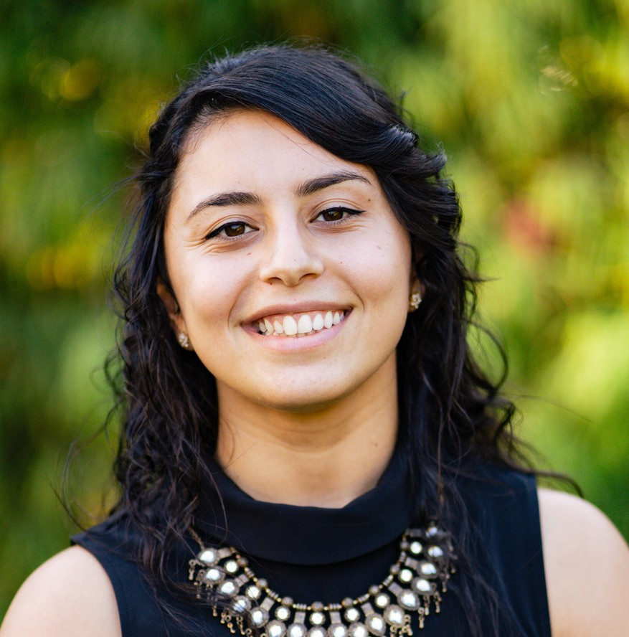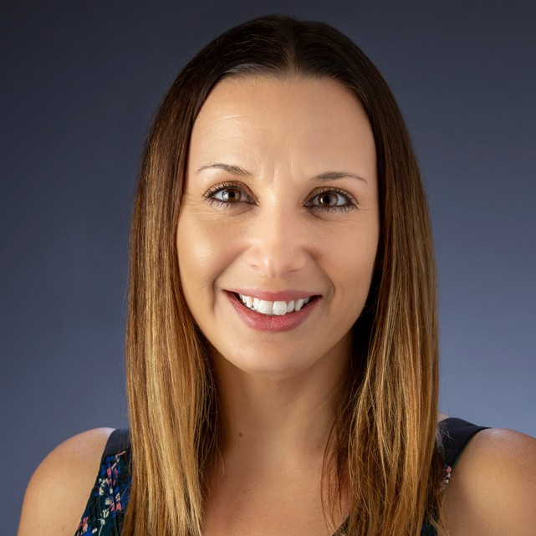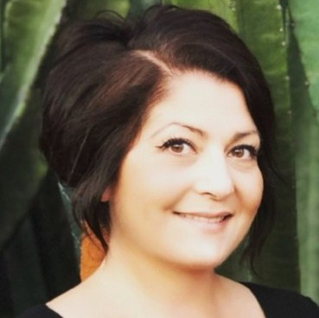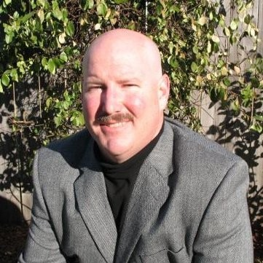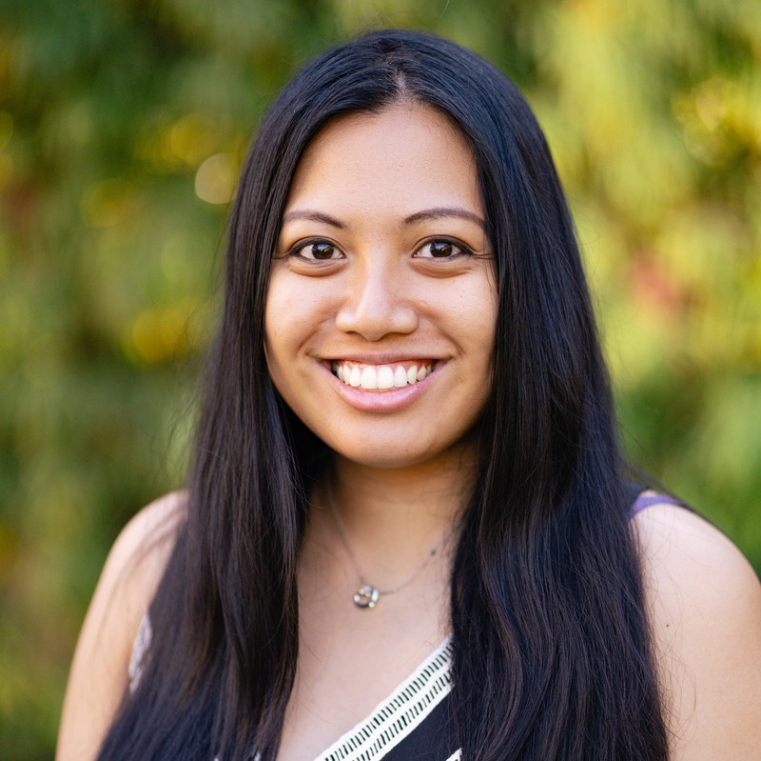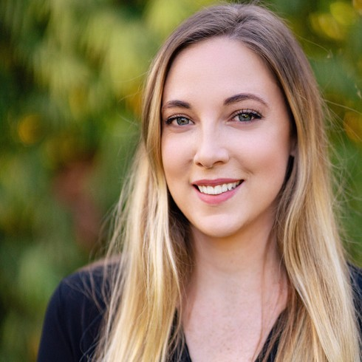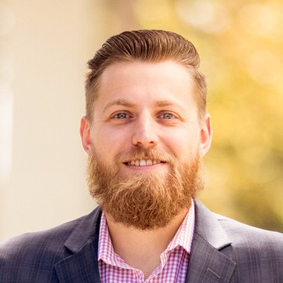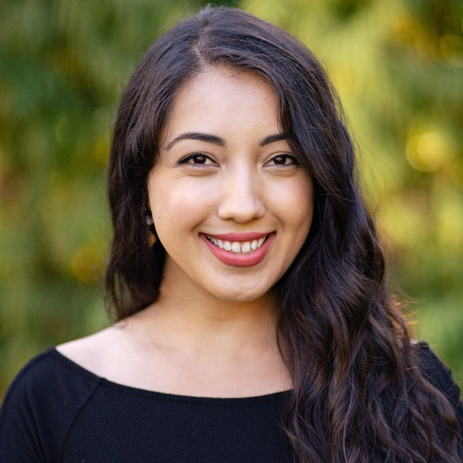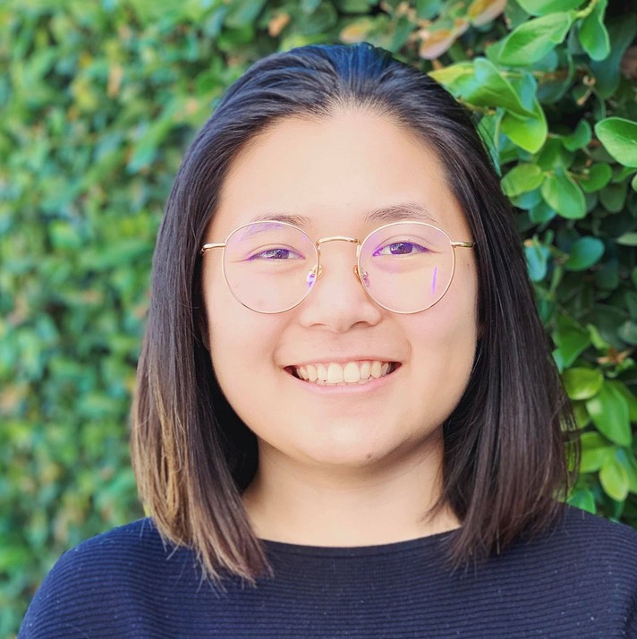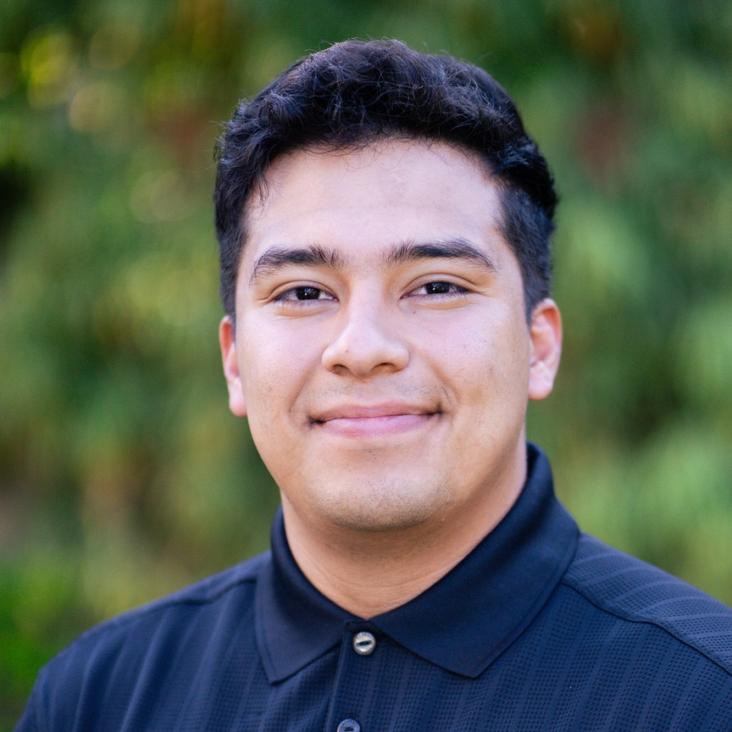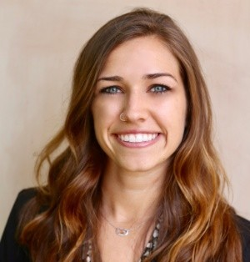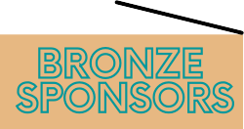ERIC WARNER, PE
MCCARTHY
CLAY WALKER, PE
HDR
JAZZY PRINCIPE
JACOBS
ESMERALDA BRISENO
JACOBS

