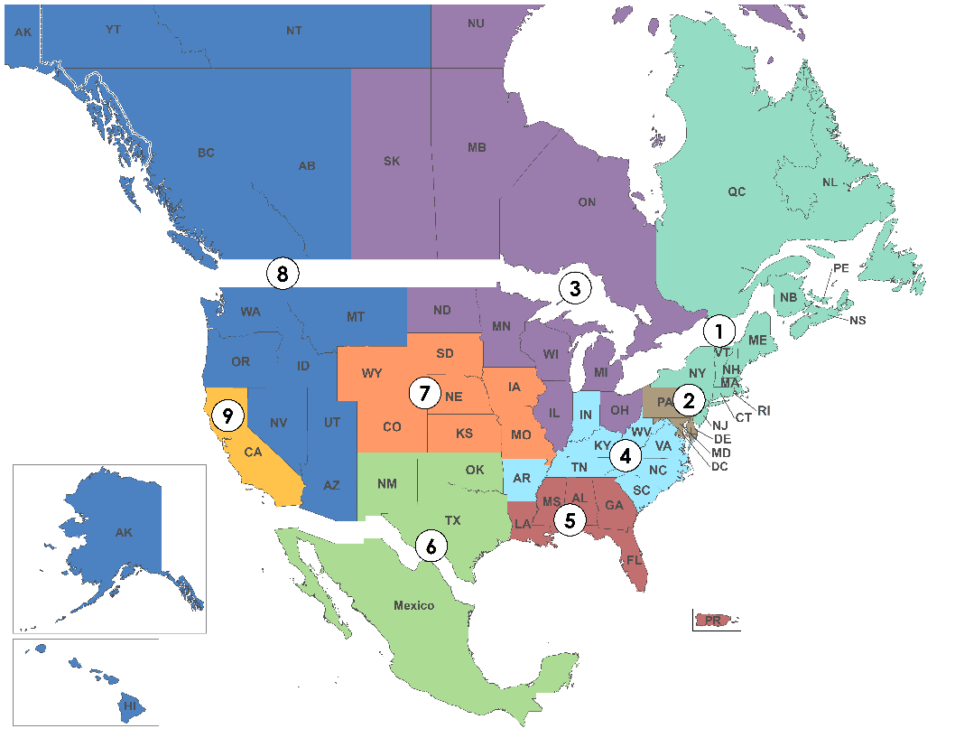
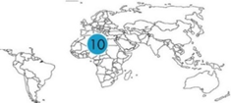
Sections
and
Branches

BEST PRACTICES GUIDE

Phone 1‐800‐548‐2723 - 1801 Alexander Bell Drive, Reston, VA 20191

Prepared by
Leader Training Committee

EXECUTIVE SUMMARY

The ASCE Leader Training Committee (LTC) has collected successful activities of Sections and Branches and compiled them into this Best Practices Guide. The purpose is to provide new ideas and activities that your Section or Branch can use to expand your program initiatives and support the mission, vision, and values of the Society. This summary provides information on how to effectively use the Best Practices Guide and contact information for comments or suggestions for future releases.

HOW TO USE THIS GUIDE

The guide currently includes multiple Best Practices organized into the following eight categories:
- Communications
- Continuing Education
- Government Relations
- Membership Development
- Section Operations
- K-12 Student Outreach
- College Student Outreach
- Public Outreach

Sections and Branches provided general information and instructions for their activities and have shared the outcomes. They also included changes they would make the next time they organize the same activity. Section and Branch contact information is listed for each activity if you should have any questions about a specific activity. Each Best Practice summary also indicates the general size of the Section or Branch that performed the activity.

ACKNOWLEDGEMENTS

The Leader Training Committee acknowledges all the Sections and Branches that submitted Best Practice summaries and the volunteers that assisted with the development of this document.

CONTACT INFORMATION

The Leader Training Committee is always looking for new Best Practices to include in its guide. The Committee plans to publish an updated version at least annually. If you have a Best Practice and would like to contribute to this guide or have any feedback or comments, please contact Nancy Berson at nberson@asce.org or at 703-295-6010. A Contact Summary of individual Best Practices follows the Table of Contents

