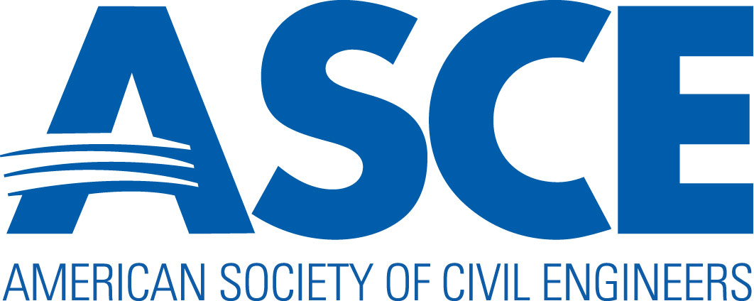

2025 OUTSTANDING SECTION / BRANCH AWARD NOMINATION FORM

INSTRUCTIONS

- An event/activity may only be used once and cannot be repeated throughout the application. Please select the most appropriate category. There are potential negative points for an event/activity that is repeated.

- Sections should NOT include activities completed by their Branches and Branches should NOT include activities completed by their Section.

- Applications are limited to 12 pages plus a copy of one newsletter.

- Point totals are listed under each category for a maximum of 125 points.

- Only list activities from October 1 – September 30 which can be either virtual or in-person.

- Please e-mail an electronic PDF file to Nancy Berson at ASCE: nberson@asce.org by October 30, 2025.

BASIC INFORMATION

Award Classification (check one): | Very Large Section/Branch (> 4000 members)  Large Section/Branch (1501-4000 members)  Medium Section/Branch (501-1500 members)  Small Section/Branch (< 501 members)
Section/Branch Nominee:
Name and Board Position of Contact Member:
ASCE Member ID:
Address:
Telephone:
E-mail:

NOMINATION QUESTIONS/SCORING
125 points maximum

A. COMMUNICATION WITH MEMBERS (15 Points Maximum)

- Newsletter (1 point per issue, 5 points maximum):
Please include one electronic newsletter with the Award nomination package or include a link to an active website. The links must be active to receive points for this section. Points will be given for the number of newsletters published either on the website, e-mailed to members or on social media.

Number of Newsletters Published Annually:
Newsletter Links (if available):

- Website (5 points maximum):
Verify that all links are active prior to submission.

Website Link:
Discuss the content included on your website:

- Social Media Tools (5 points maximum):
Provide screenshots in a separate document how you communicate with members on social media. The judges may ask you to give them access to your group/page to review if they are not public.

Discuss all active Social Media platforms and their title used to communicate with your Section/Branch

B. PROFESSIONAL / LEADERSHIP ACTIVITIES, AWARDS / RECOGNITION, SCHOLARSHIPS AND MENTORING (20 Points Maximum)

- Professional / Leadership (Non-Technical) Activities (5 points maximum):

Professional / Leadership (Non-Technical) Committee Meetings (1 point each, 2 points max)
Professional Committee: | Number of Meetings: | Presentation Topic(s):
(ie. YMF, History & Heritage, International Group)

Professional / Leadership (Non-Technical) Seminars (1 point each, 3 points max)
Date: | Approx. Attendees: | Presentation Topics / Describe Seminar:
(ie. Panel Discussion, Ethics Seminar)

- Awards/Recognition (1 point each, 5 points maximum):

Awards Given by the Section/Branch
Name of Award: | Recipient: | Describe:

Society Awards Received by the Section / Branch or its members
Name of Award: | Recipient: | Describe:

- Scholarships (5 points maximum):

Scholarships to High School Students (1 point each)
Name of Scholarship: | Amount of Scholarship: |  | Describe:

Scholarships to College Students (1 point each)
Name of Scholarship: | Amount of Scholarship: | Describe:

- Mentoring Activities of ASCE Members (5 points maximum):

Date: | Approx. Attendees: | Describe:

C. TECHNICAL COMMITTEES / INSTITUTE CHAPTERS AND ACTIVITIES (15 Points Maximum)

Section/Branch Technical Committees or Institute Chapters (minimum of 2 technical or virtual meetings per year; 1 point each, 5 points max)
Technical Committee: | Number of Meetings: | Presentation Topic(s):
(ie. Institute Chapters, Transportation Committee)

Section/Branch Technical Seminars / Courses with PDHs (1 point each, 5 points max)
Date: | Approx. Attendees: | Describe:

Other Technical / Educational Activities and Benefits for Section / Branch Members (1 point each, 5 points max)
Describe other technical / educational activities and benefits for Section / Branch members: | (for example: hosting a user group for technical software used by Members)

D. MEMBERSHIP (10 Points Maximum)

Describe efforts to involve Student Members in Section/Branch Activities (2 points):
Describe Member recruitment programs (2 points):
Describe Member retention programs (2 points):
Describe any recognition programs for employers supporting ASCE (2 points):
Describe other Membership Activities / Events (2 points):

E. PUBLIC OUTREACH ACTIVITIES (10 Points Maximum)

Describe outreach activities with elementary, middle, or high schools (1 point each, 5 points max):
Describe outreach activities via media outlets (1 point each, 3 points max): | (examples: newspaper, magazine, radio, TV, internet, billboards)
Describe other public outreach or educational activities (1 point each, 2 points max):

F.COLLEGE OUTREACH ACTIVITIES (20 Points Maximum for entire section) – CHOOSE #1 or #2.

- Section/Branch has an ASCE Student Chapter(s)

List each Student Chapter and at least one current Practitioner Advisor for each school. Note if you have less than 5 schools in your Section/Branch. (2 points each if five schools or more, 10 points maximum).
Describe Student Interaction Activities between each ASCE Student Chapters and the Section/Branch (2 points each, 10 points max): | (examples: Joint Section/Branch and student meetings, joint social activities, webinars/presentations given to students)

- Section/Branch does not have any ASCE Student Chapter(s)

Describe outreach activities with college students other than those involved with ASCE (5 points each, 20 points max): | (examples: hosting an event for community college students or undeclared engineering majors at a university)

G. COMMUNITY SERVICE, PUBLIC SERVICE, HISTORY & HERITAGE, SUSTAINABILITY, AND GOVERNMENT RELATIONS (10 Points Maximum)
NOTE: ASCE also awards a History and Heritage Award. If you have such activities and want to be considered for that award, describe those activities here and submit a nomination form for the award by November 30th If you have any questions, please contact Jennifer Lawrence at jlawrence@asce.org.
Describe public service projects (2 points): | (examples: Habitat for Humanity, Engineers Without Borders)
Describe History and Heritage Activities (2 points): | (examples: landmark nominations, publications, exhibits)
Describe Government Relations activities (2 points): | (examples: infrastructure report card, legislative drive-in)
Describe Sustainability Seminars held by the Section/Branch promoting the advancement of the principles of sustainable development (2 points): | (examples: long term infrastructure sustainability, local environmental initiatives, waterfront revitalization, LEED)
Describe Community Service events (1 point each, 2 points max):

H. DIVERSITY, EQUITY, AND INCLUSION (15 Points Maximum)
ASCE fosters a fully inclusive culture that celebrates individual uniqueness, engenders a sense of belonging, and promotes equitable opportunity for all people to participate as members and stakeholders of the civil engineering community. ASCE’s Committee on “Members of Society Advancing an Inclusive Culture” reviews this section to select Outstanding Section/Branches for their efforts in developing and implementing programs that promote an equitable and inclusive climate in the profession.
Inclusive Events - What best practices has your Section/Branch implemented to ensure meetings/events are equitable and inclusive for all prospective participants? (1 point each, 5 points max): | (examples: arrange accommodations for members with special needs such as childcare and language translation; host meetings at an accessible venue, check meeting dates to avoid conflicts with major religious holidays
Leadership & Engagement - In what ways has the Section/Branch/Group demonstrated a commitment to DEI? (1 point each, 5 points max): | (examples: Create a DEI Committee, increase diversity in leadership positions, promote awareness of best practices, hold joint activities with other engineering professional organizations for underrepresented populations such as AISES, NSBE, SHPE, SWE, etc. and promote underrepresented student participation in STEM programs and schools with a high minority populations
Inclusive Communications and Training - In what ways does your Section/Branch ensure that communications with and about members and partners are inclusive and asset-based and discuss how you Section/Branch supports DEI related training and programs? (1 point each, 5 points max): | (Examples: Closed-captioning for virtual meetings; check newsletters before publication for use of inclusive language and colorblindness interpretation; deliberately include communications from diverse perspectives; availability of paper copies upon request; examine how to make communications as accessible to students as they are to life members and sponsor DEI training)

I. ADDITIONAL SECTION / BRANCH ACTIVITIES (10 Points Maximum)
Describe any other non-standard activities that are not covered under other sections of the nomination form that your Section or Branch has undertaken to promote or advance the Civil Engineering profession to either your members or the public. Note that Sections applying for the award should not include their Branch activities and vice versa for Branches. These can include other Community Service projects, hosting of Regional meetings, fundraising, mentoring, and other best practices. Describe the activity and give dates, locations and number in attendance. Also describe any activities relative to the creation of a Section / Branch strategic plan and/or efforts to support the Society’s Strategic Initiatives (ie. sustainability efforts). These activities may also be eligible for the Leader Training Committee Best Practices Manual. A maximum of two (2) points will be given for each of up to five (5) non-standard activities.

Type of Activity/Event/Initiative: | Date (if applicable): | Describe:

