Public Outreach

8.8 Toys for Tots Holiday Social – Vermont Section
1. Section, Branch | Vermont Section
2. Section/Branch Size | Large
3. Project Contact
Name | Jordan Duffy
Phone Number | (802) 497-6100
Email | jduffy@vhb.com
4. Project Category | Public Outreach
5. Project Description | Toys for Tots Holiday Social: Combined Holiday Social event, joint meeting with other Engineering society, and Toys for Tots charity event.
6. The Process  (What you did, When and How) | A few weeks before the winter holidays we run an early evening social event on a weekday evening. The holiday social is a benefit for Toys for Tots. People who attend receive one free drink tickets to be redeemed at the bar in exchange for donating a toy to Toys for Tots. After the social event the toys are donated to a local charity organization arranged through the Toys for Tots organization. The event is informal, no RSVP required, a time range where people can drop in and out, and general mingling atmosphere. We have chosen a popular restaurant in our more densely populated part of the state to hold the event. We invited another engineering society to co-host this event with us to promote inter-organization mingling. Our younger member group is the official host of the meeting and the student chapters are also invited.
7. Those in Charge (Committee, Task Committee, Etc.) | Younger Member Committee Chair person, with help from the other members of the Section BOD. Advertising is typically handled by the Section President who sends out the newsletters.
8. Time Frame  (When Started, When Completed) | Typically start in October to begin to discuss the event and pick the best dates. November lock in the date with the venue, contact Toys for Tots to secure the donation box and drop off location, and advertise the event using our newsletter.
9. Success Factors  (The Parts that Worked Really Well) | We made it clear in the advertising that people did not need to be drinking alcohol at this event. The Toy donation was exchanged for a drink ticket and that ticket was redeemable for any of the beverages. Our advertising included that they had a popular locally made non-alcoholic root beer on tap also. I think this made more students feel comfortable attending the event as well.
10. Setback Factors  (The Parts that did Not Work Well) | One year we tried holding this on a Friday evening, two weeks before Christmas. That was a very poor choice in evenings because there were many other holiday events that night – including many local employers. The turnout that night was lower than other years. The Friday night scheduling was due to a double booking on the original night that we had planned the event. We will be holding this event on Tuesday, Wednesday or Thursday nights (Thursday seems best for our group).
11. Creativity  (This is something off the wall that we did) | Giving away “free” drinks. But if you didn’t bring a toy to donate, you had to buy your own.
12. Administration  (What was most Important?) | Co-hosting this event with the Vermont Society of Engineers has worked very well. The cost of the drinks is split with them to lower the operating cost of this event. Co-hosting also exposes our student and younger members to a broader range of engineers that are not only in the Civil Engineering field.
13. Follow-Up  (What was most important?) | Getting the collected toys to the drop off location in a timely manner to make sure that they are ready for distribution. Our donation location and organization have always been arranged ahead of time. Toys for Tots has lots of information on their website: http://www.toysfortots.org/donate/Default.aspx
14. Recommendations  (What you should ALWAYS do with this project?) | Make sure that the event space understands what type of event they will be hosting. We have set this up so that we have a small area of the bar (near the fireplace with couches) to mingle. The bar understands that our group will be mingling in that area. We also arrange ahead of time a ticket system. When someone arrives, they are handed a ticket in exchange for the donated toy. The bartender takes those tickets and adds the ordered drink to a running tab to be paid by our treasurer at the end of the night. Making sure that the establishment is ok with this setup is important to avoid any awkward situations or lack of available space.
15. Cautions  (What you should NEVER do with this project?) | Drink and Drive.
16. The Outcome | Great evening of inter-organization and inter-age socialization with the added bonus of many toys being donated to a local organization in time for the holidays.
17. Ongoing Activity  (Would you do it again?) | DEFINITELY. This has been a very successful event for the last four years that we have been running it.
18. Speaker Contact Information  (person from your Region who would be willing to speak about the Best Practice) | Many other members of our Section have also participated and helped host this event. I am submitting this form on behalf of the section.
Name | Jessica Louisos
Address | c/o Milone & MacBroom, Inc.  1 South Main Street, 2nd Floor  Waterbury, Vermont 05403
Phone Number | (802) 578-2016
Email | jessical@miloneandmacbroom.com
19. Additional Comments | This Best Practice includes the following attachments:  - Photos of the event  - Event flyer

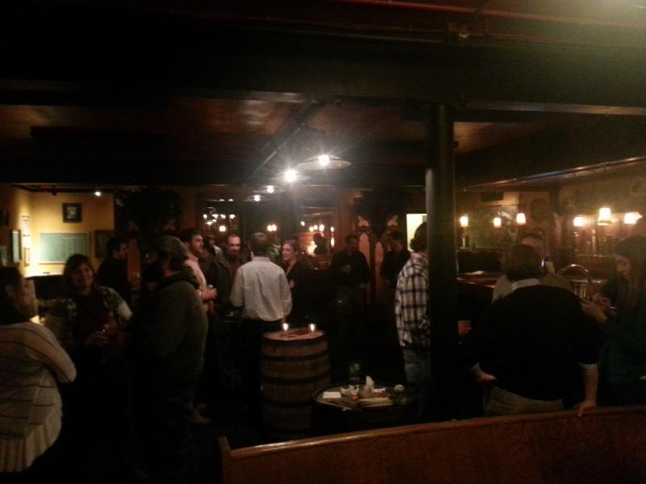
Mingling at the 2013 Holiday Social
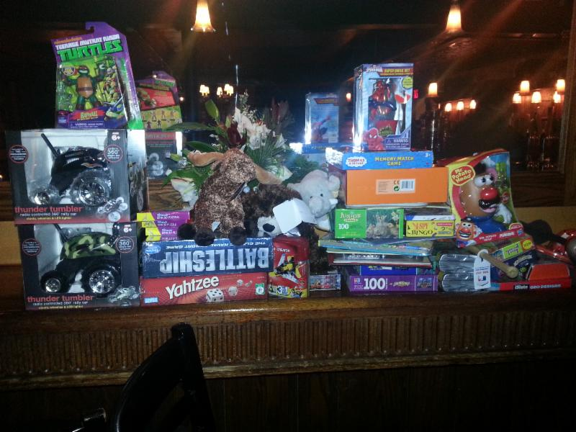
Toys collected during the 2013 event and donated to Toys for Tots.
