Public Outreach

8.7 Engineering Billboards – Connecticut Section/CSCE
1. Section, Branch | Connecticut Section/CSCE
2. Section/Branch Size | Large
3. Project Contact
Name | Jason Waterbury
Phone Number | (860) 278-7850 (ext. 3380)
Email | Jwaterbury@themdc.com
4. Project Category | Public Outreach
5. Project Description | Billboard Campaign
6. The Process  (What you did, When and How) | CSCE has sponsored two billboard campaigns. The first campaign was in April 2011, and the second campaign was in November 2011. The intended message for both campaigns was to raise public awareness as to what a Civil Engineer does and the impacts Civil Engineering has on the general welfare of the public. The executive board developed multiple designs, and contacted multiple local billboard vendors. Due to billboard availability and pricing, CBS Outdoor was selected. Each campaign included 10 billboards, located on State of CT Roads, throughout the state. In addition, a SPAG Grant was obtained for the initial campaign, which contributed $1,500 of the $5,000 cost for that particular campaign. Attached is the Billboard Summary Report for the November 2011 Campaign, which includes duration, locations, and photos of each billboard. Example photos of the April 2011 campaign are also attached.
7. Those in Charge (Committee, Task Committee, Etc.) | CSCE Executive Board
8. Time Frame  (When Started, When Completed) | April 2011 & November 2011
9. Success Factors  (The Parts that Worked Really Well) | Involvement of the entire Executive Board, and buy-in by CSCE members.
10. Setback Factors  (The Parts that did Not Work Well) | It is suggested to have the billboard designs established prior to signing a contract with the vendor. We did not do this for the November campaign, and it did create some frustrations with our vendor (CBS Outdoor).
11. Creativity
(This is something off the wall that we did)
12. Administration  (What was most Important?) | Coordination with billboard vendor.
13. Follow-Up  (What was most important?) | Spot-checking billboards by executive board members.
14. Recommendations  (What you should ALWAYS do with this project?) | Involve as many board members, and Section/Branch Members as possible. Also communicate what you are doing to your Section/Branch members to make sure they are aware of the Value being provided by the Section/Branch leadership.
15. Cautions  (What you should NEVER do with this project?) | Do not do this alone, as a one-man show. The task is too big for one person.
16. The Outcome
17. Ongoing Activity  (Would you do it again?) | Yes – CSCE is currently planning on multiple campaigns in the upcoming 2012- 2013 to build on the momentum provided by the previous two billboard campaigns. Currently in consideration for Future Campaigns is the Failure to Act study conducted by ASCE.
18. Speaker Contact Information
(person from your Region who would be willing to speak about the Best Practice)
Name
Address
Phone Number
Email
19. Additional Comments | This Best Practice includes the following attachments:  - Billboard summary report  - Photos

Conn. Society of Civil Engineers
Outdoor Display Detail
Face # | Description | Posting Market | Scheduled Dates | Sched. Days | Show. Days Over. Days P. Type | Area | Media | Ill. | F | 7-day EOI, 18+ DEC ('000s)

Summary
Name: | Conn. Society of Civil Engineers | Duration: | 10/31/2011 - 11/27/2011 | Sales Contact Info
CBS Contract #: | 1062342 | # Contracted Units: | 10 | Thomas Novinsky
Advertiser: | Conn. Society Civil Engineers | # Posted Units: | 10 | T: 203-985-0430
Agency: |  | Total Scheduled Days: | 280 | F: 203-985-0420
 |  | Total Showing Days: | 71 | tom.novinsky@cbsoutdoor.com
 |  | Total Override Days: | 0

000121P-O | New Haven Av 500 ft W/O Buckingham N/S | Hartford/New Haven | 10/31/2011 - 11/27/2011 | 28 | 8 | 0 | Regular | New Haven County | Posters | Y | E | 42,530 | 10.66
 | Design | Posted Date | Covered Date
 | Fix Infrastructure | 11/1/2011
000268P-O | Fitch St 25 ft W/O Onyx St N/S | Hartford/New Haven | 10/31/2011 - 11/27/2011 | 28 | 7 | 0 | Regular | New Haven County | Posters | Y | W | 24,615 | 8.37
 | Design | Posted Date | Covered Date
Fix Infrastructure 11/2/2011
000341P-O | Washington Ave 1500 ft N/O I-91 E/S | Hartford/New Haven | 10/31/2011 - 11/27/2011 | 28 | 8 | 0 | Regular | New Haven County | Posters | Y | S | 59,771 | 14.98
 | Design | Posted Date | Covered Date
 | Fix Infrastructure | 11/1/2011
000403P-O | Post Rd 50 ft W/O Jackson Dr N/S | Hartford/New Haven | 10/31/2011 - 11/27/2011 | 28 | 8 | 0 | Regular | New Haven County | Posters | Y | W | 47,321 | 16.10
 | Design | Posted Date | Covered Date
 | Fix Infrastructure | 11/1/2011
000557P-O | Post Rd & Old Kelsey Point S/S | Hartford/New Haven | 10/31/2011 - 11/27/2011 | 28 | 8 | 0 | Regular | Middlesex Country | Posters | N | E | 19,434 | 4.71
 | Design | Posted Date | Covered Date
 | Fix Infrastructure | 11/1/2011
000622P-O | Rt 17 1000 ft W/O Rt 77  E/S | Hartford/New Haven | 10/31/2011 - 11/27/2011 | 28 | 7 | 0 | Regular | Middlesex Country | Posters | N | S | 11,316 | 2.84
 | Design | Posted Date | Covered Date
 | Fix Infrastructure | 11/2/2011
000734P-O | Riverside St 400 ft S/O Bank St W/S | Hartford/New Haven | 10/31/2011 - 11/27/2011 | 28 | 5 | 0 | Regular | New Haven County | Posters | Y | N | 11,551 | 2.71
 | Design | Posted Date | Covered Date
Fix Infrastructure 11/4/2011

CBS Outdoor hereby certifies the accuracy of this electronically generated report, which may be relied on as if it were signed by hand and attested to by a duly authorized signatory.
Conn. Society of Civil Engineers

Outdoor Display Detail
Face # | Description | Posting Market | Scheduled Dates | Sched. Days | Show. Days Over. Days P. Type | Area | Media | Ill. | F | 7-day EOI, 18+ DEC ('000s)

000751P-O Rt 85 2000 ft N/O
Chesterfield Rd E/S
Hartford/New Haven
10/31/2011 - 11/27/2011 28 6 0 Regular New London
County
Posters Y N 28,259 9.61

Design Posted Date Covered Date
Fix Infrastructure 11/3/2011

001034P-O Center St 400 ft E/O N. Main Hartford/New
10/31/2011 - 11/27/2011 28 7 0 Regular Hartford County Posters Y W 16,580 3.88

St S/S
Haven

Design Posted Date Covered Date
 | Fix Infrastructure | 11/2/2011
001093P-O | Rt 202 325 ft W/O Walnut St S/S | Hartford/New Haven | 10/31/2011 - 11/27/2011 | 28 | 7 | 0 | Regular | Litchfield County | Posters | N | W | 13,315 | 3.34
 | Design | Posted Date | Covered Date

Fix Infrastructure 11/2/2011

CBS Outdoor hereby certifies the accuracy of this electronically generated report, which may be relied on as if it were signed by hand and attested to by a duly authorized signatory.

Page 2 of 13 Generated on: 11/8/20
Conn. Society of Civil Engineers

Contract Map
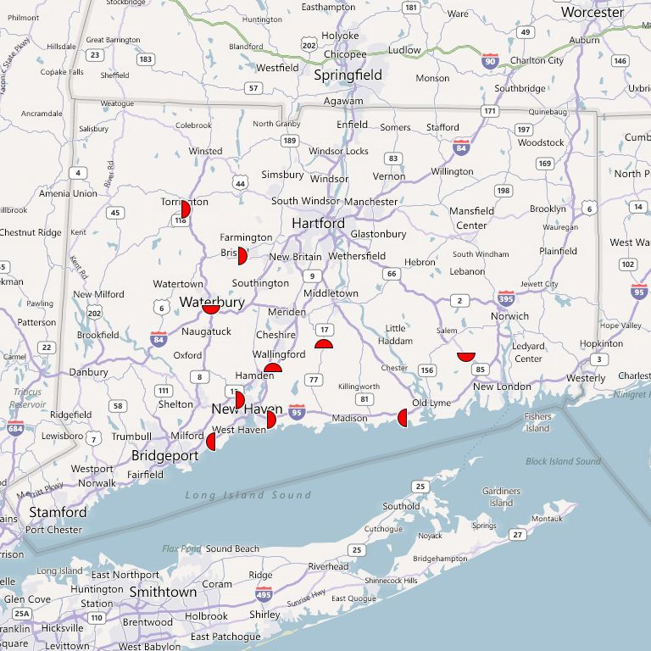
Legend

Posters

CBS Outdoor hereby certifies the accuracy of this electronically generated report, which may be relied on as if it were signed by hand and attested to by a duly authorized signatory.

Page 3 of 13 Generated on: 11/8/2011

Conn. Society of Civil Engineers

Face # 000121P-O - New Haven Av 500 ft W/O Buckingham N/S
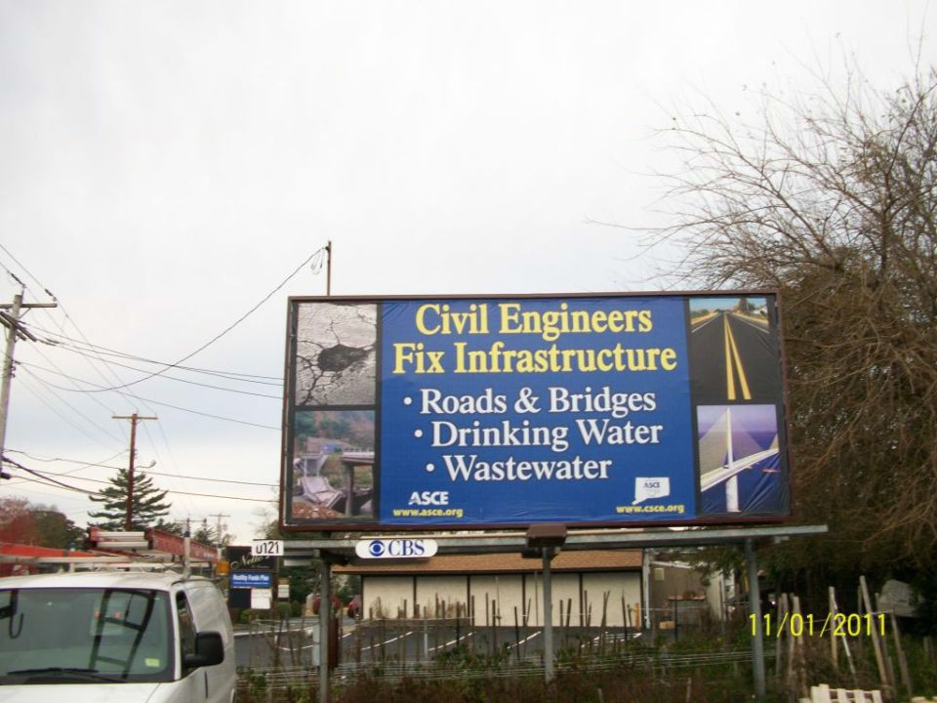
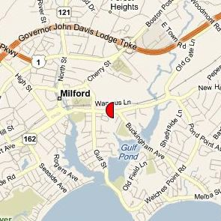
Photo taken on: 11/1/2011

Face Information
Media: | Posters | Posted Date: | 11/1/2011 | Design: | Fix Infrastructure
Area: | New Haven County | Covered Date: |  | First Received On: | 10/31/2011 (Qty: 10)
Posting Market: | Hartford/New Haven | Showing Days: | 8 | Last Received On: | 10/31/2011 (Qty: 10)
Direction Facing: | E
Illumination: | 18 hours
DEC (000’s): | 11
7-day EOI, 18+: | 42,530

CBS Outdoor hereby certifies the accuracy of this electronically generated report, which may be relied on as if it were signed by hand and attested to by a duly authorized signatory.

Page 4 of 13 Generated on: 11/8/2011

Conn. Society of Civil Engineers

Face # 000268P-O - Fitch St 25 ft W/O Onyx St N/S
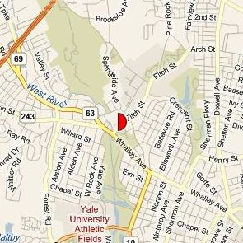
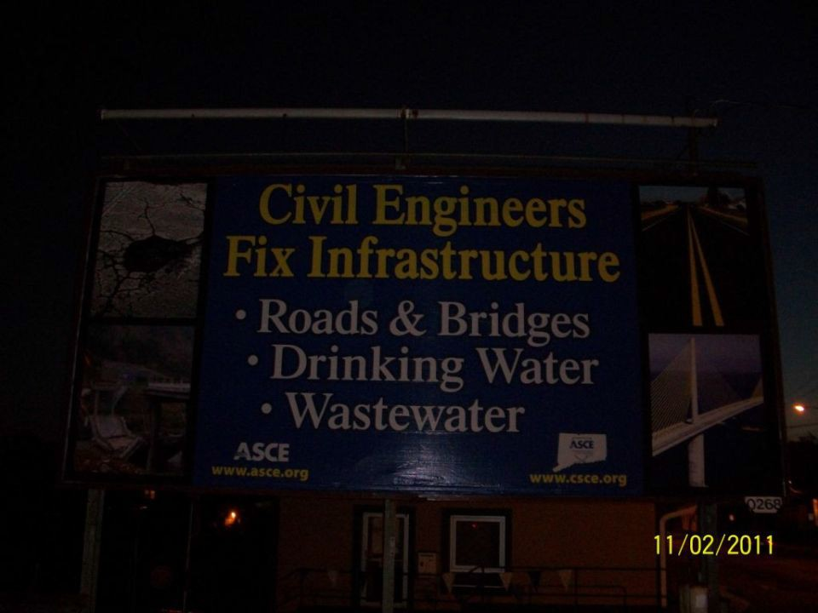
Photo taken on: 11/2/2011

Face Information
Media: | Posters | Posted Date: | 11/2/2011 | Design: | Fix Infrastructure
Area: | New Haven County | Covered Date: |  | First Received On: | 10/31/2011 (Qty: 10)
Posting Market: | Hartford/New Haven | Showing Days: | 7 | Last Received On: | 10/31/2011 (Qty: 10)
Direction Facing: | W
Illumination: | 18 hours
DEC (000’s): | 8
7-day EOI, 18+: | 24,615

CBS Outdoor hereby certifies the accuracy of this electronically generated report, which may be relied on as if it were signed by hand and attested to by a duly authorized signatory.

Page 5 of 13 Generated on: 11/8/2011

Conn. Society of Civil Engineers

Face # 000341P-O - Washington Ave 1500 ft N/O I-91 E/S
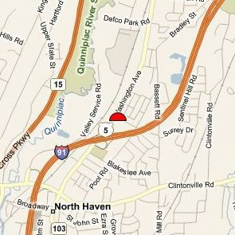
Photo taken on: 11/1/2011

Face Information
Media: | Posters | Posted Date: | 11/1/2011 | Design: | Fix Infrastructure
Area: | New Haven County | Covered Date: |  | First Received On: | 10/31/2011 (Qty: 10)
Posting Market: | Hartford/New Haven | Showing Days: | 8 | Last Received On: | 10/31/2011 (Qty: 10)
Direction Facing: | S
Illumination: | 18 hours
DEC (000’s): | 15
7-day EOI, 18+: | 59,771

CBS Outdoor hereby certifies the accuracy of this electronically generated report, which may be relied on as if it were signed by hand and attested to by a duly authorized signatory.

Page 6 of 13 Generated on: 11/8/2011

Conn. Society of Civil Engineers

Face # 000403P-O - Post Rd 50 ft W/O Jackson Dr N/S
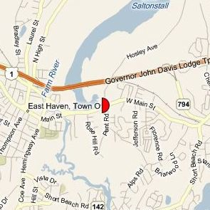
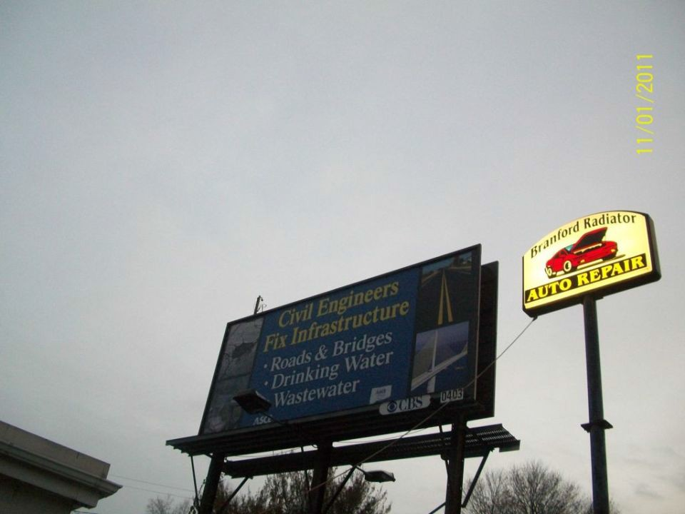
Photo taken on: 11/1/2011

Face Information
Media: | Posters | Posted Date: | 11/1/2011 | Design: | Fix Infrastructure
Area: | New Haven County | Covered Date: |  | First Received On: | 10/31/2011 (Qty: 10)
Posting Market: | Hartford/New Haven | Showing Days: | 8 | Last Received On: | 10/31/2011 (Qty: 10)
Direction Facing: | W
Illumination: | 18 hours
DEC (000’s): | 16
7-day EOI, 18+: | 47,321

CBS Outdoor hereby certifies the accuracy of this electronically generated report, which may be relied on as if it were signed by hand and attested to by a duly authorized signatory.

Page 7 of 13 Generated on: 11/8/2011

Conn. Society of Civil Engineers

Face # 000557P-O - Post Rd & Old Kelsey Point S/S
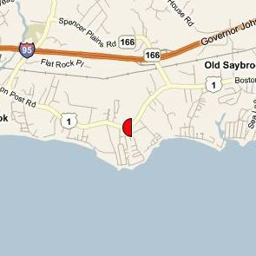
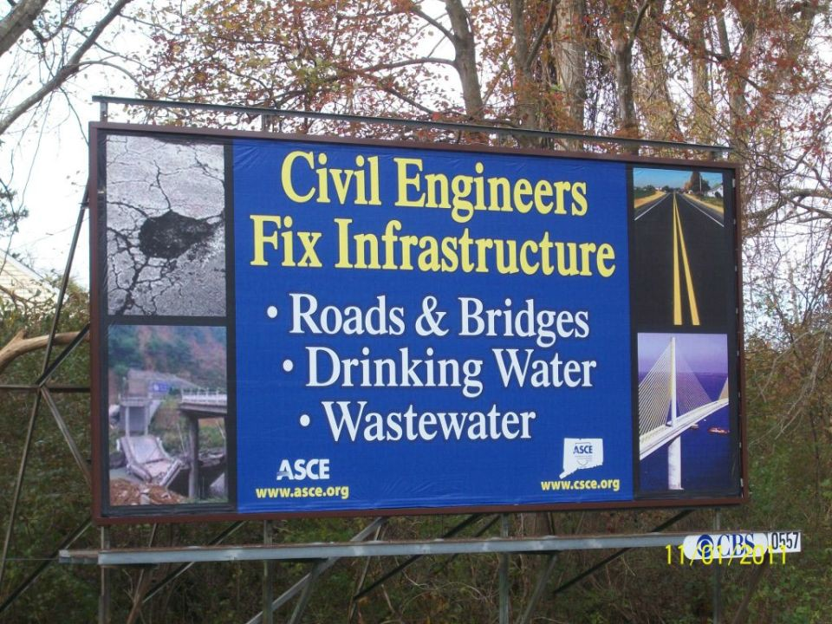
Photo taken on: 11/1/2011

Face Information
Media: | Posters | Posted Date: | 11/1/2011 | Design: | Fix Infrastructure
Area: | Middlesex Country | Covered Date: |  | First Received On: | 10/31/2011 (Qty: 10)
Posting Market: | Hartford/New Haven | Showing Days: | 8 | Last Received On: | 10/31/2011 (Qty: 10)
Direction Facing: | E
Illumination: | 12 hours
DEC (000’s): | 5
7-day EOI, 18+: | 19,434

CBS Outdoor hereby certifies the accuracy of this electronically generated report, which may be relied on as if it were signed by hand and attested to by a duly authorized signatory.

Page 8 of 13 Generated on: 11/8/2011

Conn. Society of Civil Engineers

Face # 000622P-O - Rt 17 1000 ft W/O Rt 77 E/S
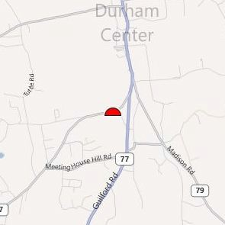
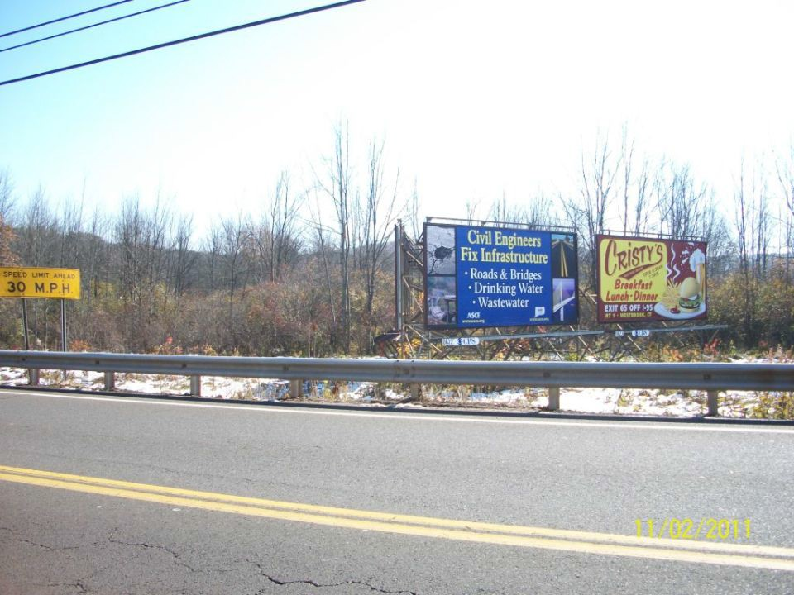
Photo taken on: 11/2/2011

Face Information
Media: | Posters | Posted Date: | 11/2/2011 | Design: | Fix Infrastructure
Area: | Middlesex Country | Covered Date: |  | First Received On: | 10/31/2011 (Qty: 10)
Posting Market: | Hartford/New Haven | Showing Days: | 7 | Last Received On: | 10/31/2011 (Qty: 10)
Direction Facing: | S
Illumination: | 12 hours
DEC (000’s): | 3
7-day EOI, 18+: | 11,316

CBS Outdoor hereby certifies the accuracy of this electronically generated report, which may be relied on as if it were signed by hand and attested to by a duly authorized signatory.

Page 9 of 13 Generated on: 11/8/2011

Conn. Society of Civil Engineers

Face # 000734P-O - Riverside St 400 ft S/O Bank St W/S
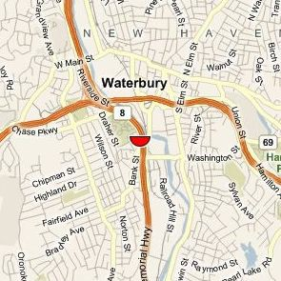
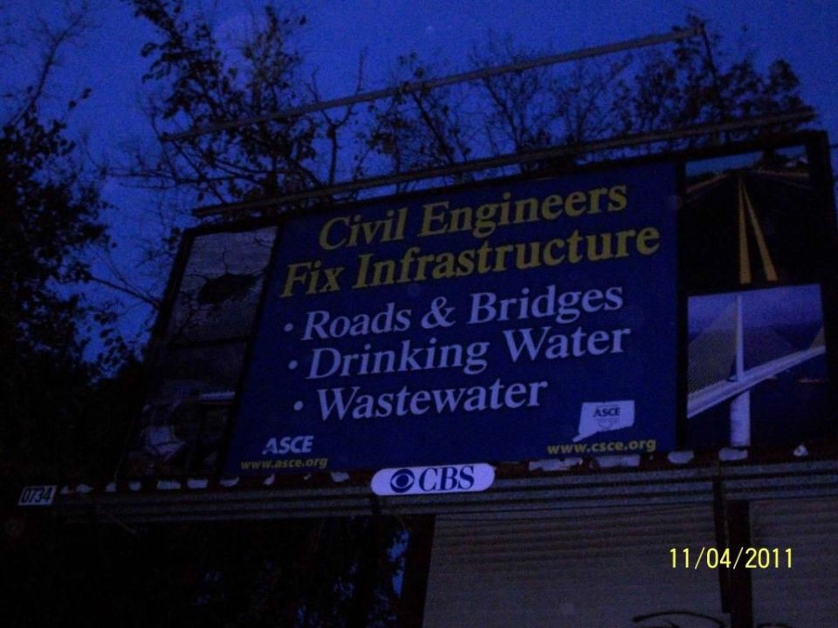
Photo taken on: 11/4/2011

Face Information
Media: | Posters | Posted Date: | 11/4/2011 | Design: | Fix Infrastructure
Area: | New Haven County | Covered Date: |  | First Received On: | 10/31/2011 (Qty: 10)
Posting Market: | Hartford/New Haven | Showing Days: | 5 | Last Received On: | 10/31/2011 (Qty: 10)
Direction Facing: | N
Illumination: | 18 hours
DEC (000’s): | 3
7-day EOI, 18+: | 11,551

CBS Outdoor hereby certifies the accuracy of this electronically generated report, which may be relied on as if it were signed by hand and attested to by a duly authorized signatory.

Page 10 of 13 Generated on: 11/8/2011

Conn. Society of Civil Engineers

Face # 000751P-O - Rt 85 2000 ft N/O Chesterfield Rd E/S
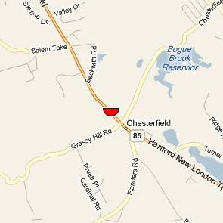
Photo taken on: 11/3/2011

Face Information
Media: | Posters | Posted Date: | 11/3/2011 | Design: | Fix Infrastructure
Area: | New London County | Covered Date: |  | First Received On: | 10/31/2011 (Qty: 10)
Posting Market: | Hartford/New Haven | Showing Days: | 6 | Last Received On: | 10/31/2011 (Qty: 10)
Direction Facing: | N
Illumination: | 18 hours
DEC (000’s): | 10
7-day EOI, 18+: | 28,259

CBS Outdoor hereby certifies the accuracy of this electronically generated report, which may be relied on as if it were signed by hand and attested to by a duly authorized signatory.

Page 11 of 13 Generated on: 11/8/2011

Conn. Society of Civil Engineers

Face # 001034P-O - Center St 400 ft E/O N. Main St S/S
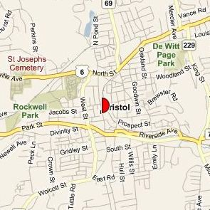
Photo taken on: 11/2/2011

Face Information
Media: | Posters | Posted Date: | 11/2/2011 | Design: | Fix Infrastructure
Area: | Hartford County | Covered Date: |  | First Received On: | 10/31/2011 (Qty: 10)
Posting Market: | Hartford/New Haven | Showing Days: | 7 | Last Received On: | 10/31/2011 (Qty: 10)
Direction Facing: | W
Illumination: | 18 hours
DEC (000’s): | 4
7-day EOI, 18+: | 16,580

CBS Outdoor hereby certifies the accuracy of this electronically generated report, which may be relied on as if it were signed by hand and attested to by a duly authorized signatory.

Page 12 of 13 Generated on: 11/8/2011

Conn. Society of Civil Engineers

Face # 001093P-O - Rt 202 325 ft W/O Walnut St S/S
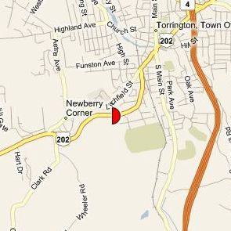
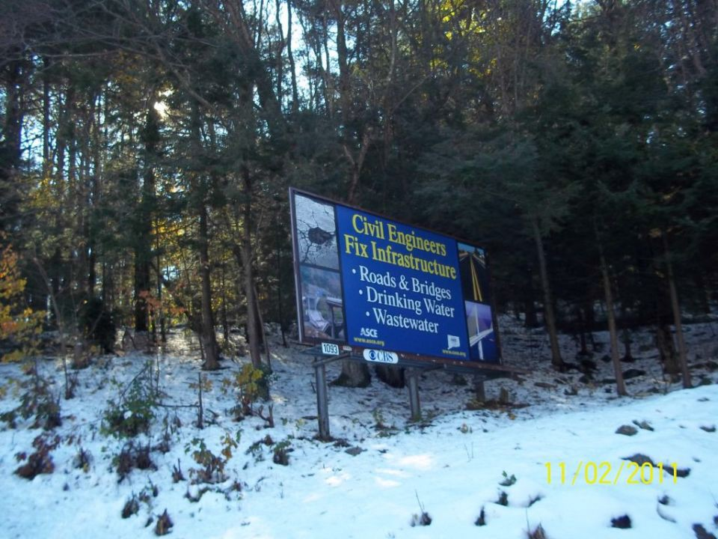
Photo taken on: 11/2/2011

Face Information
Media: | Posters | Posted Date: | 11/2/2011 | Design: | Fix Infrastructure
Area: | Litchfield County | Covered Date: |  | First Received On: | 10/31/2011 (Qty: 10)
Posting Market: | Hartford/New Haven | Showing Days: | 7 | Last Received On: | 10/31/2011 (Qty: 10)
Direction Facing: | W
Illumination: | 12 hours
DEC (000’s): | 3
7-day EOI, 18+: | 13,315

CBS Outdoor hereby certifies the accuracy of this electronically generated report, which may be relied on as if it were signed by hand and attested to by a duly authorized signatory.

Page 13 of 13 Generated on: 11/8/2011

