Public Outreach

8.2 Civil Engineering Booth at Earthfest Event – Cleveland Section
1. Section, Branch | Cleveland Section
2. Section/Branch Size | Medium
3. Project Contact
Name | Loretta Snider, PE
Phone Number | (216) 776-6810
Email | lsnider@mbakercorp.com
4. Project Category | Public Outreach
5. Project Description | ASCE Cleveland hosted a booth two year in a row at EarthFest 2008 and Earthfest 2009 at the Cleveland Metroparks Zoo. This event has taken place each year since 1990 and is Ohio’s largest environmental education event. EarthFest is a forum for education awareness and global concern and is presented through exhibits, displays, and activities.  ASCE Cleveland’s purpose for participating in Earthfest is to promote awareness of the civil engineering profession; specifically, environmental engineering and water resources and the ASCE organization as well as the importance of civil engineers in enhancing the quality of everyday life. The display was designed to attract children of all ages and provide information about the civil engineering profession to encourage civil engineering as a career choice.  In 2008 the theme for our booth was “Clean Water is an Engineered Product” and in 2009 our theme was “Green – Engineers Make It Work.” The “Green” logo was provided by the Engineer’s week organization. A brief PowerPoint presentation of the 2009 event is attached.
6. The Process  (What you did, When and How) | We contacted the outreach department at ASCE nationals. They supplied a display board and handout materials to use at our booth.
7. Those in Charge (Committee, Task Committee, Etc.) | Environmental and Water Resources Committee.
8. Time Frame  (When Started, When Completed) | We submitted a completed registration form and fee to the Earth Day Coalition organization who are responsible for hosting the event about two months in advance. EarthFest is a one-day event held on a Sunday beginning with set-up at about 8:00 am and tear- down at 5:00 PM.
9. Success Factors  (The Parts that Worked Really Well) | There are several elements about this event that work well with our Section. First, it is relatively simple to become part of an important large event and reach the general public. The preparation and cost to participate is minimal. We set-up a schedule for the volunteers with two-hour time slots that seemed worked well. The other aspect that worked well was having an interactive display. In 2009, our booth had several K’Nex bridge kits that attracted children to our booth.
10. Setback Factors
(The Parts that did Not Work Well)
11. Creativity
(This is something off the wall that we did)
12. Administration  (What was most Important?) | The support we received from ASCE National Staff.
13. Follow-Up  (What was most important?) | As a follow-up, we prepared a photo slide presentation to scroll at the following ASCE dinner meeting to hopefully inspire future activities.
14. Recommendations  (What you should ALWAYS do with this project?) | As with any event it is important to begin organizing well in advance of the event. We were able to offer volunteering opportunities to our Section and benefited with an ample number of volunteers.
15. Cautions
(What you should NEVER do with this project?)
16. The Outcome | The event received positive feedback. For example, a civil engineer who passed by the booth thanked us for participating in the event. Generally, we felt we communicated the importance of civil engineering to the general public who were interested in speaking with the volunteers and hopefully inspired a few future engineers.
17. Ongoing Activity
(Would you do it again?)
18. Speaker Contact Information
(person from your Region who would be willing to speak about the Best Practice)
Name
Address
Phone Number
Email
19. Additional Comments | This Best Practice includes the following attachments:  - Earthfest 2009 presentation slides

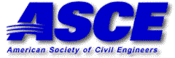

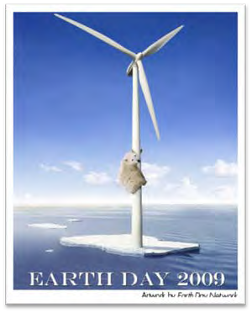
EarthFest 2009 ‐ The Green Generation

Sunday, April 19 at the Cleveland Metroparks Zoo

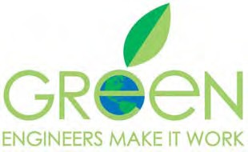

Thank You to the Following ASCE
Members for Volunteering at
EarthFest

Amy Hanna Brian Meluch Aaron Morford Michael Coppage Carolyn Young

Veronica Glashaukas David Skeggs
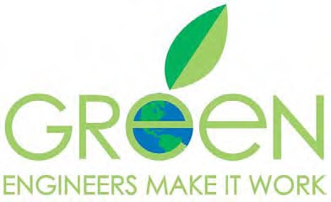
Gina Beim Loretta Snider

Loretta Snider and Brian Meluch Aaron Morford and Michael
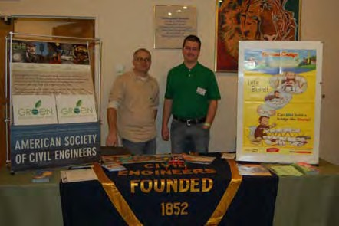
Coppage

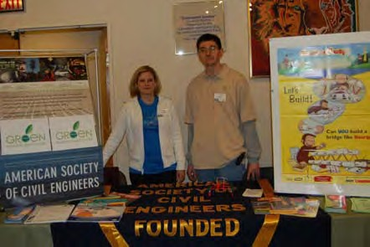

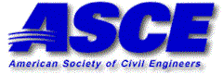

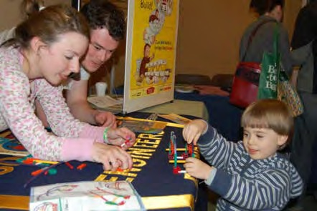
Carolyn Young and Veronica Amy Hanna and David Skeggs
Glashaukas
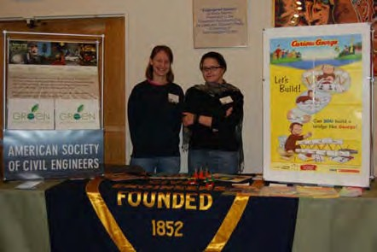

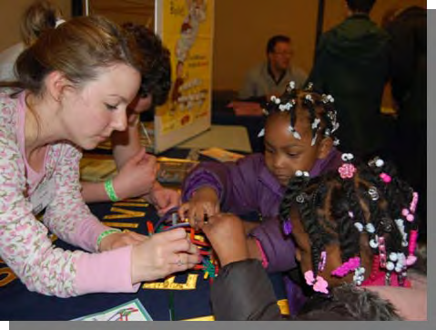

Participation in EarthFest at the Cleveland Metroparks Zoo was a chance to build public knowledge of the role of Civil Engineering in the community and hopefully inspire the engineers of tomorrow.

