College Student Outreach

7.8 Mock Interview Sessions – Pittsburgh Section
1. Section, Branch | Pittsburgh Section
2. Section/Branch Size | Large
3. Project Contact
Name | Greg Rumbaugh  Linda Kaplan
Phone Number | (724) 244-7096  (412) 229-2771
Email | gregory.rumbaugh@gmail.com  LKaplan@Pennoni.com
4. Project Category | College Student Outreach
5. Project Description | Mock interview sessions were held for local university students in the Pittsburgh sections. The workshops were held at the University of Pittsburgh and Carnegie Mellon University. All Pittsburgh section students were invited to attend.
6. The Process  (What you did, When and How) | A speaker opened the workshop for a 30-45-minute discussion on the do’s and don’ts of interviewing (attire, etiquette, etc.). All students from local universities were invited to attend this portion of the workshop. Based on the number of volunteer interviewers, students participated in multiple mock interviews. When the number of students significantly exceeded the number of volunteers, priority for the mock interviews was given to graduating seniors. The goal was to give each student the opportunity to interview with a minimum of 2 different “employers”. Interviewers were typically more experienced younger members and section members. Students submitted their resumes prior to the event for distribution among their assigned interviewers. The event closed with an opportunity for the interviewers to provide general comments back to the students.  The opening speaker was arranged approximately two months ahead of schedule. At that time, a venue was obtained through coordination with the hosting student chapter. Solicitations for volunteers were sent to section members through email approximately 1 month prior to the event. More experienced members and those with hiring experience were encouraged to attend. Although it was not the intent of the program, local company representatives volunteered since the event would also provide an opportunity to reach out to prospective new hires. Students within the section were initially contacted through their respective practitioner advisors approximately three weeks prior to the event. The week before the event the students and mock interviewers were paired. The resumes were also collected from the students and distributed to their interviewer(s) during this same time frame.
7. Those in Charge (Committee, Task Committee, Etc.) | The event was organized by an event chair. The YMF outreach and technical committees, practitioner advisors, and student chapters all played a role in the organization of the event.
8. Time Frame  (When Started, When Completed) | The even took approximately two months to organize. A “keynote speaker” and venue was secured two months before the event. Three to four weeks before the event volunteers and students were contacted to sign-up to participate. During the week before, students and interviewers were paired up and resumes were distributed.
9. Success Factors  (The Parts that Worked Really Well) | 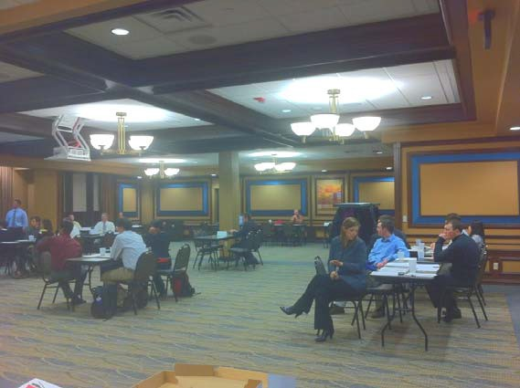  The students gave great feedback on the event. They seemed to appreciate the “mock” interview setting to develop confidence in their ability to interview. They also were able to receive feedback on how they could demonstrate their abilities better on their actual interviews. The number of interviewers who volunteered to participate made the events outstanding. On average, over 15 section members and younger members attended the events.
10. Setback Factors  (The Parts that did Not Work Well) | Pairing students and interviewers proved to be difficult at times. Cancellations at the last minute or no- shows required last-minute overhaul to the proposed schedule.
11. Creativity
(This is something off the wall that we did)
12. Administration  (What was most Important?) | It is important to have one event chair that can coordinate the students and volunteers. Due to the high number of participants in the event, this was one of the most challenging components to the event. This point of contact also provided the resumes to the interviewers after pairing the individuals on the event schedule and be available to help moderate the event (not volunteer as an interviewer).
13. Follow-Up  (What was most important?) | Students were given a survey after the event to share their thoughts on the experience and provide thoughts on ways to improve future mock interview events. Discussions were also held with volunteers on ways to more effectively use the time allotted and set maximum time allowances for each interview.
14. Recommendations
(What you should ALWAYS do with this project?)
15. Cautions
(What you should NEVER do with this project?)
16. The Outcome | The students indicated that the event was extremely successful in helping them to prepare for future interviews and built self-confidence whether they were searching for internships or entry-level positions. The event also provided a networking opportunity for more experienced section members, younger members, and students.
17. Ongoing Activity  (Would you do it again?) | Yes. It was a very valuable experience.
18. Speaker Contact Information
(person from your Region who would be willing to speak about the Best Practice)
Name
Address
Phone Number
Email
19. Additional Comments

