College Student Outreach

7.6 Student Gala – Maine Section
1. Section, Branch | Maine Section
2. Section/Branch Size | Medium
3. Project Contact
Name | Will Haskell, PE, M. ASCE
Phone Number | (207) 657-6910  (207) 318-7052
Email | whaskell@gorrillpalmer.com
4. Project Category | College Student Outreach
5. Project Description | Planning a successful “Annual Student Gala: Bridge to the Profession” event
6. The Process  (What you did, When and How) | Earlier versions of this event began back in 2004. The current format, which is still evolving, was started in April 2011. This event focuses on the graduating seniors at the University of Maine Civil Engineering Program. Senior civil engineering students have a class called the senior capstone project where the break into teams to complete a real engineering project. At the Gala event, the student teams present their project to a panel of judges made up of representatives from local engineering firms. There are cash prizes for the top three teams and the winning team gets their name engraved on the Gala-Cup. The presentations are followed by catered meal where the students get to network with Maine Section members and representatives from local engineering firms.
7. Those in Charge (Committee, Task Committee, Etc.) | Student Advisor/Practitioner, Student Chapter and Board Members
8. Time Frame  (When Started, When Completed) | This is an annual event scheduled in April. Planning for the event begins in August of the prior year.
9. Success Factors  (The Parts that Worked Really Well) | 1. Providing cash prizes to the top three student teams and raffle prizes provided by local engineering firms; 2. Designating a master of ceremonies to keep the event rolling and on schedule; 2. Inviting the student’s parents to the event so they can participate in their student’s accomplishments.
10. Setback Factors  (The Parts that did Not Work Well) | Scheduling the event during Maine high school vacation week, which created a conflict with several Maine Section Board members. Unfortunately, this may not be avoidable because of timing relative to final exams and the end of the semester.
11. Creativity  (This is something off the wall that we did) | 1. Purchased a large trophy cup that will be engraved each year with the winning team’s name and displayed in the Civil Engineering Department awards case; 2. Hand out bundles of cash to the winning teams.
12. Administration  (What was most Important?) | 1. Scheduling the venue as early as possible; 2. Sending out invitations to the student’s parents; 3. Coordinating with National to get the President or President-Elect to come to the event.
13. Follow-Up  (What was most important?) | Always coordinate and follow up regularly with the Civil Engineering Department at the college/university when setting the date for the event and planning the agenda so there are no conflicts with critical exams, or other important school functions.
14. Recommendations  (What you should ALWAYS do with this project?) | 1. Involve the Civil Engineering Department staff in the event; 2. Coordinate the event with a visit from the ASCE President or President-Elect.
15. Cautions  (What you should NEVER do with this project?) | Begin planning it two months in advance.
16. The Outcome | Provides a great way to celebrate the student’s hard work and accomplishments while reiterating the benefits of continuing their involvement with ASCE.
17. Ongoing Activity  (Would you do it again?) | Yes
18. Speaker Contact Information
(person from your Region who would be willing to speak about the Best Practice)
Name | Will Haskell, PE, M. ASCE
Address | 15 Shaker Rd, PO Box 1237, Gray, ME 04039
Phone Number | 207-318-7052
Email | whaskell@gorrillpalmer.com
19. Additional Comments | This Best Practice includes the following attachments.  - 2012 Photos  - Sample letter to parents  - Sample table sponsor placards

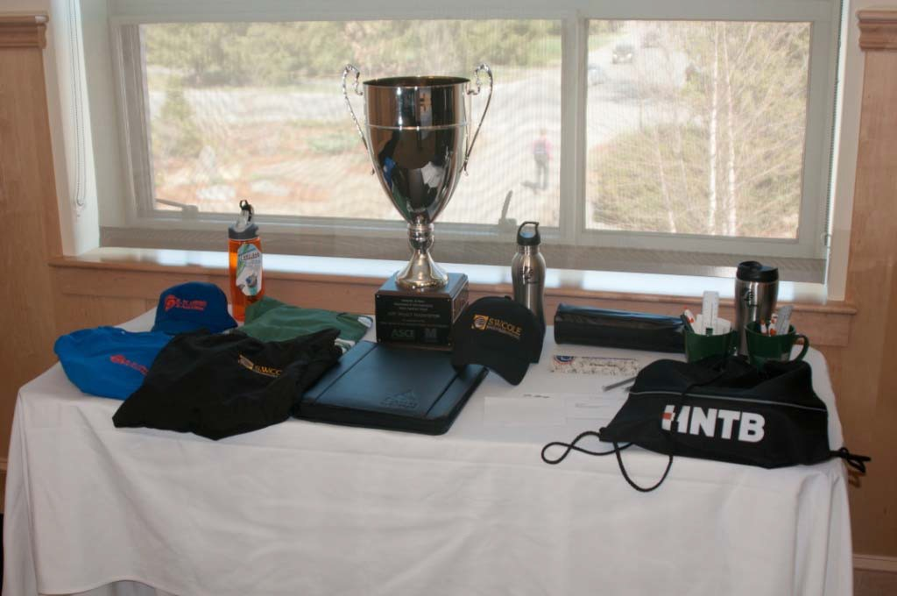
Gala Cup and Swag

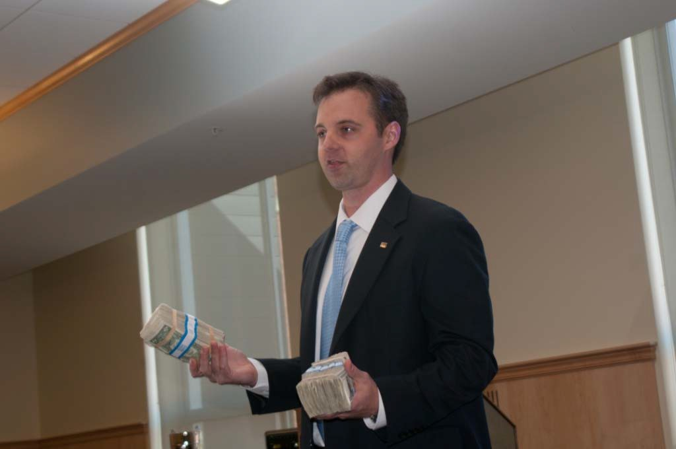
Master of Ceremonies with Bundles of Prize Money

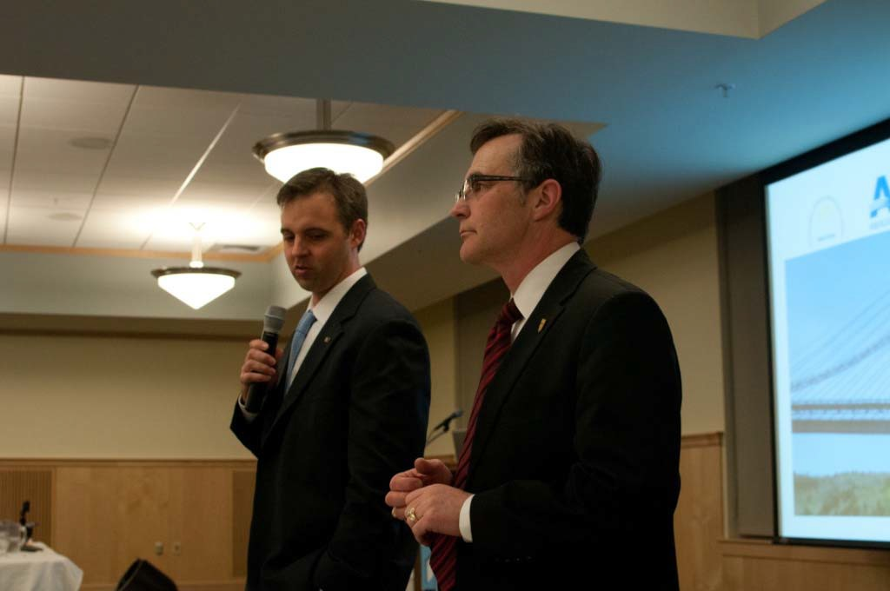
Master of Ceremonies (Past Maine Section President Walter Fagerlund) and President‐Elect Greg DiLoreto

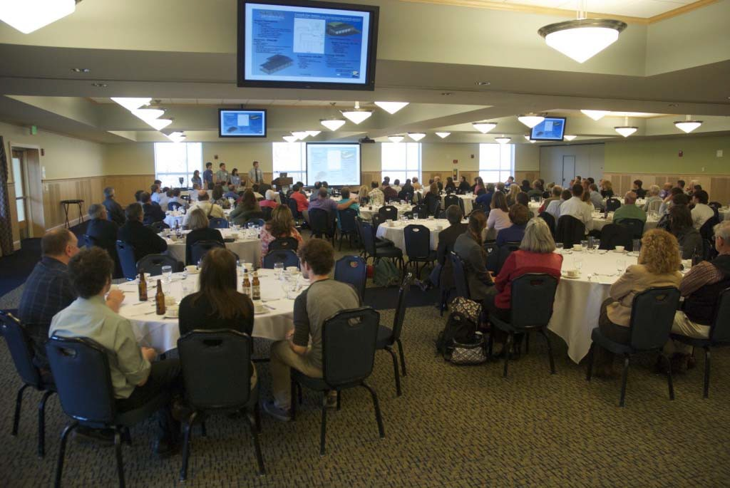
Attendees at the Gala

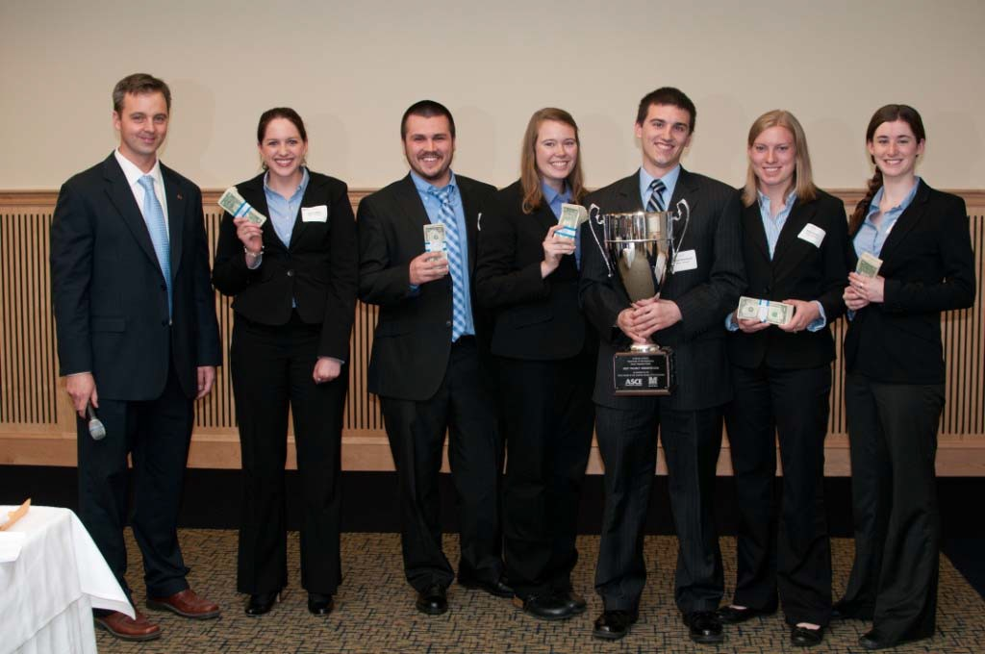
Winning Team

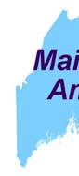
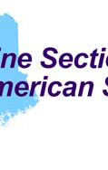
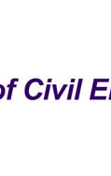
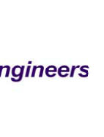
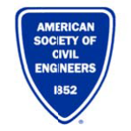

March 2, 2012

Dear Parents of 2012 Civil Engineering Graduates,

On behalf of the Maine Section of the American Society of Civil Engineers, you are cordially invited to attend this year’s Senior Gala: “Bridge to the Profession” on Thursday, April 19, 2012, from 3 pm to 9 pm.

The Senior Gala, organized by the Maine Section of the American Society of Civil Engineers
(ASCE) is a must-see event, and highlights the student achievements as part of their Senior Capstone Project. This is our second Annual Senior Gala event devoted to celebrating the students and their achievements. In the past the student capstone projects were incorporated into the social hour during our regular Maine Section meeting, however this Gala format allows the students more time to shine for the entire night.

The Senior Capstone Project is a year-long assignment that represents a culmination of studies in civil engineering at the University of Maine. The Project is a required course that involves teams of students working on a specific “real life” civil engineering project, from concept to design completion. The Project requires many of the engineering and professional skills acquired over their education and is intended to represent a work scope that the student might face in their professional careers. The students will be scored by a panel of judges based on their project poster and presentation, involving a question and answer session from the judges and guests. The results of the scoring are presented at the end of the meeting accompanied by monetary awards and the award of the coveted Gala Cup. The event will also be attended by professional engineers from the Maine Section ASCE, and will be a great opportunity for students to network and discuss the real-world experiences associated with our profession.

The event will take place at Wells Commons, on the University of Maine campus, and will include a buffet dinner, for the price of $25 per plate, which is intended to just cover the cost of the event. Checks can be made payable to the Maine Section ASCE. RSVPs are requested by April 12th and can be sent by mail or e-mail to the address below:

Katrina Martin, U-Maine ASCE Student Chapter President 5711 Boardman Hall
Orono, ME 04469
katrina.r.martin@maine.edu

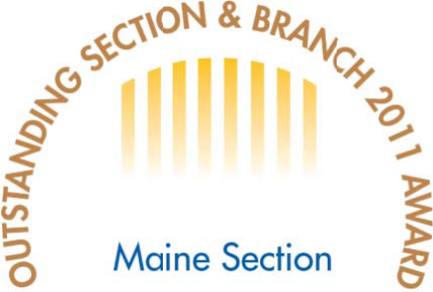
Please join us for the celebration of the great achievements by all the seniors in Civil Engineering this year at the University of Maine. This is a favorite event!

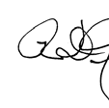
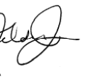
Sincerely,

Ralph D. Nelson, P.E., M.ASCE, President,
Maine Section American Society of Civil Engineers

This table generously
sponsored by:

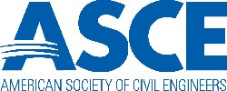

Represented by: (Your company’s representative)

