7.16 Consolidated Scholarship Program
College Student Outreach

1. Section, Branch | San Diego Section
2. Section/Branch Size
3. Project Contact
Name | Julia Shockley
Phone Number | 510-366-7682
Email | jshockley@moffattnichol.com
4. Project Category | College Student Outreach
5. Project Description | Combine three separate scholarship programs into one consolidated program.
6. The Process  (What you did, When and How) | ASCE San Diego Section and its suborganizations typically conduct college scholarship opportunities separately. Each program has a small number of scholarship awards available with relatively modest award amounts. The individual scholarship programs were struggling to receive applicants, with declining numbers each year.  In 2017, the San Diego Younger Member Forum Scholarship Chair proposed to combine the scholarship programs within the San Diego Section. The objective was to attract more students to apply by having one application for a larger number of available awards. The consolidated program also provides an opportunity for communication and teamwork among the different organizations within the San Diego Section.  The consolidated scholarship program concept was approved in 2017 and includes the following groups: San Diego Section, YMF, Pipeline/Environmental Technical Group, and Transportation Group. The Transportation Group gives out a scholarship every other year and participates accordingly. Each year, a representative from each organization and a scholarship committee reviews the submitted applications and decide on scholarship winners.  Since combining the scholarship programs, we have seen a substantial increase in applicants from previous years. Nine scholarships are typically awarded, ranging from $500 to $1,500.
7. Those in Charge (Committee, Task Committee, Etc.) | Scholarship Chairs from the San Diego Section, YMF, Pipeline-Environmental Technical Group, and Transportation Technical Group oversee the scholarship program. A scholarship committee is formed to help review the applications.
8. Time Frame  (When Started, When Completed) | Each organization celebrates their scholarship recipient at their final general meeting of the year, typically in May or June. Preparation for the scholarship program begins the previous year, ideally September or October.
9. Success Factors  (The Parts that Worked Really Well) | Key factors for the success of this program include having a straightforward and concise application, having our student chapters help with advertising, and giving the committee enough time and direction for reviewing the applications.
10. Setback Factors  (The Parts that did Not Work Well) | Our presence at community colleges within our region feels non-existent, and therefore, the number of applicants from community college are often low.
11. Creativity  (This is something off the wall that we did) | To maintain an impartial and unbiased process the applicant’s names were blacked out and replaced with fruit and vegetable names for the review panel. Created meme to promote on social media.
12. Administration  (What was most Important?) | The scholarship chairs are to communicate their expectations and goals for their organization’s scholarship. It is also important to reach out to the student chapters for schedule conflicts and advertising help.
13. Follow-Up  (What was most important?) | After the scholarship deadline, the students were given the option to receive feedback on their application. The feedback given was thorough, providing comments on their specific application and giving general advice on what the committee looks for.
14. Recommendations  (What you should ALWAYS do with this project?) | Always communicate with the local student chapters throughout the scholarship process. The student chapters provide insight on potential deadline conflicts and they are a great asset for advertising the scholarships.
15. Cautions  (What you should NEVER do with this project?) | Avoid setting the scholarship deadline around final exams or conferences. Avoid making the application overly lengthy or complicated.
16. The Outcome | Consolidation has revitalized the scholarship program for San Diego Section and subgroups. There is an increase in number of applications to the program, and communication and teamwork among the San Diego Section and subgroups is improved.
17. Ongoing Activity  (Would you do it again?) | The consolidated scholarship program has been ongoing since its introduction. It is recommended to continue this program and possibly look for more funding to provide more scholarship opportunities.
18. Speaker Contact Information
(person from your Region who would be willing to speak about the Best Practice)
Name | Julia Shockley
Address | Moffatt & Nichol  1660 Hotel Circle North, Suite 500  San Diego, CA 92108
Phone Number | 510-366-7682
Email | jshockley@moffattnichol.com
19. Additional Comments | Copies of the flyer and application for the 2020 scholarship program are attached.

FLYERS (made using Canva):

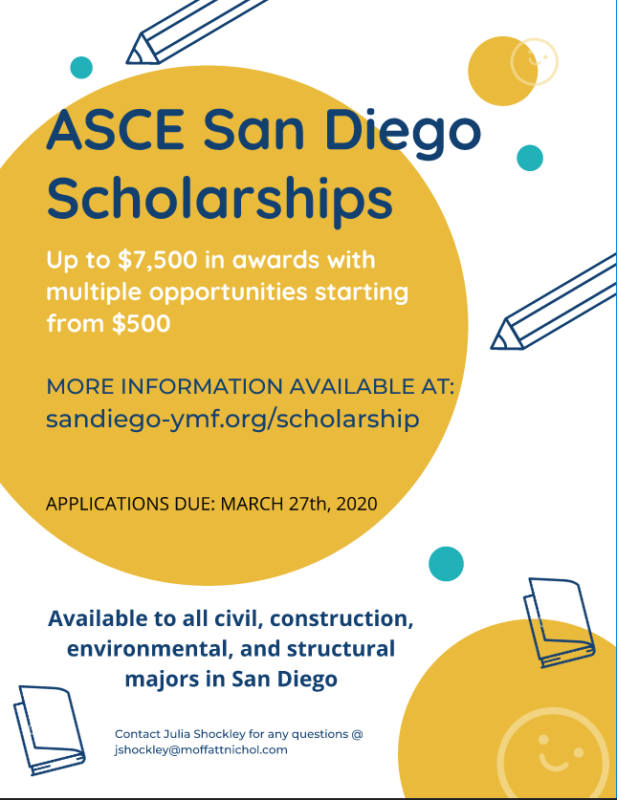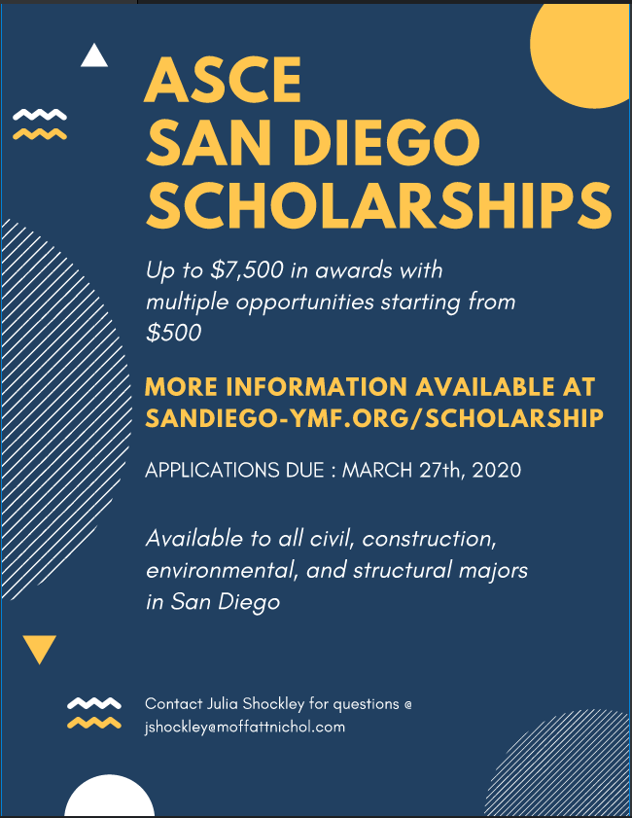

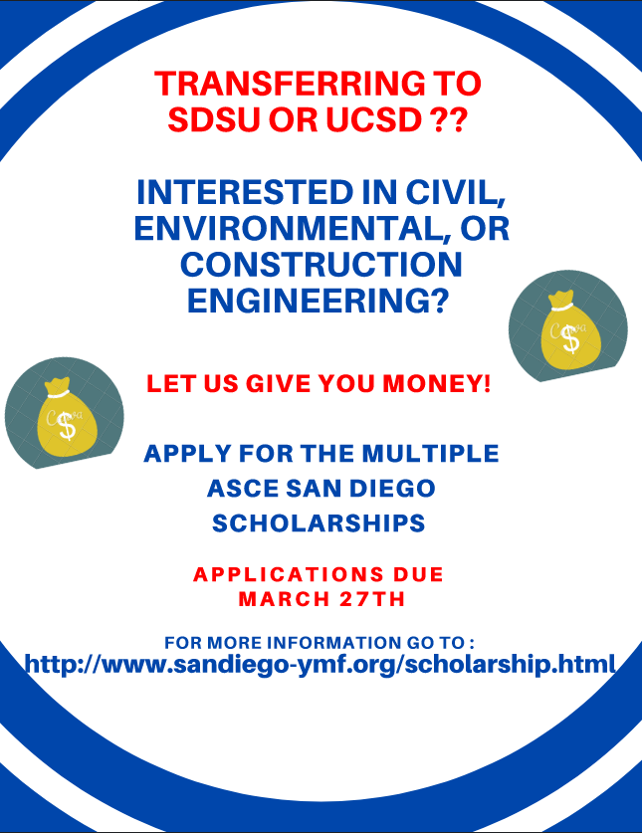

SCHOLARSHIP SECTION ON WEBSITE:

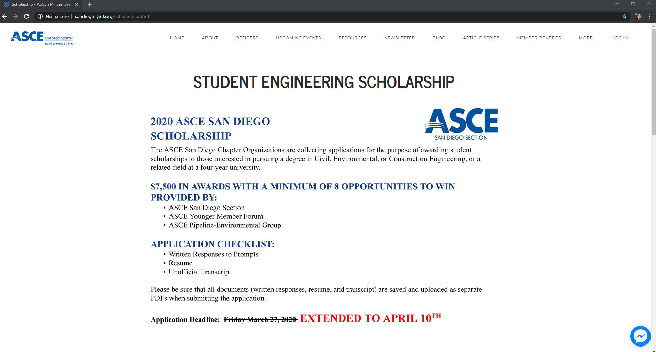
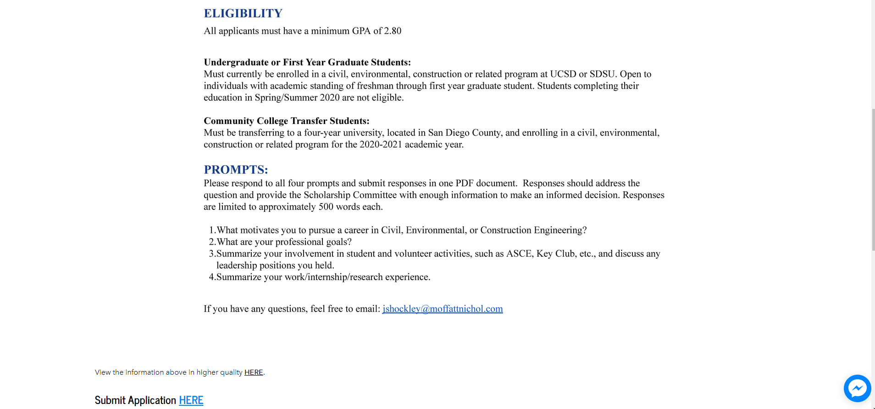

SCHOLARSHIP APPLICATION (made using Google Forms):

