College Student Outreach

7.11 Student/Professional Networking – Illinois Section
1. Section, Branch | Illinois Section
2. Section/Branch Size | Very Large
3. Project Contact
Name | Taylor Leahy
Phone Number | 312-780-7733
Email | leahyt@cdmsmith.com
4. Project Category | College Student Outreach
5. Project Description | The ASCE-IL Section hosted a Student Members and Professional Members networking event that combined a resume workshop and a social networking aspect with bowling. The ASCE-IL Section’s three universities, the Illinois Institute of Technology, Northwestern University, and the University of Illinois at Chicago, had student members participate in the event. Our goal was to create a comfortable environment for students to attend and network with working professionals. Students were also encouraged to bring their resumes for personal review. Likewise, all professional members of ASCE were encouraged to network with students, provide personal value of an ASCE membership, and give feedback on their careers.
6. The Process  (What you did, When and How) | - Brainstormed social events that would bring students and professionals together, was budget friendly, easy to travel to, and have value to both professionals and students. A combined networking event of bowling and a resume workshop was the event everyone agreed upon.  - It was a joint venture between the ASCE Student Outreach Committee, Younger Member Group, and Transpiration & Development Institute. The ASCE student chapter at the University of Illinois-Chicago was also involved by hosting the event at their university.  - Applied for the ASCE Student Member’s Transition Sub-Committee STAY Grant to receive funds for the event. Additional sponsorship request was advertised to companies. This helped make the event free for all participants, which would encourage attendance at the event. Funding paid for the costs of bowling, pizza and drinks.  - The event was structured to follow the ASCE Student Member’s Transition Sub-Committee’s Student Transition Goals which include:  - Forge lasting relationships between organization entities  - Strengthen relationships with individual members  - Educate students about the value of society membership  - Help build students’ desire for continued affinity to ASCE  - Advertised through ASCE student chapters, email blasts through ASCE, and sponsorship letters. Registration signup link was created through 123signup.com.
7. Those in Charge (Committee, Task Committee, Etc.) | - The ASCE-IL Section Student Outreach Committee: planned the event details and applied for the grant sponsorships.  - Younger Member Group: organized the event itinerary, registration, and additional sponsorship requests.  - Transportation & Development Institute: organized the food catering.  - ASCE Student Chapter at the University of Illinois-Chicago: organized the reservations for the event venue.
8. Time Frame  (When Started, When Completed) | Planning took about 2 months, between September and November 2015.  - September, 2015 – applied for the STAY Grant Funding from ASCE.  - October, 2015 – planned the event details, distributed responsibilities, and advertised.  - November 17, 2015 – event date.
9. Success Factors  (The Parts that Worked Really Well) | - Creating a networking event that had both a social and professional value for students and professionals.  - Finding a location that is simple to travel to for students and professionals.  - Applying for the ASCE STAY Grant and receiving corporate sponsorship to keep the registration cost free for all attendees to increase attendance.  - Following the ASCE Student Member’s Transition Sub-Committee’s Student Transition Goals to structure the event and to produce different ideas into the event planning.  - Being proactive to encourage professional members to interact with students and give insight on their career experiences, as well as the benefit of being an ASCE member.
10. Setback Factors  (The Parts that did Not Work Well) | The event went very smoothly. An improvement that can be made is to incorporate ASCE resources (available online) into the event for students such as:  - Student Member Resource Guide  - Career Stages Brochure  - Institutes Brochure  - ASCE gift packs
11. Creativity  (This is something off the wall that we did) | Incorporating a social and professional value to the festivities. It was not just a networking bowling social, but also a resume workshop for students to get resume critique from working professionals.
12. Administration  (What was most Important?) | Gaining resources and positive feedback from the ASCE Student Member’s Transition Sub-Committee. Also, have the ASCE-IL Institutes and Committees collaborate to make a successful event.
13. Follow-Up  (What was most important?) | - Post report to the ASCE Student Member’s Transition Sub-Committee for the STAY Grant.  - “Thank you” follow-ups to sponsoring companies.  - Post-survey to students to remind them of the value of ASCE membership.
14. Recommendations  (What you should ALWAYS do with this project?) | Be proactive in the event planning and during the event itself. It can be one thing to just host a networking event, but to plan and encourage the interaction between students and professionals can make the occasion a positive experience for everyone.
15. Cautions  (What you should NEVER do with this project?) | Do not have one person plan the event- try to involve several champions in planning the social. The more people or groups, to a certain limit, that participate in planning helps promote getting more members to attend through each group.
16. The Outcome | Attendance Data: 77 (41 students, 33 professionals, and 1 outside guest).
17. Ongoing Activity  (Would you do it again?) | Yes, we plan to make this an annual event. The date of the social also worked because it was before student finals and the holiday season.
18. Speaker Contact Information
(person from your Region who would be willing to speak about the Best Practice)
Name | Taylor Leahy
Address | 125 S. Wacker Dr. Chicago, IL 60607
Phone Number | 312-780-7733
Email | leahyt@cdmsmith.com
19. Additional Comments | This Best Practice includes the following attachments:  - STAY Grant Final Report

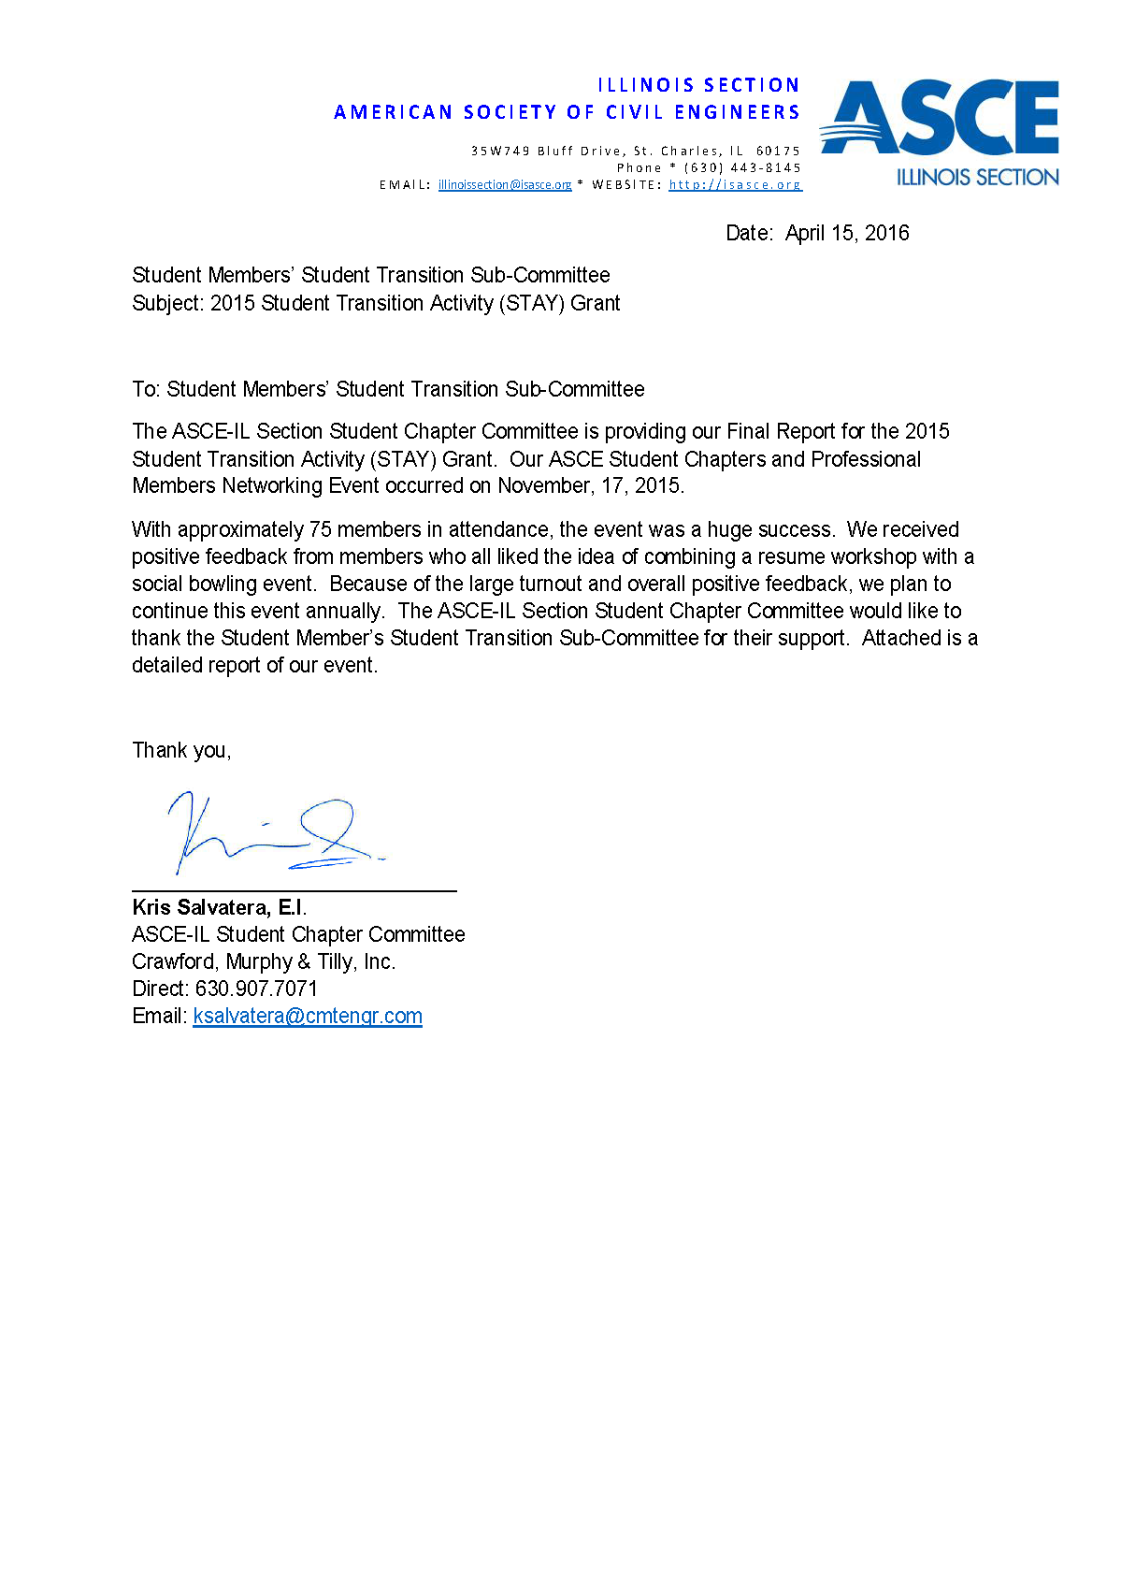

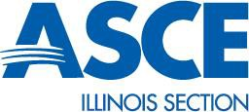
STAY PROGRAM GRANT POST-EVENT REPORT
I L L I N O I S S E C T I O N
A M E R I C A N S O C I E T Y O F C I V I L E N G I N E E R S

3 5 W 7 4 9 B l u f f D r i v e , S t . C h a r l e s , I L 6 0 1 7 5
P h o n e * ( 630 ) 443 - 8145
E M A I L : illinoissection@isasce.org * W E B S I T E : h t t p : / / i s a s c e . o r g

Section/Branch: Illinois Section

Project Contact: Kris Salvatera, ASCE-IL Section Student Chapter Committee Contact Phone Number: 630-907-7071
Contact Email: ksalvatera@cmtengr.com

Summary

With the support of the Stay Grant Program, The ASCE-IL Section hosted a Student Members and Professional Members networking event which combined a resume workshop with social networking aspect with bowling. The ASCE-IL Section’s three (3) universities: the Illinois Institute of Technology, Northwestern University, and the University of Illinois at Chicago all had student members participate in the event. Our goal was to create a comfortable environment for students to attend while networking with working professionals. Students were also encouraged to bring their resumes for personal review. Likewise, all professional members of ASCE were encouraged to network with students and provide personal value of an ASCE membership as well as give feedback on their careers

Event Details

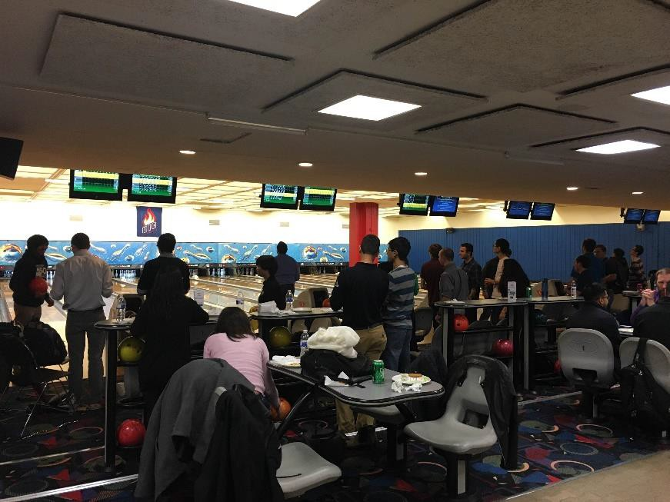
Date: November 17, 2015

Location: University of Illinois at Chicago Attendance Data: 75
Student Members: 34

Professional Members: 33

Guest: 1

Expenses
I L L I N O I S S E C T I O N
A M E R I C A N S O C I E T Y O F C I V I L E N G I N E E R S

3 5 W 7 4 9 B l u f f D r i v e , S t . C h a r l e s , I L 6 0 1 7 5
P h o n e * ( 630 ) 443 - 8145
E M A I L : illinoissection@isasce.org * W E B S I T E : h t t p : / / i s a s c e . o r g

TOTAL PURCHASES
Item Description | Cost
Name Tags | $ 4.29
Water/Soda/Cookies/Plates | $ 50.98
Poster Board | $ 36.00
Pizza | $ 172.66
Raffle | $ 160.00
Bowling | $ 740.00
Total Purchases | $ 1,163.93

STAY GRANT EXPENSES
Item Description | Cost
Name Tags | $ | 4.29
Water/Soda/Cookies/Plates | $ | 50.98
Pizza | $ | 172.66
Bowling | $ | 740.00
Total Purchases | $ | 967.93
Stay Grant Left Over | $ | 32.07

SPONSORSHIP EXPENSES
Item Description | Cost
Raffle Gift Cards | $ 160.00
Poster Board | $ 36.00
Total Purchases | $ 196.00

Stay Grant Left Over: +$32.07

The total event costs were significantly lower than we anticipated. This was because we were able to work with the ASCE Student Chapter at UIC to book the bowling reservation and receive a student discount which included 2 hours of bowling and shoe rental.

As part of the YMG coordinating the event, sponsorship recruitment is for all student events for the year. A total of $196.00 from sponsorship funding budget was used for this specific event. We wanted to note that we used company sponsorships towards the raffle prizes to the students as well as the welcome board with all company logos. These items were excluded from the STAY Grant due to the grant requirements. A total of $32.07 was left over from the $1000 STAY Grant received.

STAY Grant Transition Goals
I L L I N O I S S E C T I O N
A M E R I C A N S O C I E T Y O F C I V I L E N G I N E E R S

3 5 W 7 4 9 B l u f f D r i v e , S t . C h a r l e s , I L 6 0 1 7 5
P h o n e * ( 630 ) 443 - 8145
E M A I L : illinoissection@isasce.org * W E B S I T E : h t t p : / / i s a s c e . o r g

Forge Lasting Relationships between Organizational Entities
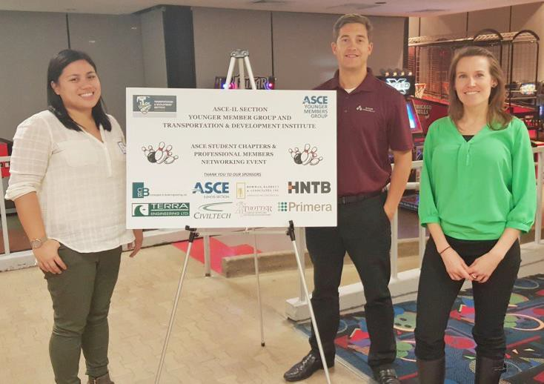
The ASCE-IL Section Student Chapter Committee involved the ASCE-IL Younger Member Group and the Transportation & Development Institute to take the lead in organizing the event. In addition, the ASCE-University of Illinois-Chicago Chapter were asked to be part of organizing the event as they were the host-school. This gave responsibility to 3 ASCE-IL organizational entities to work together. The ASCE-UIC Chapter booked the venue and were able to get a discounted rate as they were a student organization of the university. The YMG and T&DI group then organized the bowling assignments, resume workshop and food planning and coordination. These different groups of ASCE-IL worked together and allowed students to work the professional members.

Strengthen Relationships with Individual Student Members

All professional members participating were members of ASCE. Bowling assignments were broken into lanes where professionals were paired with students. Upon registration, professionals were: encouraged to personally network with students, ask about their professional goals, and speak about how their ASCE professional membership continues to help their careers. We hoped that each student was able to leave feeling they personally networked with at least 1 professional. The goal in mind was to make students feel welcome in our professional community

The resume workshop also allowed students to get resume advice through ASCE professionals volunteering their time. This one-on-one interaction allowed students to meet professionals and gain valuable feedback to what employers may want to see on student resumes.

For future events, we plan to create some sort of script template to give to professionals. We believe this will help professionals engage with students easily. These benefits both students and professionals on enhancing their networking skills

I L L I N O I S S E C T I O N
A M E R I C A N S O C I E T Y O F C I V I L E N G I N E E R S

3 5 W 7 4 9 B l u f f D r i v e , S t . C h a r l e s , I L 6 0 1 7 5
P h o n e * ( 630 ) 443 - 8145
E M A I L : illinoissection@isasce.org * W E B S I T E : h t t p : / / i s a s c e . o r g

Educate Students about the Value of Society Membership

Educating students about membership was done through the networking process. Upon registration, professional members were encouraged to talk to students on their transition from student member to professional member. Also, professionals were asked to talk about their professional ASCE membership and activity including: technical institute involvement, continuing education, and the overall value their ASCE membership has on their careers.

We did receive the “supporting resources and information” email which included information on brochures and presentations we could have used during the event. Unfortunately, our event schedule was occurred rather quickly as we wanted to do it before the holidays, so we did not have enough time to order the material.

However, going over the resources material, we thought it was a great tool to use and would definitely order the supporting material for future events. We did use the student survey in our online post event survey to the students. The online survey results are attached.

Help Build Student’s Desire for Continued Affinity to ASCE
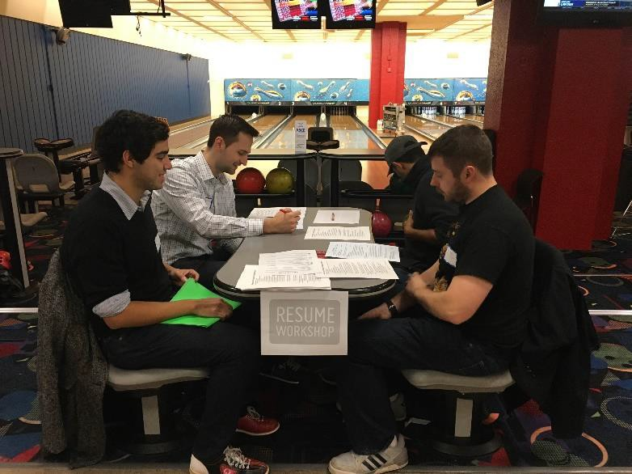
Our goal for this event was to show
students the value of ASCE
membership through the professional members themselves. There is value to teach students the advantage of ASCE membership through the personal experience of professional members. We hope students were able to gain personal insight from professionals and leave feeling that a continued ASCE membership can be a great tool for their careers after college.

For future events, we will bring more of the technical resources available through ASCE to add additional information for students. Please see our post-event survey at the end of the report.

Event Feedback
I L L I N O I S S E C T I O N
A M E R I C A N S O C I E T Y O F C I V I L E N G I N E E R S

3 5 W 7 4 9 B l u f f D r i v e , S t . C h a r l e s , I L 6 0 1 7 5
P h o n e * ( 630 ) 443 - 8145
E M A I L : illinoissection@isasce.org * W E B S I T E : h t t p : / / i s a s c e . o r g

Through word of mouth, we received a lot of compliments from students that they felt comfortable networking with working professionals. For those participating in the resume review workshop, students felt they received direct insight on what civil engineering companies are looking for. Professional members said they felt good to volunteer their time at the event but most importantly, they had so much fun bowling after a hard day at work.

Post Survey. We emailed all students a link to a post-event survey. Out of 34 students, only 10 replied back. We are uncertain why the response turnout was low, but we felt like the survey still provided insight on what students know about ASCE. Questions in the ASCE supporting resources were a majority of the survey questions. What we learned from the survey was students really enjoyed our ASCE event but may not initially be aware of all the advantages ASCE membership has to offer beyond college.

Summary

The ASCE-IL Student and Professional Networking Event (Bowling and Resume Workshop) was a huge success due to the large turnout and positive feedback we received. Our goal was to network students with professionals in fun event while including a formal resume workshop review. With the help of the ASCE-IL technical groups and student chapters, both professionals and students worked together to create a smooth and successful event. Not only did students feel like they were able to network with people in their desired professions in a fun atmosphere, but we hoped they were able to get personal insight from professionals about the value of continuing their ASCE membership.



