K-12 Student Outreach

6.11 Civil Engineering Clubs – Hawaii Section
1. Section, Branch | Hawaii Section
2. Section/Branch Size | Medium
3. Project Contact
Name | Jon M. Young
Phone Number | (808) 754.2931
Email | outreach.ascehi@gmail.com
4. Project Category | K-12 Student Outreach
5. Project Description | Organization of Civil Engineering Clubs
6. The Process  (What you did, When and How) | The formation of Civil Engineering (CE) Clubs is an ASCE Society-wide initiative. ASCE provides a club guide, topic modules with several weeks’ worth of activities in each module, and lots of free resources to help launch and run a successful club. See http://www.asce.org/Civil_Engineering_Club/.  The Hawaii Section has taken that initiative one step further by forming an organization of CE Clubs.  The main purpose for the organization is to share resources and better enable us to have students from different high schools meet each other at the club activities. The sharing of resources would minimize the time required by an engineer to lead a club. As a result, it would encourage more volunteers to serve as a club lead engineer.  By consolidating our resources into an organization, one lead engineer could coordinate an activity, such as a site visit, for multiple clubs. If the clubs were independent, the lead engineer for each club would need to make those arrangements.  For the pilot year, ASCE developed a bridge topic module that requires six to seven meetings to complete. For the upcoming school year, ASCE is developing a water topic module.  A Hawaii organization contest committee developed a Parking Lot Layout design contest for the recently completed school year. We will be doing the same contest for the upcoming school year. Concurrently, another contest committee will be developing a Water System design contest for the 2014-15 school year.
7. Those in Charge (Committee, Task Committee, Etc.) | The committees of our organization and the committee chairs are listed below.  - CE Club Coordinator: Jon Young, Hawaii Asphalt Paving Industry  - Lead Engineers: Jon Young and Taka Kimura, Parsons Brinkerhoff  - University of Hawaii (UH) Campus Visit: Jon Young  - Site Visits: Taka Kimura  - Career Shadowing: Taka Kimura  - Guest Speakers: All lead engineers  - Service Projects: Kapiolani Street and Leanne Sakamoto from the UH ASCE student chapter.  - Design Contest: Mark Rau, dck pacific construction, LLC  - End of Year Gathering: Jon Young  With only two clubs and a few volunteers, the leaders had to chair multiple committees. As more clubs are formed, there will be more lead engineers that can serve as committee chairs, reducing the burden of each leader. It takes many volunteers to make the organization work. A full list of the volunteers for the 2012-13 school year is attached.
8. Time Frame  (When Started, When Completed) | A CE Club is an annual activity that is aligned with the school year calendar. The 2012-13 school year was the pilot year for the clubs across the nation.
9. Success Factors  (The Parts that Worked Really Well) | The students that participated in club activities on a regular basis found the club to be informative and educational about the field of civil engineering and what engineers do.
10. Setback Factors  (The Parts that did Not Work Well) | We did not have the support of the faculty advisor at one of the two clubs (see “administration” below for the role of the faculty advisor). Without the faculty advisors active involvement, it was very difficult to get participation by the students.
11. Creativity  (This is something off the wall that we did) | None.
12. Administration  (What was most Important?) | It is critical that the faculty advisor play an active role in the clubs as they see the students daily. The faculty advisor needs to encourage students to attend club meeting and participate in activities outside of school such as site visits. The faculty advisor also needs to ensure that the students are working on their design project between meetings. Faculty advisors also provide valuable insight into the school’s culture and guidelines.
13. Follow-Up  (What was most important?) | This year Jon Young served as the lead engineer for the two clubs. For the next school year, four others have committed to become lead engineers. With the projected increase of volunteers, it will be critical for the lead engineers to coordinate with each other and be responsive. For the next school year, we are experimenting with a Facebook group to serve as a coordination platform for the lead engineers. A LinkedIn group is also being considered.
14. Recommendations  (What you should ALWAYS do with this project?) | It all starts by obtaining the commitment of a lead engineer. Once a person has committed to be a lead engineer, a school is selected. Generally, the school selected is either in close proximity to the lead engineer’s work place or the lead engineer’s Alma Mater.  In addition, it is important to register your club with ASCE to take advantage of the resources available. Contact outreach@asce.org for details.
15. Cautions  (What you should NEVER do with this project?) | A club should never get started without a lead engineer. Successful clubs have a lead engineer, a committed faculty advisor and strong volunteer support.
16. The Outcome | For the pilot year, the organization of CE Clubs was a success. Our organizational plan was presented in an ASCE national webinar as a case study for starting clubs and may someday be used as a model for other states.
17. Ongoing Activity  (Would you do it again?) | This past school year was the inaugural year of the organization of CE Clubs in Hawaii. We started the year with three clubs and ended with two clubs. For the next school year (2013- 14), we have four schools committed with possibly two others. We plan to continue our program for the years to come and anticipate the number of clubs to increase each year.
18. Speaker Contact Information
(person from your Region who would be willing to speak about the Best Practice)
Name | Jon M. Young, PE, LEED AP
Address | 1287 Kalani Street, Suite 202  Honolulu, HI 96817
Phone Number | 808.754.2931
Email | outreach.ascehi@gmail.com
19. Additional Comments | To view additional information about the Civil Engineering Club, please view our monthly newsletters (links provided below).  - December 2012: http://p0.vresp.com/FQcQ1T  - January 2013: http://p0.vresp.com/L8RJJa  - February 2013: http://p0.vresp.com/4AgWb4  - March 2013: http://p0.vresp.com/2RnDzs  - April 2013: http://p0.vresp.com/3RYG72  -  This Best Practice includes the following attachments:  - Photographs representing main activities of the club  - Overall Program for the CE Clubs in Hawaii  - List of Volunteers for the 2012-13 School Year  - Career Shadowing Day Guidelines  - Student Handout for the Parking Lot Layout Design Contest

Photographs representing main activities of the clubs:

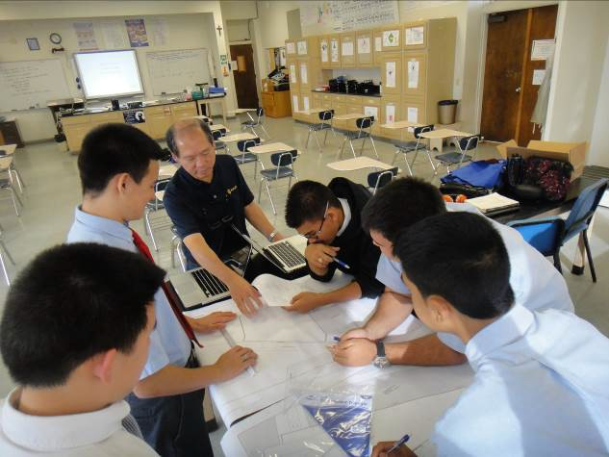
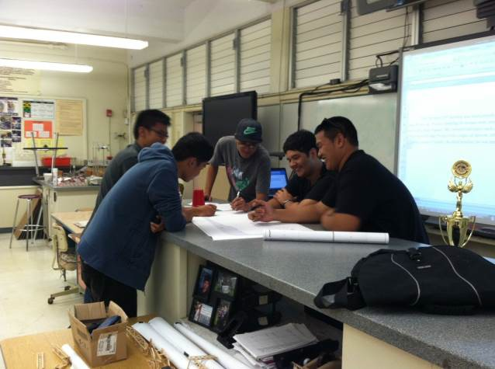
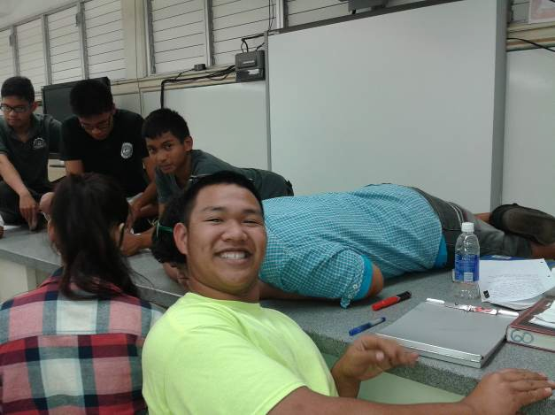
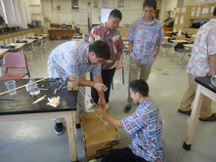

Club Meetings: Club meetings were held twice monthly on campus and after school. The typical meeting was between 60 to 90 minutes. Hands-on activities are the key to keeping students engaged. The ASCE CE Club guide has several activities with detailed instructions to get you started.

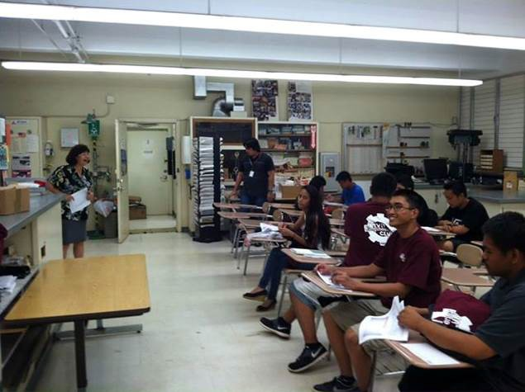
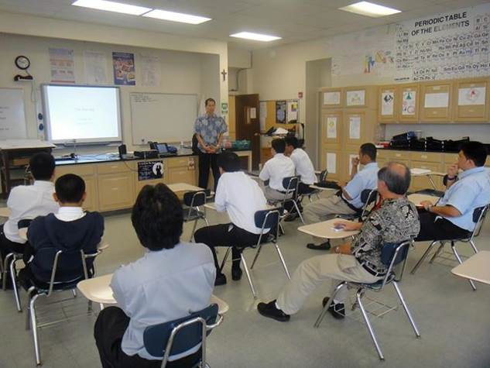
Guest Speakers: Professional engineers and others related to civil engineering took time out of their busy schedule to be guest speakers at the club meetings.

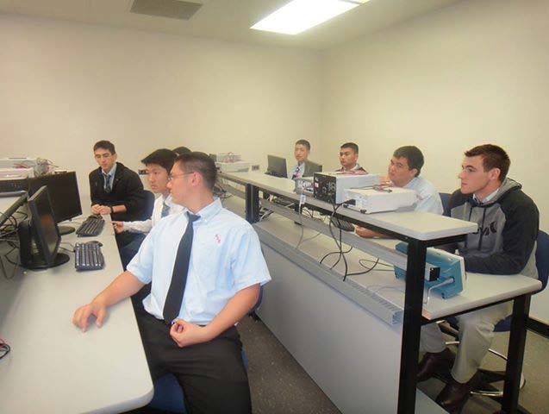
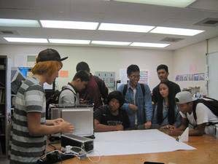
University of Hawaii Campus Visits: The club members had the opportunity to tour the engineering facilities at the University of Hawaii.

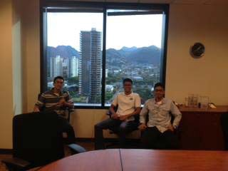
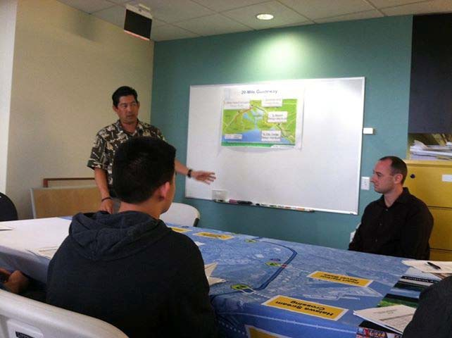

Career Shadowing: Engineering companies donated their time to provide the club members with a “day” in the life of a civil engineer.

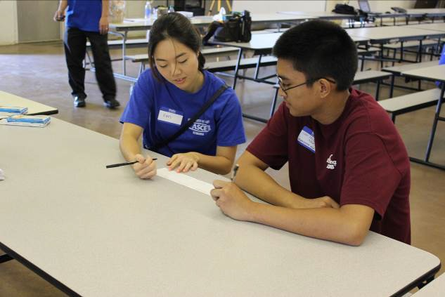
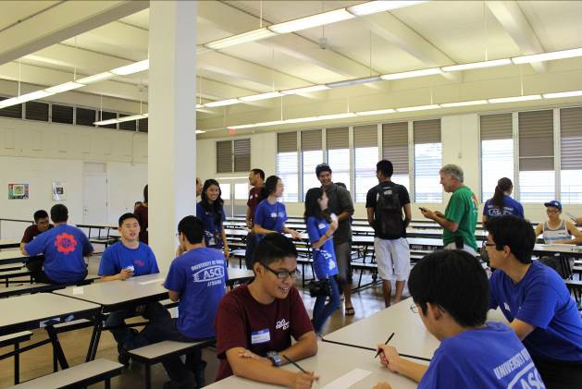

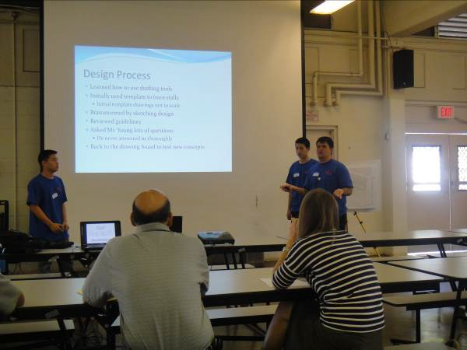

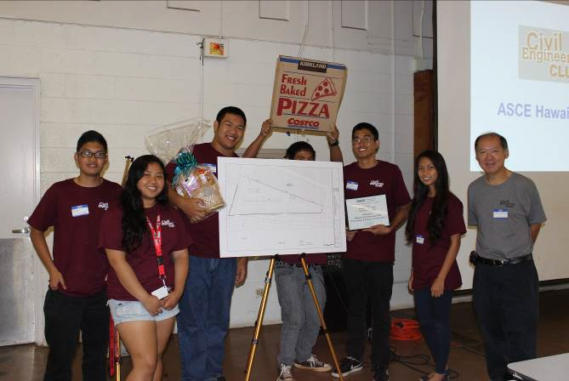
End of Year Gathering: The End of the Year Gathering was attended by the clubs from Farrington High School and Saint Louis School and the ASCE University of Hawaii Student Chapter. Jon Young welcomed everyone to the event and got started by acknowledging all of the volunteers that made the year possible. Next, the two clubs presented their Parking Lot Layout Designs. While the judges tallied their results, the members of the clubs and the student chapter engaged in a 3D Tic Tac Toe competition. The judges provided critique of the designs and announced the Farrington High School CE Club as the winner of the contest. The day ended with a pizza lunch.

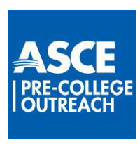

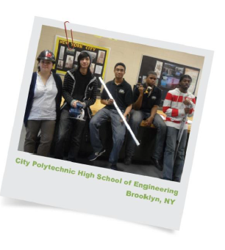

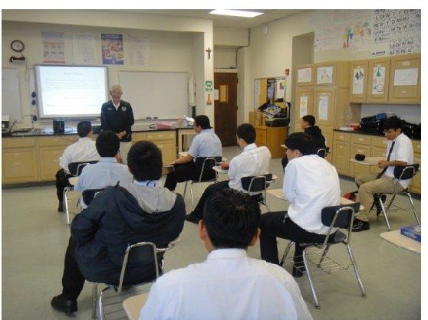

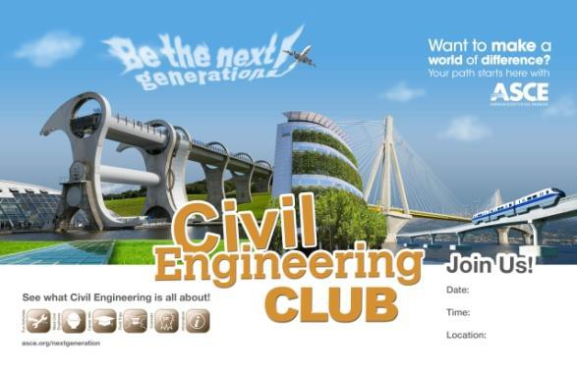
Civil Engineering Club

- sponsored by ASCE

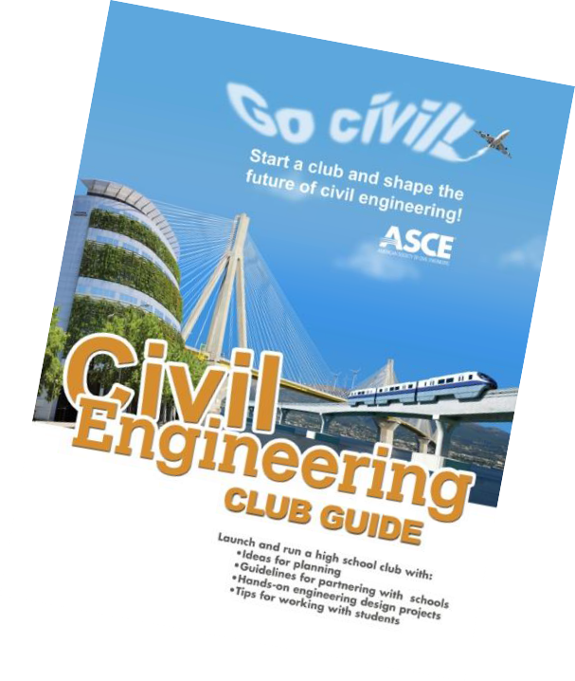

What is Civil Engineering Club?

- After-school club for High School students

- Recommended for Students with expressed interest
in engineering/STEM

- Student Centered

- Activity Based

- Vehicle for creating a sustainable partnership

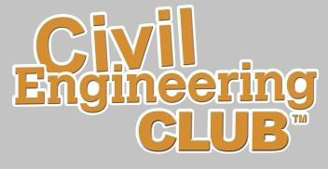

ASCE Hawaii Clubs

Hawaii Club Goals

- Develop an organization

- Provide a uniform experience

- Share resources

- Interact between schools

Hawaii Club Presentation

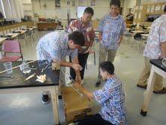
- Club activities

- Club schedule

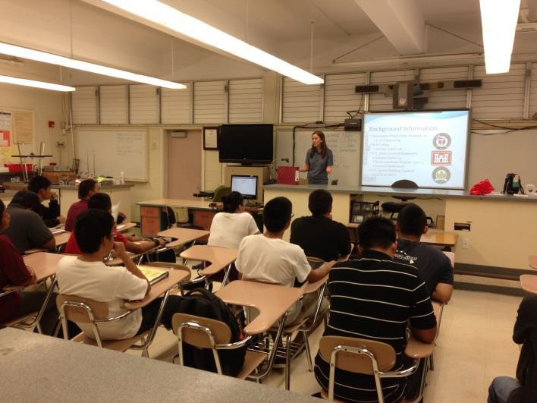
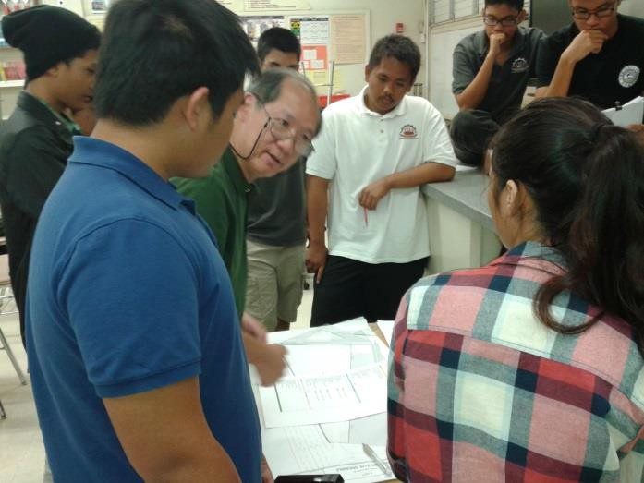
- Newsletter

Goals for the Students

The club activities will accomplish the following goals:
- Learn the design process
- Improve problem solving abilities
- Improve written and spoken communications
- Improve time management
- Practice team work and respect for others
- Show appreciation
- Value giving back to your community
- Learn about college – opportunities, meet students

Club Activities

Club Meetings

- After school

- 60 to 90 minutes long

- Twice monthly
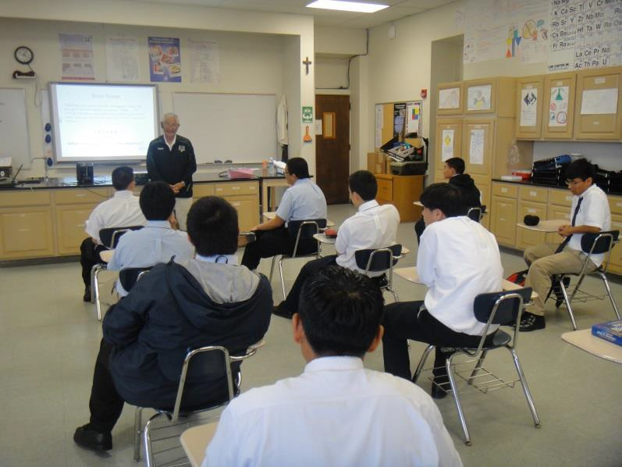

Meeting Agenda
Items:
- Club Business
- Guest Speakers
- Brain Teasers (i.e. SO ND JF ??)
- Activity (i.e. marshmallow
tower
- ASCE Module (i.e. bridges)
- Design Contest (i.e. parking lot
layout)

University of Hawaii Campus Visit

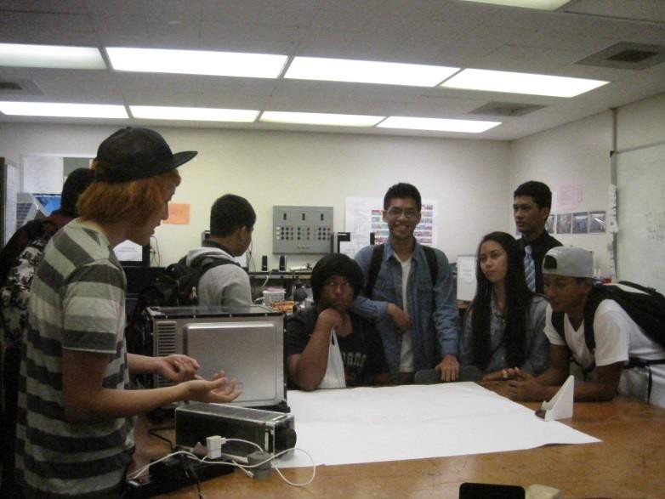
- Visit Holmes Hall -- UH Manoa Campus

  - Learn about the college

  - Engineering labs

  - Classrooms

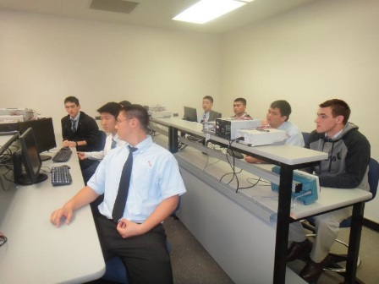
  - Meet college students

Priority are Juniors

Career Shadowing

- Visit Consulting Companies

  - Small group – 5 students maximum

  - See the inside of a consulting firm

  - Learn what engineers do

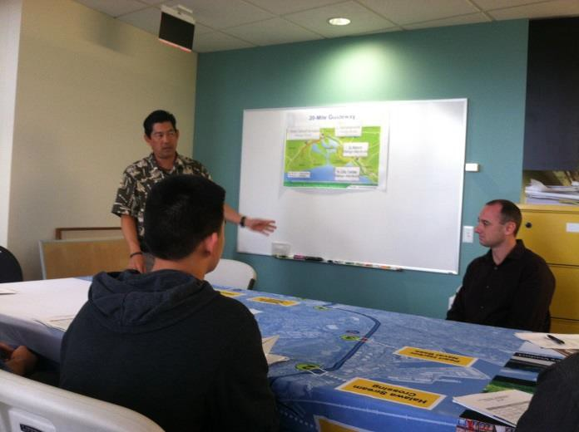
  - Understand the other professions that are needed to operate a consulting firm

Priority are Seniors

Site Visits

- Possibilities:

  - Construction Sites

  - Existing Facilities

  - Manufacturing Sites

- Where Applicable –

Discuss the design process

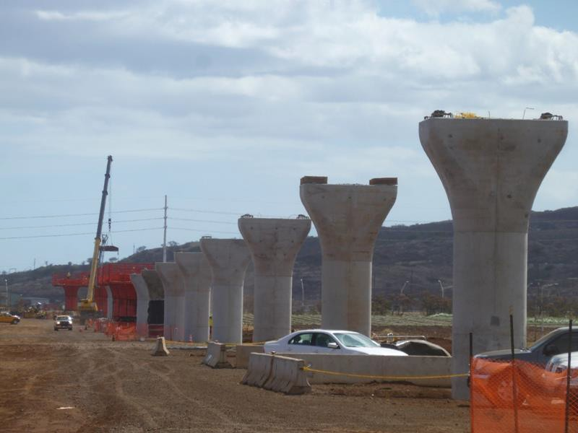

Possible Site Visit: Rail Project in Kapolei

Service Projects

- Club members are encouraged to participate in service projects to give back to the community

- Join the ASCE Student Chapter on their service projects

- Opportunity to meet UH students

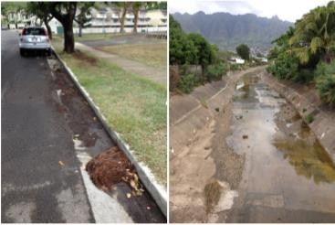

Hahaione Stream & Street Clean Up

Guest Speakers

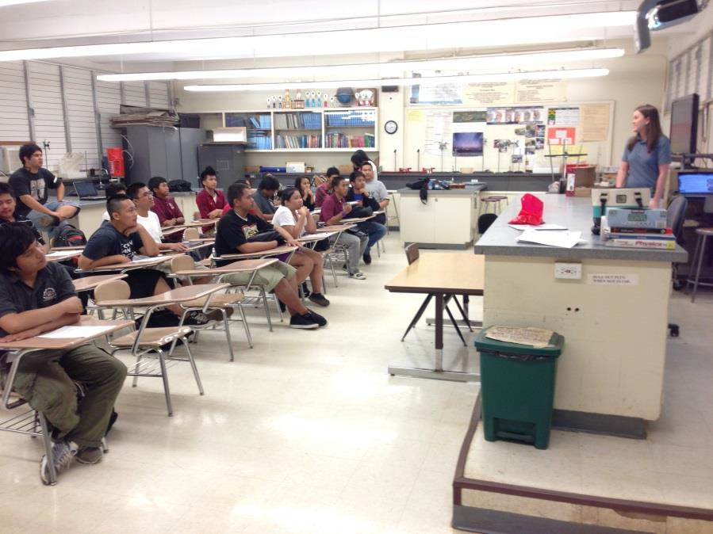
    - All speakers:
  - High school
  - College
  - Explain their decision
- Topics:
  - Careers
  - Project affecting their school
  - Other topics of interest to the clubs
- Guest speaker once a quarter

ASCE 2013-14 Engineering Module

Water Module:
- Water Sense Activity -- 1 meeting
- Engineered Water Supplies Activity -- 1 meeting
- Irrigation Activity -- 1 meeting
- Water Filtering Activity -- 2 meetings
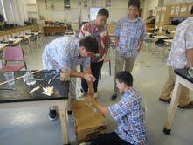
- Optional speaker, field trip, or community service
activities -- 1 – 3 meetings

The Saint Louis School club participated in the testing of the “Irrigation Activity”

2013-14 Design Contest

Parking Lot Layout Design:
- Practice Lot -- 1 meeting
- Lot #1 and regulations -- 1 meeting
- Lot #2 and report format including costs -- 1 meeting
- Lot #3 and judging score sheet -- 1 meeting
- Select lot and CPM schedule – 1 meeting
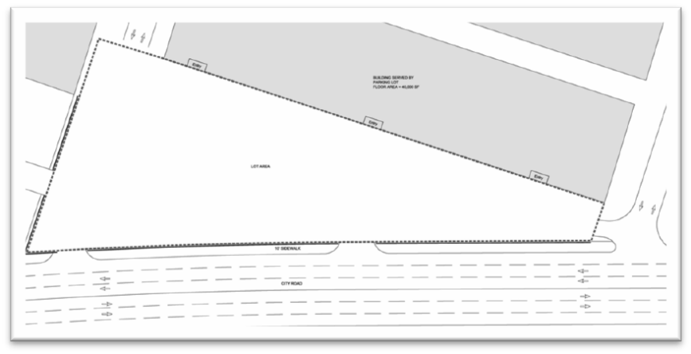
- Work on project -- 1 – 4 meetings
- Top 3 designs will make a presentation
at the end of year gathering

This year’s parking lot to layout
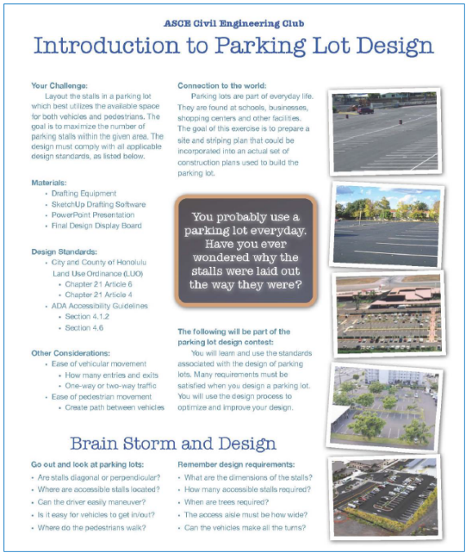

Club T-Shirt Design Contest

- One design for the Hawaii clubs
- Club shirts will be in their school colors

- Design contest between clubs

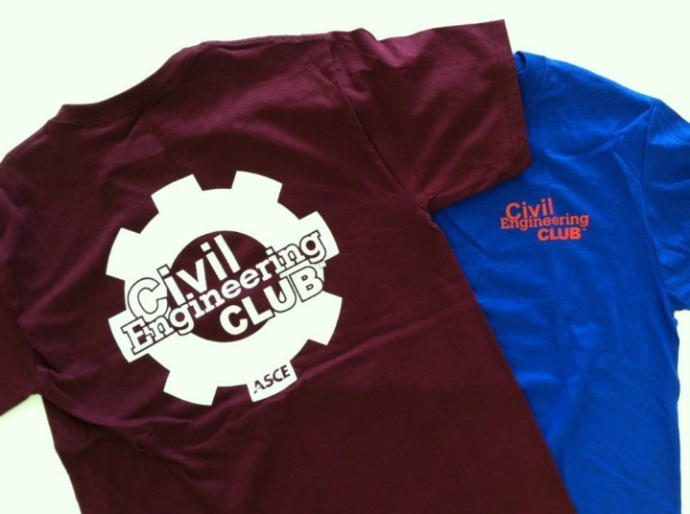

2012-13 Club t-shirt: design by
Farrington High School

Club Schedule

- Club sign-up
1st Quarter

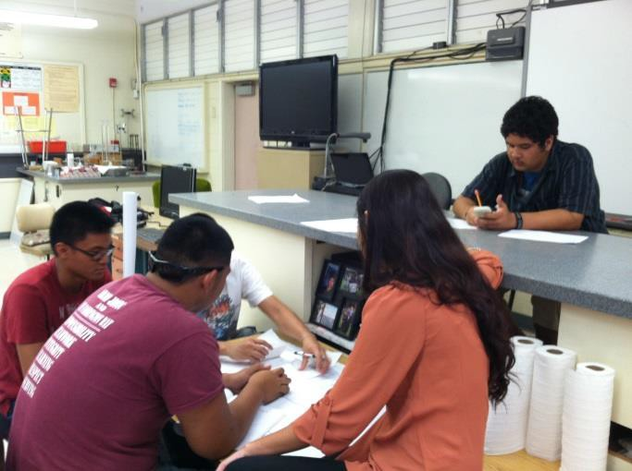
- Club meeting (2 per month)
- Guest speaker
- UH campus visit (juniors)
- Club t-shirt design contest
- Start ASCE module
- Service projects (on-going)

2nd Quarter

- Club meeting (2 per month)

- Guest speaker

- Site visit

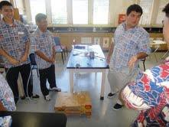
- Complete ASCE module

- ASCE student chapter fun and games

- Service projects

(on-going)

3rd Quarter

- Club meeting (2 per month)

- Guest speaker

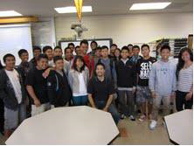
- Career Shadowing (seniors)

- Start design contest

- Service projects (on-going)

4th Quarter

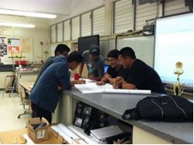
- Club meeting

(2 per month)

- Guest speaker

- Complete design contest
- Service projects (on-going)

- End of year gathering

End of Year Gathering

- Welcome and acknowledgements
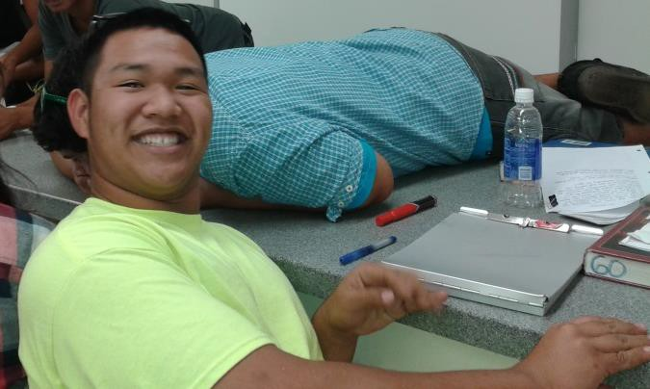
- Design contest presentations
- 3D tic tac toe competition
- Awards:
  - 3D tic tac toe competition
  - West Point Bridge Design contest
  - Judges assessment of design contest entries
  - Design contest awards
- Lunch

CE Club Monthly Newsletter

Content:

- Message from the CE Club Coordinator

- Reports from each school written by the students

- My First Engineering Job

- Calendar of events for upcoming month

- Sponsors logos

CE Club Monthly Newsletter

Distribution:

- Club members

- Club faculty and administration

- Club leaders in Hawaii and the other states

- University of Hawaii STEM staff

- Sponsors

- ASCE student chapter executive committee

- ASCE parent chapter members

- ASCE National CE Club staff

Hawaii Civil Engineering Clubs - 2012-13 Volunteers
Faculty Advisors Farrington High School
  - Bebi Davis, Physics/Robotics Teacher
  - Bob Miller, Building and Construction Teacher
  - Jeremy Seitz, IET Core Teacher
  - Sunghwan Yi, Chemistry Teacher
Saint Louis School
  - Dwayne Yamaguchi, Science Teacher
  - Eric Young, School Community Liaison
Waipahu High School
  - Bill Speed, Director, Academy of Engineering

Lead Engineers
  - Farrington High School – Jon Young, Hawaii Asphalt Paving Industry
  - Saint Louis School – Jon Young, Hawaii Asphalt Paving Industry
  - Waipahu High School – Taka Kimura, Parsons Brinkerhoff

Parking Lot Layout Design Contest Team
  - Mark Rau, dck pacific construction
(leader, student handout, report format, scoring sheet)
  - Kristi Grilho, Belt Collins Hawaii (practice lot)
  - Jami Hirota, Sam O. Hirota, Inc. (plans for lots 1, 2 and 3, judge)
  - Clifton Miyasaki, Fukunaga & Associates, Inc. (regulation handout, judge)
  - Alan Okamoto, Hida, Okamoto & Associates, Inc. (sample plan, unit costs, judge)
  - Jon Young, Hawaii Asphalt Paving Industry (scoring sheet, description of costs)

Career Shadowing
Taka Kimura, Parsons Brinkerhoff – Organizer Participating Companies:
  - AECOM
  - CH2M Hill

University of Hawaii Campus Visit
Jon Young, Hawaii Asphalt Paving Industry – Organizer University of Hawaii at Manoa, College of Engineering
  - Myhraliza Aala, S.T.E.M. Marketing and Public Affairs Officer
  - Student Ambassadors:
    - Jonathan Kutsunai
    - Amanda So
    - Jacob Soares
    - Cathy Wong

Guest Speakers
  - Martha Dawiczyk, Saint Louis School
  - Beverly Ishii-Nakayama, SLSH
  - Lara Karamatsu, Parsons Brinckerhoff
  - Taka Kimura, Parsons Brinckerhoff
  - Mark Watase, Mark Development, Inc.
  - Jessica Wiggs, U.S. Army Corps of Engineers
  - Michael Yee, Howard Hughes Corporation

Service Projects
ASCE Student Chapter, Community Service Committee:
  - Kapiolani Street
  - Leanne Sakamoto

Financial Support
  - ASCE National
  - ASCE Hawaii Section
  - Geolabs, Inc.
  - Sam O. Hirota, Inc.

End of Year Gathering
  - Registration – Lynn Young, Substitute Teacher
  - 3D Score Keeper – Michael Young, Math Teacher, Niu Valley Middle School
  - Photographer – Lindsay Nakashima, Belt Collins Hawaii

ASCE Hawaii Section - Civil Engineering Club™ Activities
Corporate Job Shadowing

INTRODUCTION:

For the 2012-13 school year, ASCE National has started a pilot program of civil engineering clubs in the high school. In Hawaii, three schools – Farrington High School, Saint Louis School, and Waipahu High School – are participating in the pilot programs. Each club meets twice a month and does activities such as field trips, visit to the Holmes Hall and design contest. Corporate job shadowing is another activity that would be great to incorporate into to program.

The ASCE Civil Engineering Club Guide states that “Civil Engineering Clubs are a great way for students to get to know civil engineering in an up close and personal way.” One method of providing this experience to the participating students is to hold job shadowing days where students visit local civil engineering firms to see what happens in an actual engineering office and to speak with practicing civil engineers about their jobs. This provides a real world connection that allows students to see what their lives might be like if they pursue a career in civil engineering. It also allows them to ask questions and delve deeper into specific civil engineering disciplines that may interest them.

THE JOB SHADOWING PROGRAM:

The specific details of the job shadowing day will be largely up to the host company but the following are guidelines that should be followed to provide a similar experience for all students involved. Note that these guidelines are for the minimum that should be done during a shadowing day. Additional activities can be planned at the company’s discretion.

- Students participating in the Job Shadowing program will be high school students with a priority given to seniors.
- The recommended group size visiting any company on a given day is 5 students.
However, each company has the discretion to have a smaller or larger group.
- Students will be responsible for transportation to and from the host company.
- Students will visit with multiple professionals during the day. A good guide is to have the number of participating professionals at least equal to the number of participating students. To get the most from their visit, it is suggested that each professional have a different role at the company to give the students a broad perspective. In addition to engineers, students can visit with CADD operators, planners, contractors, project managers, etc.
- A suggested time for visits with each professional is between 30 minutes to 60 minutes to be determined by the host company. Professionals are encouraged to have an interactive discussion with the students.
- Each company will assign a liaison to serve as the host. The liaison’s responsibilities will be:
  - Greet the students when they arrive
  - Give an introductory presentation that should include some company background, a short bio of each of the engineers that the students will shadow, and an explanation of day’s agenda.

  - Facilitate the Job Shadowing flow by indicating when sessions are done and escorting students to the next visit. If desired, the host company may elect to assign one host engineer to each student who will be responsible for escorting their student from visit to visit.
  - Hold a short closing meeting with all the students to thank them for coming, solicit feedback, answer any lingering questions, and ask for suggestions on how the experience could be improved.
  - Take a group picture with the students and include the participating professionals if they are available.

