Section Operations

5.9 Student Transition – Lehigh Valley Section
1. Section, Branch | Lehigh Valley Section
2. Section/Branch Size | Large
3. Project Contact
Name | Gregory Kuklinski, P.E., M. ASCE
Phone Number | (484) 221-6763
Email | gkuklinski@benesch.com
4. Project Category | Section Operations
5. Project Description | Student Transition techniques
6. The Process  (What you did, When and How) | See attached PowerPoint and word document description
7. Those in Charge (Committee, Task Committee, Etc.) | Practitioner Advisors, Student Relations Committee (Section)
8. Time Frame  (When Started, When Completed) | Past 3 years
9. Success Factors  (The Parts that Worked Really Well) | See attached documents
10. Setback Factors  (The Parts that did Not Work Well) | See attached documents
11. Creativity  (This is something off the wall that we did) | See attached documents
12. Administration  (What was most Important?) | See attached documents
13. Follow-Up  (What was most important?) | See attached documents
14. Recommendations  (What you should ALWAYS do with this project?) | See attached documents
15. Cautions  (What you should NEVER do with this project?) | See attached documents
16. The Outcome | See attached documents
17. Ongoing Activity  (Would you do it again?) | Yes!! It is ongoing every day! In fact, I was talking to the Lafayette students today!
18. Speaker Contact Information
(person from your Region who would be willing to speak about the Best Practice)
Name | Gregory Kuklinski, P.E., M. ASCE
Address | 250 Cetronia Road, Suite 150, Allentown, PA 18104
Phone Number | 484-221-6763
Email | gkuklinski@benesch.com
19. Additional Comments | This Best Practice includes the following attachments:  - Presentation outline  - PowerPoint slides

Lehigh Valley Section Best Practice – Student Transitions
By: Gregory Kuklinski, P.E., M. ASCE

At the MRLC in Portland, OR in 2012, Greg Kuklinski, P.E., M. ASCE gave a presentation on what the Lehigh Valley Section has been doing in the past few years to transition students from Student Members to Associate Members. As a summary from his presentation:

Introduction:
  - Student Members are the future of ASCE
  - Many students do not know that ASCE exists beyond the college campus
  - Once students know the benefits of ASCE after college, they are more likely to stay involved

Importance of Practitioner Advisor – Student Chapter Handbook, 2011
  - A Student Organization usually has a Faculty Advisor and two Practitioner Advisors (PA) appointed by their respective ASCE Section.
  - PA’s, along with Faculty Advisors (FA), serve as the Advisory Personnel for their respective Student Organization.
  - Normally, one of the PA’s is a Younger Member and a recent graduate. PA’s serve as representatives of the local Section/Branch.

Importance of Practitioner Advisor – Best Practice
  - Practitioner Advisor for Lehigh University from 2003‐Present.
  - On‐campus presence and face recognition are very important. Students must know who you are. Being a graduate of the University is a plus.
  - The PA should coordinate activities on campus between Section and YM’s.
  - The PA should recommend professionals to talk to students in class about working in the field.

Importance of Faculty Advisor – Student Chapter Handbook, 2011

  - The Faculty Advisor (FA), an ASCE member, should be appointed by its ASCE Section.
  - The FA is the mainstay of the Student Organization, representing continuity from year to year as Student Organization members change.
  - The FA works with PA’s to educate students about the CE profession.
  - The FA should be an active member of ASCE and keep abreast of incentives/programs relating to student activities.

Importance of the Faculty Advisor – Best Practice
  - At Lehigh U, both FA’s are ASCE members as well as PE’s. They encourage participation with the Steel Bridge and Concrete Canoe Competitions.
  - Students hear about ASCE from their professors and see them help out with ASCE activities which is important.
  - PA’s as well as the Section should have a good working relationship with the FA’s.

Younger Member Interaction
  - Younger Members (Age 35 and under) are the closest generation to the Students.
  - Since many YMG’s have social activities, these are good opportunities to interact with Student Chapters.
  - Presentations about resume writing, life after college and panel discussions (ALONG WITH FREE FOOD!) on campus tend to be extremely popular.

Ideas for Joint Activities with Younger Members
  - Panel Discussion (with local Civil Engineers and Professors as Panelists
  - Hershey Bears Hockey Game
  - Resume Review (Before the Career Fair)
  - Bowling Night
  - Bridge Tour (with a Faculty Advisor)
  - Minor League Baseball or Hockey Game
  - If possible, try and combine activities
  - with multiple Sections / Branches

Section / Branch Interaction
  - Most Sections/Branches have monthly lunch/dinner meetings where students get invited.
  - Section/Branch members are the future employers of the students. Many employers feel that involvement in ASCE is a benefit to the company.
  - A Section/Branch Student Relations Committee is a key link between the PA, FA, and Student Chapter President.
  - Section / Branch mentoring programs

Section / Branch Interaction Best Practices
  - Dedicate at least one monthly meeting to students at their campus and have them give the presentation. Encourage reduced rates for students.
  - Start an awards program to deserving students involved in ASCE.
  - A Student Relations Committee has been a good liaison between ASCE Section and students.
  - Students should be encouraged to attend monthly dinner meetings or provide a subsidy. by their FA and PA.

ASCE Membership Presentation Best Practice
  - ASCE Membership Presentation to all students at Lehigh U. which included:
    - Facts about the ASCE organization
    - Costs of dues after college
    - ASCE publications
    - How to find a Younger Member Group
  - I offered that I will connect students with the Younger Member Chair in the area that the student finds employment.
  - “Yes, there is an ASCE after college.”

SUMMARY
  - Make sure the PA’s are engaged with the students. Having an alumni PA is a plus.
  - Invite FA’s to be on the Section/Branch Board.
  - Have a monthly Section/Branch meeting at your local college.
  - Give a yearly presentation to students about the benefits of ASCE after college. Give them contact information for a YMG in their area of employment.
  - Most importantly, be PROACTIVE!
  - Stay in communication, offer assistance and come to student events on campus.
  - Face recognition is very important!

How to Gain Membership from Student Transitions – College to Professional

Gregory Kuklinski, P.E., M.ASCE

Committee on Geographic Units

Workshop for Section & Branch Leaders Portland, OR
January 13, 2012

Overview

- Introduction

- Importance of the Practitioner Advisor

- Importance of the Faculty Advisor

- Younger Member Interaction

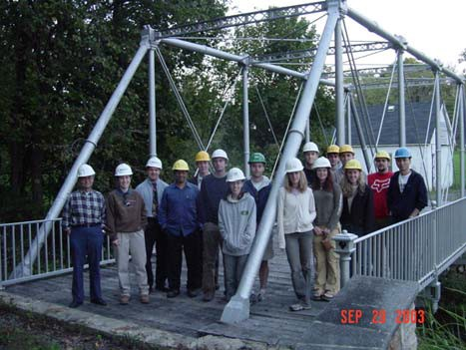
- Section / Branch Interaction

- ASCE Membership Presentation

- Summary

Introduction

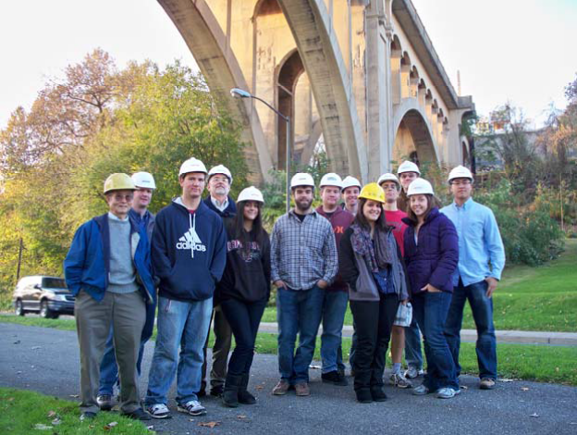

Lehigh University & Lafayette College Students – 2011 Lehigh Valley Section Annual Bridge Tour

- Student Members are the future of ASCE

- Many students do not know that ASCE exists beyond the college campus

- Once students know the benefits of ASCE after college, they are more likely to stay involved

- Goal is to give all of you some Best Practices for your Section / Branch

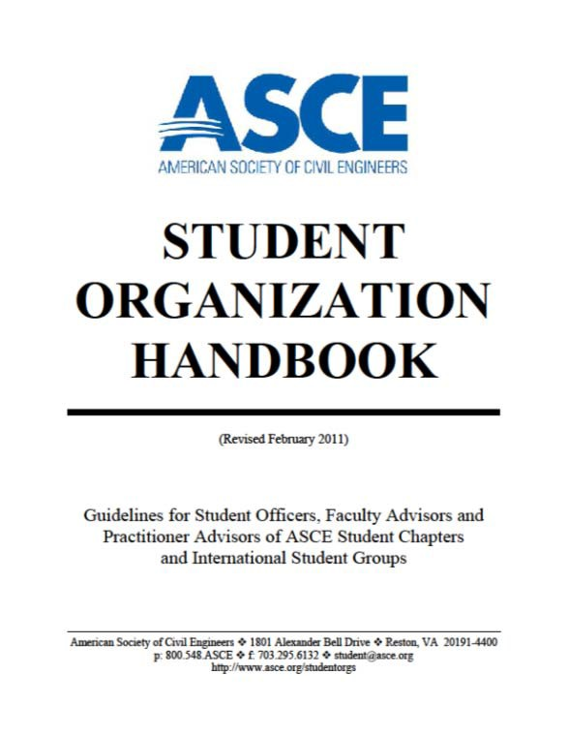

Importance of the Practitioner Advisor

2011 Student Organization Handbook

- A Student Organization usually has a Faculty Advisor and two Practitioner Advisors (PA) appointed by their respective ASCE Section.

- PA’s, along with Faculty Advisors (FA), serve as the Advisory Personnel for their respective Student Organization.

- Normally, one of the PA’s is a Younger Member and a recent graduate. PA’s serve as representatives of the local Section/Branch.

Importance of the Practitioner Advisor

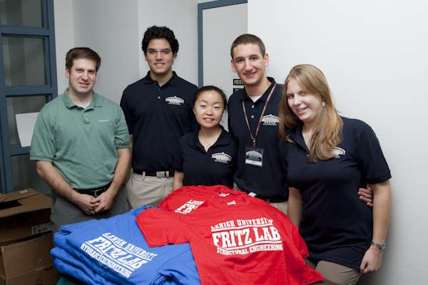
Personal Experience / Best Practices

- Practitioner Advisor for Lehigh University from 2003-Present.

- On-campus presence and face recognition are very important. Students must know who
you are. Being a graduate of the University is a plus.

- The PA should coordinate activities on campus between Section and YM’s.

- The PA should recommend professionals to talk to students in class about working in the field.

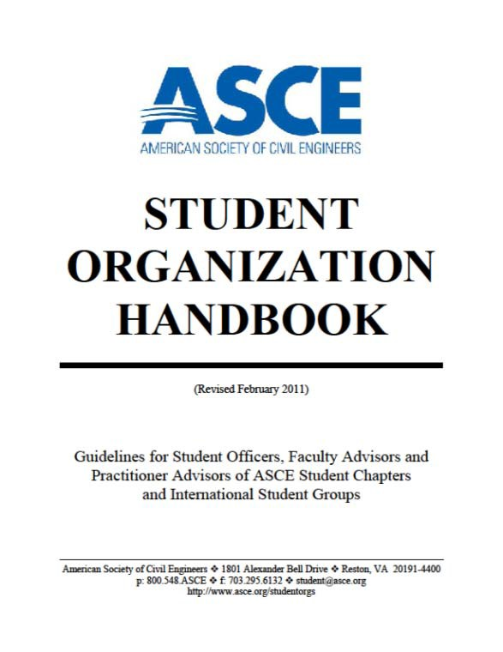

Importance of the Faculty Advisor

2011 Student Organization Handbook

- The Faculty Advisor (FA), an ASCE member, should be appointed by its ASCE Section.

- The FA is the mainstay of the Student Organization, representing continuity from year to year as Student Organization members change.

- The FA works with PA’s to educate students about the CE profession.

- The FA should be an active member of ASCE and keep abreast of incentives/programs relating to student activities.

Importance of the Faculty Advisor

Personal Experience

  - At Lehigh U, both FA’s are ASCE members as well as PE’s. They encourage participation with the Steel Bridge and Concrete Canoe Competitions.

Concrete Canoe Competition
- Students hear about ASCE from their professors and see them help out with ASCE activities which is important.

- PA’s as well as the Section should have a good working relationship with the FA’s.

Younger Member Interaction

- Younger Members (Age 35 and Under) are the closest generation to the Students.

- Since many YMG’s have social activities, these are good opportunities to interact with Student Chapters.

- Presentations about resume writing, life after college and panel discussions (ALONG WITH FREE FOOD!) on campus tend to be extremely popular.

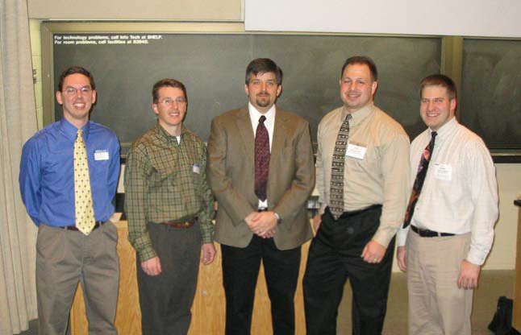
Panel Discussion at Lehigh U.

Younger Member Interaction

Ideas for Joint Activities with Younger Members

- Panel Discussion (with local Civil Engineers and Professors as Panelists

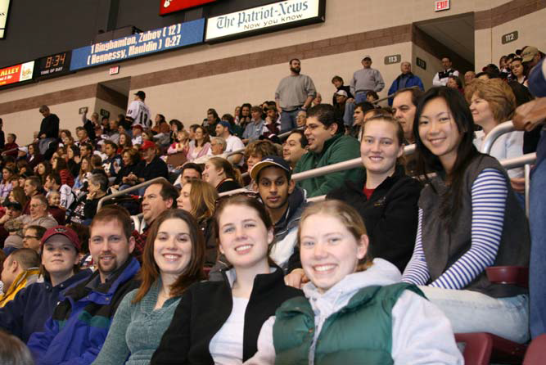
- Resume Review (Before the Career Fair)

- Bowling Night

- Bridge Tour (with a Faculty Advisor)

- Minor League Baseball or Hockey Game

If possible, try and combine activities with multiple Sections / Branches

Hershey Bears Hockey Game

Section / Branch Interaction

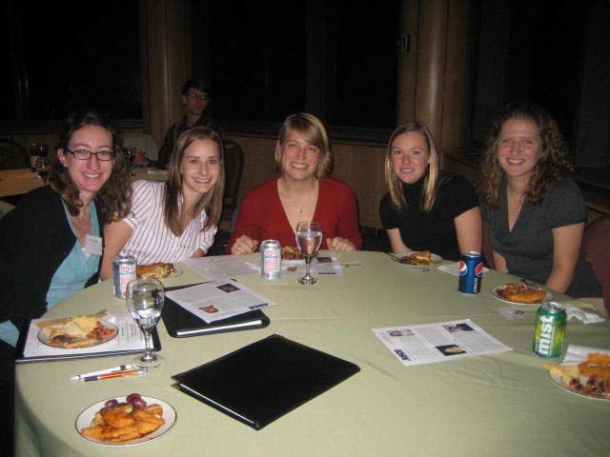
Lehigh U. students at Section Dinner Meeting

- Most Sections/Branches have monthly lunch/dinner meetings where students get invited.

- Section/Branch members are the future employers of the students. Many employers feel that involvement in ASCE is a benefit to the company.

- A Section/Branch Student Relations Committee is a key link between the PA, FA, and Student Chapter President.

- Section / Branch mentoring programs

Section / Branch Interaction

Personal Experience

- Dedicate at least one monthly meeting to students at their campus and have them give the presentation. Encourage reduced rates for students or provide a subsidy.
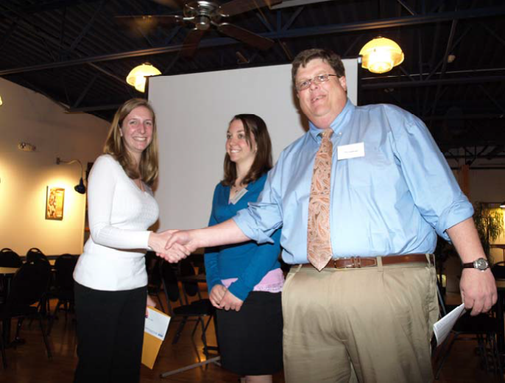

➢Start an | awards | program | to
deserving | students | involved | in
ASCE.

➢A Student Relations Committee has been a good liaison between Section and students.

2011 Lehigh Valley Section Student Award Winner
➢Students should be encouraged to attend monthly dinner meetings by their FA and PA.

ASCE Membership Presentation

Personal Experience

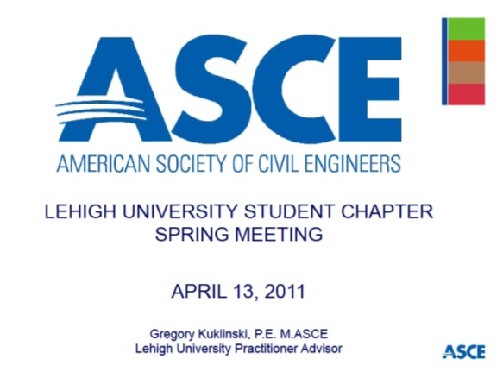
- ASCE Membership Presentation to all students at Lehigh U. which included:

 Facts about the ASCE organization

 Costs of dues after college

 ASCE publications

 How to find a Younger Member Group

BEST PRACTICE: I offer that I will connect students with the Younger Member Chair in the area that the student finds employment.

- “Yes, there is an ASCE after college.”

Summary

Best Practices for your Section / Branch

- Make sure the PA’s are engaged with the students. Having an alumni PA is a plus.

- Invite FA’s to be on the Section/Branch Board.

- Have a monthly Section/Branch meeting at your local college.

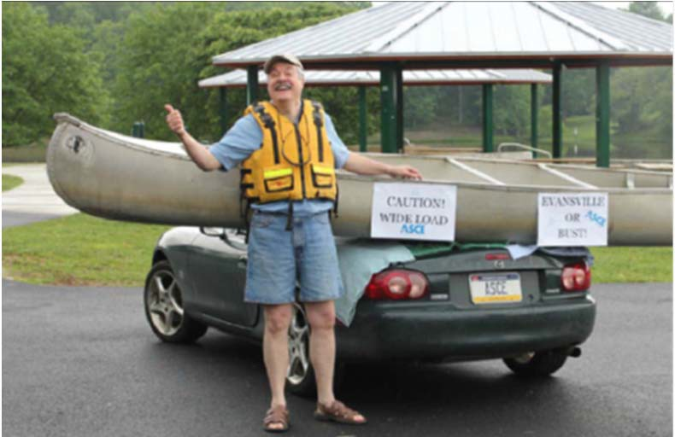
- Give a yearly presentation to students about the benefits of ASCE after college. Give them contact information for a YMG in their area of employment.

- Most importantly, be PROACTIVE!
Stay in communication, offer assistance and come to student events on campus.

Face recognition is very important!

Questions??

Questions??

Gregory Kuklinski, P.E., M.ASCE Alfred Benesch & Company Allentown, PA gkuklinski@benesch.com

Lehigh University Practitioner Advisor Committee on Geographic Unit

