Section Operations

5.4 Indoor Putt-Putt Golf and Corn Hole Tournament Fundraiser – Maryland Section
1. Section, Branch | Maryland Section
2. Section/Branch Size | Medium
3. Project Contact
Name | Keith Duerling
Phone Number | (410) 615-1954
Email | kduerling@ascemd.org
4. Project Category | Section Operations
5. Project Description | An annual indoor putt-putt golf and corn hole tournament is held to raise funds for college scholarship endowments. A local hotel is contracted to allow us to set up indoor golf holes and corn hole games in their banquet facility. Fees are charged to participants and event sponsors. Food and drinks are served. A raffle of donated items is also included.
6. The Process  (What you did, When and How) | A contract is reached with the hotel to house and cater the event. Golf putters were donated by a local golf facility. Companies set up, and break down, the holes on the day of the event and provide corn hole boards.
7. Those in Charge (Committee, Task Committee, Etc.) | The Maryland Section Scholarship Committee manages the event. Funds raised are distributed to endowments at the three engineering universities in Maryland.
8. Time Frame  (When Started, When Completed) | Advertise in the winter, hold the event in March and the complete the accounting by Summer.
9. Success Factors  (The Parts that Worked Really Well) | Companies are encouraged to build and decorate their own holes. The three judged to be best win prizes. Companies can be event sponsors. Premium sponsors have their names on give-away backs and can provide advertisement contents for the bags.
10. Setback Factors  (The Parts that did Not Work Well) | Making sure that there is enough help to run the event. We have a committee of about 12 people.
11. Creativity  (This is something off the wall that we did) | We have a different theme every year; attendees are encouraged to dress according to the theme, and create golf holes to match the theme. Some of the hole designs are very innovative!
12. Administration  (What was most Important?) | Keeping records of commitments and payments. Making sure the facility is laid out. Registration is set up at the event and giveaways are provided.
13. Follow-Up  (What was most important?) | Receiving payments from firms that made commitments.
14. Recommendations  (What you should ALWAYS do with this project?) | Get younger members and student chapters involved.
15. Cautions  (What you should NEVER do with this project?) | Never forget that the goal of the project is to enhance the scholarship endowments at the three universities under the Maryland Section’s area of responsibility. Need plenty of space. Need to price the sponsorships and attendees right to make money but encourage participation.
16. The Outcome | We raise over $10,000 annually for ASCE scholarship endowments.
17. Ongoing Activity  (Would you do it again?) | Yes, this year will be our 26th year!
18. Speaker Contact Information
(person from your Region who would be willing to speak about the Best Practice)
Name | Keith Duerling
Address | 1209 St. Andrews Way, Baltimore Maryland 21239
Phone Number | 410-615-1954
Email | kduerling@ascemd.org
19. Additional Comments | This Best Practice includes following attachments:  - Photos of the fundraising event attached.

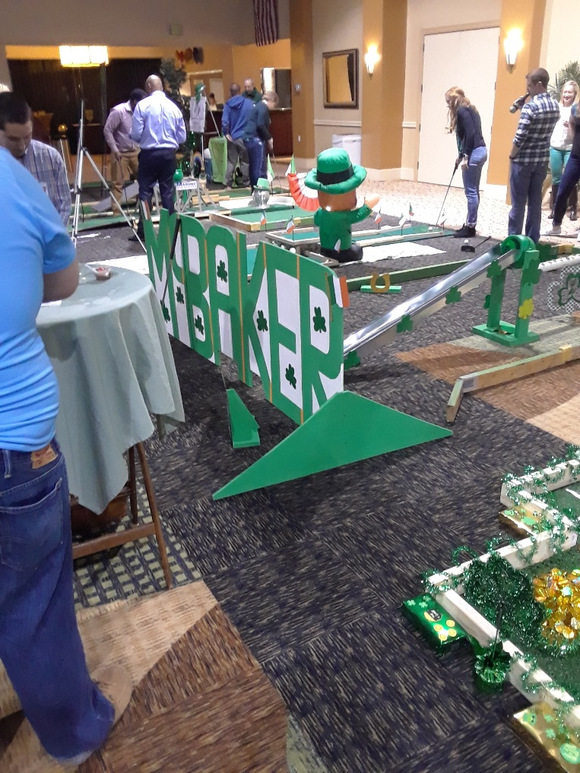

Photo 1. Putt-putt golf area.

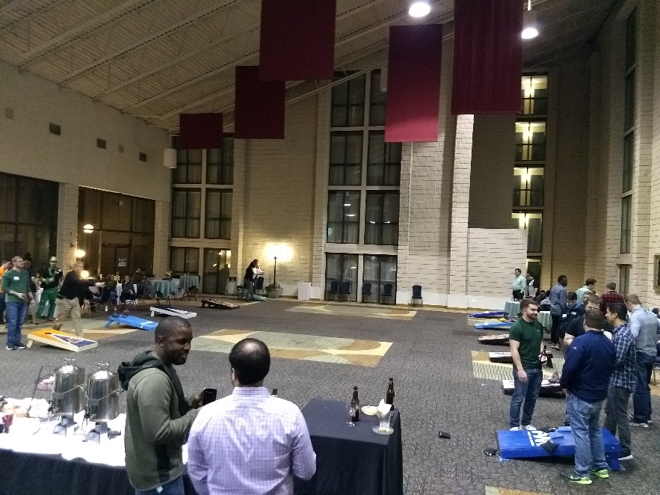

Photo 2. Corn hole area.
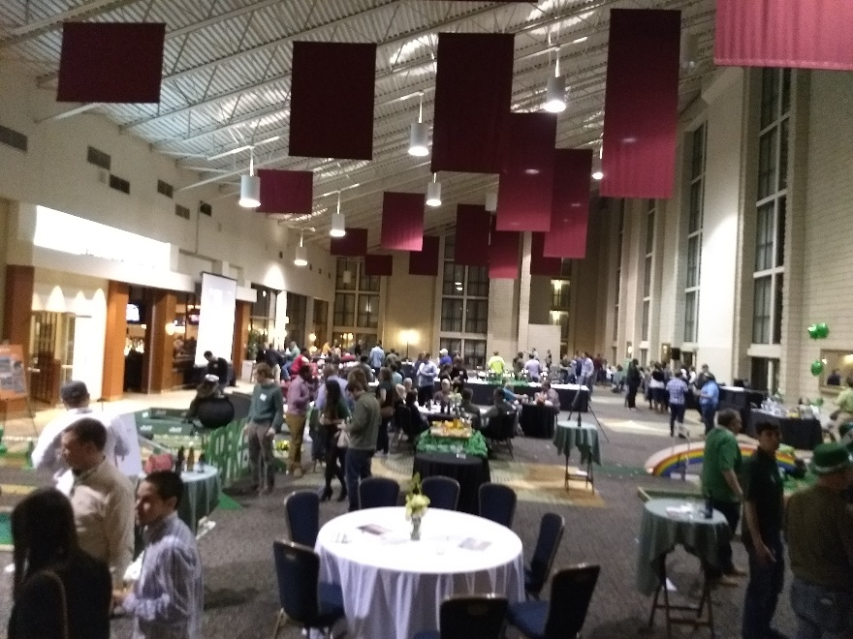

Photo 3. General view of event.

