Section Operations

5.3 Meeting Speaker Selection – Baton Rouge Branch
1. Section, Branch | Louisiana Section, Baton Rouge Branch
2. Section/Branch Size | Medium
3. Project Contact
Name | Jack Koban, PE PG
Phone Number
Email | programs@ascebr.org
4. Project Category | Section Operations
5. Project Description | The project involved targeting a high turnout at local Branch luncheons.
6. The Process  (What you did, When and How) | Selecting speakers and topics of interest to our membership.
7. Those in Charge (Committee, Task Committee, Etc.) | Director of Programs
8. Time Frame  (When Started, When Completed) | Continual.
9. Success Factors  (The Parts that Worked Really Well) | Getting speakers that could provide worthy PDH topics, providing an Ethics PDH.
10. Setback Factors
(The Parts that did Not Work Well)
11. Creativity
(This is something off the wall that we did)
12. Administration
(What was most Important?)
13. Follow-Up
(What was most important?)
14. Recommendations  (What you should ALWAYS do with this project?) | Meetings with PDH topics bring the membership together more so than those that don’t provide PDH. Meetings with Public Figures also gather the membership together.
15. Cautions
(What you should NEVER do with this project?)
16. The Outcome | Elevated membership turnout at branch functions.
17. Ongoing Activity
(Would you do it again?)
18. Speaker Contact Information
(person from your Region who would be willing to speak about the Best Practice)
Name
Address
Phone Number
Email
19. Additional Comments

5 – Section Operations
5.4

5.4 Indoor Putt-Putt Golf Tournament Fundraiser – Maryland Section
1. Section, Branch | Maryland Section
2. Section/Branch Size | Medium
3. Project Contact
Name | Keith Duerling
Phone Number | (410) 887-3764
Email | kduerling@baltimorecountymd.gov
4. Project Category | Section Operations
5. Project Description | An annual indoor putt-putt golf tournament is held to raise funds for college scholarship endowments. A local hotel is contracted to allow us to set up indoor golf holes throughout their ground floor and banquet facility. Fees are charged to players and hole sponsors. Food and drinks are provided to the players. A silent auction is also included.
6. The Process  (What you did, When and How) | An agreement was reached with the hotel to house and cater the event. Golf putters were leased from a local golf facility. Crews are needed to set up, and break down, the holes on the day of the event.
7. Those in Charge (Committee, Task Committee, Etc.) | The Maryland Section Scholarship Committee manages the event. Funds raised are distributed to the three engineering universities in Maryland.
8. Time Frame  (When Started, When Completed) | Advertise in the Fall, hold the event in February and the complete the accounting by Summer.
9. Success Factors  (The Parts that Worked Really Well) | Companies are encouraged to build and decorate their own holes. The three judged to be best win prizes.
10. Setback Factors  (The Parts that did Not Work Well) | Making sure that there is enough help to build and break down the holes.
11. Creativity  (This is something off the wall that we did) | Some of the hole designs are very innovative!
12. Administration  (What was most Important?) | Keeping records of commitments and payments. Setting up starting hole assignments for players.
13. Follow-Up  (What was most important?) | Receiving payments from firms that made commitments.
14. Recommendations  (What you should ALWAYS do with this project?) | Get younger members and student chapters involved.
15. Cautions  (What you should NEVER do with this project?) | Never forget that the goal of the project is to enhance the scholarship endowments at the three universities under the Maryland Section’s area of responsibility. The funds should not be diverted to other activities.
16. The Outcome | We have raised over $10,000 annually for our scholarship
17. Ongoing Activity  (Would you do it again?) | Yes, this year will be our 17th year!
18. Speaker Contact Information
(person from your Region who would be willing to speak about the Best Practice)
Name
Address
Phone Number
Email
19. Additional Comments | This Best Practice includes following attachments:  - Photos of the fundraising event

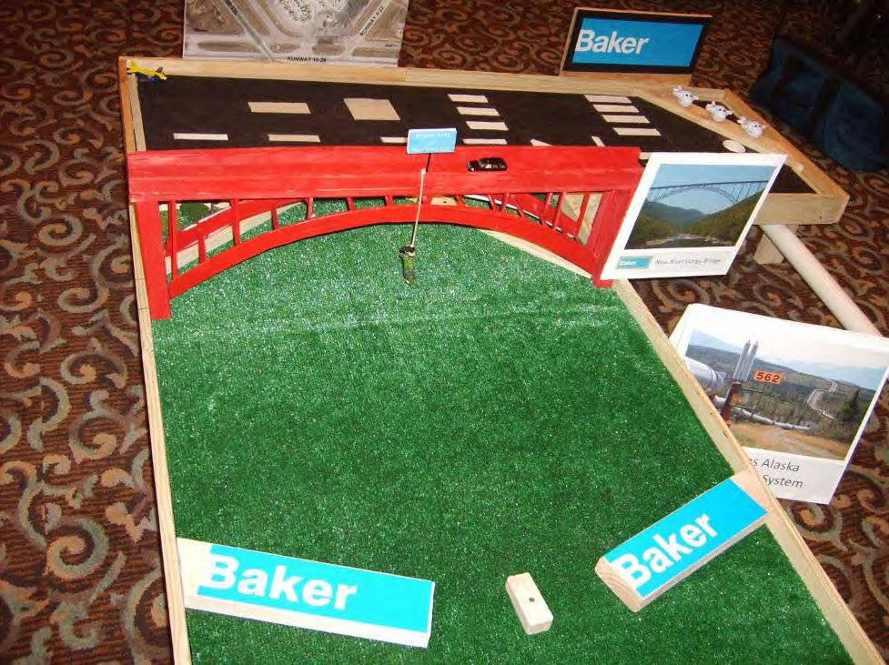

Figure 1: Sponsor designed hole.

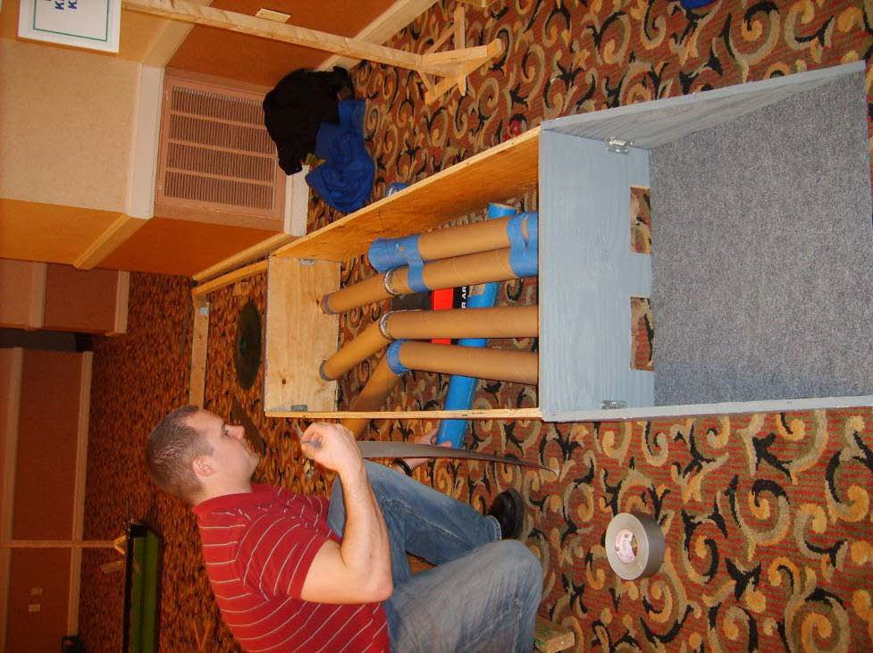

Figure 2: Students and young engineers often assist with hole setup.

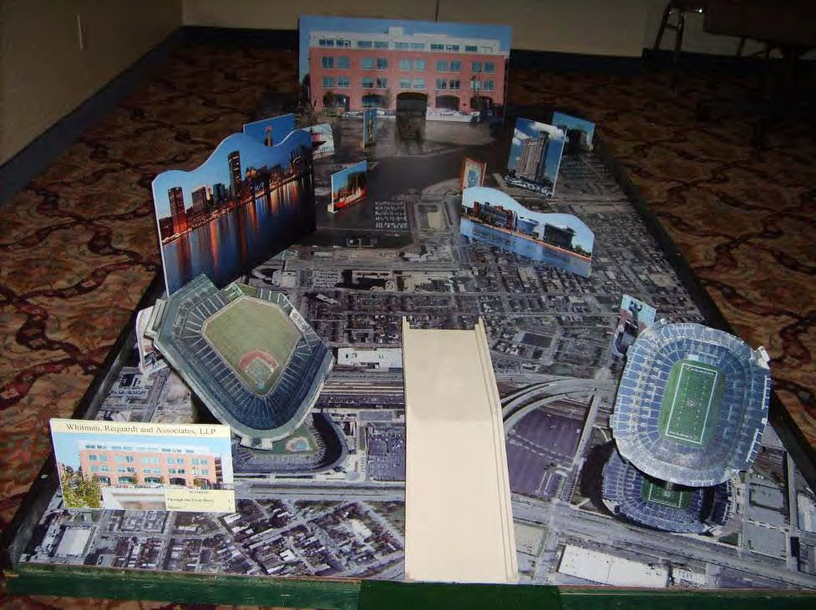

Figure 3: Baltimore themed hole from local engineering firm.

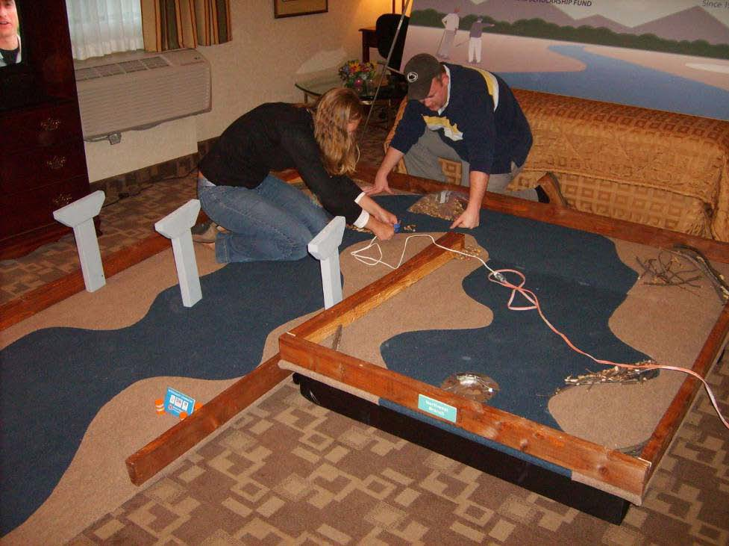

Figure 4: Hole construction often has theme’s (note bridge piers and stream)

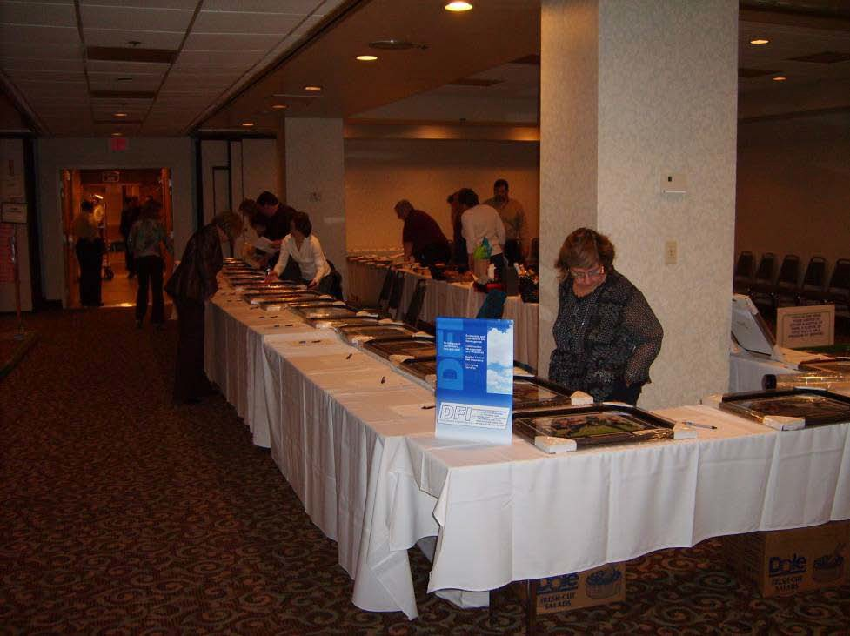

Figure 5: Silent auction setup

5 – Section Operations
5.5

5.5 Section Anniversary Party and Awards Ceremony – New Hampshire Section
1. Section, Branch | New Hampshire Section
2. Section/Branch Size | Medium
3. Project Contact
Name | Brian Vincent
Phone Number | (603) 224-4182
Email | bkih1234@myfairpoint.net
4. Project Category | Section Operations
5. Project Description | 50-year anniversary celebration and Award Ceremony. Awards included NH OCEA award, Student scholarship awards and ASCE Lifetime Membership Awards.
6. The Process  (What you did, When and How) | We carefully selected a venue for the event that was a central location in NH to try and get good attendance. We put some time into selecting a venue that would be more appealing than our usual monthly meeting venues. In the end, the venue we selected was a bit fancier than the usual venues and more expensive. This did mean higher ticket prices, but the food and atmosphere were better quality and perhaps that helped people justify the higher expense. It also helped with creating the atmosphere for the event that we were trying to achieve. We wanted this to be a special event.  We heavily promoted the event to the membership via email announcements and reminders, as well as through the Section Newsletter. We also sent invitations to other area sections. We had members from both the Maine, Vermont and Boston sections attend. Anni Autio, on behalf of BSCES made a special proclamation recognizing the NH Section’s 50th anniversary.  We worked very hard to get a “unique keynote speaker” that would create interest and hopefully a good draw. To save on the expense of a key note speaker, we made an agreement with our speaker that in exchange for him speaking, we could commit a number of volunteers to an annual event he organizes.  The planning process began several months before the event. It seems that this is necessary if you are trying to get a top-notch venue that is affordable along with a top-notch speaker. We tried to select a date that was free and clear from other events put on by the NH Section and other local engineering societies.  We requested and obtained sponsorships from local engineering firms to defray some of the costs, particularly because we invited award winners to attend free of charge.  We also made sure that we had a “full time” photographer at the event (one of our board members).
7. Those in Charge (Committee, Task Committee, Etc.) | Brian Vincent, Britt Audet, Jay Hodkinson and Ken Milender.
8. Time Frame  (When Started, When Completed) | We began planning the event in November 2008 and the event was held in May 2009.
9. Success Factors  (The Parts that Worked Really Well) | The venue, dinner/food was excellent, the registration went well and awards went well. The main speaker had an excellent topic that was appreciated.
10. Setback Factors  (The Parts that did Not Work Well) | Electronics for the main speaker did not work well, and the main speaker presentation seemed to be a little too long. There was a bit of a glitch with the number of tables/seats available, but it was quickly corrected.
11. Creativity
(This is something off the wall that we did)
12. Administration  (What was most Important?) | Staying organized with attendee sign ups, cash flow and committee coordination.
13. Follow-Up  (What was most important?) | Place photographs of the event on our website immediately following the event. Thank sponsors within our section newsletter.
14. Recommendations  (What you should ALWAYS do with this project?) | Make sure electronics ARE going to work. Plan ahead.
15. Cautions  (What you should NEVER do with this project?) | Rush things and leave loose ends and hope for the best.
16. The Outcome | Very well received.
17. Ongoing Activity
(Would you do it again?)
18. Speaker Contact Information
(person from your Region who would be willing to speak about the Best Practice)
Name
Address
Phone Number
Email
19. Additional Comments

5 – Section Operations
5.6

5.6 Seattle City Light’s Diablo Dam Good Dinner Tour – North Branch
1. Section, Branch | Seattle Section, North Branch
2. Section/Branch Size | Small
3. Project Contact
Name | Phil Cohen
Phone Number | (360) 240 5546
Email | philc@co.island.wa.us
4. Project Category | Section Operations
5. Project Description | Provided a private tour opportunity to ASCE Seattle Section & branch members and their families of Seattle City Light’s Diablo Dam Good Dinner Tour on Friday, May 16, 2008. See http://www.ci.seattle.wa.us/light/tours/Skagit/
6. The Process  (What you did, When and How) | I contacted the Seattle City Light tour liaison person and asked for guidance in August 2007. I then started worked on funding, schedule, attendance, publicity, and transportation details until the week before the tour which was May 8, 2008.
7. Those in Charge (Committee, Task Committee, Etc.) | Phil Cohen, ASCE North Branch President, 2007- 2008. Transportation assistance provided by Inga Drechsel, ASCE North Branch President, 2006-2007.
8. Time Frame  (When Started, When Completed) | August 2007 – Made inquiry for private group tour for up to 50 ASCE members & their families and got details of a 3.5-hour tour, lunch, and boat ride.  August 2007 – Contacted ASCE director for north branch and requested funding support from the Seattle Section to help underwrite part of the $55 ticket cost  September 2007 – Started working on bus transportation for Seattle members and North Branch members December 2007 – Confirmed reservations for private tour for May 16, 2008  February 2008 – Worked on getting charter bus for Seattle ASCE members  February 2008 – Discussed risk management aspects of the tour with ASCE Reston, VA March 2008 – Started publicizing the tour with ASCE section and branch newsletters April 2008 – Confirmed final tour numbers with Seattle City Light  April 2008 – Cancelled charter bus and had members carpool to save money. Selected rendezvous location in Sedro-Woolley, WA  May 2008 – Sent out last call for participants  May 16, 2008 – Went on tour
9. Success Factors  (The Parts that Worked Really Well) | - Using an organization that is used to giving large public tours (Seattle City Light) to engineers be our host for the museum, powerhouse and dam tour,  - Getting ASCE to underwrite part of the cost e.g. $35 of a $55 tour  - Taking all day to do the tour  - Getting lucky with the weather: clear sky – temps in the 80’s and incredible alpine scenery all around us  - Car pooling
10. Setback Factors  (The Parts that did Not Work Well) | Trying to coordinate bus schedule with people’s schedule and desired pickup locations
11. Creativity
(This is something off the wall that we did)
12. Administration  (What was most Important?) | Advance planning, and announcements of the tour (publicity)
13. Follow-Up  (What was most important?) | Publicity and in-depth knowledge of the tour components
14. Recommendations  (What you should ALWAYS do with this project?) | Plan in advance by 6 to 8 months, keep the prices within reason.
15. Cautions  (What you should NEVER do with this project?) | Try to plan something of this size in 2 to 3 weeks. Schedule, it at the same time as another ASCE event.
16. The Outcome | Outcome was good. People relaxed during the tour and enjoyed themselves.
17. Ongoing Activity
(Would you do it again?)
18. Speaker Contact Information
(person from your Region who would be willing to speak about the Best Practice)
Name
Address
Phone Number
Email
19. Additional Comments | Some hardship was brought about having the tour on Friday and it created work schedule conflicts for some members so they couldn’t attend. Other members were happy to give up a work vacation day so they could have the full weekend for other activities. Seattle City Light only offered the tour on weekdays.

5 – Section Operations
5.7

5.7 Automated Online Dallas Branch Survey – Dallas Branch
1. Section, Branch | Texas Section, Dallas Branch
2. Section/Branch Size | Large
3. Project Contact
Name | Sean P. Merrell
Phone Number | (972) 464-4834
Email | smerrell@browngay.com
4. Project Category | Section Operations
5. Project Description | Automated Online Dallas Branch Survey
6. The Process  (What you did, When and How) | Early on in the process to develop the new officers and committee chairs, we wanted to get a better understanding of where the Dallas Branch stood in the eyes of our members. This also allowed us to develop programs and speakers for our members based on their responses.
7. Those in Charge (Committee, Task Committee, Etc.) | A committee could be set up, but we believe all the leaders of the Branch have to be involved to develop a well thought out and meaningful survey. No one wants to waste their time answering a silly survey. The webmaster was important for making it user friendly online on our website. It is important for the branch president to follow up with the officers and committee chairs to ensure they utilize the information received from the survey.
8. Time Frame  (When Started, When Completed) | 1 month to develop the survey, 1 month to take the online survey (with a few reminders to our members), 1 month to review and act upon the results and comments from the survey.
9. Success Factors  (The Parts that Worked Really Well) | Pretty much everything worked well
10. Setback Factors  (The Parts that did Not Work Well) | The response rate could have been better. Next time we should encourage members to participate in the survey by offering random prizes to those who take the survey.
11. Creativity  (This is something off the wall that we did) | Utilized the automated survey module from our Branch website.
12. Administration  (What was most Important?) | Developing useful and well thought out questions.
13. Follow-Up  (What was most important?) | Make sure the officers and committee chairs review the results and comments from the survey. Be sure to thank those who participated in the survey.
14. Recommendations  (What you should ALWAYS do with this project?) | Make sure you brainstorm with all your branch officers and committee chairs on what sort of information you want to ask your members about. Then be sure to review all the developed questions (and answers) with the branch officers as well
15. Cautions  (What you should NEVER do with this project?) | Ask too many questions. Make the survey too long. Constantly bug them to fill it out.
16. The Outcome | A good overview of how our members see how the branch is providing to their needs. It also gave us a good direction on what type of speakers and meeting location we should be looking for in the future. Overall it really gives you the pulse of the members.
17. Ongoing Activity  (Would you do it again?) | Yes, but not more than once a year at the branch level. We might even offer a random prize or two to those who complete the survey next time.
18. Speaker Contact Information
(person from your Region who would be willing to speak about the Best Practice)
Name
Address
Phone Number
Email
19. Additional Comments | This Best Practice includes the following attachments:  - Survey results
.

