Section Operations

5.10 100 Year Anniversary – Georgia Section
1. Section, Branch | Georgia Section
2. Section/Branch Size | Large
3. Project Contact
Name | Lisa S. Woods, P.E., F.SEI, M. ASCE, 2012-2013 Georgia Section President
Phone Number | (404) 274-2785
Email | lswpe1@gmail.com
4. Project Category | Section Operations
5. Project Description | The Georgia Section celebrated its 100-year anniversary in 2012. The Georgia Section was proud to be able to promote civil engineering in many different ways in 2012. The celebration included electronic billboards located around Atlanta during Engineers Week in February, publishing a book celebrating 100 years of civil engineering excellence in Georgia, publishing articles highlighting different aspects of civil engineering in the Georgia Engineer magazine throughout the year, and hosting a historic civil engineering walking tour through downtown Atlanta. The GA ASCE Annual Meeting & Centennial Gala was held September 7th at the Georgia Tech Hotel and Conference Center with ASCE National President Andy Herrmann in attendance. Georgia Section Past Presidents were also honored. A special centennial logo and bookmarks were created for the occasion and a centennial display was produced that anchored a booth at the 2012 ASCE Annual Civil Engineering Conference in Montreal. Governor Deal declared September 7, 2012 Civil Engineering Day in Georgia and the Georgia Section also rolled out a new website during the Centennial year.  Please check out www.ascega.org.  Centennial Gala  The Georgia Section celebrated its Centennial with a spectacular Gala at the Georgia Tech Hotel and Conference Center on September 7, 2012. A comedian and motivational speaker served as Master of Ceremonies and Reginald DesRoches, PhD, Chair of the Georgia Tech School of Civil & Environmental Engineering, welcomed the over 120 attendees.  Melissa Wheeler and Katherine Gurd, PE provided a picture-filled presentation showing 100 years of civil engineering in Georgia and unveiled the book ASCE Georgia 1912-2012: Celebrating 100 Years of Engineering Excellence. Fourteen Past Presidents of Georgia ASCE were present and recognized.  Society ASCE President Andrew Herrmann, PE, SECB was the Guest Speaker, speaking on infrastructure needs in the United States. Ernie Pollitzer, PE presented project and engineer of the year awards.  The evening ended with the installation of the 2012-2013 Board of Directors and passing of the gavel. A raffle of Atlanta Falcons tickets raised over $500 for the ASCE Georgia Scholarship Fund. The event was an outstanding commemoration of 100 years of ASCE in Georgia.  Centennial Commemorative Book  The Centennial Commemorative Book celebrates 100 years of engineering excellence in Georgia. The book showcases 31 unique projects that forever changed Georgia. Written from the unique perspective provided by civil engineers, the book celebrates civil engineering in Georgia by highlighting significant projects. In coinciding with the Georgia Section’s centennial (1912 – 2012), the projects are intertwined with major events that occurred during the time period, such as World War II, the 1996 Atlanta Olympic Games, and the growth of Georgia’s population from 2.5 million to nearly 10 million.  The commemorative edition features over 90 photographs, including many unique and historical images that offer insight into the growth of Georgia in the last 100 years. The book spotlights significant achievements such as construction of the tallest hotel in the western hemisphere (Westin Peachtree Plaza), the world’s busiest airport (Atlanta Hartsfield-Jackson International Airport) and the fourth-busiest port in the United States (Port of Savannah). The book was written mainly by Georgia Section ASCE members.  Development of the book was spearheaded by the ASCE Georgia Section Centennial Committee, which was led by Melissa Wheeler, M. ASCE and Katherine McLeod Gurd, P.E., M.ASCE. The team spent countless hours digging through old records and documents to put this historic book together. All team members contributed to the development of this book, which we feel is representative of the enormous impact that civil engineers have made to Georgia’s growth during this time period.  Get Your Copy!! Pick up your copy online at http://www.ascega.org/georgia-asce-centennial-book/.
6. The Process  (What you did, When and How) | Just the book alone was a huge undertaking, so make sure that you have a nice size committee and spread out the work and dates of activities.
7. Those in Charge (Committee, Task Committee, Etc.) | The Section has a History and Heritage standing committee so we added a 100 Year Anniversary Committee underneath that. Chairs were Melissa Wheeler and Katherine Gurd.
8. Time Frame  (When Started, When Completed) | We began brainstorming ideas about a year in advance. Each project for the centennial celebration needed its own champion/committee and schedule.
9. Success Factors  (The Parts that Worked Really Well) | We had an excellent committee that successfully planned and completed many events/ideas in a short timeframe.
10. Setback Factors  (The Parts that did Not Work Well) | We have had some issues with the book. Make sure that you sign a contract and work with a reputable publisher.
11. Creativity  (This is something off the wall that we did) | I know this is a stretch but off the wall for us – we hired a comedian and motivational speaker that served as Master of Ceremonies for our Gala.
12. Administration  (What was most Important?) | Finding strong, organized chairs for the committee and dedicated committee members.
13. Follow-Up  (What was most important?) | As with all projects, make sure to check-in and follow-up on all activities along the way.
14. Recommendations  (What you should ALWAYS do with this project?) | Make sure that you have a contract no matter what you do! Make sure that you schedule the ASCE National President way in advance.
15. Cautions  (What you should NEVER do with this project?) | Don’t spread yourself and your committee too thin.
16. The Outcome | All of our events were very successful, and we satisfactorily celebrated such a monumental milestone.
17. Ongoing Activity  (Would you do it again?) | Yes!
18. Speaker Contact Information
(person from your Region who would be willing to speak about the Best Practice)
Name | Lisa Woods
Address
Phone Number | 404-274-2785
Email | lswpe1@gmail.com
19. Additional Comments | This Best Practice includes the following attachments:  - Gala presentation slides

4/24/2013

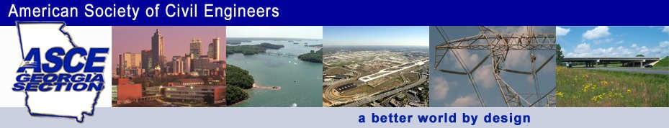
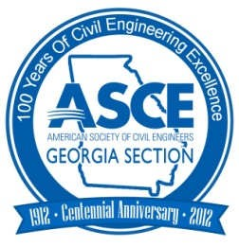

ASCE Georgia Section
Celebrates 100 Years of Civil Engineering Excellence

Ideas for Section/Branch Milestone Activities
Presidents and Governors Forum September 24, 2012

Lisa S. Woods, P.E., F.SEI, M.ASCE
Georgia Section President

About the Georgia Section

Founded in 1912
3000 members Georgia Section – Atlanta
Branches – Northeast (Athens), Savannah, South Metro (Atlanta)

4/24/2013

Milestone Planning

Determine List of Activities
What? When? Who? How?
How much?

Needs
•Committee Support
•Talented Members
•$$$
•Sponsors
•SPAG ®

Logo
Centennial Activities

Georgia Engineer Magazine Articles Billboards
Bookmarks Centennial Book Centennial Display
Historic Downtown Atlanta Walking Tour

4/24/2013

Centennial Activities
Civil Engineering Day in Georgia – Governor Proclamation
Annual Meeting and Gala
Update of Website – www.ascega.org

Centennial Logo

4/24/2013

Georgia Engineer Magazine - Centennial Articles
Introductory Article
100 years of Transportation (Roads, bridges, airports) 100 years of Environmental Protection (Env rules, erosion
control, remediation, solid waste)
100 years of Water Resources (Water Supply, Wastewater, Dams, drinking water treatment, stormwater)
100 years of Growth (key buildings, geotechnical, parks, pipelines)
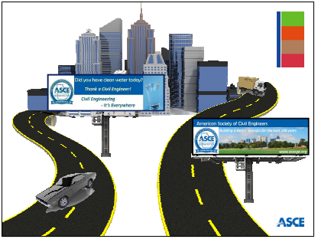
100 years of Energy

4/24/2013

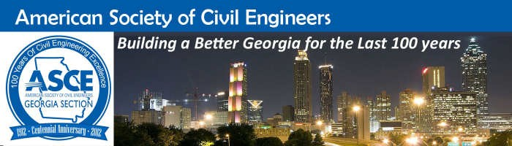

Billboards and Bookmarks

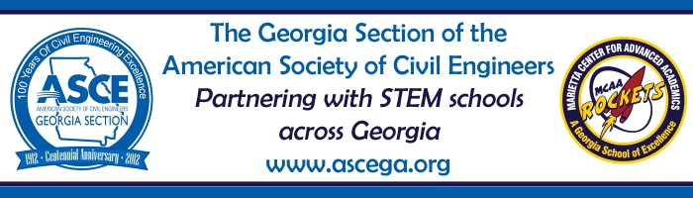
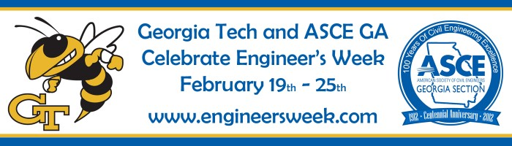

Billboards and Bookmarks

4/24/2013

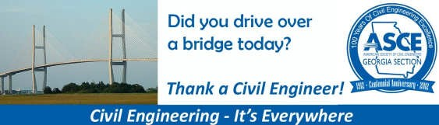

Billboards and Bookmarks

Electronic
Billboard Specifics

Clear Channel – 6 billboards – 62,842 spots - $1500 Clear Channel - 2 billboards - free
Georgia Tech – 1 billboard - free
Simple Message – Thank a Civil Engineer Reached 3.5 million motorists
9 different designs
11 days during Engineers Week

4/24/2013

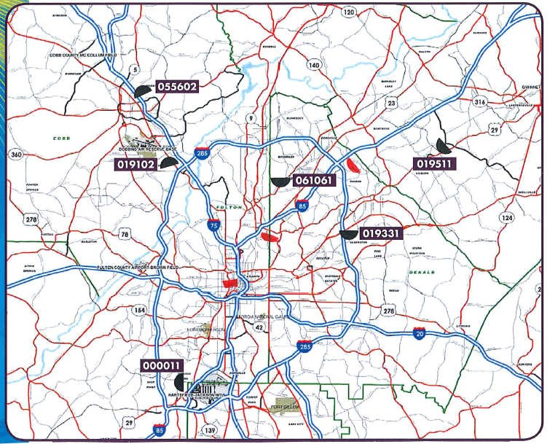

Billboard Map

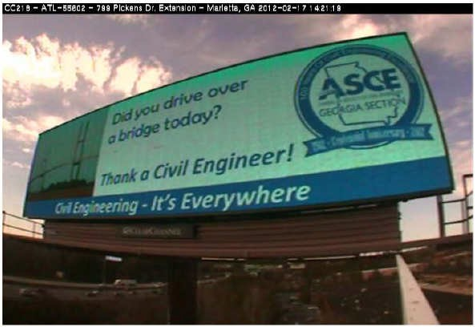
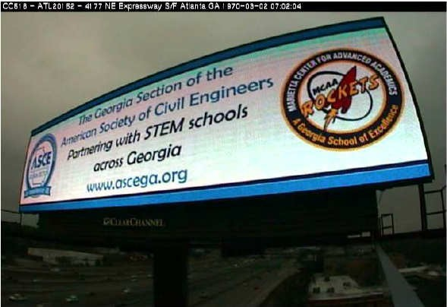

Billboard Photos

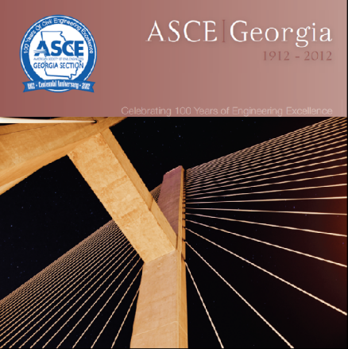
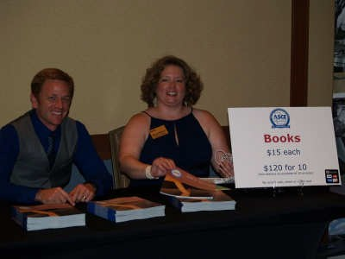
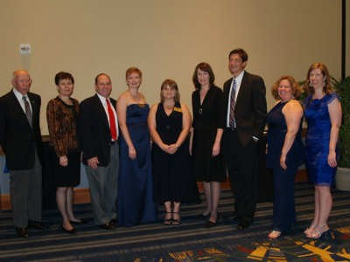
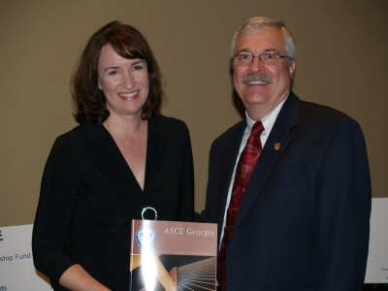
4/24/2013

100 Years of Civil Engineering in Georgia Book

100 Years of Civil Engineering in Georgia Book

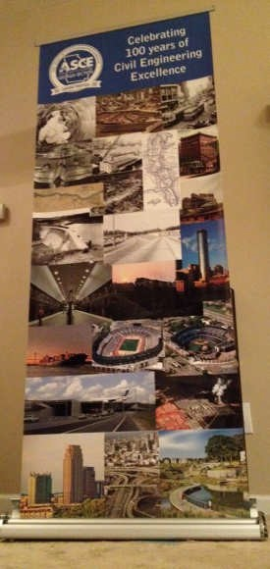
4/24/2013

100 Years of Civil Engineering in Georgia Book – Lessons Learned

If It Sounds Too Good To Be True, It Probably Is!! Sign a Contract!

Display at ASCE National Conference in Montreal, October 18-20, 2012

•Post Up Stand
•$250

4/24/2013

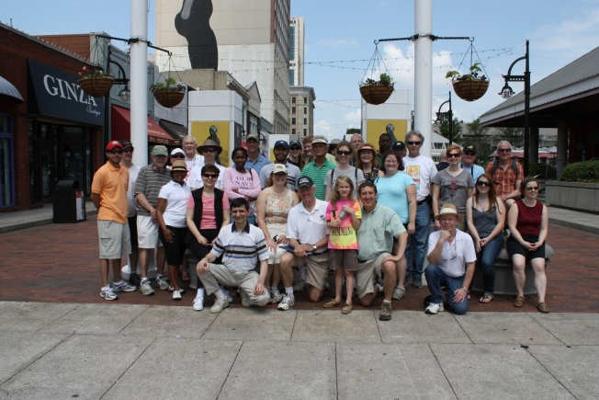

Historic Downtown Atlanta Walking Tour

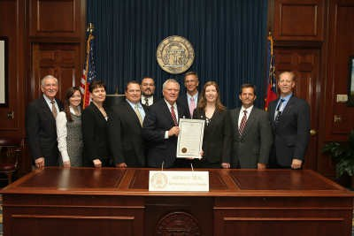
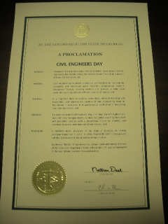

Civil Engineering Day in Georgia Proclamation by Governor Nathan Deal

4/24/2013

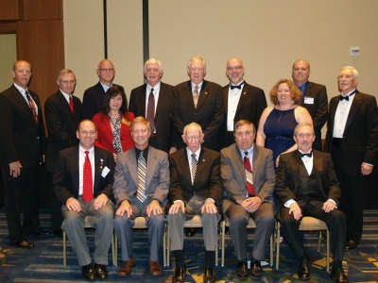

Annual Meeting and Gala – September 7, 2012
•Andy Herrmann – Guest Speaker
•Dr. DesRoches – Chair of CEE at Georgia Tech
•Recognized Past Presidents
•Slide Show Covering 100 Years of Civil Engineering in Georgia
•Sold Centennial Book
•Emcee/Pianist

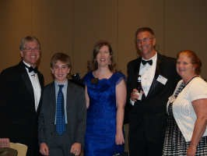
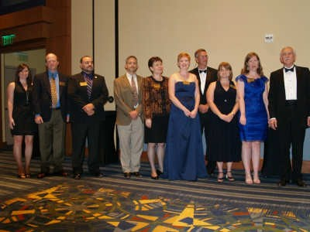
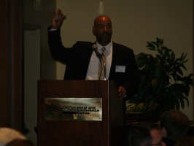

Annual Meeting and Gala – September 7, 2012

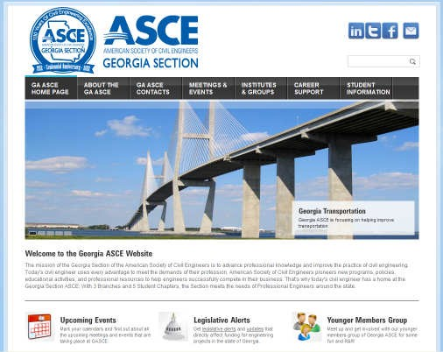
4/24/2013

Complete Renovation of Georgia Section Website
www.ascega.org
•Requested RFPs
•$2500 for a complete redo of the website
•$100/month for unlimited updates

Other Ideas

Centennial Lapel Pin Calendar
Press Releases

4/24/2013

Summary – Lessons Learned

Invite the ASCE National President well in advance!
Don’t Stretch Yourselves Too Thin Sign a Contract!
Give and Take

QUESTIONS?

Lisa S. Woods, P.E., F.SEI, F.ASCE
Georgia Section President

