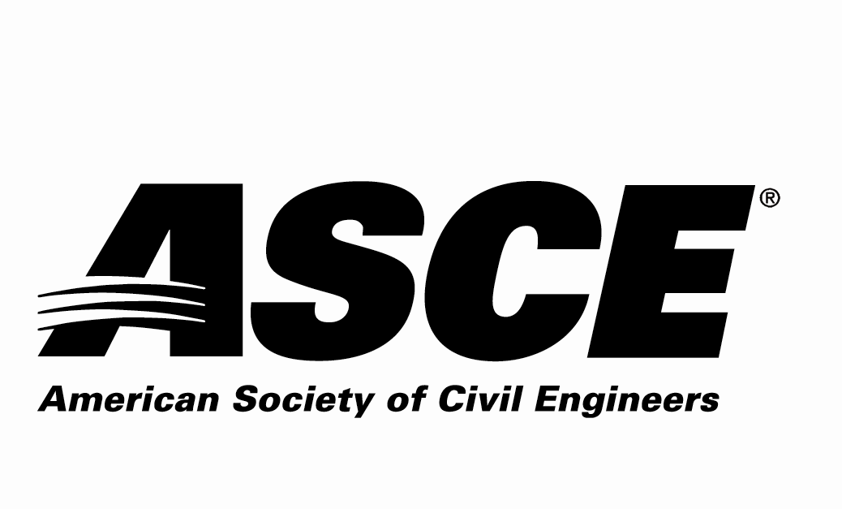 | REGION 7

Individual Nomination Form

Outstanding ASCE Faculty/Practitioner Advisor Award

Due Date: Nominations must be received by April 30, 2021

Application Materials Required
Individual Nomination Form and Electronic Photo of Nominee (jpg)

Entry Instructions
Electronic submittal is requested. Please e-mail the following 2 electronic files (less than 10 MB per e-mail):
- File 1: File name = nominee’s last name.pdf
Completed Nomination Form
- File 2: File name = nominee’s last name.jpg
JPG Photo of Nominee

E-mail to: jcjackataylor@gmail.com– with the Subject line name of:
“ASCE R7 Award Application – Outstanding ASCE Faculty/Practitioner Advisor for (nominee’s last name)”

For more information contact:
Jennifer Jacka-Taylor - ASCE Region 7 Awards Committee
jcjackataylor@burnsmcd.com or 785-587-5094

The Award
The award is given annually to an outstanding ASCE Faculty/Practitioner Advisor who supports ASCE student chapters and civil engineering students.

Award Criteria
The nominee must be active with ASCE Students in Region 7 the spring of the year the award is given or the fall of the previous year. The nominee shall be a member of ASCE in Region 7.

Awards Ceremony
The selected individual will be recognized in 2021 at awardee’s Section or Branch meeting.

Nominator Contact Information (This is the person making the nomination)
Name:
Employer:
Address:
 | Street |  | City | State | Zip
Phone Number:
Email Address:
Current ASCE Membership: Yes No ASCE Member #:
P.E.? Yes or No
P.E. Registration State: P.E. Registration #:

Name of the person you would like to Nominate for the Outstanding Faculty or Practitioner Advisor Award?
Name: | Are you a licensed P.E.: Yes No
Employer:
Address:
 | Street |  |  |  |  | City |  |  | State | Zip
Phone Number:
Email Address:
P.E. Registration State: |  |  |  |  | P.E. Registration #:
Current ASCE Membership: |  |  |  | Yes No |  |  | ASCE Member #:

Nominee ASCE Membership Information:
ASCE Section nominee belongs to:
Colorado Section
Denver Branch Northern Branch Southern Branch SW Branch Western Slope Branch
Iowa Section
Kansas Section
Wichita Branch
Kansas City Section
Nebraska Section
South Dakota Section
Black Hills Branch Eastern Branch
St. Louis Section
Wyoming Section

Outstanding Faculty or Practitioner Advisor Nomination Information Section for:

Please answer the following questions as thoroughly as possible and ensure that the response to this nomination information section is 3 pages or less.

1. Describe the nominee’s ASCE involvement with ASCE Student Members.

2. Provide any other information regarding the nominee to be considered for this award.

