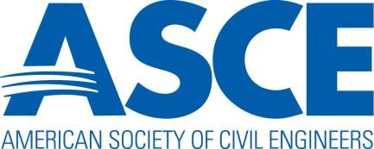

2020-2021 Section and Branch
Action and Activity Calendar

2020

March 11-13 Legislative Fly-in, Washington DC

June 1 Submissions are due for the Outstanding Section & Branch Web Award

Sept. 1 Section and Branch Leadership Reports Due

Sept. 13-14 Presidents and Governors Forum in Reston

Oct. 28-31 Annual Convention in Anaheim, CA

Oct. 30 Outstanding Section and Branch Award nominations are due

Nov. 30 Section, Branch, and Region Annual Reports are due

Dec. 15 Section Federal Tax Filing due to ASCE’s Accounting Dept.

2021

January 8-9 Regions 1, 2, 4, & 5 Multi-Region Leadership Conference in Charlotte, NC

January 22-23 Regions 3, 6 & 7 Multi-Region Leadership Conference in Denver, CO

February 12-13 Regions 8 & 9 Multi-Region Leadership Conference in Anaheim, CA

