State Government Relations Resources for Sections and Branches
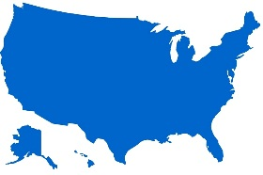
Legislative and Regulatory Tracking: View pending legislation and regulatory proposals in your state on ASCE’s state legislative tracking service. This page has a link to every state’s latest activity: http://cqrcengage.com/asce/states

Social Media Sites: Follow ASCE government relations on social media to stay on top of current state and federal policy. Check out ASCE’s Government Relations Facebook Page, and our Save America’s Infrastructure blog.

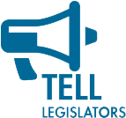
State and Local Key Alerts: ASCE can reach out to our members to urge action on legislative proposals that affect the engineering profession. Through a few easy clicks, members can send messages to their state legislators and Members of Congress.

New! Government Relations University: Modeled after the popular PR University, this program provides advocacy training from ASCE staff who will travel to your locality to conduct the program.

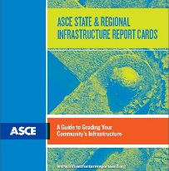
State Report Card Guidebook: This publication is designed to help Sections and Branches get started with the process of producing a state or regional infrastructure report card.

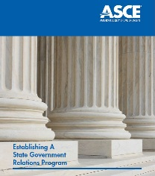

State Government Relations Manual: A basic manual on how to create and successfully run a state government relations program.

Testimony, Talking Points, and Issue Briefs: Staff can assist with drafting testimony, position papers, letters to legislators, and editorials. ASCE also provides materials for visits with elected officials.

  - Key Contact Program
Grassroots advocacy plays a critical role in the Society’s ability to meet its mission, vision and strategic priorities. We can and do lobby. Mobilizing ASCE members quickly in support of or against legislation is vital to our success. The Key Contact Program is the foundation of that mobilization with its self-identified Key Contacts. Help grow ASCE’s culture of advocacy by becoming a Key Contact today!

- Become a Key Contact. Learn about public policy issues important to the engineering profession and be the first to receive timely legislative Key Alerts for your state and the federal government.
- One-click, pre-drafted emails to communicate with federal and state elected officials.
- FREE Key Contact-only quarterly webinars & issue briefings.
- Advocacy training for Key Contacts that helps hone elevator pitches, maximizes influence, and gets results.
- Back Home Meetings materials to further relationships with elected officials in their district.
- Leadership opportunities as Federal and State Advocacy Captains.
- Brings civil engineering issues to Congress at the annual Legislative Fly-In in DC each spring.
- Improves your soft skills by providing opportunities to network, negotiate, interact with the public, build coalitions, use social media, etc.
- Celebrates a culture of advocacy with the Outstanding Civil Engineer Advocate of the Year Awards.

You can sign up to be a Key Contact online at http://www.asce.org/keycontacts/. Questions? Contact the ASCE Government Relations Team at govwash@asce.org or 202-789-7850.

